- 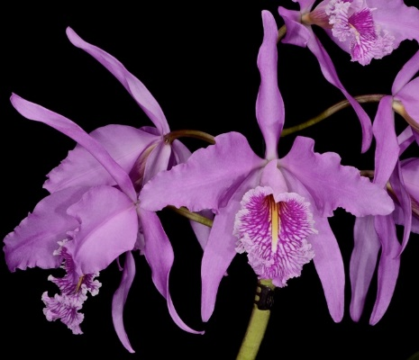 Seven open flowers on one inflorescence; sepals and petals concolor lavender, margin gently undulated; lip tubular, pale lavender, densely striated with crisp fuchsia veins, margin heavily ruffled, keel bright yellow; column white, completely enclosed by sidelobes; substance firm; texture crystalline
- 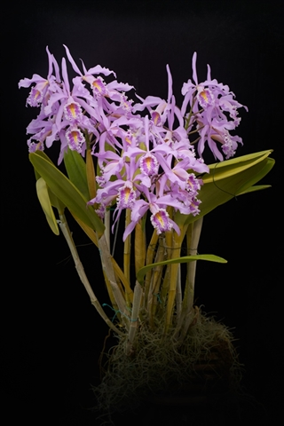 Thirty open flowers evenly arranged on three erect inflorescence on a 50cm wide x 50cm tall self-supporting plant growing on a 20cm teak basket; foliage firm, unblemished, medium green; sepals and petals are clear light lavender; lip heavily veined violet, margin heavily ruffled, picotee pale pink, midlobe yellow centrally, side lobe enclosed column; column and anther cap white; substance firm, texture crystalline
- 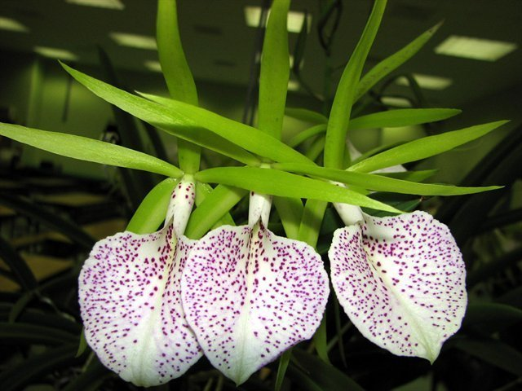 Five stellate, very flat flowers on one inflorescence; sepals and petals clean saturated lime green lightly speckled maroon on reverse; lip spade shaped resembling B. nodosa, white heavily spotted royal purple; substance heavy; texture matte
- 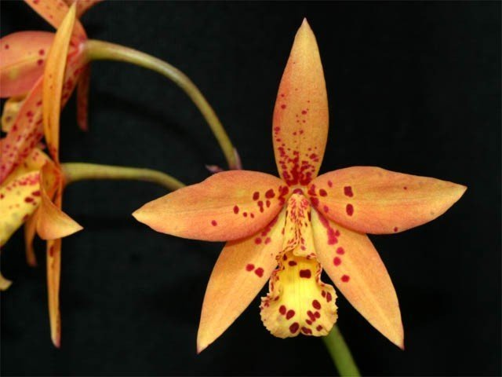 Thirty flat, stellate flowers and five buds on seven inflorescences; sepals and petals buttercup yellow blushed orange proximal two third, randomly spotted garnet red proximally, increasing in density toward column; lip trumpet shaped, buttercup yellow blushed orange distally, randomly spotted garnet red, margin lightly undulated and serrated; substance good; texture sparkling.
- 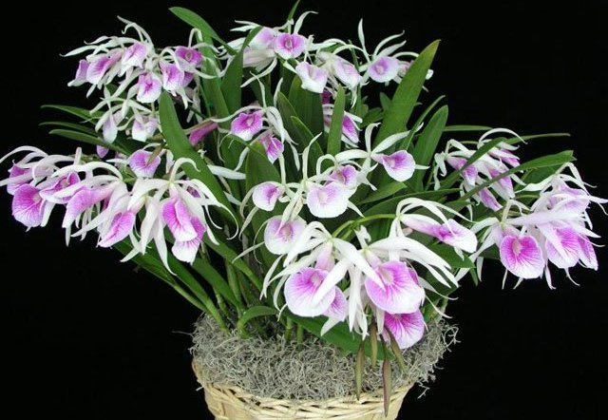 Fourty five open, cupped flowers on ten inflorescences displayed evenly on a well grown plant 70cm wide x 50cm tall on a 20cm decorative basket; foliage erect, clean with no brown tips; sepals and petals cream blushed light pink, slightly twist; lip trumpet shaped, recurved at apex, veined fuchsia radiating from throat to margin with suffusing fuchsia proximally, throat buttercup yellow with maroon striations; substance average, texture crystalline.
- 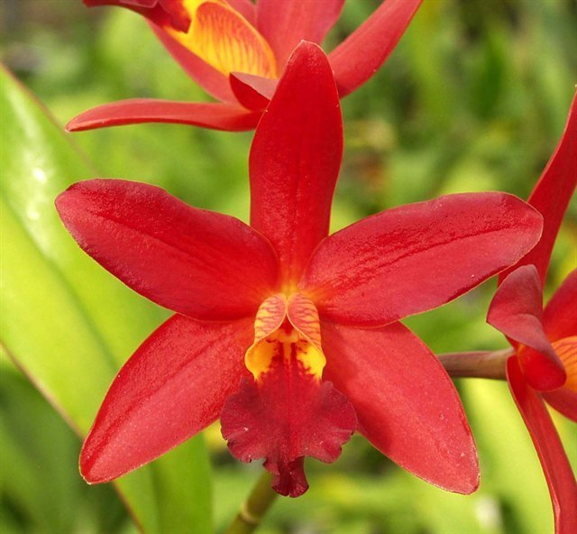 Twelve well-presented flowers on an upright inflorescence; sepals and petals concolor bright red; lip golden yellow, midlobe dark red with two longitudinal maroon veins proximally, margin undulated, sidelobes veined dark red; column cream suffusing red distally, enclosed by sidelobes; anther cap ivory; substance hard; texture glossy, lip velvety.
- 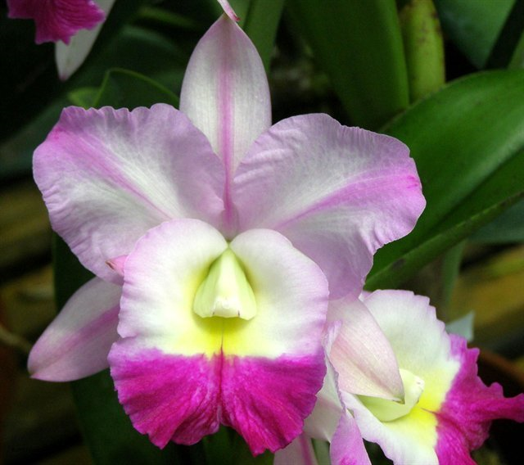 Four very flat and round flowers on two inflorescence, sepals and petals white blushed lavender with darker pink midline, petal tips splashed rose pink; lip white blushed lavender marginally, distal skirt suffused and veined dark fuchsia, bright lemon yellow throat; column and anther cap ivory; substance firm, texture crystalline.
- 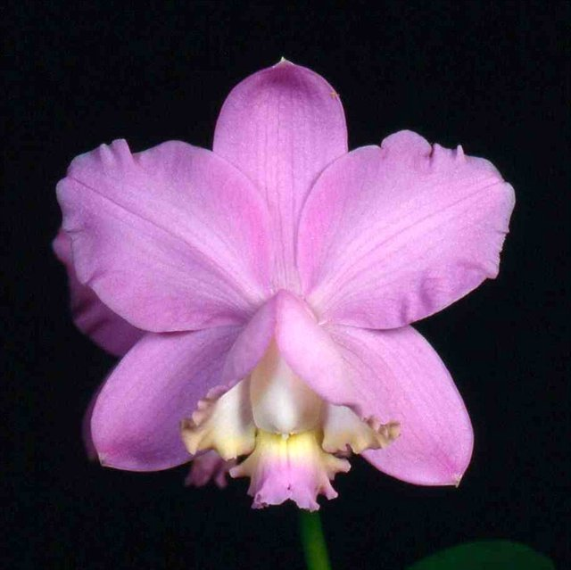 Eight flat well-presented flowers on three inflorescence, sepals and petals concolor rose pink, slightly undulated; lip isthmus, margin ruffled, interior ivory, exterior rose pink, midlobe butter yellow proximally and rose pink apically, side lobe butter yellow marginally; column ivory prominent, partially enclosed by sidelobes; substance firm, texture crystalline.
- 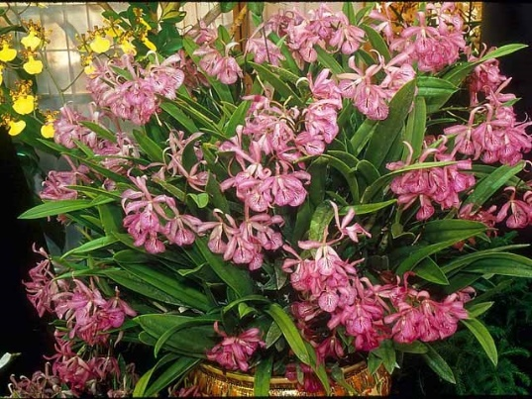 Two hundred and eighty flowers and twenty buds on fifty five inflorescences evenly displayed on a round specimen-sized plant 90 cm wide x 65 cm high completely engulfing the original 15cm pot; foliage firm, grass green with no damage or brown tips; sepals and petals lavender heavily spotted dark pink; lip lavender, trumpet shaped, heavily spotted fuchsia coalescing into radiating veins; substance average; texture matte.
- 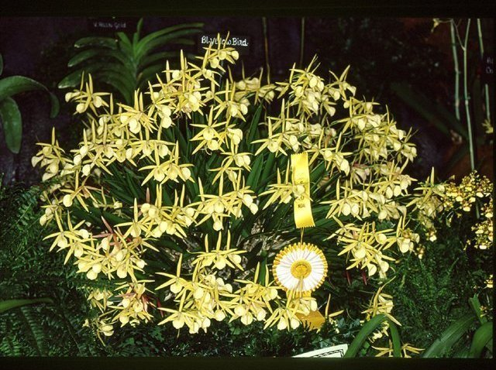 Three hundred flowers and fifty buds on one forty gracefully arching inflorescences well displayed atop of an immaculate canopy of foliage creating an impressive floral mound 90 cm wide x 60 cm tall engulfing the original 20cm terracotta bulb pan; flowers yellow with brick red overlay fading to butter yellow with age; sepals and petals open, flat, stellate, spotted maroon proximally; lip resembled B. nodosa, speckled maroon; substance firm; texture satiny.

