- 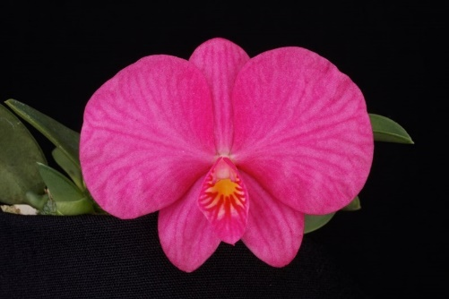 Two full flowers and one bud on three inflorescences; sepals and petals flat, wide, and overlapping, vibrant hot pink veined magenta; lip cream with hot pink distally, heavily veined magenta, throat yellow; column white blushed pink; substance firm; texture crystalline.
- 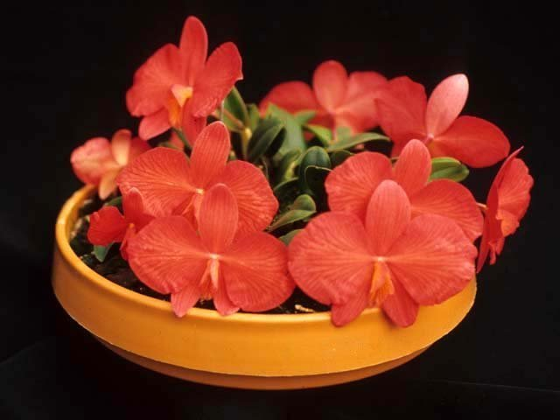 Eleven flowers and four buds on fifteen short inflorescences borne on a compact, circular plant with flowers almost completely hide the clean and neat foliage growing on an 20cm shallow bulb pan; sepals and petals extremely flat, salmon orange with brick red veining; lips tubular, white heavily veined red, throat yellow; anther cap and column white; substance medium; texture crystalline.
- 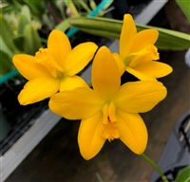 Eight flowers on two inflorescences held well above foliage; sepals and petals flat, concolor bright golden yellow; lip gold, sidelobes fold over column, midlobe lingulate, ruffled distally; keels brick red; column and anther cap cream; substance firm; texture diamond dust.
- 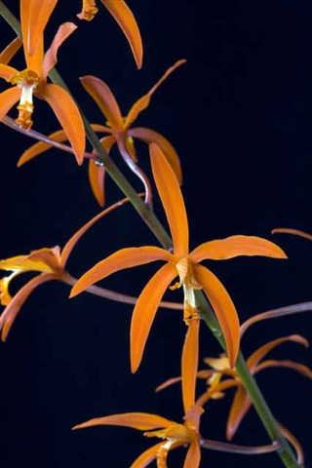 Eleven stellate flowers and seven buds pleasingly arranged on a tall, erect inflorescence; sepals and petals slightly reflexed, solid bright tangerine orange; lip tubular, cream-colored, striped orange, tangerine orange overlaid distally, margin ruffled; substance firm; texture matte.
- 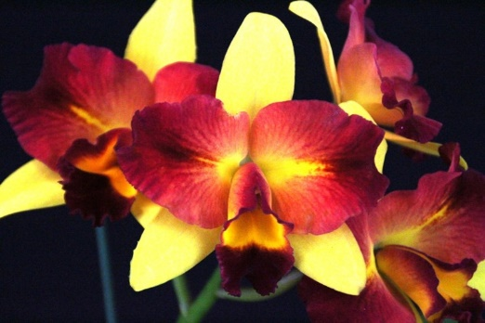 Four vibrant flowers on one inflorescence; sepals concolor canary yellow; petals golden yellow proximally at midline, yellow overlaid red darkening to deep ruby red distally, veined brick red; lip tubular, throat golden yellow, suffusing deep ruby red marginally and entire midlobe, margin undulating; anther cap cream; column blushed red distally; substance firm; texture crystalline, lip velvety.

