SPECIES DATA REPORT
Cattleya mantiqueira (Fowlie) Van den Berg 2008
Synonym: Sophronitis mantiqueirae Fowlie 1972; Hadrolaelia mantiqueirae (Fowlie) Chiron & V.P.Castro 2002; *Sophronitis coccinea subsp. mantiqueirae Fowlie 1968; Sophronitis coccinea var parviflora hort;
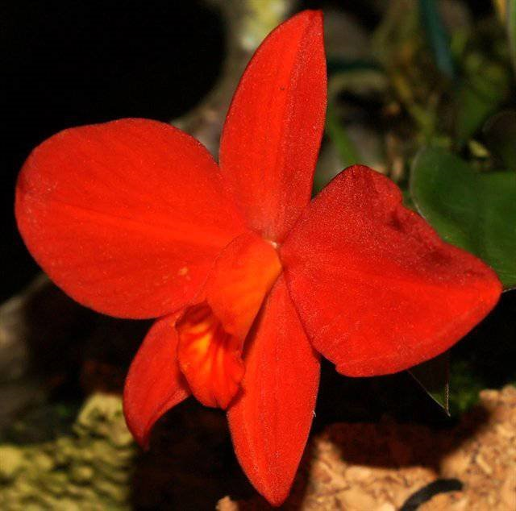
Found in southeastern and southern Brazil on moss or lichen covered saplings in creek gulches and on ridge crests at elevations of 1200 to 1890 meters as a small sized, cool growing epiphyte with short to 1" long, fat, ellipsoid (elongated sphere), fusiform (spindle shaped) to ovoid (eggshaped) to subglobose (nearly sphere shaped) pseudobulbs and carrying thick, rigid, leathery, narrowly ovate, oblong to oval and curved, reddish tinted on reverse, shortly petiolate base leaves that blooms in the summer on a short, terminal, single flowered inflorescence.
It is closely related to C. coccinea. While C. coccinea inhabits the first coastal mountain range, C. mantiqueirae occurs from the second range, the Sierra da Mantiqueira, to slightly farther inland. These habitats has short periods of drier weather different from those of C. coccinea. The absence of rain or fog can sometimes last a few days. Plants start to be found only on coarser barked trees where moss can grow providing moisture for the orchids. Plants and flowers of C. mantiqueirae are similar to C. coccinea but they average one half to two third their size. Flower shapes are not as round so the flowers look smaller in the first glance. The color is similar but albino varieties have not been recorded.
Awards: 2 AM, 1 CCM
Hybrids: 8 F1 hybrids, 10 Total progeny. No pictures or awards seen on Orchidwiz. All but one hybrid are registered before the year 2000.

Cattleya angereri (Pabst) Van den Berg 2008
Synonym: Laelia angereri Pabst 1975; Hoffmannseggella angereri (Pabst) V.P.Castro & Chiron 2002; Sophronitis angereri (Pabst) C. Berg & M.W. Chase 2000
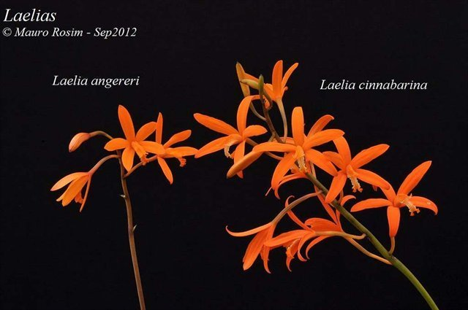
Found as a medium to large sized, cool growing lithophyte under bushes at 1000-1300 meters in the northeast of Minas Gerais state of Brazil. They have hot summers and cool winter nights which are typically dry, but there is daily dew in the winter so light misting through the winter is required. Pot with a rocky base media such as solite or aliflor and add a little crushed tree fern, then grow in a cool environment with indirect bright light and you will be rewarded with an erect, 8 to 10" [20 to 25 cm] long, racemose inflorescence with up to 10 flowers occuring in the winter and early spring in cultivation. This species has a short rhizome giving rise to elongate, cylindrical, slightly thickened basally pseudobulbs carrying a single, apical, lanceolate leaf. Larger plant with more compact and smaller flower spikes than C. cinnabarina
Awards: ‘Sciurba’ 83 pts CBM/AOS in 1975
Hybrids: 13 offsprings, 15 total progeny with 2 second generation hybrids and no third generation. Limited award given to progeny. Notable is Bc. Martha Miller (x B. subulifolia) ‘Susana’ AM/CCM/AOS and C. Tropical Sunshine (x C.neokautskyi) ‘Patience’ HCC/CCM/AOS.

Cattleya esalqueana (Blumensch. ex Pabst) Van den Berg 2008
Synonym: Laelia esalqueana Blumensch. ex Pabst 1973; Hoffmannseggella esalqueana (Blumensch. ex Pabst) V.P.Castro & Chiron 2002; Sophronitis esalqueana (Blumensch. ex Pabst) Van den Berg & M.W.Chase 2000
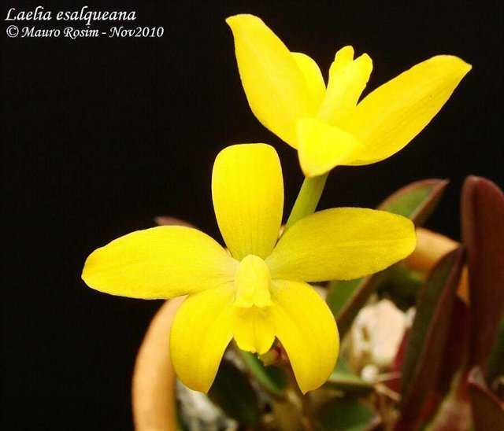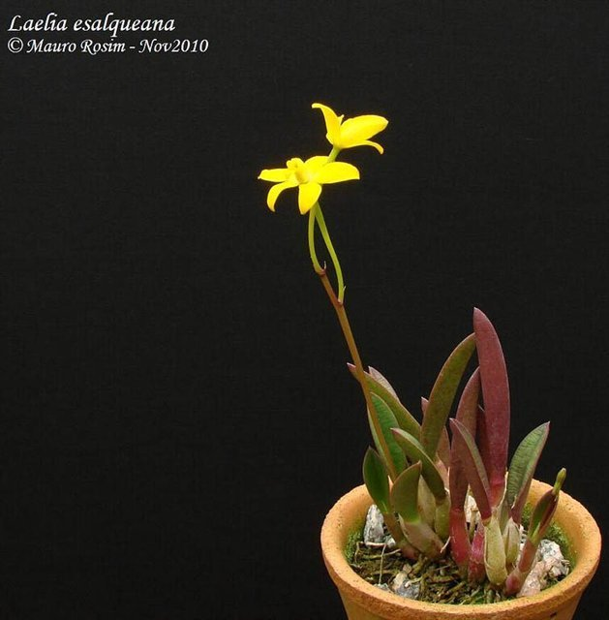
Found in Sao Paulo State of Brazil at elevations around 1100 to 1300 meters as a mini-miniature sized, cool growing, rupicolus lithophtye with clustered, stubby, fat, narrowly conical pseudobulbs carrying 1 to occasionally 2, thick, rigid, leathery, narrowly oblong, concave to scoop shaped, acute leaves that blooms in the late spring and early summer on a terminal, 1.6 to 2" [4 to 5 cm] long, simultaneously 2 to 4 flowered inflorescence arising through a sheath and just exceeds the length of the leaf.
Awards: 1 HCC, 1 CCM, 1 CBR
Hybrids: 20 offsprings/ 213 total progeny. Desirable characteristics are miniature plant, bright yellow color that carries through generations. Most well-known and influential hybrid is C. Jungle Elf (x C. aclandiae). It is a foundation hybrid for yellow with red spots Cattleya breeding. Many popular hybrids came out of this line of breeding including C. Jungle Eyes, C. Jungle Gem, Rlc. Sunspots.
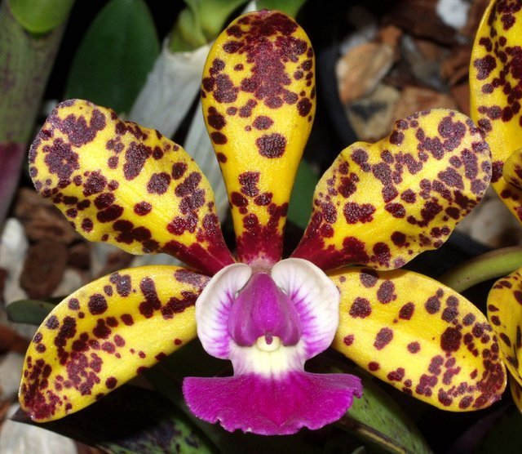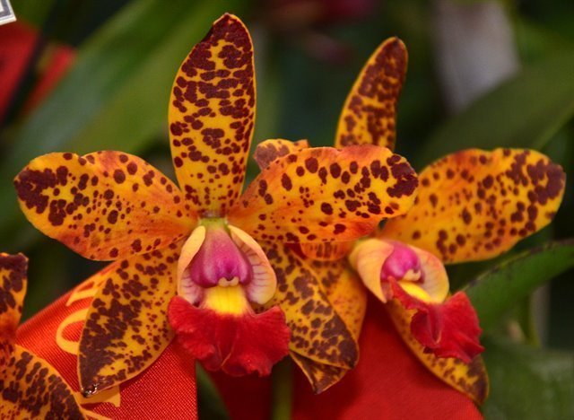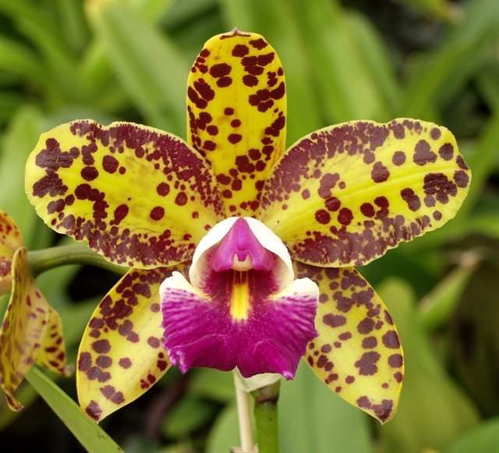
Cattleya briegeri (Blumensch. ex Pabst) Van den Berg 2008
Synonym: Laelia briegeri Blumensch. ex Pabst 1973; Hoffmannseggella briegeri (Blumensch. ex Pabst) V.P.Castro & Chiron 2002; Sophronitis briegeri (Blumensch. ex Pabst) C. Berg & M.W. Chase 2000
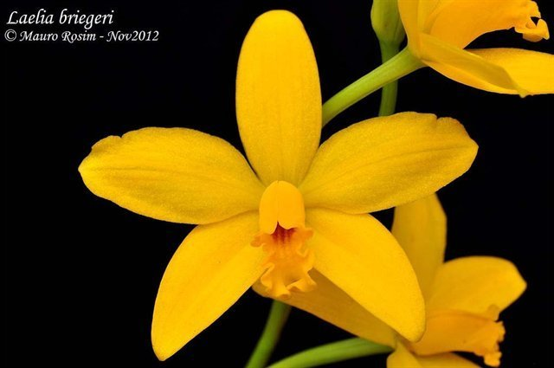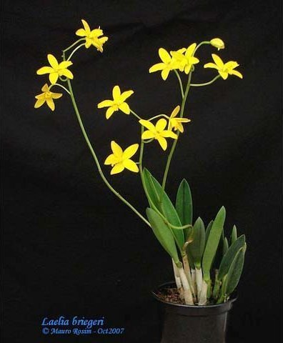
Found in Brazil at elevations around 1370 meters as a miniature to small sized, cool growing, rupicolus Laelia growing directly on rocks in small cracks and crevasses with small, cylindrical pseudobulbs carrying a single, apical, stiff, coriaceous, ovate-lanceolate, acute leaf and blooms in the later spring on a terminal, erect, 8 to 10" [20 to 25 cm] long, single flowered inflorescence that is much longer than the leaf. Similar looking to C. esalqueana but larger plants and flowers and taller inflorescences.
Awards: 7 AMs, 4 HCCs, 1 CBM
Hybrids: 89 offsprings/ 980 total progeny. One of the most breeded in the rupiculous group because of its large quantity of well-formed yellow flowers on a tall upright spike. Desirable characteristics are excellent vigor, well formed, relatively large flower/plant ratio, and compact plants. However, C. briegeri requires an extended dry period making it challenging and confusing for unfamiliar grower, and this can pass down to its hybrids. Flower shape and small lip are also dominant
Most well-known hybrid is Rth. Love Sound (x Rth. Bouton D’Or) is a parent of another 148 offsprings. Bright yellow flowers with broader segments and slightly broader lip looks like an improved version of the parent species.
Other popular breeding hybrids of C. briegeri are C. Tokyo Magic (x C. Irene Finney) with pale to bright yellow flowers and two tone lip with dark purple, Rlc. Haw Yuan Moon (x Rlc. Waikiki Gold) with bright lemon yellow with gold lip.
Most hybrids and progeny awards are after the year 2000 due to the increasing interest in breeding compact/colorful Cattleya hybrids recently. Hybridization aims to further improve the shape of C. briegeri (fuller petals, larger lip)

Cattleya brevipedunculata (Cogn.) Van den Berg 2008
Synonym: Sophronitis brevipedunculata [Cogn.] Fowlie 1972; Hadrolaelia brevipedunculata ( Cogn. ) Chiron & V.P.Castro 2002; Sophronitis rosea var brevipedunculata [Cogn] Fowlie; *Sophronitis wittigiana var. brevipedunculata Cogn. 1902
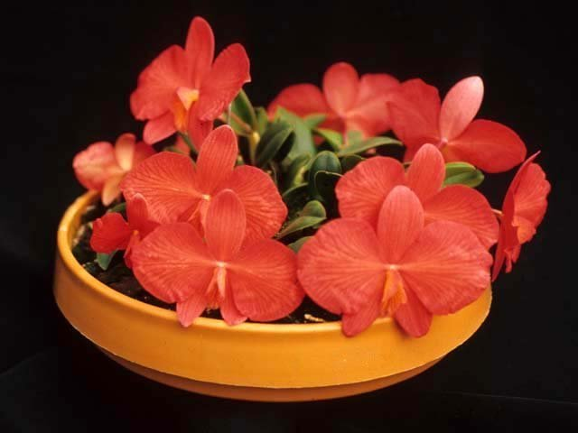
This is a Brazilian epiphytic, or lithophytic, cool growing, miniature orchid from Minas Gerais State and is found on vellozia trees or in humus pockets on the rocks below them in drier cool winter mountain habitats in scrub and cacti at elevations of 1220 to 2000 meters where their water comes mainly from the cloud cap on the high mountains at night and condensation. They have sulcate (marked with parallel groove), globose to cylindrical pseudobulbs that are arranged in two ranks along the rhizome and carry a single, apical, erect, stiff, leathery, leaf that blooms in the late winter and spring in Brazil on a terminal, short to .4" [1 cm] long, solitary to 3 flowered inflorescence. Blooms are pollinated by hummingbirds indicated by the flower color.
This genus differ from others in the C. coccinea complex because of the purple element in the flower (purple red instead of orange red). This is a species that grows more interior of Brazil and in much drier habitats. Plants are more similar with C. cernua than C. coccinea and when not in bloom can be easily confused with C. cernua.
Awards: 9 AMs, 5 HCCs, 1 CCE, 3 CCMs, 1 CHM
Hybrids: 34 offsprings/ 132 total progeny. Most popular primary hybrid is C. Arizona (x C. coccinea) further diversifying C. coccinea genetics. Desirable characteristic of C. brevipedunculata is slightly larger flowers and more compact plants and foliage with shorter inflorescences presenting the flowers in a more pleasing way. Hybrids of C. brevipedunculata dominates in small plant size, round shape, short flower stem, and low flower count, flat profile, small lip. When cross with lavender parents will produce bright purple offsprings (ex: C. Miyuki Little King)

Reference:
OrchidWiz Encyclopedia version 4.1
Orchid Plus Online
American Orchid Society Magazine
Issue July 2003 page 26 - 35
Issue December 2011 page 14 - 18
Jay Pfahl’s Internet Orchid Species Photo Encyclopedia:
http://www.orchidspecies.com/sophmantiqueirae.htm
http://www.orchidspecies.com/laeliaangereri.htm
http://www.orchidspecies.com/laelesalqueiana.htm
http://www.orchidspecies.com/laelbreigeri.htm
http://www.orchidspecies.com/sophbrevipedunculata.htm

