SPECIES DATA REPORT
Cattleya jongheana (Rchb.f.) Van den Berg 2008
Synonym: Laelia jongheana Rchb.f. 1872; Bletia jongheana Rchb.f 1872; Hadrolaelia jongheana ( Rchb.f. ) Chiron & V.P.Castro 2002; Sophronitis jongheana (Rchb. f.) C. Berg & M.W. Chase 2000
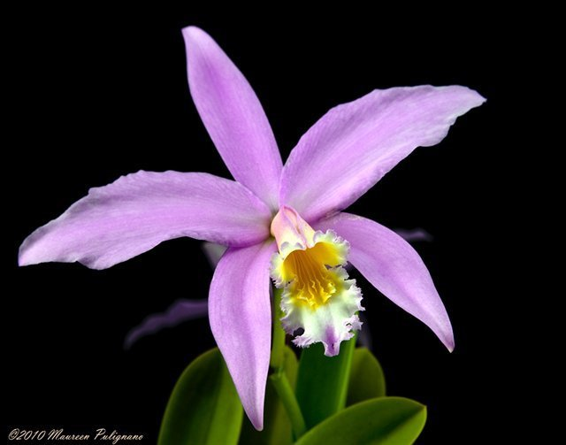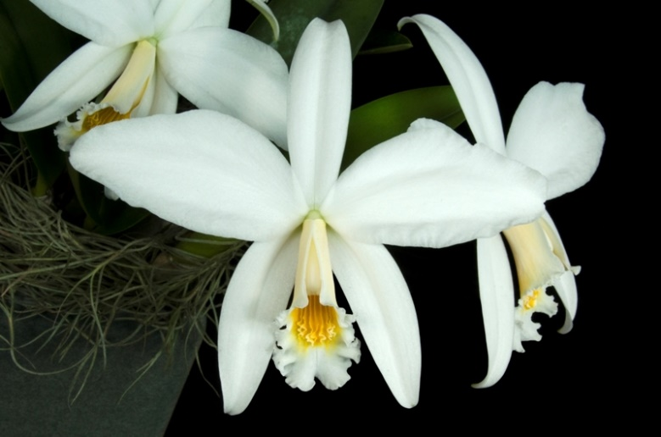
This is a Brazilian, miniature, cool growing, very rare epiphytic species with a solitary leaf found in central Minas Gerais at elevations of 1300 to 1600 meters in small patch forests exposed to sunlight and winds. It is currently one of the most endangered of orchids. Plants are attached to trees that grow in the steep-sided rocky gulches. Even during the dry season, these gullies normally have at least a trickle of flowing water. Plants are often subjected to near freezing temperature during rest season in winter, and wide day/night temperature fluctuation throughout the year
Pseudobulbs ovoid to ellipsoid, dark green, sulcate, subtended by a white, apressed sheath and carrying a single, apical, very leathery, oblong-ellptic, obtuse or emarginated (concaved leaf margin) leaf that blooms in the late winter till spring on a 5 3/4" [14 cm] long raceme with 1 or 2 long-lived flowers. It used to belong to a section of Laelia called Hadrolaelia, well-known for species that produce fairly large flowers on small plants. C. jongheana produces the largest flowers in the section, around 6 inches acoss. The wide spreading, heavy textured flowers open nearly flat with tubular lip facing downward. The most striking feature is the midlobe with seven extremely wavy keels, eggyolk colored throat and frilly lip margins.
Varieties: f. alba (white form with yellow throat), f. flamea (petals with darker veins).
The typical color varies from medium to dark pink or rose-purple.
Awards: 2 FCCs, 18 AMs, 13 HCCs, 3 CCEs, 6 CCMs, 1 CHM. Most recent FCC is the alba clone ‘Paradox’ (pictured above right) in 2017 with 91 points
Hybrids: 58 off springs/ 98 progeny. However, none are remotely well-known as the parent species. Hybridization isn’t very active either. Only 14 offsprings/ 18 progeny are registered after 2005. Positive traits include large flower for the size of (already compact) plant, flat flowers, striking frilly lips. Negative traits include open flowers with smaller lip and difficulty in cultivation.
SPECIES DATA REPORT
Cattleya amethystoglossa Linden & Rchb. f. ex Warner 1862
Synonym: Cattleya amethystoglossa var. alba L.C.Menezes & Braem 2006; Cattleya amethystoglossa var. lilacina (Rchb.f.) Fowlie 1977; Cattleya amethystoglossa var. rosea Rolfe 1892; Cattleya guttata keteleerii Houlet. 1875; Cattleya guttatta lilacina Barb. Rod. 1882; Cattleya guttata prinzii Rchb.f 1856; Cattleya guttata Lindley var prinzii [Rchb.f]A.D.Hawkes; Cattleya purpurina R. Br 1882; *Epidendrum amethestoglosum Rchb.f 1861; Epidendrum elatius Rchb.f var prinzii Rchb.f 1862
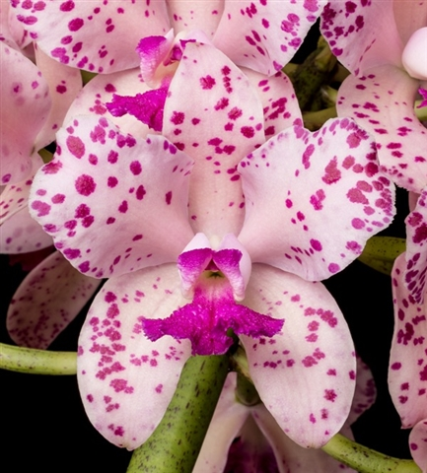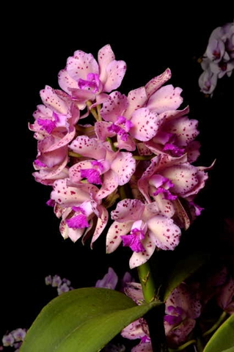
Found in Bahia, Minas Gerais and Pernambuco states of Brazil as a large sized, cool to warm growing epiphyte at elevations around 600 meters growing on rock outcrops near the sea and on palms in full sun with lots of warmth and humid air with tall, cylindrical pseudobulbs carrying 2 apical leaves.
This species first appeared in the collection of Herr Reichenheim at Berlin and was described in 1856 in BONPLANDIA by Reichenbach as Cattleya guttata var. prinzii, named to honor Herr Print who had sent the plant from Brazil. It appeared in England in the collection of Mr. F. Coventry, of Shirley, whose solitary plant went to Mr. Warner in 1860. Figured in Warner's SELECT ORCHIDACEOUS PLANTS as Cattleya amethystoglossa. It has since been imported in large quantities from its native home in the province of Bahia. The stems are cylindrical, two to three or more feet high, bearing two leaves from four to eight inches long making it one of the tallest Cattleyas. Flowers are about three to four inches across, fleshy, in an upright cluster containing five to twenty flowers. Petals are similar to sepals but somewhat broader, petals and sepals bright rose spotted with amethyst-purple, especially toward the margins. Lip is three-lobed, the lateral lobes folding over the column, the middle lobe spreading, notched in the front margin, deep amethyst-purple. It is an intermediate to warm species, very variable in habit and floral coloring.
The species blooms in the fall, winter and early spring with a terminal, several to many [10 to 30] flowered inflorescence carrying fragrant flowers.This species is easily adapted to cultivation, needs ample light, water and fertilizer while growing and a definite rest after flowering.
This species is very similar to C guttata yet differs in the flowers which are white or pale rose, spotted dark rose or mauve on the sepals and petals and the lip has white lateral lobes with magenta flare, a magenta midlobe with granular texture, and a pale golden or white throat.
Varieties: f. coerulea (blue), f. alba (white), f. albescence (nearly white), f. venosa (lightly veined), f. salmonea (salmon-colored), f. suavissima (soft/lightly colored), f. flamea (splashed sepals and petals), f. aura-coerulea (coerulea form with light yellow background), f. aurea or var. sulphurea (yellow), f. amesiana, heavily spotted form, lack of spot form, strange spots patterns forms, etc….
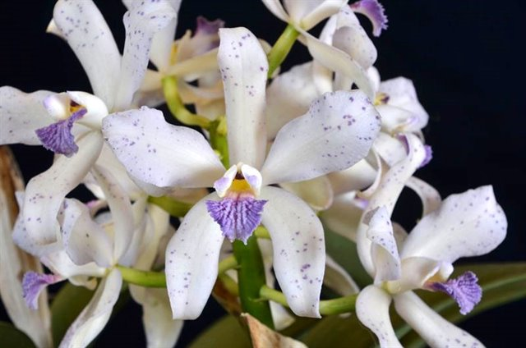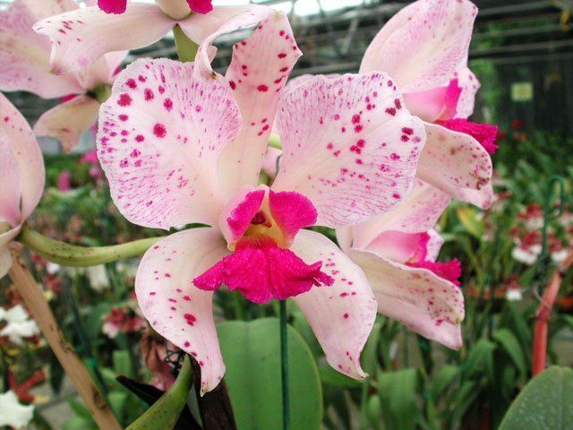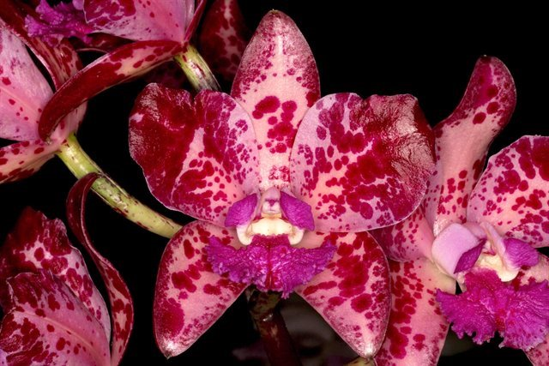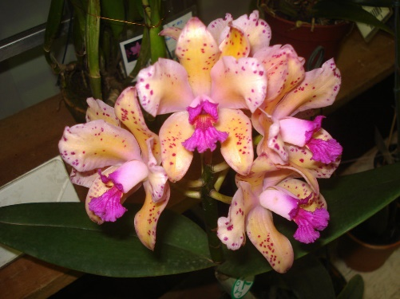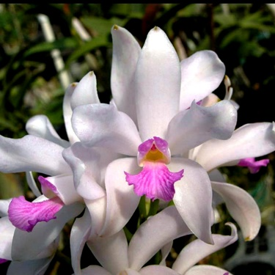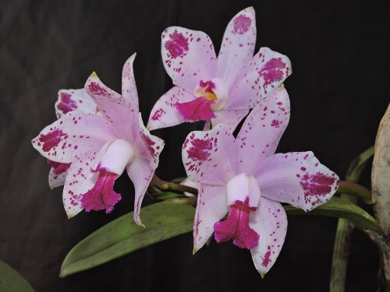
Awards: 45 AMs, 19 HCCs, 2 CCEs, 5 CCMs, 2 JCs. Most recent awarded AM is the coerulea clone ‘Dona Ana’ with 80 points in 2017, highest awarded for flower quality is ‘H & R 4’ with 88 points in 2009. Nowadays, flowers of C. amethystoglossa are extensively bred using polyploidy for rounder form, especially wider and flatter petals comparing to wild type, however, there is no FCC to date.
Hybrids: 138 Offsprings/ 534 Progeny. This species is not the most prolific Cattleya breeder. Most well known is the older primary hybrid C. Interglossa (1902), and the newer C. Leoloddiglossa (2010) – a well representation for a new breeding direction: spotted blue Cattleyas pioneered by Fred Clarke. The primary hybrid C. Loddiglossa has its spots suppressed by the other parent (C. loddigesii) is now crossed with C. tigrina (or C. leopoldii) to enhance the spots and intensify the blue coloring. The resulting hybrid is C. Leoloddiglossa. Since registered, it has received 1 FCC, 7 AMs, 1 HCC, and 1 CCM.
Desirable trait: Incredible lip color and texture, spots on flowers, high flower count, heavy substance, improved flower shape from polyploidy breeding, ease of culture, many color forms
Undesirable trait: Very tall plant, small lip shape, summer.
BUILDING BLOCK REPORT
Cattleya loddigesii Lindl. 1823
Synonym: Cattleya arembergii Scheidw. 1843; Cattleya candida B.S.Williams 1852; Cattleya loddigesii f. virginalis M.Wolff & O.Gruss 2007; Cattleya loddigesii subsp. purpurea Brieger ?; Cattleya loddigesii var. candida Guidon 1858; Cattleya ovata Lindley 1838; Epidendrum canaliculatum Vell. 1825; Epidendrum harrisoniae Rchb.f; Epidendrum loddigesii Rchb.f 1861; Epidendrum violaceum Lodd. 1819
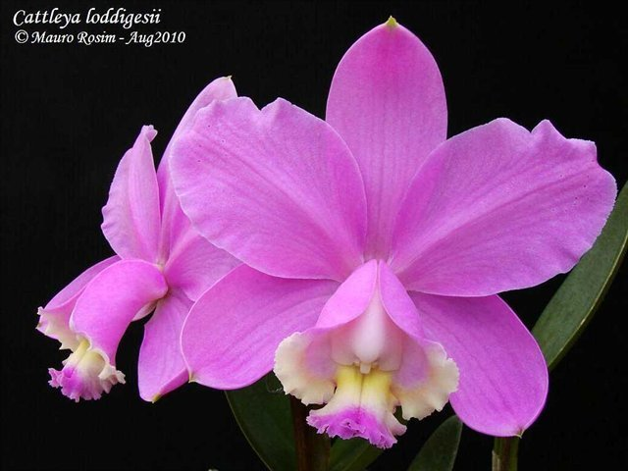
A medium sized, cool to warm growing, bifoliate epiphyte or lithophyte that is from near the coast from Bahia Brazil south to Argentina and Paraguay, in both sun and shade with cylindrical, narrowing basally pseudobulbs carrying 2 apical, elliptic-oblong, leathery, obtuse leaves and blooms in the winter/early spring on a terminal, 12" [30 cm] long, long-lived inflorescence subtended by a small, broad, dried sheath that has waxy, fragrant, long-lived flowers. This is the second species to be described in the genus Cattleya after C. labiata
Introduced into England from Rio de Janeiro by Messrs. Loddiges, of Hackney, under the name of Epidendrum violaceum early in the nineteenth century, it was placed into the new genus, Cattleya, under the name Cattleya loddigesii, by Lindley when he established the new genus in 1824. The cylindrical stems are about a foot high, with leaves from four to five inches long. Flower stem bears from two to five flowers up to four and a half inches across. Petals and sepals similar and nearly equal, the lateral sepals somewhat bowed, the petals slightly broader and waved along the margins, delicate rose-lilac. Lip is trilobed, the lateral lobes almost rectangular, erect, the front edge toothed, colored as the petals and sepals on the outside, whitish inside; the middle lobe spreading, much crisped at the margin, pale amethyst-purple; the disk whitish to pale yellow. A widespread species in southern Brazil, it grows in many types of situations, on trees, on bare rocks, in deep shade and in full sun, hence giving rise to a wide range of forms. The species Cattleya harrisoniana is sometimes considered as a variety. The demarcation lines between this species, Cattleya intermedia, and several other so-called species are not sharp and a modern taxonomic investigation of the group would be worthwhile.
C. loddigesii vs. C. harrisoniana:
Cattleya loddigesii | Cattleya harrisoniana
Wider segments, lighter substance, lower flower count (2-3, rarely 4 per inflorescence) | Narrower segments, heavier substance, higher flower count (up to 6-8 per inflorescence)
Pink, with varied amount of spotting, whitish lip with less defined white/cream/pink keels, no vein on sidelobes | Lavender, darker pink, whitish lip with fleshy yellow-orange keels on disc, yellow veins on interior of sidelobes
Sidelobes loose from column, far exceeding its length, can be as long as midlobe | Sidelobes tightly enclosed column, only slightly exceeding its length exposing column and long midlobe
Downward facing column | Forward facing column
Winter/early spring blooming | Summer blooming
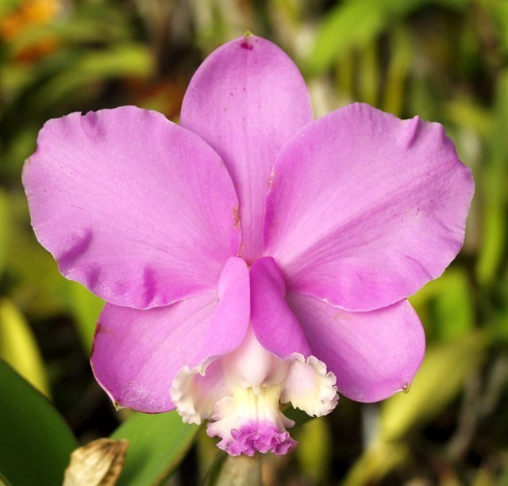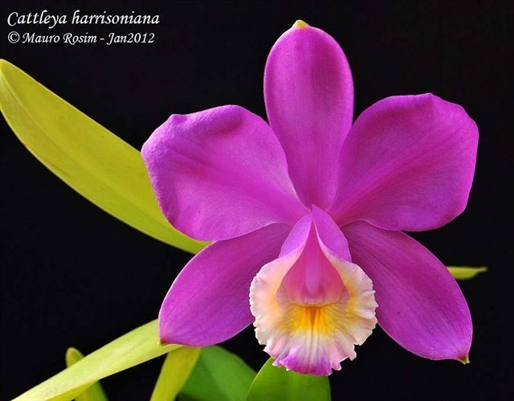
Variety: C. loddigesii is unusually uniform, light pink to magenta color (tipo) in contrast with the highly variable C. intermedia in the smaller Brazilian Cattleya group. However, there are several variety to be noted: var candida or f. alba (pure white), f. coerulea (blue), var. punctate (speckled form), f. aquini (peloric)(pictured below left), f. striata or f. venosa (veined) (pictured below right)
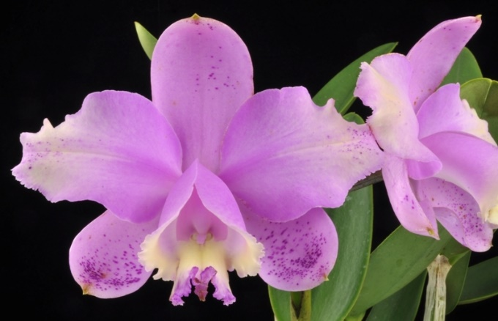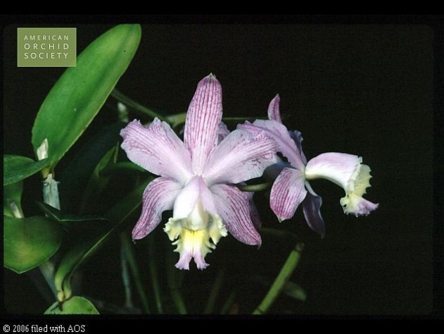
Awards: (excluding C. harrisoniana) 4 FCCs, 40 AMs, 19 AMs, 1 CCEs, 5 CCMs, 2 AQs, 2 JCs
C. loddigesii is so uniform that finding improved clones or improving them through hybridization proves to be difficult. Most of the larger, broader petal eaxmples did not seem to appear until the late 1990s. Through line breeding, this species has achieved fuller, richer color, and flatter than plants from 20 years ago. One of the finest breakthrough in breeding is the FCC clone ‘A-doribil’ awarded 91 points in 2006. It has two large, full flowers with flat, non-twisting petals and an unusually round form and rich rose pink never seen before. The exceptional clone is a parent of two AQ award for fine breeding line: ‘Aranda B’ x ‘A-doribil’ in Mar 2014 and again with ‘A-doribil’ x ‘Francisco’s Gift’ in Jan 2015 furthering improving ‘A-doribil’ form and lip symmetry
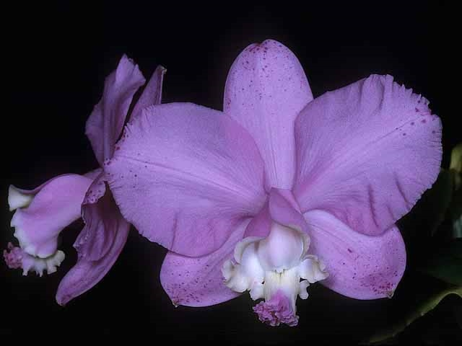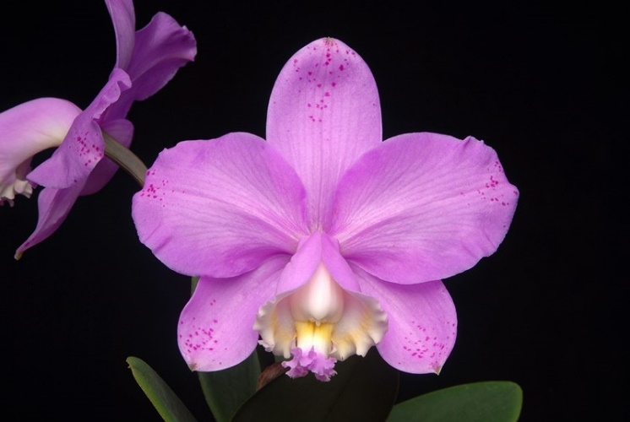
Above pictures with ‘A-doribil’ to the left with 12.2 cm natural spread and its offspring ‘Krull’s Perfection’ (pictured right), one of the seedling from the 2015 line. ‘Krull’s Perfection’ has a natural spread of 13.0 with near perfect symmetry and was awarded FCC/AOS with 90 points. With these development, it has raised the standard of this species so high that most recent awards even the HCCs has to have flower larger than 12cm NS (ex: the clone ‘Uriah’ HCC/AOS 79 points in 2018 has NS of 13.5cm). The problem is with petals larger than 5cm, they tend to become wavy toward the margin and become less flat precluding higher scores.
Hybrids: 445 offsprings/ 9065 progeny.
Among the oldest and most well-known primary hybrid is C. Brabantiae (x C. aclandiae) registered in 1863. It retain the shape and the beautiful color of C. loddigesii but with more spotting (fine or coarse) and a more open lip with isthmus shape like one of C. aclandiae. The hybrid has received 1 FCC, 22 AMs, 13 HCCs to date with 329 progeny under its belt, it is a hybrid for breeding of pink spotted flowers
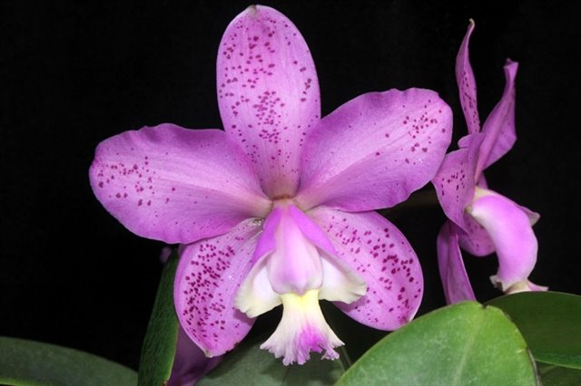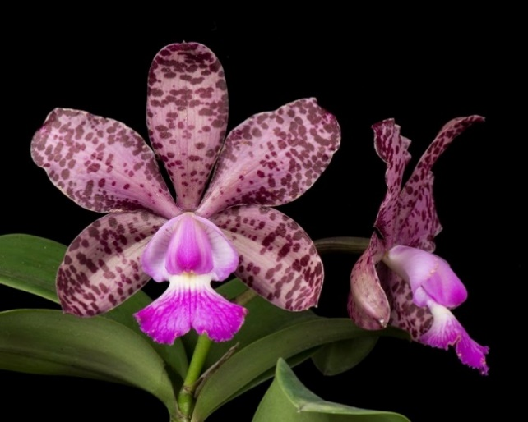
An interesting hybrid is C. Crystelle Smith (C. Beaufort x C. loddigesii). This is an example of how color of C. loddigesii can dominate the other parent. While the flowers of C. Beaufort are yellow to orange red, when crossing with C. loddigesii, the majority of hybrid color is soft pink but with a unique contrasting bright yellow/orange lip of the other parent. C. Crystelle Smith is well awarded with 12 AMs, 12 HCCs, 1 CCM.
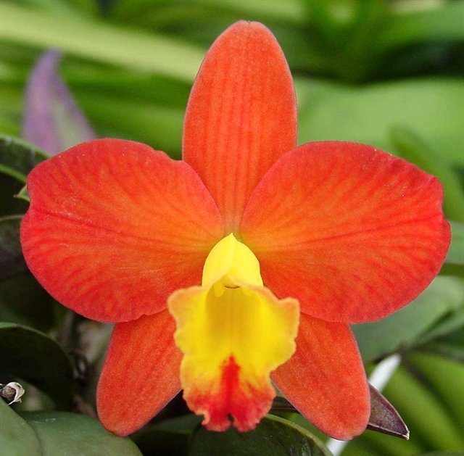 x 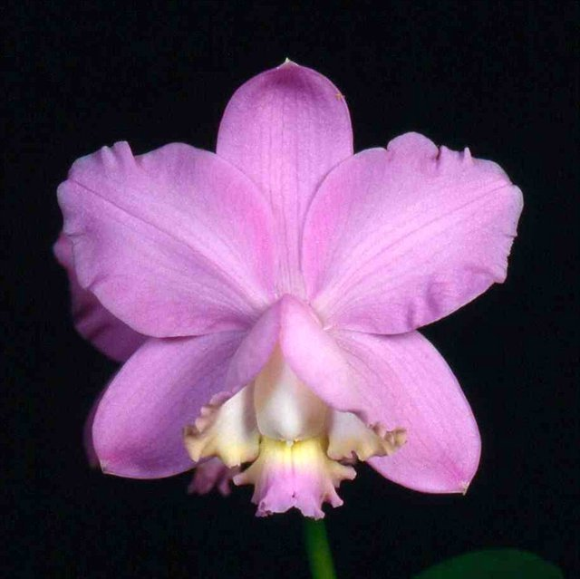 = 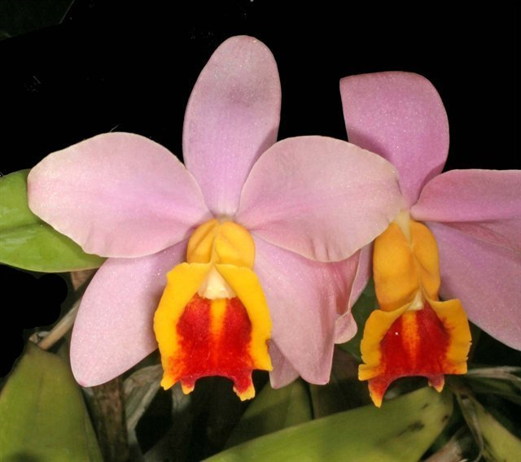
C. loddigesii also feature strongly in the background of spring blooming, small to midsized hybrids. The species, especially polyploidy cultivars is extremely dominant with respect to flower color, size, grow habit, number of flowers, full shape, and small lip. Fine and sparse spotting of sepals and petals are common. Plants are vigorous and often bloom twice a year.
One such hybrid is the recent Rlc. Durigan (Rlc. Waianae Leopard x C. Corcovado) registered in 2005. This hybrid has received 7 AMs, 9 HCCs, 1 AQ. With C. Brabantiae being one of the grandparent and C. loddigesii being the only major contribution for the round shape, this hybrid has it all. The first award is the AQ in Nov 11th, 2008. That group of plant alone yielded 3 AMs, 7 HCCs and it represents an important landmark in spotted Cattleya breeding: “Recognized for unparalleled excellence in spotted hybridizing; spots consistent; substance heavy; flower count good; full range of colors pleasing.”
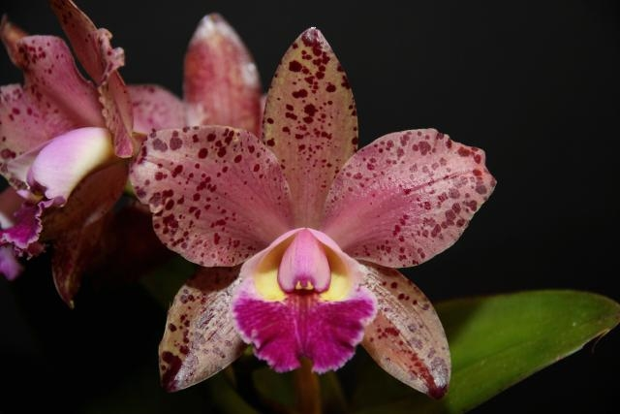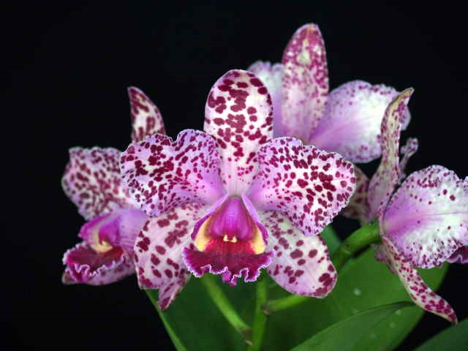
A new trend with breeding pioneered by Fred Clarke is the direction of blue spotted bifoliate Cattleyas as in the case of C. Loddiglossa. According to Fred Clarke, C. loddigesii give the offspring a contrasting yellow band on the interior of the midlobe making the tip of the midlobe appeared bluer. Could this be the blue form of C. harrisoniana being used in this case? (high flower count, yellow keels in the midlobes?). Similarity is noted with C. Pittiae (C. schilleriana x C. loddigesii). Regardless, they are certainly unique and impressive breeding direction.
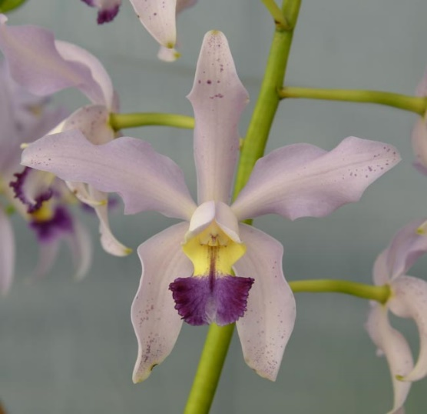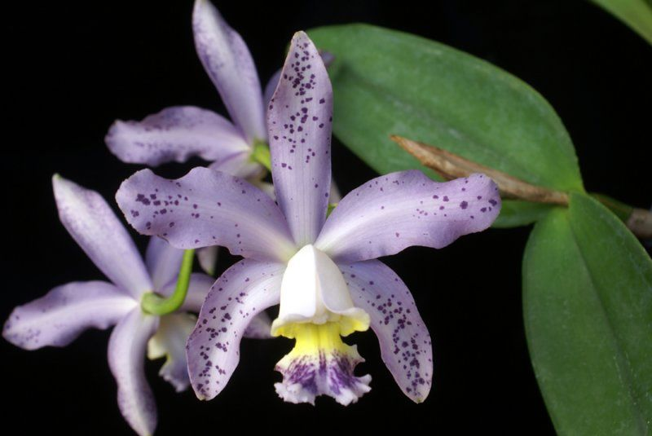

BUILDING BLOCK REPORT
Cattleya aclandiae Lindl. 1840
Synonym: Cattleya acklandiae J.E. Planch. 1851-2; Cattleya aclandiae f. alba (L.C.Menezes) F.Barros & J.A.N.Bat. 2004; Cattleya aclandiae var. alba L.C.Menezes 2002; Cattleya aclandiae var. grandiflora F.Buyss. 1878; Cattleya aclandiae var. salmonea auct. 1893; Cattleya aucklandiae Heynh 1841; Cattleya auclandii Beer 1854; Epidendrum acklandiae Rchb.f 1862; Epidendrum aclandiae Rchb.f
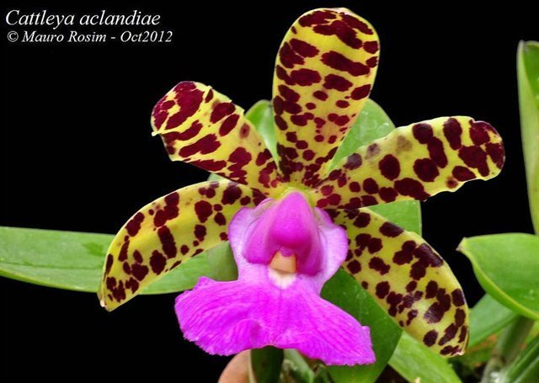
Found in Bahia Brazil as a dwarf sized, warm growing epiphytic species found in rather dry areas near the coast at elevations of 100 to 400 meters on rough barked trees with sea breezes but little rain that has slender, jointed, furrowed pseudobulbs carrying 2 apical, spreading, elliptic, thick, fleshy, red spotted, obtuse leaves and blooms in the summer and fall on a short, terminal, inflorescence held within the developing leaves that carries 1 to 2, large in proportion to the plant, fragrant, waxy, long-lasting flowers.
Introduced in 1839 by Lady Akland, of Killerton, near Exeter, it was named for her by Dr. Lindley when he first described the species in the BOTANICAL REGISTER, in 1840. This is one of the smallest in habit among the Cattleyas, the slender, cylindrical, furrowed stems being from three to five inches long, the two leaves each from two to three inches in length. A short peduncle bears one or two flowers from three to four inches across. Petals and sepals are similar, fleshy, yellowish green transversely blotched and spotted with blackish purple. The rather fiddle-shaped lip is three-lobed, the lateral lobes small and curved toward the column, white tinged with rose, the midlobe broadly kidney-shaped, wavy, bright rose-purple veined with deep purple. The exposed column is short, thickened with wing-like margins, a deep amethyst-purple. Found growing near sea level on small isolated trees in the arid lands near the coast of the province of Bahia, over which a sea breeze blows constantly, it is a warm growing species demanding great light. It requires little compost but should be heavily watered during its growing season. Frequently it produces new growths and flowers twice a year, in May and June, its normal season, and again in the fall. Not common in cultivation, it is a delightful dwarf species with bold flowers, but it is does have a reputation as being difficult to grow.
This plant definitely appreciates a dryer winter rest after which it will bloom in the spring and early summer as the new growth appears. This is one of the most light tolerant Cattleya and can withstand a bit of direct sun.
Variety: f. coerulea (blue lip, back ground of sepals and petals tend to be green), f. alba (sepals and petals green and spotless, lip pure white), f. albescens (white to nearly white lip with lighter spotting to sepals and petals), f. nigrescens (dark sepals and petals)
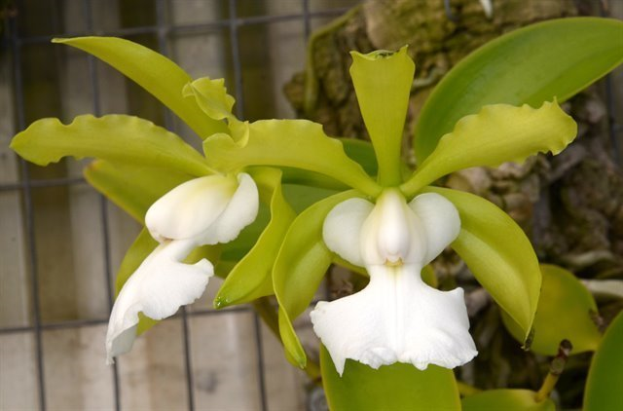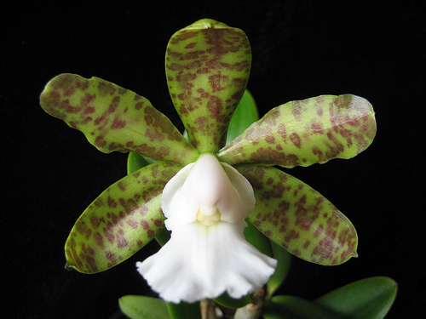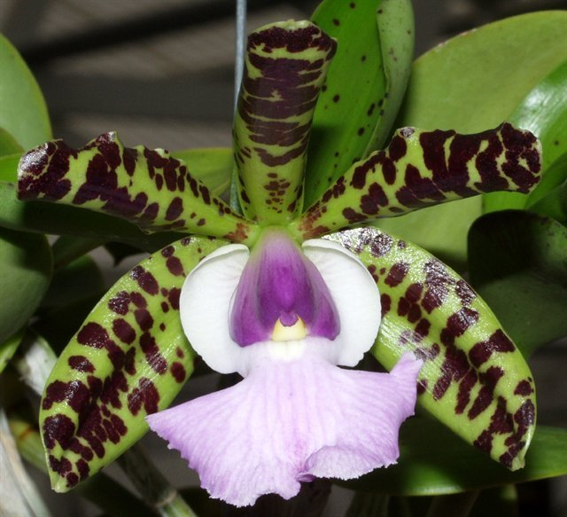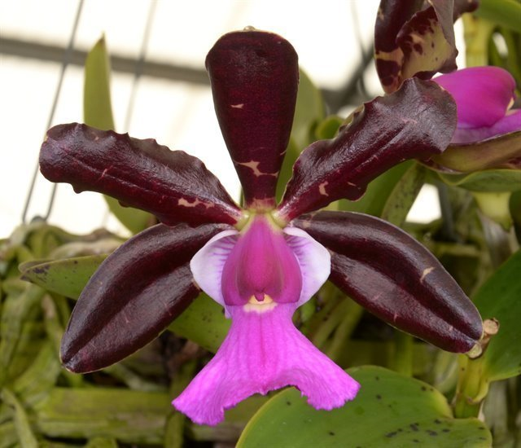

Awards: 1 FCC, 32 AMs, 26 HCCs, 1 CCE, 2 CCMs, 2 CHM, 1 JC
Most awards given in the last 15 years are AM. The highest award belongs to ‘Krull-Smith’ FCC/AOS with 93 points in May 2009, this is also the only FCC of this species to date.

Hybrids: 186 Offsprings/ 2111 Progeny
Desirable trait: Impressive spots and contrasting flower color (usually recessive in the first generation but will start to appear in second and third generation), large unique isthmus lip is a dominant trait, decorative column, excellent substance, fragrance, small plant stature.
Undesirable trait: low flower count and open, somewhat cupped shape are also dominant trait. sprawling growth habit.
C. Brabantiae as mentioned above, a really well known primary hybrid, correct the flaws in the shape of C. aclandiae by using the C. loddigesii parent, also adding colors to the hybrid.
C. Jungle Elf (below left) is a major hybrid for breeding yellow with red spots. Prior to Jungle Elf, there weren’t any yellow with red spot hybrids. In 1987, this grex introduced yellow star-shaped flowers and a few have red spots. The hybrid received 1 AM and 7 HCCs within 2 years after registered. It is a remarkable accomplishment consider the novelty nature of this hybrid.
C. Precious Stones (below middle) are another landmark hybrid, not as highly awarded as the previous but has contribute to a lot of future hybridization. When bred with red flowered C. Psyche (coccinea x cinnabarina), the spotting on C. aclandiae is completely suppressed resulting in solid red colored flower with compact grow habit. This hybrid is then used in many breeding program for many brightly colored red/orange mini Cattleya breeding
C. Jungle Gem (below right) is the resulting hybrid of Jungle Elf and Precious Stones. With C. aclandiae on both side, the recessive spots in C. Precious Stone would appear with color of flower ranging from rusty orange to clear yellow
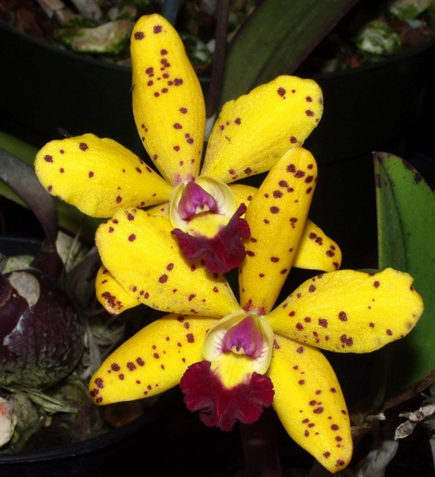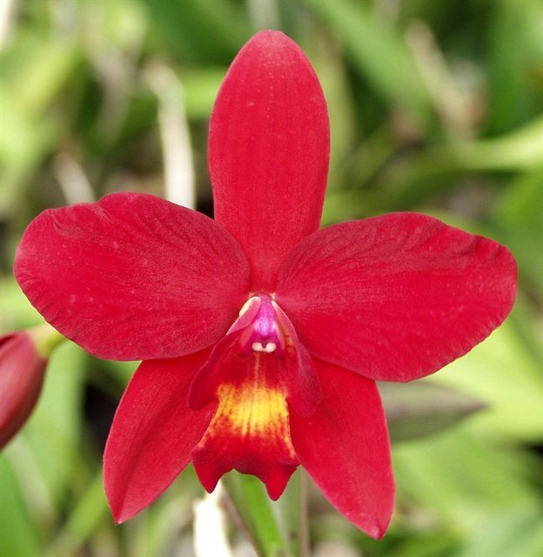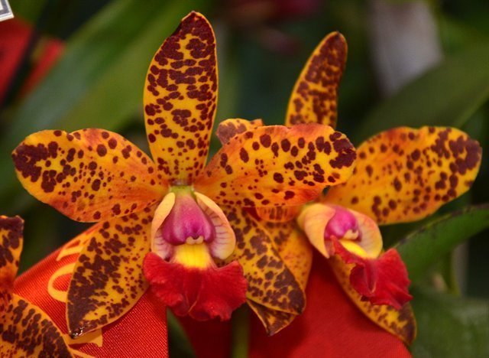
Almost all yellows with red spots hybrids originate from C. Jungle Elf including the notable C. Jungle Eyes, C. Sunspots, C. SunCoast Sunspots, C. Jungle Gem, C. Katherine Clarkson.
C. Landate is a wellknown heavily spotted hybrid with C. guttata as the other parent. C. aclandiae has reduced the size of C. guttata and C. guttata has increased the flower count of C. aclandiae resulting in the best of both spotted world

Reference:
OrchidWiz Encyclopedia version 4.3
Orchid Plus Online
American Orchid Society Magazine
Issue June 2010 page 25 – 33
Issue April 2005 page 36 – 41
Issue June 2017 page 44 – 49
Issue January 2017 page 46 – 57
Issue May 2013 page 20 – 27
Jay Pfahl’s Internet Orchid Species Photo Encyclopedia:
http://www.orchidspecies.com/laeljongheana.htm
http://www.orchidspecies.com/cattamethystoglossa.htm
http://www.orchidspecies.com/cattloddigesii.htm
http://www.orchidspecies.com/cataclandiae.htm
The Bifoliate Cattleyas Beginner’s Handbook XVIII
http://www.aos.org/orchids/additional-resources/bifoliate-cattleyas.aspx

