BUILDING BLOCK REPORT
Cattleya bicolor Lindley 1836
Synonym: Cattleya bicolor f. alba (Fowlie) F.Barros & J.A.N.Bat. 2004; Cattleya bicolor subsp. brasiliensis Fowlie 1977; Cattleya bicolor subsp. canastrensis L.C.Menezes & Braem 1992; Cattleya bicolor subsp. minasgaerensis Fowlie 1977; Cattleya bicolor var. caerulea auct. 1894; Cattleya bicolor var. lewisii auct. 1896; Cattleya bicolor var. mearuresiana B.S.Williams 1888; Cattleya bicolor var. olocheilos Klinge 1898; Cattleya bicolor var. splendida Rchb.f 1857; Cattleya bicolor var. wrigleyana Rchb.f. 1885; Cattleya dupontii Ruschi 1970; Cattleya grossii Kraenzl. 1897; Cattleya measuresiana (Lindl.) Blumensch. 1961; Cattleya tetraploidea Brieger 1978; Epidendrum bicolor [Lindl.] Rchb.f 1861; Epidendrum iridee Desc. 1821
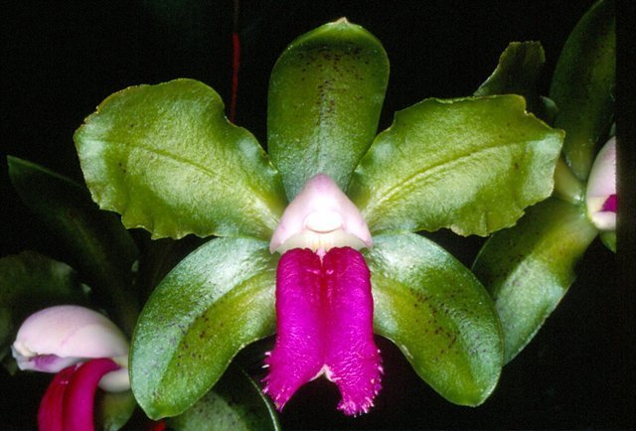
The slender stems are from eighteen to thirty inches high, jointed and covered with whitish membranaceous sheaths, bearing two leaves about six inches long. The inflorescence is nearly erect, with two to five or more flowers. Flowers range from three to four inches across. The sepals and petals are fleshy, with a distinct midnerve, greenish brown to olive-brown spotted with purple, the petals somewhat wavy, the lateral sepals bowed inward. The lip is spade-shaped, without side lobes, curved downward with a central longitudinal depression or line, crimson-purple, occasionally margined with white. This species is unique in lacking the lateral lobes of the lip, a character usually inherited by its hybrid progeny, limiting its value in breeding. Variable in coloring, particularly with respect to the lip, this species is suited to intermediate conditions, blooms during spring and into midsummer, occasionally blooming twice, about March and again in September.
The species has 3 distinct morphologic groups which are currently recognized as subspecies bicolor, subspecies minasgeraisensis, subspecies brasiliensis. Subspecies bicolor is often referred to as the coastal race, is compatible with the type specimen, usually diploid, most intensely colored flowers with narrower lips. They are usually half the size of plants of the tetraploid subspecies minasgeraisensis found in the interior. Plants of ssp minasgeraisensis may have growth up to 5ft with less intensely colored flower and wider lip. Ssp brasiliensis is not quite as tall and with dark reddish brown sepals and petals with a bright intensely rose colored lip which is even wider than the lip on subspecies minasgerainensis.
Varieties: f. alba, f. albescens-punctata, ssp. brasiliensis (dark reddish brown with intense rose lip), f. coerulea, f. marginata (lip with white picotee), f. punctata, ssp. minasgeraisensis, ssp. grossii
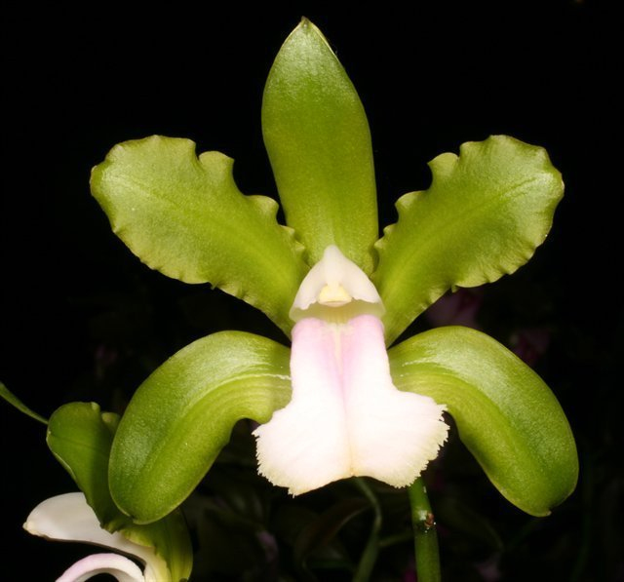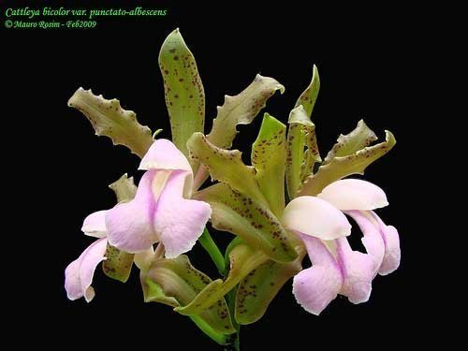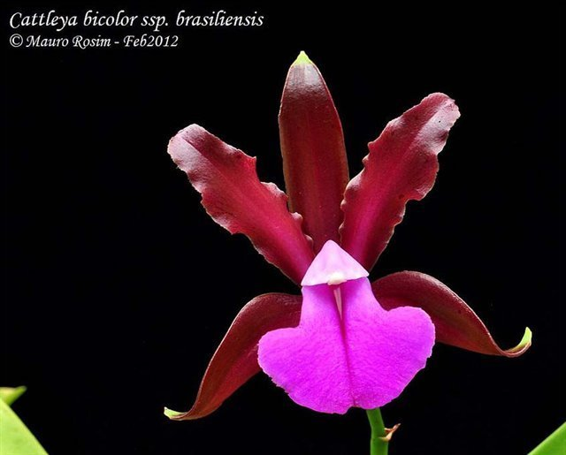
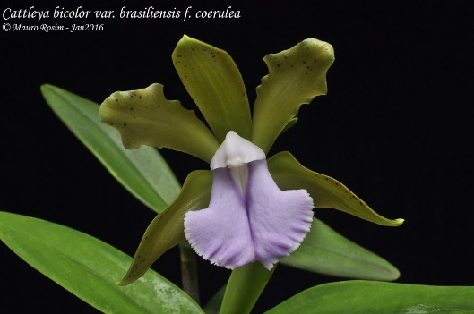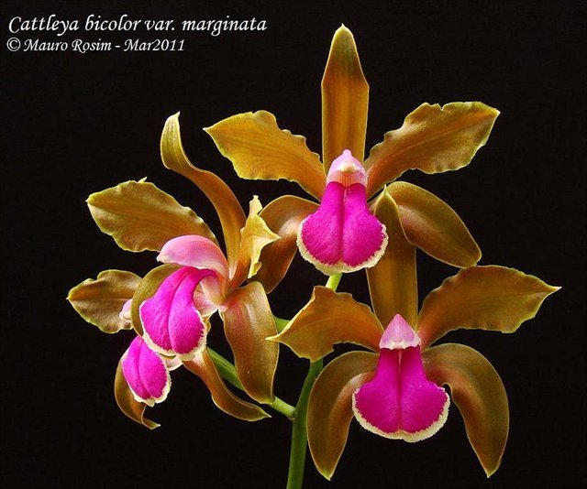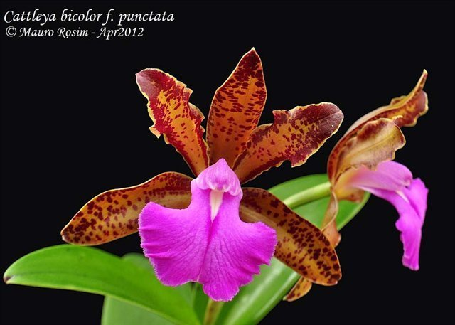
Awards: 12 AMs, 6 HCCs, 5 CCMs, 1 JC, 1 CHM, 2 CBMs
One of the best example of modern C. bicolor is the clone ‘Alto do Serra’ with 87 pt AM/AOS in 2010 with flat flowers, well arranged, above 7 flowers/inflorescence, broad segment with natural spread above 10cm
Hybrids: 280 offsprings, 13977 total progeny
This species dominates its hybrids in shape, size, growth habit, lip shape, flower count, and heavy substance. Its hybrids tend to have flat flowers. This species has been used to produce green and bronze-colored hybrids.
Desirable trait: Heavy waxy substance, satiny/glossy texture, variable lip color, flat flower, erect inflorescence, unusual coloration, broad lip among the bifoliates, fragrance.
Undesirable trait: Open flower (better with tetraploid form of the species), lingulate lip shape that lacks side lobes, large plants.
One of the most well-known primary hybrid is Bc. Binosa (x B. nodosa) has received 8 AMs, 5 HCCs, 3 CCMs is also popular with star-shaped breeding with 73 offsprings and 106 total progeny. Most well-known of its children is Bc. Memoria Vida Lee (Bc. Binosa x C. Brazillian Treasure) pictured right
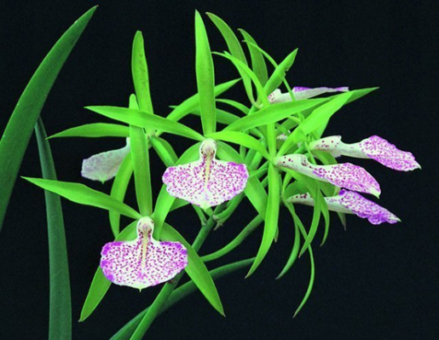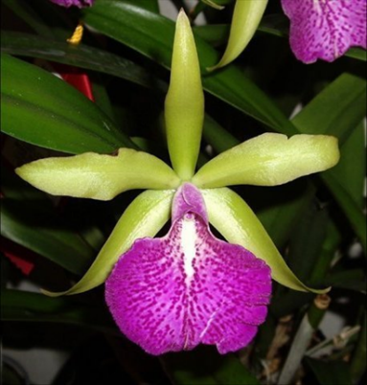
Next up is the unusual Myrmecocattleya Memoria Louise Fuchs (x Myrmecophila tibicinis) with 1 FCC, 8 AMs, 4 HCCs, and 1 AQ, taking the best of both parents. C. bicolor broaden and flatten the segments, and intensify the color of Mcp. tibicinis, and in exchange Mcp. tibicinis lends its prominent sidelobes to the broad lip of C. bicolor. Unfortunately it has not been hybridized any further.
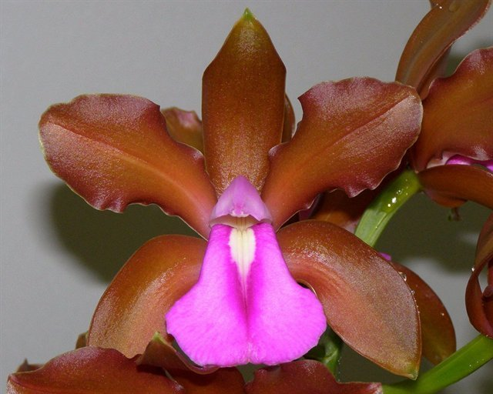 + 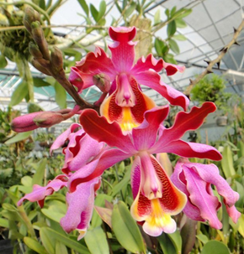 = 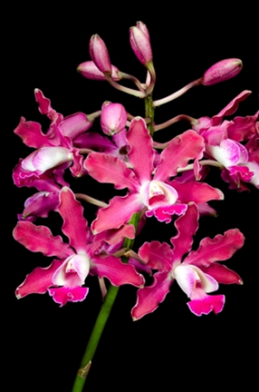
Ctna Keith Roth (x Bro. sanguinea) (1966) 3 AMs, 2 HCCs pictured left with 190 Offsprings/ 563 Progeny. Among those are the highly awarded Ctna. Jamaica Red (Bro. sanguinea x Ctna. Keith Roth) (1972) pictured middle with 14 AMs, 9 HCCs, and 1 AQ, and the intensely red Ctna Koolau Sunset (C. Mae Hawkins x Ctna. Keith Roth) pictured right with 6 AMs, 2 HCCs
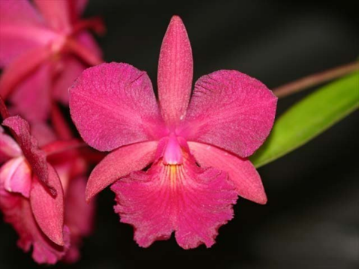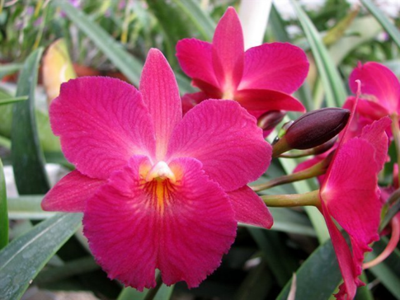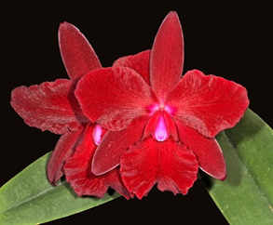
C. Iris (x C. dowiana) (1901) is undoubtedly the most influential C. bicolor’s primary hybrid to date with 105 offsprings and 10680 total progeny. The flower of this hybrid does not resemble C. dowiana, therefore C. bicolor has dominate nearly all aspect except for more erect dorsal sepal and slightly broader segments. Similarly C. Adula (x (C. dowiana x C. warscewiczii)) has 34 offsprings and 4884 total progeny. These type of hybrid is mostly used to back cross with C. dowiana to reinforce yellow with red lips. These hybrids are in the back ground of many large flowered Cattleya hybrid most notably Rlc. Fortune for breeding of yellow with red lips, and Rlc. Malworth for breeding yellow and orange hybrids.
C. Mrs. Mahler (x C. guttata) (1901) pictured left is one of the oldest primary hybrid that start the direction of spotted Cattleya breeding, is currently with 42 offsprings and 100 total progeny. Among those are the reddish bronze C. Allen Condo (C. Summerland Girl x C. Mrs. Mahler) (1998) pictured middle with 1 FCC, 9 AMs, 1 HCC, and 1 CCM, most of which are awarded within the last 10 years, and the densely spotted C. Fort Motte (C. Mrs. Mahler x C. Brabantiae) (1973) pictured right with 5 AMs and 4 HCCs
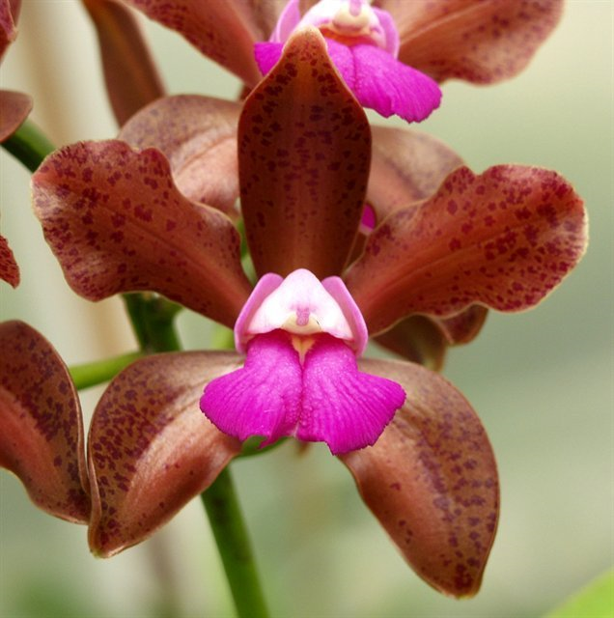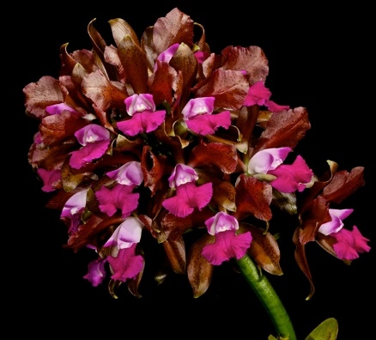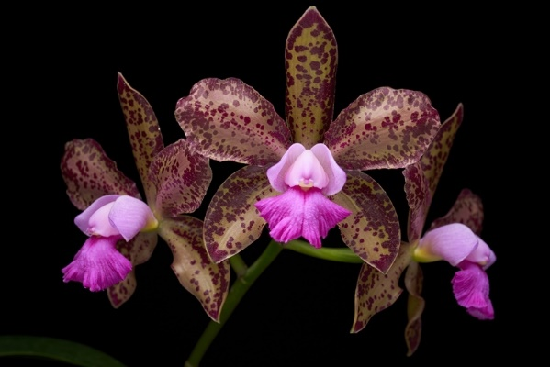
C. Batalinii (x C. intermedia) (1960) with 40 Offsprings and 505 total progeny utilized the peloric form of C. Intermedia is the background of many well-known peloric Cattleya. For example the commonly known Ctna. Sacramento Splash, and Rth. Burana Beauty
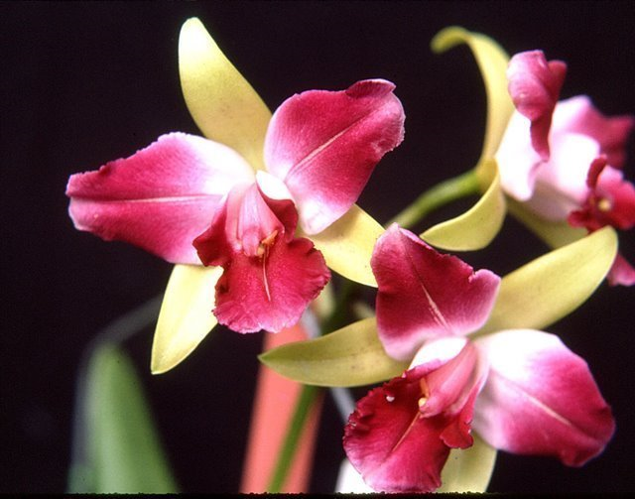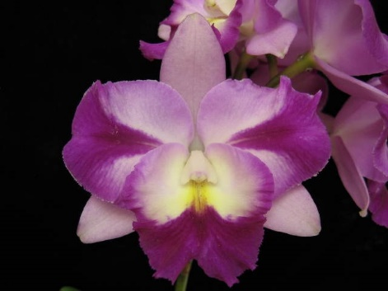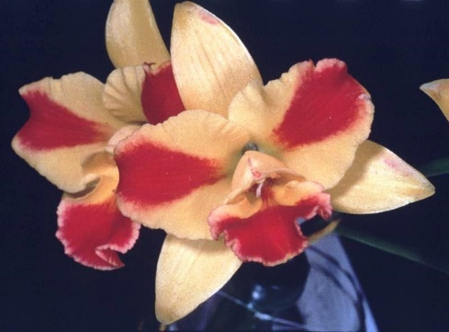

SPECIES DATA REPORT
Cattleya quadricolor Lindley 1853
Synonym: Cattleya candida [Kunth] Lehm. 1895; Cattleya caucaensis Ballif. 1901; Cattleya chocoensis Linden 1870; Cattleya labiata var trianae subvar chocoensis Veitch 1887; Cattleya quadricolor Lindl. 1853; Cattleya ruckeri Linden 1865; *Cymbidium candidum Kunth 1816
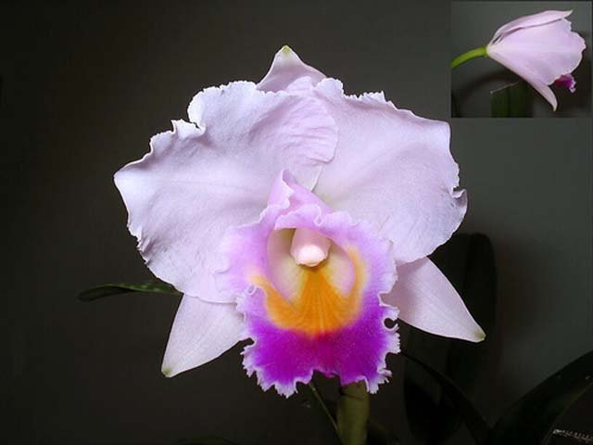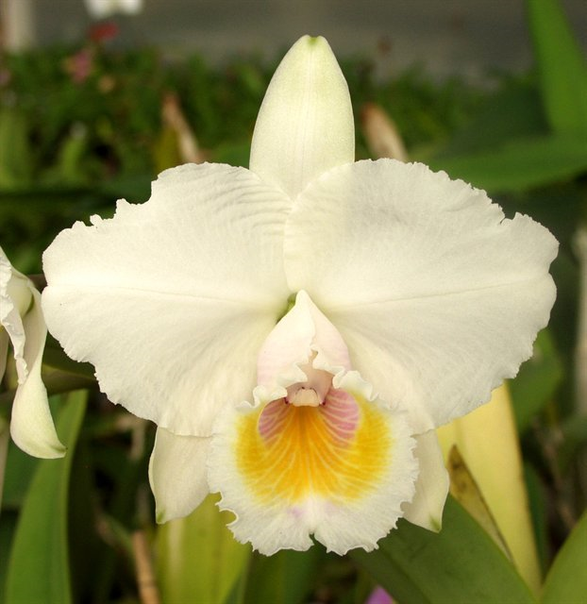
The similarity between C. trianae and C. quadricolor has always been a problem for botanists. They have the same color patterns in their flowers. They both bloom at the same time of the year and their growths mature at the same time. They both rest for several months before flowering, both have the widest-petaled flowers of any of the large-flowered Cattleya species and the flowers are exceptionally long lasting. Because of these similarities, it is easy to say C. quadricolor is merely a variety of C. trianae.
Cattleya quadricolor, however, grows in a different area of Colombia than C. trianae. They are found on the eastern slope of the central cordillera of the Andes in Colombia at elevations of 600 to 1500 meters as a medium sized, warm to cool growing epiphyte on branches high up in tall trees and require high light to bloom which occurs in the spring and summer on a erect, short, 2 to 3 flowered inflorescence with fragrant flowers that do not open well and keep a bell shape, a distinct characteristic that is not shared with C. trianae or any other Cattleya species. An interesting quick Identification diagnostic for this species is that C quadricolor's leaves can be rolled up without cracking or breaking, while if done to C trianae the leaf will crack or break. Cattleya quadricolor has a fairly strong, pleasant fragrance, while C. trianae has a more subtle, muted scent. Cattleya quadricolor also grows under somewhat different conditions than C. trianae. In his 1894 article in The Orchid Review(vol. 2, pg. 307), the American plant hunter, John Lager, described the species as growing “on level land and to a great extent marshy and at time inundated, consequently the moisture the plants receive throughout the year is considerable.” He goes on to say that the conditions drench the plants in a heavy mist all year and that C. quadricolor requires more moisture than C. trianae to grow well. C. quadricolor is clearly a different plant from C. trianae in many respects although it took decades for this to be fully recognized.
Varieties: f. alba, f. albescens, f. semialba, f. coerulea
Awards (including C. candida and C. chocoensis): 13 AMs, 4 HCCs
Hybrids: 47 offsprings, 2127 total progeny
Hybridizers have done relatively little with C. quadricolor compared with the other large-flowered Cattleya species. Most efforts have been aimed at trying to keep its wide-petals while still enjoying fully open flowers in the hybrids. The color of its flowers are as beautiful as any you will find in the large-flowered group, so there is hybridizing potential in the species. Fortunately, the typical cupped presentation of this species is recessive
Desirable trait: colorful lip, wide petals, fragrance,
Undesirable trait: soft substance, pastel color, cupped flowers (fortunately this is recessive).
Notable hybrids: Bc. Morning Edition (x C. Morning Glory) and C. Snowdrift (Cynthia x Annette)
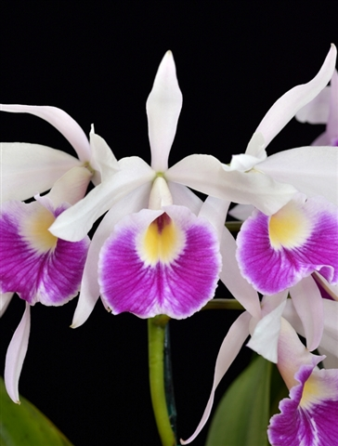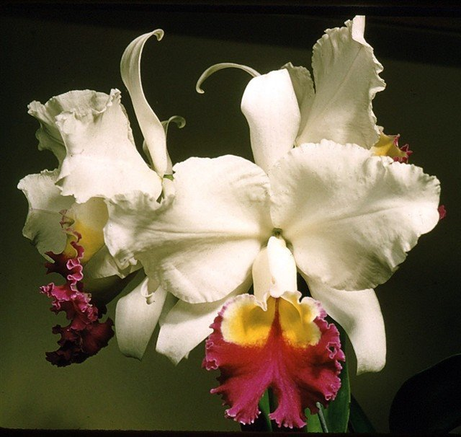
Overall, C. quadricolor make up a small percentage to modern day Cattleya hybrid. But hybrids like C. Annette (x C. warscewiczii) taking in the floriferousness well opened flowers of C. warscewiczii and the broad segment of C. quadricolor has become a foundation for many well known hybrid nowadays such as Rlc. Toshie Aoki, Rlc. Haw Yuan Gold,…
SPECIES DATA REPORT
Cattleya mendelii O Brien 1883
Synonym: Cattleya bluntii H.Low 1876; Cattleya cupidon hort. 1894; Cattleya hackbridgensis auct. 1890; Cattleya labiata var. bella Rchb.f 1882; Cattleya labiata var. mendelii Sanders 1887; Cattleya mendelii f. morganiae (B.S.Williams & T.Moore) M.Wolff & O.Gruss 2007; Cattleya mendelii var. bella (Rchb.f.) B.S.Williams & T.Moore 1886; Cattleya mendelii var. grandiflora B.S.Williams & T.Moore 1882; Cattleya mendelii var. morganae (R.Warner & L.O.Williams) Braem 1986; Cattleya morganiae B.S.Williams & T.Moore 1882
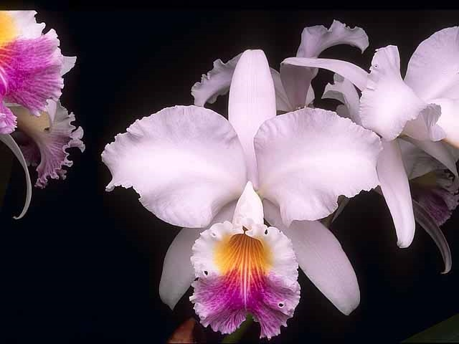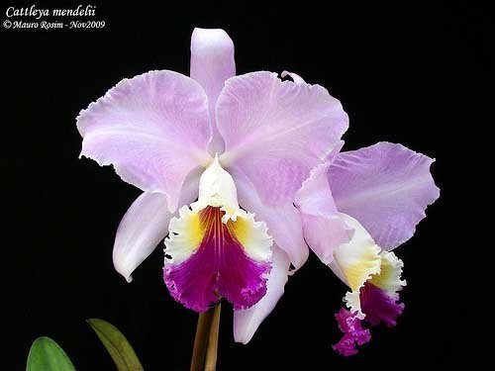
A medium sized, cool to warm growing epiphytic and lithophytic species from the eastern Cordillera of the Colombian Andes on exposed rock outcroppings and cliffs elevation 2500 to 3000 ft with cylindrical, grooved, shiny pseudobulbs carrying a single, apical, oblong, round apically, very leathery leaf that blooms in the late spring on a terminal, short, few [2 to 5] flowered, long lived inflorescence with fragrant flowers that open well. This species has growth similar to C. mossiae because it completes the growths in the fall, rests for several months before sending up buds and flower in the spring. They have medium-sized 5- to 6-inch flowers with relatively good shape. Their sepals and petals were very pale lavender, sometimes white, and the lip varied from pale to rich dark lavender, and most clones had a distinctive striping radiating down the center of the lip. C. mendelii were even grown for cut flowers in the early days of the cut-flower industry, but were rapidly replaced by darker lavender species like Cattleya mossiae as florist’s tastes turned to darker flowers
Variety: f. concolor, f. alba, f. coerulea, f. pincelata (flare petals), f. semialba…
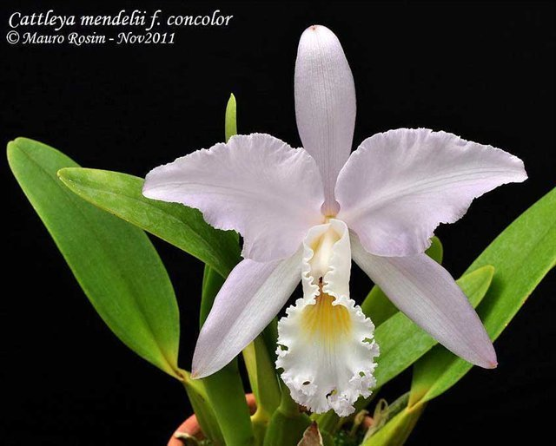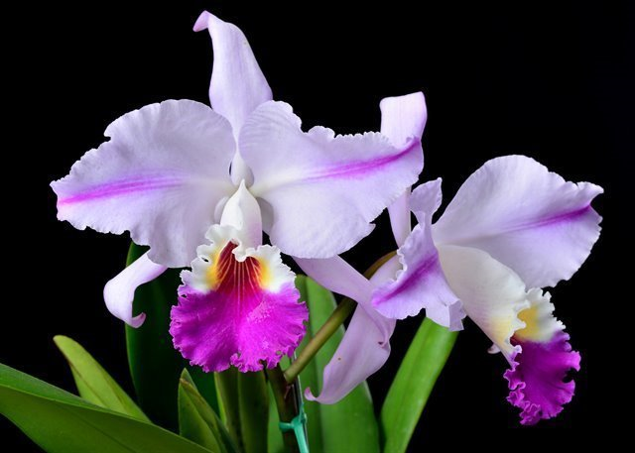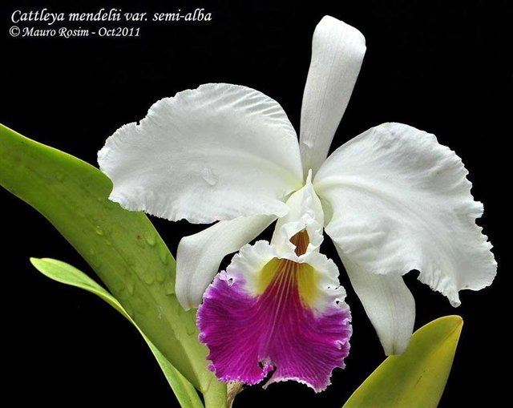
C. mendelii has more semialba clones than any other of the Cattleya species. Despite that, there are only a few true alba clones that has been found. C. mendelii ‘Stuart Low’, FCC/RHS with its 8-inch flowers is considered the finest alba form of the species, and it is still available commercially to date.
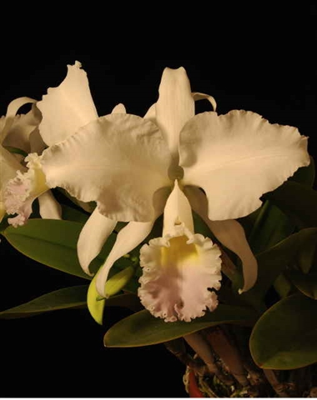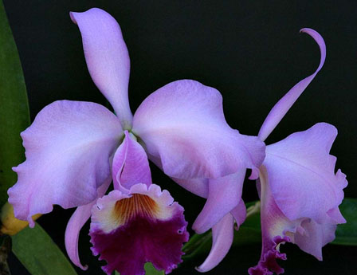
Relatively few dark-petaled clones of C. mendelii have been found, and these have seldom been as beautiful as those with pastel sepals and petals and a contrasting darker lip. Cattleya mendelii also has flowers of relatively thin substance, which adds to their delicate beauty.
Awards: 3 AMs, 6 HCCs
Hybrids: 162 offspring, 14550 total progeny.
The first C. mendelii imported into Europe in the late 1800s were an unusually fine strain of the species with 8 inches flowers instead of the usual 6-7 inches. Because of this, they were the collector’s favorites and the hybridizer’s first choice in breeding. These C. mendelii were the parents of many of our early Cattleya hybrids, including some of the most outstanding hybrids ever produced. The grand old strain of C. mendelii that made the species famous and contributed so much to early Cattleya hybrids disappeared because the native habitat was literally stripped of all the plants, even down to the few specimens that adorned the houses of those who lived there. The old lavender clones of C. mendelii that were in cultivation slowly disappeared, as the fashion for dark-petaled Cattleya hybrids emerged and they could no longer be replaced from the jungles
The early C. mendelii hybrids often had very large, round flowers using a particularly fine strain of the species. Brassocattleya British Queen (Bc. Digbyano-Mendelii x C. Lord Rothschild) was one such hybrid that had enormous flowers with wide, overlapping petals. One of the parents, the primary cross Brassocattleya Digbyano-mendelii, itself received four First Class Certificates and two Awards of Merit from the Royal Horticultural Society for its fine flowers. Many of C. mendelii’s other primary hybrids also had large, round flowers, particularly Cattleya Atlantic (x trianaei), and Cattleya Armainvillierensis (x warscewiczii).
Desireable trait: C. mendelii increased the size and shape without changing the color of the other parent.
Undesirable trait: thin substance, pastel colored, overshadowed by C. mossiae
Notable hybrids includes the primary C. Suavior( x C. intermedia) (1887) pictured left. This hybrid takes the splahed petaled C. intermedia to the next level by beefing up the size and flower segment while maintaining the high contrast creating the cornerstone for breeding of splashed petal standard Cattleya. One of the most influential for the breeding direction is C. Moscombe pictured right, a close progeny of C. Suavior
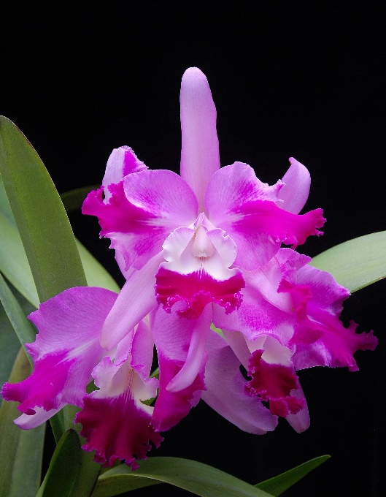
C. mendelii is also the great grandparent of major cornerstone hybrids for large purple/lavender and even artshade/yellow hybrid includes C. Bonanza (1949) C. Horace (1938) C. J A Carbone (1945) all of which are still beautiful even for today’s standard with their full size, voluptuous, contrasting clear pink/lavender flowers.
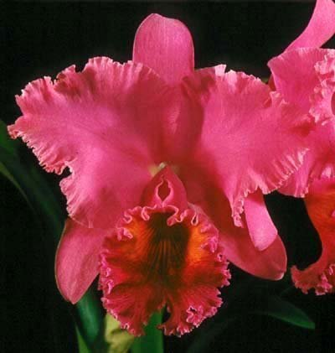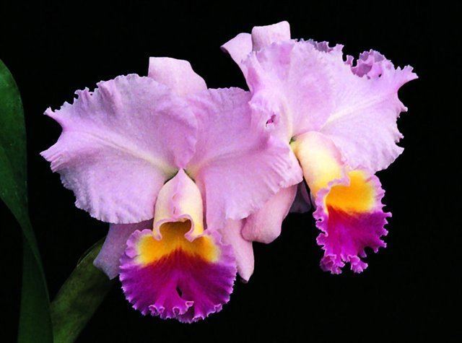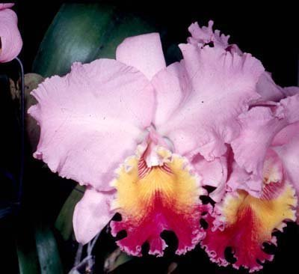

Reference:
OrchidWiz Encyclopedia version 4.3
Orchid Plus Online
American Orchid Society Magazine
Issue April 2007 page 34 - 47
Chadwick & Son Orchids Inc
https://chadwickorchids.com/content/cattleya-quadricolor
https://www.chadwickorchids.com/content/cattleya-mendelii
Jay Pfahl’s Internet Orchid Species Photo Encyclopedia:
http://www.orchidspecies.com/cattlabicolor.htm
http://www.orchidspecies.com/cattquadricolor.htm
http://www.orchidspecies.com/catmendelii.htm
The Showy Cattleya, Queen of the Orchids Beginners' Handbook – XV
http://www.aos.org/orchids/additional-resources/cattleya-queen-of-the-orchids.aspx
The Bifoliate Cattleyas Beginner’s Handbook XVIII
http://www.aos.org/orchids/additional-resources/bifoliate-cattleyas.aspx

