Significant species | F1/Progeny | Awards | Season | Strength | Weakness
C. loddigesii*  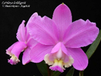 | 445/9065 | 4 FCCs, 40 AMs, 19 AMs, 1 CCEs, 5 CCMs, 2 AQs, 2 JCs | Late W,  Early Spr | Small plants and habits, full round flat flower (polyploidy), good substance, long lasting. | Few flowers, small lip, color dominant.
C. bicolor*  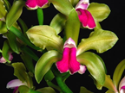 | 280/13977 | 12 AMs, 6 HCCs, 5 CCMs, 1 JC, 1 CHM, 2 CBMs | Spr-mid Su, rarely F | Heavy substance, waxy/glossy texture, flat flower, erect inflorescence, contrasting broad lip, fragrance, unusual color. | Open flower, lip lacking sidelobes, can be large plants.
C. aclandiae*  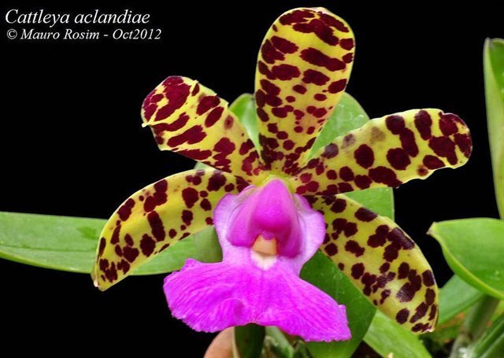 | 186/2111 | 1 FCC, 32 AMs, 26 HCCs, 1 CCE, 2 CCMs, 2 CHM, 1 JC | Spr – early Su | Contrasting spots (recessive in 1st gen), large unique isthmus lip (dominant), excellent substance, small plants, fragrance. | Open flower, rambling growth habit, cupped shape (dominant), low flower count.
C. mendelii*  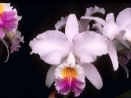 | 162/14550 | 3 AMs, 6 HCCs | Late Spr | Large, full flower, increasing size/shape w/o changing color of other parents, contrasting lip, nice semi-albas, fragrance. | Soft, delicate substance, pastel color, overshadowed by C. mossiae.
C. quadricolor*  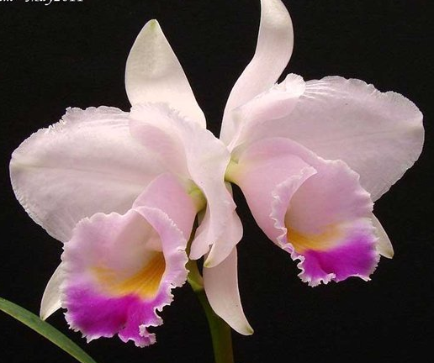 | 47/2127 | 13 AMs, 4 HCCs | Spr, Su | Colorful lip, wide petals, fragrance, tolerate more moisture. | Soft substance, pastel color, flower does not open fully (recessive).
C. amethystoglossa*  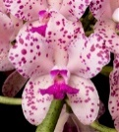 | 138/534 | 45 AMs, 19 HCCs, 2 CCEs, 5 CCMs, 2 JCs | F, W, early Spr | Strong lip color, texture; spots, high count, heavy substance, good shape (polyploidy), strong stem, many color forms. | Very tall plants, small lip.
C. jongheana  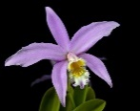 | 58/98 | 2 FCCs, 18 AMs, 13 HCCs, 3 CCEs, 6 CCMs, 1 CHM | Late W, Spr | Large flower on compact plant, flat upward facing flower, striking frilly lip. | Open flower, lip small, difficult to cultivate.
C. mantiqueirae  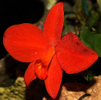 | 8/10 | 2 AM, 1 CCM | Su | Striking color, miniature plant, flower large for plant size. | Not often hybridized, poorer shape, inferior to good C. coccinea.
C. brevipedunculata  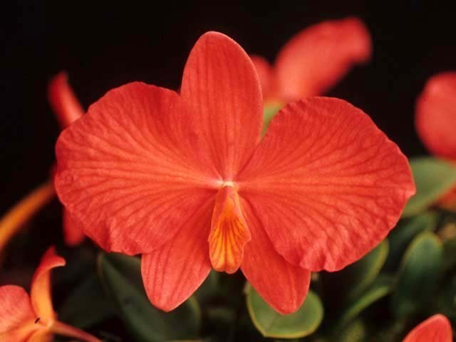 | 34/132 | 9 AMs, 5 HCCs, 1 CCE, 3 CCMs, 1 CHM | Late W, Spr | Larger flower than C. coccinea, more compact, more pleasing flower presentation on shorter stem; colorful, round, flat. | Short stem, low flower count, small lip.
C. briegeri  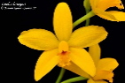 | 89/980 | 7 AMs, 4 HCCs, 1 CBM | Late Spr | Flat, well formed, large flower, compact, long inflorescence, bright yellow color, vigor. | Challenging requiring extended dry period, star shaped, small lip.
C. esalqueana  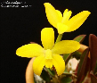 | 20/213 | 1 HCC, 1 CCM, 1 CBR | Late Spr, early Su | Bright yellow, miniature, inflorescence long enough to display flower over foliage | Few flower, small lip, star shaped.
C. angereri  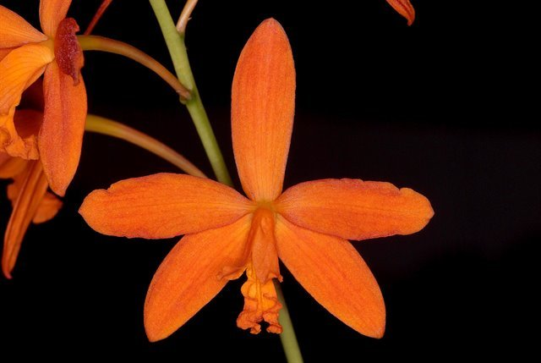 | 13/15 | 1 CBM | W, early Spr | Orange, red coloration, flat profile, long inflorescence, compact plant | Inferior to C. cinnabarina regarding flower size and count, star shape, small lip.

November 2018 questions report
- Differentiate questions:
  - Meristem is the tissue of plant that are undifferentiated, mostly found in growing tissue (growing tips of roots and shoots). Meristematic cells give rise to different part of plants and are responsible for growth. Mericlone is the cloned copy of the parent plant using meristematic tissue division.
  - Variety different morphologic type of the same species occurs naturally through mutation. Cultivar means cultivated variety. Although some cultivars can occur in nature as plant mutations, most cultivars are selected by plant breeders for high quality. Clone is a genetically identical copy of a cultivar that are created by vegetative means such as cutting, keiki, or tissue culture
  - Species is the basic unit of classification and a taxonomic rank, as well as a unit of biodiversity. In both the original Latin and in English “species" is the spelling of both the singular and plural forms. Specie is a technical term referring to the physical form of money, particularly coins.
  - Genus, plural genera, biological classification ranking between family and species, consisting of structurally or phylogenetically related species or a single isolated species exhibiting unusual differentiation (monotypic genus)
- The first name of the grex is always the pod parent
- False, because those plants will not be genetically identical to the original cultivar. This is sexual reproduction so there will be genetic variations amongst the children
- False, because those plants will not be genetically identical to the original cultivar. This is sexual reproduction so there will be genetic variations amongst the children
- A mutation that result in a visible change in morphology is a new cultivar and can be given a new cultivar name only when plant is distinct from the others and is uniform in its appearance, and also that those attributes do not change.
- Hybrid genera with four (sometimes three) genera in their background must end with –ara. The genus name is derived from the originator's name (or choice of name) with an -ara suffix _ Potinara (Brassavola x Laelia x Cattleya x Sophronitis) or Vuylstekeara (Miltonia x Odontoglossum x Cochlioda).
- Keiki is a baby plant produced asexually by another orchid plant, especially Dendrobium, Epidendrum, and Phalaenopsis orchids. The baby plant is an exact clone of the mother plant, sometimes flowering while still attached to the mother.

