The Genus Cattleya
Lindley 1824
Type species: Cattleya labiata
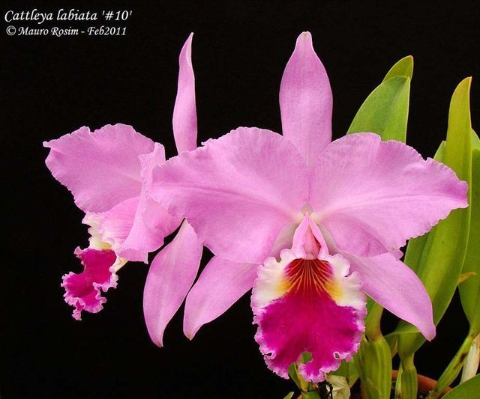 Cattleya /ˈkætliːə/ is a genus of around 110 species of orchids from Costa Rica and the Lesser Antilles south to Argentina. The genus was named in 1824 by John Lindley after William Cattley, who received and was the first to bloom a specimen of Cattleya labiata. William Swainson had discovered the new plant in Pernambuco, Brazil, in 1817 and shipped to the Glasgow Botanic Gardens for identification. Swainson requested that a few plants be later sent to Cattley, who was able to bloom one a full year before the plants in Glasgow. It would be another 70 years before they would be rediscovered in the wild because of a mixup in the assumed location of the plants. The genus is abbreviated C in trade journals.

They are widely known for their large, showy flowers, and were used extensively in hybridization for the cut-flower trade until the 1980s when pot plants became more popular. This genus and the numerous hybrids come close, through their beauty, to the idealized picture of the orchids. The flowers of the hybrids can vary in size from 5 cm to 15 cm or more. They occur in all colors except true blue and black.
The typical flower has three rather narrow sepals and three usually broader petals: two petals are similar to each other, and the third is the quite different conspicuous lip, featuring various markings and specks and an often frilly margin. At the base, the margins are folded into a tube. Each flower stalk originates from a pseudobulb. The number of flowers varies; it can be just one or two, or sometimes up to ten.
Physical characteristic:
Cattleya orchids are among the most familiar orchids in the world. They are native to the New World tropics, with an enormous number of hybrid forms have been produced as well, both by crossing different Cattleya species with each other and by crossing Cattleya species with species in related genera. Cattleya are epiphytes, growing on trees or rocks (rupicolous). Pseudobulb cylindrical, clavate (club shaped) or fusiform (spindle shaped), erect or more rarely arched, covered by paleaceous sheaths. Leaf one, two, or rarely three, green, sometimes suffused with dark pink, terminal on pseudobulb, conduplicate, elliptical, oblong or elliptic-lanceolate, coriaceous to fleshy. Inflorescence generally a few-flowered raceme, more rarely multiflorous (up to 25 flowers), generally subtended by a single or double oblique spathe, rarely borne on special leafless pseudobulbs, in this case spathe lacking, scape bracts sometimes present; floral bracts always present.
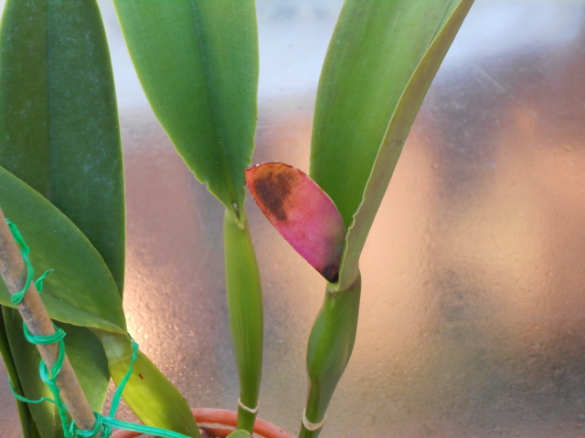
Cattleya flowers are resupinate, showy and long-lasting and often very fragrant. The flowers of the largest modern hybrids can exceed eight inches in diameter, while the smallest hybrids have flowers of just two to three inches, often exceeding the size of the plant. Sepals pink, yellow to golden, brown to dark red or green, sometimes spotted, membranaceous to fleshy, linear-lanceolate to oblong, lateral sepals sometimes falcate. Petals of the same colour, texture, and shape as the sepals, or with the median portion dilated, sometimes more or less falcate (sickle shaped), margins sometimes revolute (curled back) or undulate (wavy). Labellum trilobed, lateral lobes generally well developed, ovate to triangular and overlapping over the column, more rarely short and clasping or flat, or lacking, median lobe sessile (attached directly) or separated by a clear isthmus (a narrow connecting passage), generally dark shades of pink, magenta or brown to yellow, sometimes with veins or spots and smooth texture, or fleshy with granulose or papillose texture. Column generally without appendages, white or (when exposed) pink to magenta.
Distribution
Cattleyas are found from 2,000 to nearly 5,000 feet above sea level, almost invariably growing in the branches or on the trunks of living trees. Mr. Lager stated that the best specimen plants were found growing in almost full sunlight (a further indication of escape from the "jungle" floor). In regions where the plants are found growing along narrow streams, the forest shade is so dense that the plants received little sunlight, and in such locations did not flower, but developed long, thin pseudobulbs. In their native habitat, the more exposed the plants are to sunlight, the more profuse they are in flowering.
At lower elevations, cattleyas invariably grown along the courses of streams. On higher elevations they are found growing in deep hollows or gullies. The explanation is quite simple, because the atmospheric moisture (humidity) in river valleys and elevated gullies is high.
Most Colombian cattleyas have no well-defined resting period (evergreen), but seasonal periods of two rainy and two dry seasons during the year do occur. Variations in elevation and climate, however, seem to influence their period of flowering.
Legacy:
For most of the second half of the 20th century, and to some degree still, Cattleya was the "standard" orchid to which other orchids were compared by growers.
Well into the early 1800s, epiphytic orchids were widely (and erroneously) believed to be parasitic on the trees on which they were found, feeding on their sap, leading to the persistent failure of many efforts to bring beautiful new orchids into cultivation. By the time Cattleyas were being imported from their native lands in significant numbers, however, the challenges of growing these orchids had already been largely resolved. (Chadwick and Chadwick 2006)
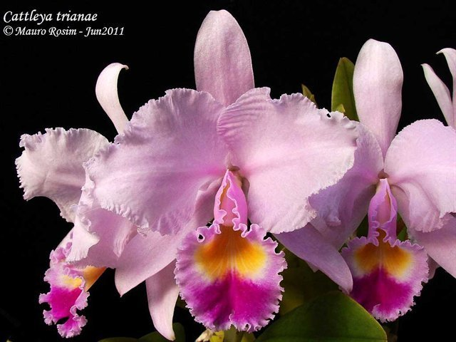
By the mid-19th century, Cattleya orchids were extremely popular with orchid hobbyists in Europe--and quickly became big business as well. In the 1920s, Lewis Knudson, an American researcher, developed a sterile growing technique that dramatically reduced seedling mortality and represented an enormous efficiency improvement for commercial growers. Cattleyas became an important source of cut flowers for florists in the U.S., as they had been for some years in Europe, where the use of these expensive flowers was a status symbol. In the 1930s and 1940s in the U.S., Cattleya orchids replaced camellias and gardenias as the classic flowers for use in corsages. By the 1950s, however, Cymbidium orchids were replacing cattleyas for use in corsages. Cymbidiums were longer-lasting and were smaller and more compact, yet still large enough to make a corsage from a single flower. They also traveled better and were less expensive to grow. In fact, cymbidiums were so much cheaper than cattleyas that the cattleya market for corsages faded away. However, cymbidiums became so cheap that their glamour quickly faded and the market for orchid corsages in general declined. Although the orchid corsage market was much diminished, the second half of the 20th century saw an explosion in orchid breeding for the cut flower industry and orchid hobbyists. In the 1960s, a new, far more efficient, method of cloning orchids was developed in France, dramatically reducing the cost of propagating new and unusual varieties. Today, cattleyas are available in a dazzling array of colors, sizes, shapes, textures, and fragrances, although many of the fine old varieties are no longer commercially available. (Chadwick and Chadwick 2006)
Classification within the genus Cattleya:

In 2000 the first DNA study of the Laeliinae was reported in Lindleyana. One of the results of that study was the realization that the Brazilian laelias did not belong with the Mexican group of species that included the type for that genus (Laelia anceps). The initial solution was to place them in Sophronitis although other authors proposed to split these species into several segregate genera. With the publication of Genera Orchidacearum Vol 4 in 2006 and the acceptance of the circumscriptions therein, a plethora of name changes took place in artificial hybrid names in this alliance. While many familiar names changed, the situation would have been significantly worse had this group of species been carved into a number of smaller genera.
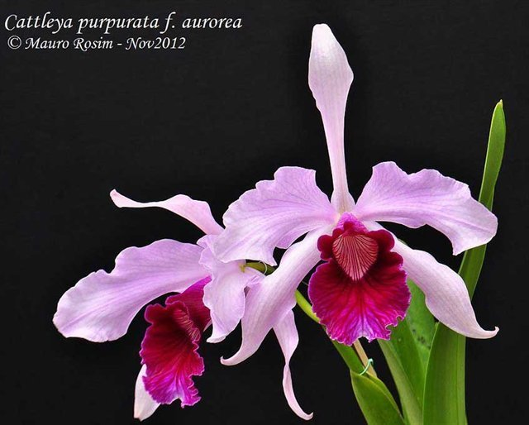
Recent DNA studies with nine plastid regions plus the original ITS dataset have lead to a better understanding of this group. While this expanded Sophronitis is always supported, it is also imbedded among species traditionally recognized as Cattleya presenting the need to further alter the definitions of the genera that make up the alliance. There are effectively two solutions; creation of new genera for the various subgroups of Cattleya or lump all Sophronitis species with Cattleya and deal with these groupings as subgenera or sections of a greatly expanded Cattleya. This latter solution provides better nomenclatural stability for artificial hybrids of species in this alliance since changes would not result in transfers to new genera.
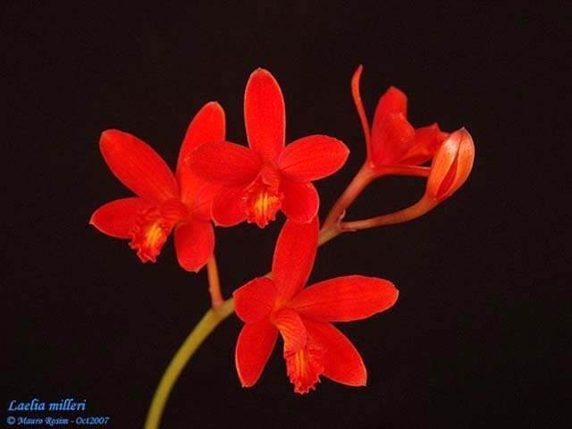
- SUBGENUS Cattleya
  - Section Cattleya
      - C. aurea (S. Panama to Colombia)
      - C. dowiana (Costa Rica).
      - C. gaskelliana (Colombia to Trinidad).
      - C. iricolor (Ecuador to Peru).
      - C. jenmanii (Venezuela to Guyana).
      - C. labiata (Brazil)
      - C. luteola (N. Brazil, Ecuador to Bolivia).
      - C. mendelii (NE. Colombia).
      - C. mooreana (Peru).
      - C. mossiae (N. Venezuela)
      - C. percivaliana (Colombia to W. Venezuela).
      - C. quadricolor (Colombia)
      - C. rex (Peru to N Bolivia).
      - C. schroederae (NE. Colombia).
      - C. trianae (Colombia).
      - C. warneri (E. Brazil).
      - C. warscewiczii (Colombia).
    - Series Cattleyodes
      - C. crispa (SE. Brazil)
      - C. grandis (Brazil - SE. Bahia to N. Espírito Santo).
      - C. lobata (SE. Brazil.)
      - C. perrinii (SE. Brazil)
      - C. purpurata (SE. & S. Brazil)
      - C. tenebrosa (Brazil - SE. Bahia to Espírito Santo).
      - C. virens (SE. Brazil)
      - C. xanthina (Brazil - Bahia to Espírito Santo).
    - Series Hadrolaelia
      - C. alaorii (Brazil - Bahia).
      - C. bicalhoi (Brazil - S. Minas Gerais to Rio de Janeiro).
      - C. jongheana (Brazil - Minas Gerais).
      - C. praestans (SE. Brazil)
      - C. pumila (SE. & S. Brazil)
      - C. sincorana (Brazil - Bahia).
    - Series Microlaelia
      - C. lundii (Bolivia to Argentina).
    - Series Parviflorae
      - C. alvarenguensis
      - C. alvaroana (Brazil - Rio de Janeiro).
      - C. angereri (Brazil - Minas Gerais).
      - C. blumenscheinii (Brazil - Minas Gerais).
      - C. bradei (Brazil - Minas Gerais).
      - C. briegeri (Brazil - Minas Gerais).
      - C. campacii (Brazil).
      - C. caulescens (Brazil - Minas Gerais).
      - C. cinnabarina (Brazil - S. Minas Gerais, Rio de Janeiro).
      - C. colnagoi (Brazil - Minas Gerais).
      - C. conceicionensis Brazil - Minas Gerais)
      - C. crispata (Brazil - Minas Gerais)
      - C. endsfeldzii (Brazil - Minas Gerais).
      - C. esalqueana (Brazil - Minas Gerais).
      - C. flavasulina (Brazil - Minas Gerais)
      - C. fournieri (Brazil - Minas Gerais)
      - C. ghillanyi (Brazil - Minas Gerais).
      - C. gloedeniana (Brazil - São Paulo)
      - C. gracilis (Brazil - Minas Gerais: Serra do Cipó)
      - C. guanhanensis
      - C. harpophylla (Brazil - Minas Gerais to Espírito Santo).
      - C. hatae
      - C. hegeriana
      - C. hispidula (Brazil - Minas Gerais).
      - C. hoehnei (Brazil - Espírito Santo)
      - C. itambana (Brazil - Minas Gerais).
      - C. kautskyana (Brazil - Espírito Santo).
      - C. kettieana (Brazil - Minas Gerais)
      - C. kleberi
      - C. liliputana (Brazil - Minas Gerais: Serra do Ouro Branco).
      - C. locatellii
      - C. longipes (SE. Brazil - Serra do Cipó).
      - C. luetzelburgii (Brazil - Bahia).
      - C. macrobulbosa
      - C. marcaliana (Brazil - Bahia).
      - C. milleri (Brazil - Minas Gerais).
      - C. mirandae (Brazil - Minas Gerais).
      - C. munchowiana (Brazil - Espírito Santo).
      - C. neokautskyi (SE. Brazil)
      - C. pabstii (Brazil - Minas Gerais)
      - C. pendula (Brazil - Minas Gerais)
      - C. pfisteri (Brazil - Bahia).
      - C. presidentensis (Brazil - Minas Gerais).
      - C. reginae (Brazil - Minas Gerais).
      - C. rupestris
      - C. sanguiloba (Brazil – Bahia)
      - C. tereticaulis
      - C. vandenbergii
      - C. vasconcelosiana
      - C. verboonenii (Brazil - Rio de Janeiro).
      - C. viridiflora
    - Series Sophronitis
      - C. acuensis (Brazil - Rio de Janeiro).
      - C. alagoensis (Brazil - Alagoas)
      - C. brevipedunculata (Brazil - Minas Gerais).
      - C. cernua (Brazil to NE. Argentina).
      - C. coccinea (Brazil to NE. Argentina).
      - C. dichroma (Brazil - Rio de Janeiro).
      - C. mantiqueirae (SE. Brazil).
      - C. pygmaea (Brazil - Espírito Santo).
      - C. wittigiana (Brazil - Espírito Santo).
  - Section Lawrenceanae
      - C. lawrenceana (Venezuela, Guyana, N. Brazil).
      - C. lueddemanniana (N. Venezuela).
      - C. wallisii (N. Brazil)
- SUBGENUS Cattleyella
      - C. araguaiensis (Brazil)
- SUBGENUS Intermediae
      - C. aclandiae (Brazil)
      - C. amethystoglossa (Brazil)
      - C. bicolor (SE. Brazil)
      - C. dormaniana (Brazil)
      - C. elongata (Brazil)
      - C. forbesii (Brazil)
      - C. granulosa (Brazil)
      - C. guttata (Brazil).
      - C. harrisoniana (SE. Brazil).
      - C. intermedia (SE. & S. Brazil, Paraguay, Uruguay).
      - C. kerrii (Brazil).
      - C. loddigesii (SE. Brazil to NE. Argentina).
      - C. nobilior (WC. Brazil to Bolivia).
      - C. porphyroglossa (Brazil).
      - C. schilleriana (Brazil).
      - C. schofieldiana (Brazil)
      - C. tenuis (NE. Brazil).
      - C. tigrina (SE. & S. Brazil).
      - C. velutina (Brazil)
      - C. violacea (lowland Amazon rainforest & Guyana).
      - C. walkeriana (WC. & SE. Brazil).
- SUBGENUS Maximae
      - C. maxima (Venezuela to Peru)

Reference:
OrchidWiz Encyclopedia version 4.2
Orchid Plus Online
American Orchid Society - Cattleya
http://www.aos.org/orchids/additional-resources/cattleya-queen-of-the-orchids.aspx
http://www.aos.org/blog/general/hereditary-influences-of-the-cattleya-alliance.aspx
http://www.aos.org/orchids/additional-resources/bifoliate-cattleyas.aspx
http://www.aos.org/orchid-awards-judging/sophronitis-to-cattleya-tansfers.aspx
http://www.aos.org/orchids/additional-resources/ecological-habitat-of-cattleyas.aspx
The World Monocot Checklist – Cattleya
http://e-monocot.org/taxon/urn:kew.org:wcs:taxon:35777
The Encyclopedia of Life – Cattleya orchids
http://eol.org/pages/29122/overview
Wikipedia – Cattleya
https://en.wikipedia.org/wiki/Cattleya
Chadwick, A. A., & Chadwick A. E. (2006). The Classic Cattleyas. Portland, Oregon (U.S.A.): Timber Press.

