The Genus Aganisia
Lindley 1839
Type species: Aganisia pulchella
The genus name derives from a Greek nymph, lover of the god Apollo. Specimens collected early on rarely lasted more than two years in cultivation. Seed grown plants have a much longer life expectancy. Plants are rarely seen due to being difficult to cultivate without a controlled environment. These South American dwarf and epiphytic plants spread through rhizomes with a climbing habit. Highly prized for its "blue" flowers. Bloom time is early spring through summer. Small flowers with rose to blue tinted violet. Flower with short column foot and elongated stipe.
Aganisia are warm to hot grower with high humidity, good air movement and adequate moisture with a slight dry period for 2-3 months when water is slightly reduced. Need moderate shade/ filtered sunlight to grow well. Slightly dry out in between watering. Do not subject plant to prolonged dry period.
Aganisia received 15 awards globally with 11 from AOS including 1 FCC, 6 AMs, 2 HCCs, 1 cultural award and a Certificate of Botanical Merit. All awards are exclusively from the species Aganisia cyanea. The General Scale or Cymbidium scale should be used for judging process
Aganisia is hybridized extensively due to the rare “blue” color it imparts onto its offspring. There are 28 F1 hybrids and 74 Progeny to date. Most hybridizing is done on Aganesia cyanea.
It was once thought to be monospecific i.e., a single species in this genus; however, four species are now known:
Aganisia cyanea* (Lindl.) Rchb.f. - Blue orchid - Venezuela, Colombia, Peru, Brazil
Aganisia fimbriata Rchb.f. - Brazil, Venezuela, Colombia, Peru, Guyana, Suriname
Aganisia pulchella Lindl. - Trinidad, French Guiana, Suriname, Guyana, Venezuela, Brazil
Aganisia rosariana (V.P.Castro & J.B.F.Silva) F.Barros & L.R.S.Guim. - Brazil (Rondônia)

SPECIES DATA SHEET
Aganisia cyanea (Lindl.) Rchb.f. 1876
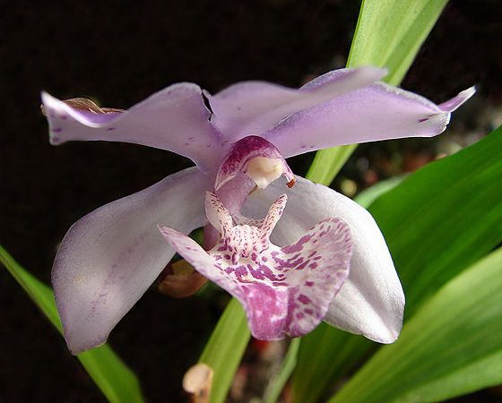
Synonym: Acacallis coerulea (Rchb. f.) Schltr. 1918; Acacallis cyanea f. alba Roeth & O.Gruss 2006; Acacallis hoehnei (Hoehne) Schltr. 1918; Acacallis oliveriana (Rchb. f.) Schltr. 1914; Aganisia coerulea Rchb.f 1876; Aganisia cyanea Rchb.f not Benth. 1869; Aganisia cyanea f. alba (Roeth & O.Gruss) Meneguzzo 2015; Aganisia oliveriana Rchb. f. 1878; Aganisia tricolor NE Br. 1885; Kochiophyton caeruleum Hoehne 1910; Kochiophyton coeruleus Hoehne 1906; Kochiophyton coeruleus Hoehne 1910; Kochiophyton negrense Schlechter 1906
Aganisia cyanea or the Blue Orchid is a small-medium sized epiphytic plant with slender creeping rhizome and small egg shaped pseudobulbs. Basal Inflorescence is racemic, up to 10 fragrant sky-blue to mauve with the color appeared almost blue in sunlight. Blue color is more intense when developed in the shade and when freshly open but flower rapidly takes on a hint of pink. Lip is white at the base and became deep indigo-blue near the tip. Plants require bright filtered light, warm temperature, strong airmovement, and being kept moist during growing season and reduce water in the fall slightly. Plant deteriorate rapidly if root condition is stale. Take care to keep medium fresh
Varieties: n/a
Awards: Received 15 awards globally with 11 from AOS including 1 FCC (‘Lionstar’ with 92 pts in 1988), 6 AMs, 2 HCCs, 1 cultural award and a Certificate of Botanical Merit
Hybrids: Hybridized extensively with other closely related genera especially Zygopetalum to make blue/indigo hybrid including the ever-popular Zygonisia Cynosure recently bred in 2007. Total of 72 progenies recorded in Orchidwiz
Reference:
OrchidWiz Encyclopedia version 3.3
Jay Pfahl’s Internet Orchid Species Photo Encyclopedia:
http://www.orchidspecies.com/acacaliscyanea.htm accessed 6/5/2017
Charles Baker’s Orchid Culture Sheets
https://orchidculture.com/cod/free/FS251.html accessed 6/5/2017

