The Genus Anguloa
Ruiz & Pavon 1794
Type species: Anguloa uniflora
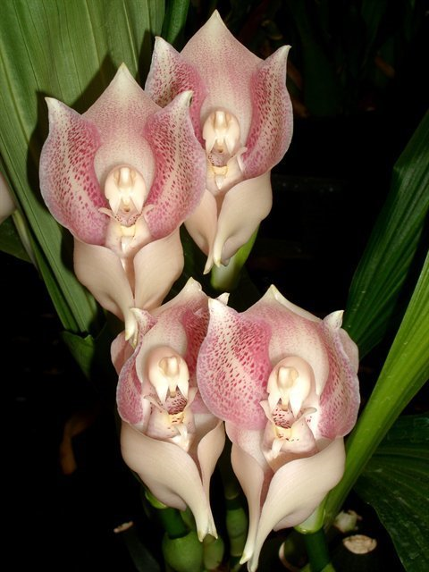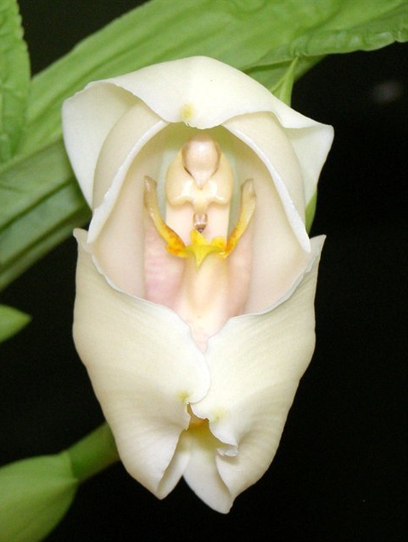
This small genus of thirteen terrestrial or sometimes epiphytic species (9 distinct species and 4 natural hybrids) is found in Colombia, Venezuela, Ecuador and Peru and has large, fleshy pseudobulbs that have large, plicate, imbricate, deciduous leaves. The long, lanceolate and plicate leaves of a full-grown Anguloa can be more than 1 m long. Two to four leaves grow from the base of each pseudobulb. The single flowered inflorescence arises from the base of the new pseudobulb as the new growth begins. The flower is large, showy, fleshy and cup shaped with a 3 lobed lip and 4 pollina that moves within the sepals and petals. These species need a cool to cold environment with some shade, high humidity and lots of fertilizer while growing. They need a 2 to 3 week dry rest in the late winter. Resume water and fertilizer after simultaneous initiation of the new growth and the new inflorescence.
There are two basic groups of anguloas, white and yellow/red. White anguloas can produce up to six inflorescences per pseudobulb and the yellow/red up to 12 in late spring and early summer. There is usually one cupped flower per inflorescence.The flowers of all species are strongly fragrant of cinnamon.
Anguloa is commonly called the Tulip orchid because of the peculiar shape of the flower. The genus is closely related to Lycaste and is often interbreed readily resulting in spectacular hybrids of Angulocaste
Judging Anguloa: In my opinion general scale is the way to go. However, I can also see Vanda scale working well for this emphasizing more on the sepals than petals and lips because sepals are generally more visible due to the cupped nature of the flower.
Significant species | Offspring/Progeny | Awards
Ang. clowesii* | 37/163 | 6 AMs, 1 CCE, 5 CCMs
Ang. cliftonii | 18/37 | 6 AMs, 3 HCCs, 5 CCMs,
Ang. hohenlohii | 17/24 | None
Ang. eburnea | 12/62 | 5 AMs, 1 HCC, 1 CCM, 1 CHM
Ang. uniflora | 11/14 | 4 AMs, 2 HCCs, 2 CCMs, 1 CHM
Ang. x ruckeri | 10/22 | 8 AMs, 3 HCCs, 1 CCE, 3 CCMs, 1 CBM
Ang. virginalis | 10/17 | 3 AMs, 1 HCC, 1 CHM
Ang. brevilabris | 4/12 | 3 CCEs, 3 CCMs, 1 CHM
Ang. dubia | 3/3 | 3 AMs, 1 HCC, 2 CCMs, 1 CHM
Ang. tognettiae | 3/3 | None
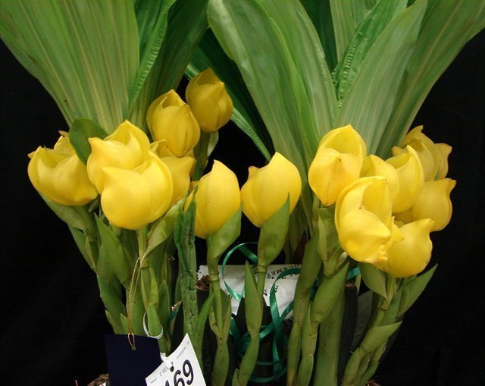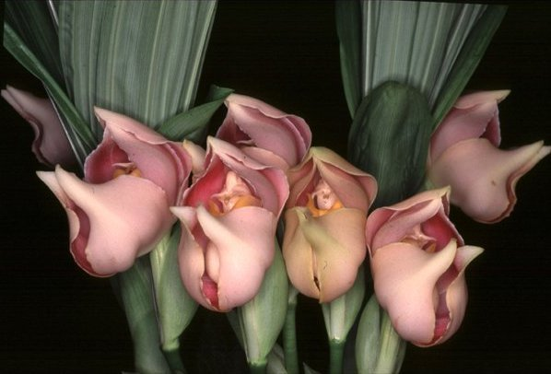
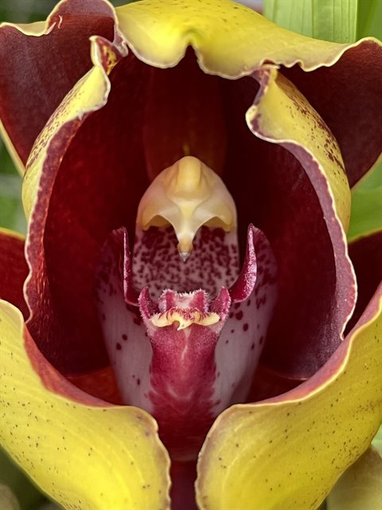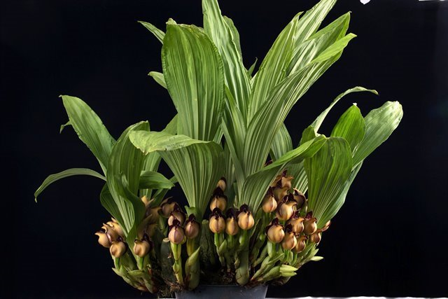
BUILDING BLOCK REPORT
Anguloa clowesii Lindley 1844
Synonym: Anguloa clowesii var. aurea A.DC. ex Oakeley 1999; Anguloa clowesii var. flava A.DC. 184
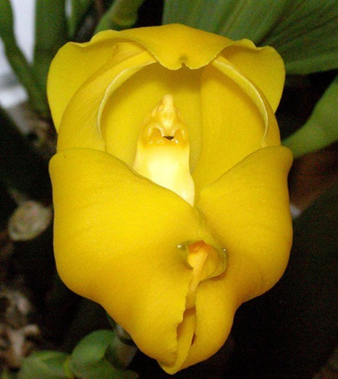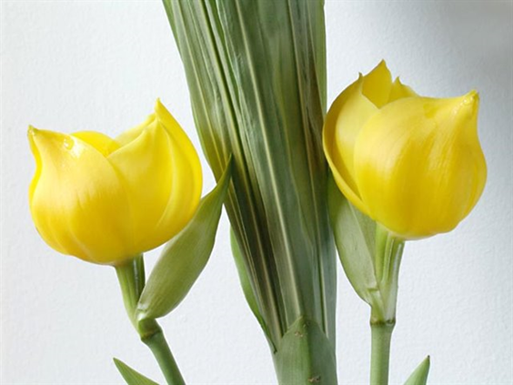
A large terrestrial sometimes epiphytic plant with large, clustered, conical-pyriform, sulcate, slightly compressed pseudobulbs with 3 to 4, deciduous, apical, plicate, obovate or elliptical, obtuse leaves found at elevations of 1800 to 2500 meters, commonly called the Cradle Orchid, as it has a rocking lip, which is enclosed completely by the sepals and petals as in a tulip which gives the plant it's other common name the Tulip Orchid. It is found in Colombia and Venezuela on the eastern slope of the Andes next to the Llanos and is a cool to cold growing orchid that has large, waxy, highly fragrant (chocolate, mint, coconut and citrus scented) solitary flowers smelling of wintergreen and chocolate occurring from the spring through the summer on an erect, 12" [30 cm] long, sheathed, often 2 inflorescence holding the flowers at mid-leaf height that arise basally as the new growths appear in the late winter.
Varieties: N/A
Awards: 6 AMs, 1 CCE, 5 CCMs
Hybrids: 37 offsprings, 163 total progeny
Anguloa clowesii is coveted for its bright golden yellow color, sepals and petals segments are very broad, and unlike Lycaste, petals are much wider, almost comparable to the size of sepals. Hybrids within Anguloa is limited. The shape of the flowers are pretty much similar across the genus. The most well-known natural hybrids within the genus is Ang. x ruckeri (clowesii x hohenlohii). It’s deeply colored and very full flower, blooming with good vigor. The grex received 8 AM and 3 HCC from the AOS, more than any Anguloa out there.
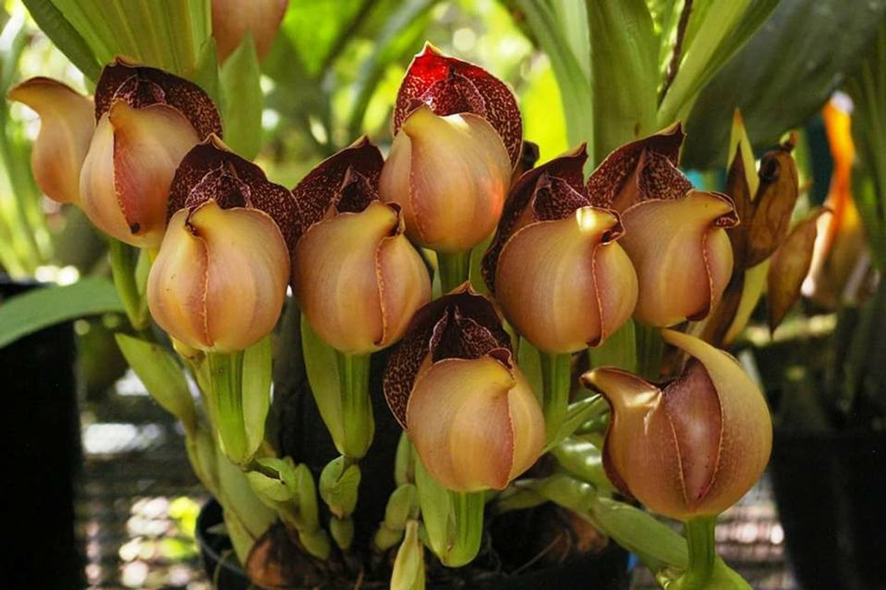
Anguloa are very readily bred with Lycaste to create Angulocaste. Anguloa are most often added for the yellow color and the curious tulip shape. Angulocaste contains some of the easiest orchids to grow. However,flowers malformation is relatively common. Fusion of sepals at the base and fusion of petal and lip are typical and can make the not open of display completely. The flowers are generally cupped but not fully tulip-shaped like those of Anguloa. This is not necessarily a bad thing. It does enhance the fullness of the appearance of these flowers.
Angulocaste Apollo (Ang. Clowesii x Lyc. Imschootiana) creates a sensation when first exhibited. It is bright yellow, sometimes with red spots, sometimes with the open shape of Lycaste. Flowers are well-displayed on multiple upright scape. It is a sight to behold. Interestingly, the red spots occasionally come through to the offsprings.
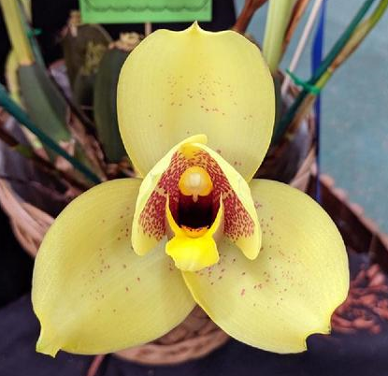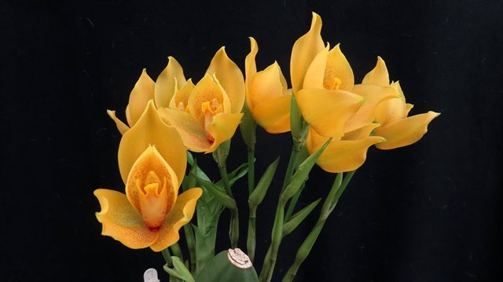
Angulocaste Olympus (Angcst. Apollo x Lyc. Sunrise) is one of the most highly awarded and hybridized of the Angulocaste. The clone ‘Chadds Ford’ is a beautiful example. It has gotten an FCC and multiple cultural award including a CCM of 99 points. Color of various clones can range from a beautiful soft yellow to white, pink, apricot, spotted.
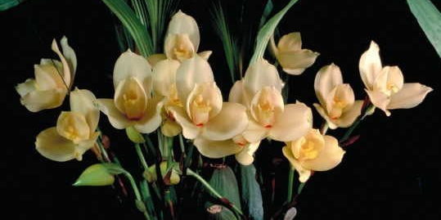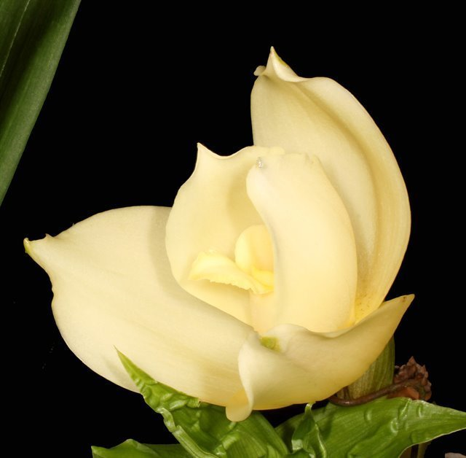
Many other fine examples of Angulocaste includes: Angcst. Paul Gripp, Angcst. Nowra, Angcst. Jupiter, Angcst. Santa Barbara, etc…, many common traits of the offsprings are full shape, multiple well-displayed flowers.
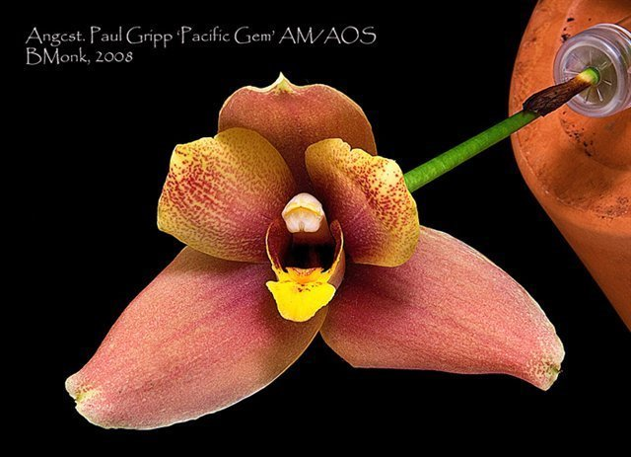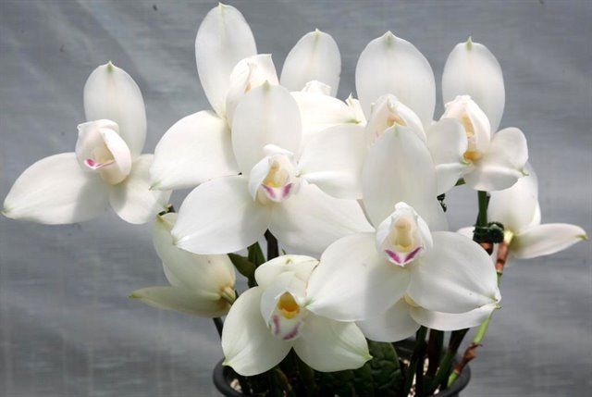
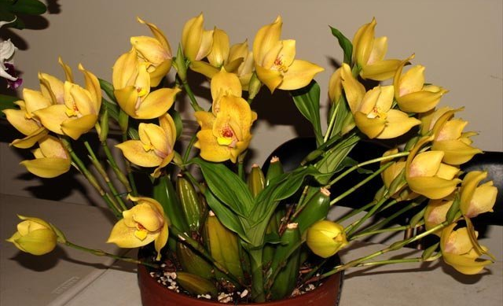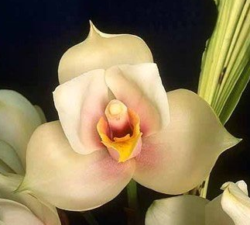
Finally Lysudamuloa (Lyc x Sud x Ang) combines the best of the 3 genera, greatly improves the form and color of the original species. Example: Lys. Jim Riopelle and Lys. Yi-ying Sakura
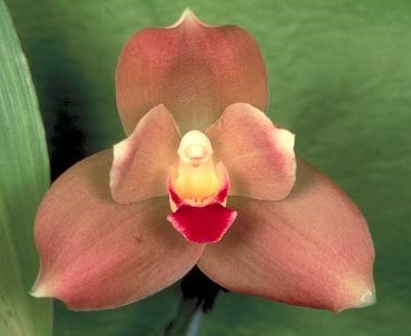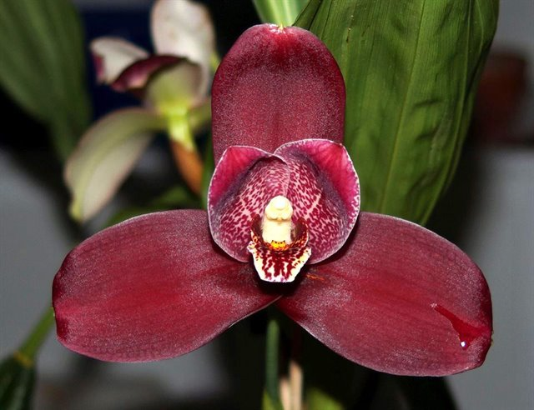
Not often bred with Maxillaria, however, such hybrid is possible albeit rare. Angularia Denise Barrow ‘Mid-Michigan’ (And. clowesii x Max. striata) received an AM/AOS in 2018 for its outstanding gold flowers and an AD for new and interesting breeding direction.
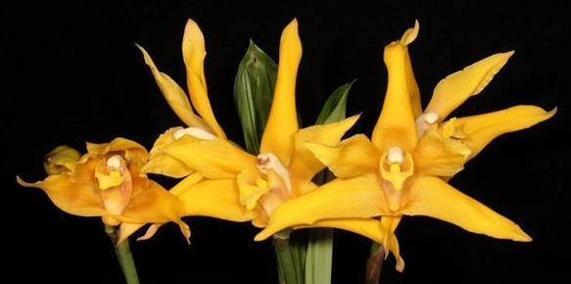
Reference:
Internet Orchid Species Photo Encyclopedia
http://www.orchidspecies.com/
OrchidWiz Encyclopedia version 9.1
Orchid Plus Online
Wikipedia Encyclopedia
https://en.wikipedia.org/wiki/Lycaste
Orchid Magazine
Angulocastes: Intergeneric Hybrids Offering Handsome Foliage and Outrageous Flowers, Issue Dec 1991, page 22-27
Anguloa: New World Orchids with Worldwide Appeal, Issue Oct 2008, page 22-23

