The Genus Bifrenaria
Lindley 1832
Type species: Bifrenaria atropurpurea
Bifrenaria is a genus rarely seen in cultivation, although their attractive, fragrant flowers and robust nature of the plants should made them more popular; they can be a challenge to flower. Plants are sympodial, roots with thick velamen and round section, four-angled fleshy pseudobulbs of one internode and only one (except for B. steyermarkii) apical plicate enervated leathery leaf. Basal receme inflorescence bearing up to 10 flowers rarely surpass the leaves length. Flowers are generally fragrant; sepals are slightly larger than petals. The lateral ones comes together to the column foot forming short spur. This is a main characteristic to distinguish Bifrenaria from its related genera. The column is slightly arching and generally without wings or any other appendages. Labellum shape varies, attaches to foot of column, with a longitudinal channeled callus often with a basal claw.
Plants like it humid and breezy year round even when watering is being withheld. They prefer well drained medium because roots and pseudobulbs rot easily when wet for long period. Amazon forest species require higher and more constant temperature and humidity. All species need most water and fertilizer when actively growing.
Bifrenaria is a small genus with only 21 sympodial species divided into 2 subgroups: lithophytic to epiphytic robust plants with large firmly substance flowers and epiphytic delicate plants with smaller flowers are occasionally called Stenocoryne or Adipe.
Large species: four-sided pseudobulbs, short and erect inflorescence bearing up to 10 fleshly large flowers. Usually strongly fragrant. Labellum has 3-4 lobes and an elongated low callus. Originated in the southeast of Brazil. Plants prefer well lit area
- Subgroup 1 - epiphytes with pollinarium with entire stipe and a salient callus just on its anterior region: B. calcarata, B. mellicolor
- Subgroup 2 - pollinarium with entire stipe but the callus is entirely salient and fleshy: B. tetragona, B. wittigii
- Subgroup 3 – bifurcated stipe: B. altropurpurea*, B. tyrianthina*, B. inodora*, B. harrisoniae*
- Uncategorized: B. verboonenii
Small species: smaller and not as noticeably four-sided pseudobulbs, long and delicate inflorescence bearing higher number than the large flower group (max of 10). Flowers smaller, not particularly fragrant. Labellum entire or slightly lobed on the apex. Usually found in less sunny and more humid area.
- Subgroup 1 - Amazonian species with elongated rhizomes: B. venezuelana, B. longicornis
- Subgroup 2 - Bright orange flower with acute petals, sepals and labellum which do not open well: B. aureofulva*
- Subgroup 3 - Petals parallel to the column: B. charlesworthii, B. racemosa
- Subgroup 4 - Petals oblique to the column: B. clavigera, B. silvana, B. leucorhoda, B. stefanae, B. vitellina
Miscellaneous
- B. maguirei, B. steyermarkii
Hybridizing is rarely done in this genus. Theoretically hybridizing could be done with other genera in Maxillarieae tribe but so far most important intergeneric hybrids are those with Lycaste.
Genus Bifrenaria received a total of 76 awards and a big portion of it (32) went to B. harrisoniae, which includes 7 AMs, 4 HCCs, 8 cultural awards, and 3 others in the AOS judging system alone.
Can utilize the General Scale for judging Bifrenaria.

SPECIES DATA SHEET
Bifrenaria harrisoniae (Hooker) Rchb. f. 1855
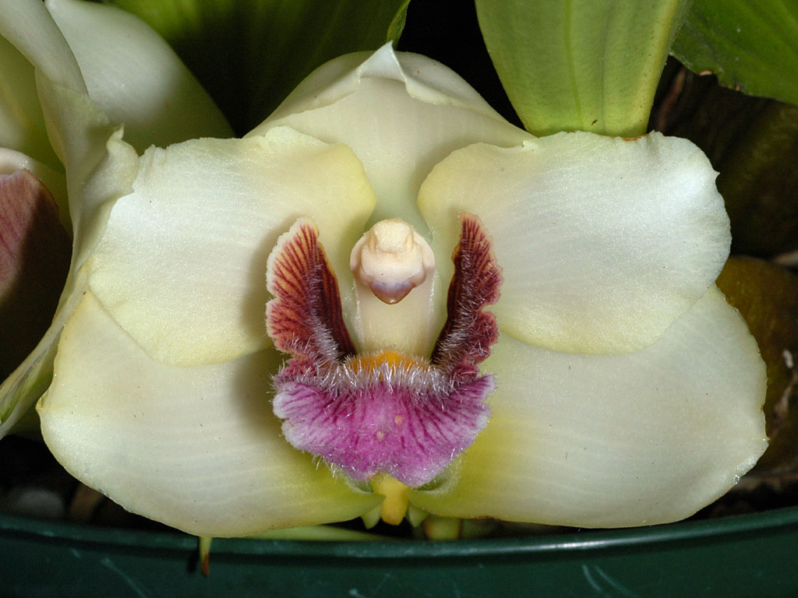
Synonym: Dendrobium harrisoniae Hooker, Maxillaria harrisoniae (Hooker) Lindley, Lycaste harrisoniae (Hooker) B. S. Williams, Colax harrisoniae Lindley, Maxillaria pubigera Kraenzlin, Maxillaria spathacea Lindley, Stanhopea harrisoniae G. Don.
Harrison’s Bifrenaria is found in coastal Brazil near Rio de Janeiro as a medium sized, warm growing lithophyte or occasional epiphyte found at 200 to 700 meters. The plant is grown exposed to strong wind and almost full sun with their roots bury in the cracks of rock with excellent drainage and warm temperature. Flower is waxy, long lasting and heavily fragrant. Plants normally produce 2 inflorescence per pseudobulb with 2 flowers each. Flowers is mostly white but can be greenish, yellowish to pink. The hairy lip is rich purple/magenta to red with darker veins. Blooming season is March to May in the Northern hemisphere. Provide slightly cooler and drier winter rest with continuing high light and humidity. Avoid repotting unless medium is stale. Plants prefer to be pot bound and resents root disturbance.
Varieties: var. alba, var. purpurescens, var. pubigera, var. grandiflora.
Awards: 22 AOS awards including 7 AMs, 4 HCCs, 8 cultural awards, and 3 others. Total of 32 awards globally.
Hybrids: total of 12 progeny recorded on Orchidwiz. This is the most hybridized species in the genus, bred with Lycaste to improve petals and lips and provide substance and fragrance

Reference:
OrchidWiz Encyclopedia version 3.3
Jay Pfahl’s Internet Orchid Species Photo Encyclopedia:
http://www.orchidspecies.com/bifharrisonii.htm accessed 6/5/2017
Charles Baker’s Orchid Culture Sheets
https://orchidculture.com/cod/free/FS1.html accessed 6/5/2017
SPECIES DATA SHEET
Bifrenaria inodora Lindl. 1843
Synonym: Bifrenaria aurantiaca Wms. Non Lindley 1894; Bifrenaria fragrans Barb. Rodr. 1881; Bifrenaria fuerstenbergiana Schlechter 1906; Lycaste inodora Hort.; Stenocoryne inodora [Barb Rodr.] Kraenzl. 1896
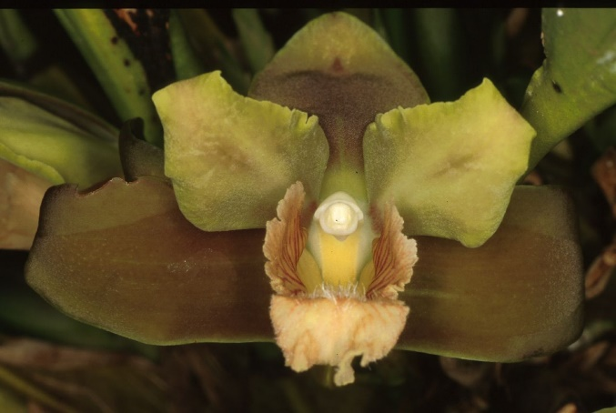
After B. harrisoniae, B. inodora is the second most awarded Bifrenaria to date. Is named because in contrast to other large flower Bifrenaria, B. inodora is missing fragrance (inodora=without fragrance.) Medium sized epiphyte found at up to 1000 meters. Plants produce 2-3 flowers per inflorescence. Flowers are green to greenish yellow, petals are held in forward position; lip is hairy, ranging from white, yellow, to light rose and purple in color. Their basic growing condition is similar to those of warm growing Lycaste with a distinct dry and cool rest period. Avoid repotting unless medium is stale. Plants prefer to be pot bound and resents root disturbance.
Varieties: n/a
Awards: 6 AOS awards to date, with 1 AM (‘Well’s Acres’ with 81 pts in 1989), 2 HCCs (‘Alfredo’ with 78 pts in 1987, and ‘Magnifico’s Jam’ with 79 pts in 1989), 1 CCM (‘Cardinal’s Roost’ with 82 pts in 1996). Overall, the species was granted 13 awards globally.
Hybrids: total of 5 progeny recorded on Orchidwiz, chosen for interesting lip color, and heavy substance

Reference:
OrchidWiz Encyclopedia version 3.3
Jay Pfahl’s Internet Orchid Species Photo Encyclopedia:
http://www.orchidspecies.com/bifinodora.htm accessed 6/5/2017
American Orchid Society article
http://www.aos.org/orchids/collectors-items/bifrenaria-inodora.aspx accessed 6/5/2017

