The Genus Lycaste
Lindley 1842
Type species: Lycaste macrophylla (Poepp. & Endl.) Lindl. 1843
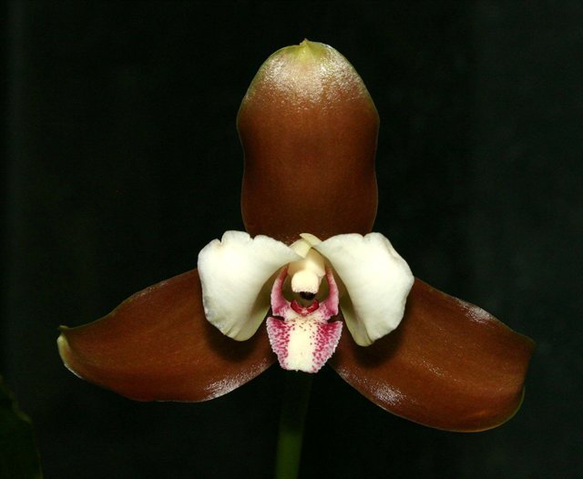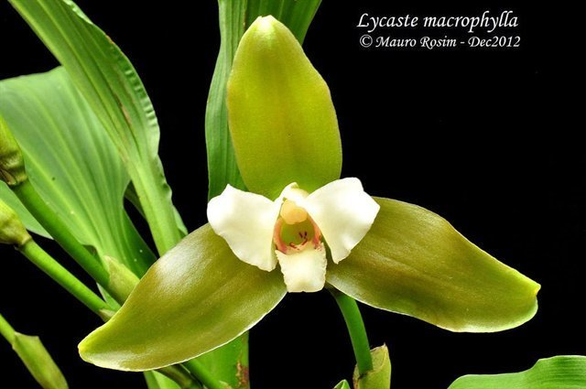
This genus has epiphytes, lithophytes and terrestrials in it's 52 species that are spread throughout Central America, the West Indies and South America south to Peru and Bolivia at elevations of 500 to 2800 meters. They have plicate, deciduous leaves with short, ovate, thick, ribbed pseudobulbs with 2 or 3, thin, heavily-veined, apical leaves with foliaceous sheaths at the base, giving rise to a lateral inflorescence with more than one arising from the base of the pseudobulb with a single flower in most species. The flowers are large, often fragrant, with sub-equal spreading sepals and petals, a three lobed lip that is flexibly united to the column foot, a slender column that is wingless or narrowly 2 winged, has a basal foot, an apical anther, 2 to 4 pollina with 2 very short to elongate stipites. Humid, shady conditions are required with water and fertilizer as the plant is growing; as the leaves begin to yellow and fall the water needs to be reduced along with a drop in temperatures to assure a good blooming.
The Lycastes have been divided into four sections, one of which has two subsections:
Section Deciduosae - deciduous, that is, they usually lose their leaves during an annual dormant period. All but two of the Deciduosae have spines at the apices of their pseudobulbs that become exposed when the leaves are dropped - the exceptions are a Xanthanthae species, Lycaste lasioglossa, and a Paradeciduosae species, Lycaste tricolor. Both of these species lack spines, and may bloom when leaves are still present.
Subsection Xanthanthae - have yellow to orange blooms; the name is from xantho - yellow, and anthos – flower. The recognized Xanthanthae species include:
Lycaste aromatica,
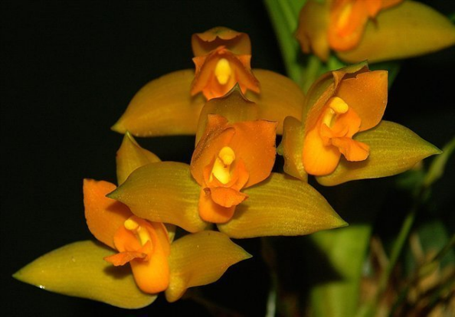
Lycaste bradeorum,
Lycaste campbelli,
Lycaste cochleata,
Lycaste consobrina,
Lycaste crinita,
Lycaste cruenta,
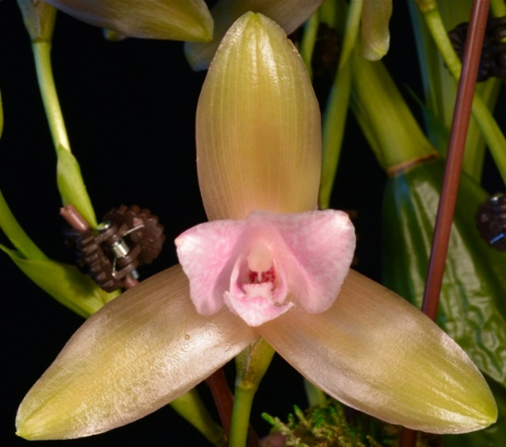
Lycaste deppei,
Lycaste lasioglossa,
Lycaste macrobulbon.
Subsection Paradeciduosae - have pink-marked white blooms; the name is from para- similar or near, and deciduosae- deciduous ones. The Paradeciduosae species include:
Lycaste brevispatha,
Lycaste tricolor.

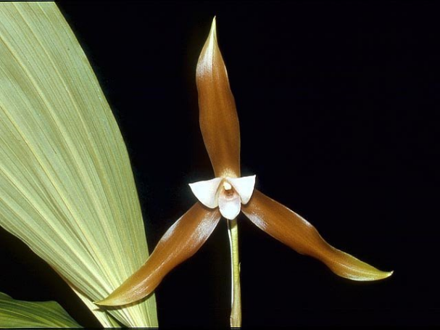
Section Longisepalae – has very long sepals.The Longisepalae species include:
Lycaste schilleriana

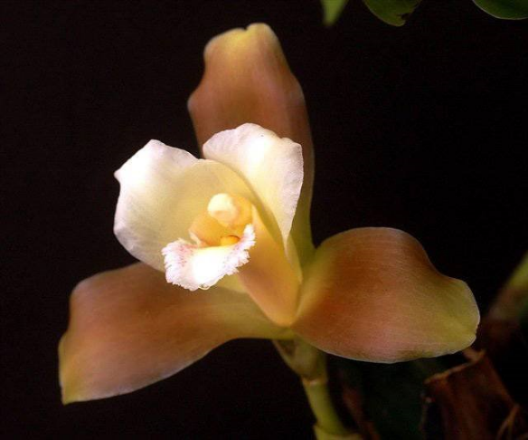
Section Macrophyllae - keep their leaves during dormancy; the name is from macro- large and phyllae- leaves. The Macrophyllae form a large complex, with subspecies and varieties that can be considered to be in the process of differentiating into new full species. The Macrophyllae species include:
Lycaste dowiana,
Lycaste leucantha,
Lycaste macrophylla
Lycaste macrophylla var. desboisiana
Lycaste macrophylla subsp. macrophylla
Lycaste macrophylla subsp. puntarenasensis
Lycaste macrophylla subsp. xanthocheila
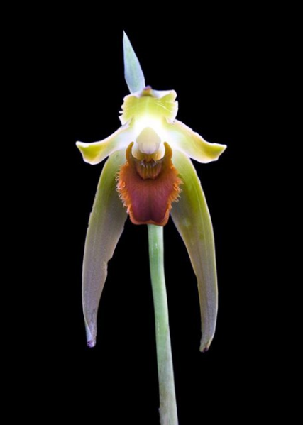
Lycaste neglecta,
Lycaste powellii,
Lycaste skinneri,
Lycaste xytriophora.

Section Fimbriatae - typically have fringed lips. The Fimbriatae species include:
Lycaste longipetala,
Lycaste mesochlaena.
A recently published (2003) revision of Lycaste by Henry Oakeley and Angela Ryan split off most of the species of section Fimbriatae as the new genus Ida. The 34 species of Ida occur in South America or in the Caribbean Islands (Ida barringtoniae), while true Lycastes occur mostly in Mexico and Central America. The genus Ida is recognized by the World Checklist of Monocotyledons.
Significant species | Offspring/Progeny | Awards
Lyc. virginalis* | 108/885 | 8 FCCs, 62 AMs, 48 HCCs, 6 JCs, 2 CHMs, 12 CCMs, 2 CCEs, 1 AQ
Lyc. aromatica | 32/72 | 3 AMs, 12 CCMs, 1 CCC
Lyc. macrophylla* | 49/705 | 5 AMs, 6 HCCs, 1 JC, 2 CHMs, 6 CCMs,
Lyc. cruenta | 35/767 | 8 AMs, 3 HCCs, 1 JC, 1 CHM, 4 CCMs,
Lyc. brevispatha | 28/82 | 3AMs, 2 HCCs, 2 JCs, 10 CHMs, 1 CBM
Lyc. lasioglossa* | 30/402 | 4 AMs, 4 HCCs, 1 JC, 2 CCMs,
Lyc. campbellii | 16/33 | 2 AMs, 3 HCCs, 3 CCMs, 1 CCE, 1 CBR
Lyc. deppei | 26/66 | 1 AM, 4 HCCs, 1 JC, 4 CCMs,
Lyc. macrobulbon* | 27/223 | 2 HCCs, 1 CHM, 1 CBR, 3 CCMs,
Lyc. dowiana | 19/51 | 2 HCCs, 2 JCs, 1 CCM

Judging Lycaste: In my opinion general scale is the way to go. However, I can also see Paph scale working well for this emphasizing more on the sepals than petals and lips. Plus, they are generally single flower per inflorescence.
BUILDING BLOCK REPORT
Lycaste virginalis [Batem. ex Lindley] Lindley 1843
Synonym: Lycaste alba Cockerell 1919; Lycaste albida Hort 1892; Lycaste amabilis Hort. 1892; Lycaste jamesiana hort. 1889; Lycaste schoenbrunnensis Umlauft 1893; Lycaste skinneri f. virginalis (Scheidw.) Christenson 1996; Lycaste skinneri subvar. alba (Dombrain) A.H.Kent 1893; Lycaste skinneri var. alba Dombrain 1872; Lycaste skinneri var. albaviridis Mills. ex Oakley 2008; Lycaste skinneri var. armeniaca Rolfe 1892; Lycaste skinneri var. cobanensis Archila 2002 Lycaste skinneri var. gloriosa R.Warner & B.S.Williams 1885; Lycaste skinneri var. labelloalba Oakley 2008; Lycaste skinneri var. labelloflava Oakley 2008; Lycaste skinneri var. reginae B.S.Williams 1887; Lycaste skinneri var. superba T.Moore 1861; Lycaste skinneri var. virginalis (Scheidw.) Gajon-Sanchez 1930; Lycaste virginalis [Scheidw.]Lindley 1888; Maxillaria skinneri Lindl. 1840; *Maxillaria skinneri Bateman ex Lindley 1842; Maxillaria virginalis Scheidw. 1842
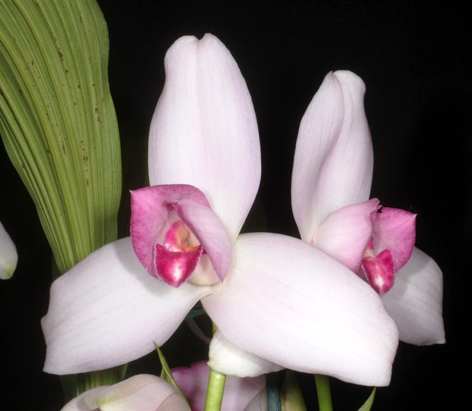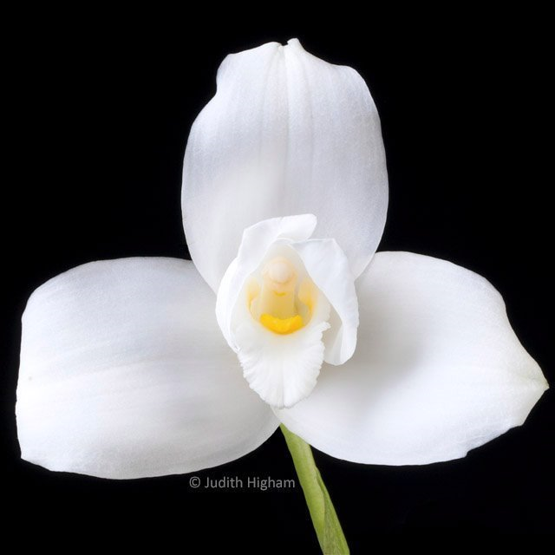
This is a warm to cold growing, large sized, epiphytic or lithophytic orchid from wet montane forests and pine-oak-liquidambar forests at altitudes of 1200 to 1800 meters that has ovoid, compressed pseudobulbs carrying several, apical, deciduous, plicate, elliptic-lanceolate, acuminate leaves, dropping in the autumn, from that time on the plant needs no water or fertilizer and should only be resumed with the emergence of the new growth and flowering in the winter and early spring. The inflorescence is erect, with a few at once, 6 to 12" [15 to 30 cm] long, single flowered inflorescence with the peduncle being concealed by inflated sheathing bracts. The flower is long-lasting, fragrant, and highly variable in size and color. This orchid is the national flower of Guatemala where it is known by the common name 'Monja Blanca' or white nun orchid, it is also found in Mexico, Guatemala, Honduras and El Salvador.
Varieties: f. alba (white), f. albescent (offwhite/blush), f. ruborosa (pink), f. rubra (dark pink), f. semi-alba (mostly white), ssp. ipala (warm tolerant, smaller plants, now known as Lycaste guatamalensis), var. armeniaca (apricot), var. delicatissima
Awards: 9 FCCs, 63 AMs, 48 HCCs, 7 JCs, 2 CHMs, 2 CCE, 12 CCMs, 1 AQ
Hybrids: 108 offsprings, 885 total progeny

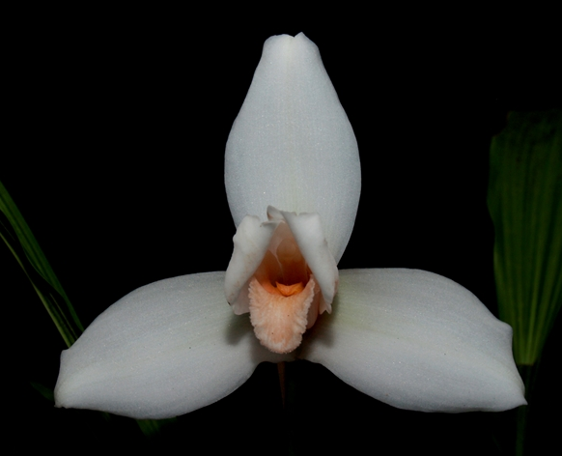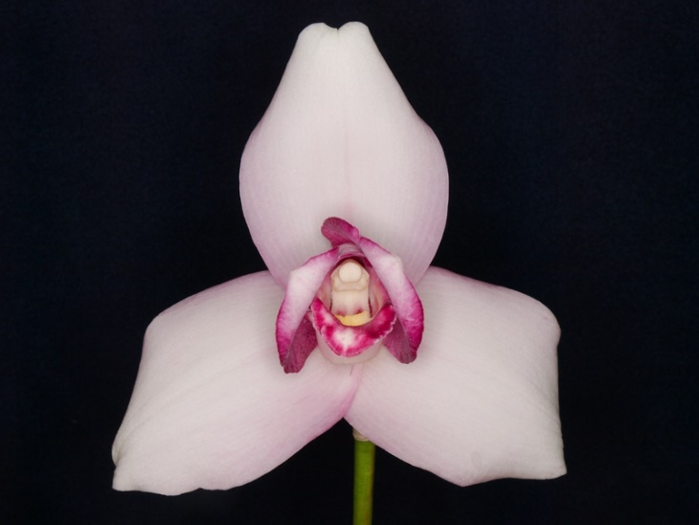
This is the cornerstone species of Lycaste breeding due to its large size flower and close to perfect shape. It presents in the ancestry of nearly all Lycaste hybrids. For a long time, no hybrids that were made can surpass the beauty of a well-grown plant of this Lycaste species in flower size, shape, and overall appeal. However, there are several advantages to hybridizing. First of all, Lycaste virginalis only bloom in pink, white, or shade of apricot. Adding other species will enhance the color spectrum of such hybrids. Furthermore, this species is the most difficult Lycaste to grow well, hybridizing provides hybrid vigor to the offspring.
Lycaste Balliae (1896) is one of the oldest orchid hybrid out there and also the foundation hybrid for three quarter of current registered Lycaste out there. Balliae diversifies the color range of typical virginalis to include rose pink to red, green, and yellow thanks to the other parent Lycaste macrophylla. The hybrid seems to perform well, is vigorous, and produce multiple flowers as well. The flower on these have wider spreading petals which seem to display the center of the flower better
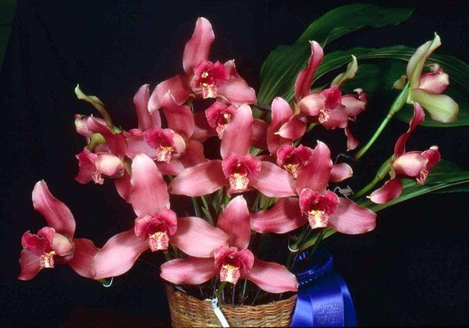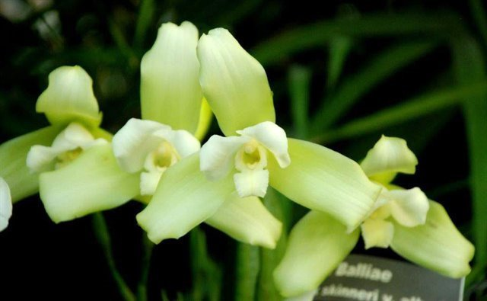
Lycaste Imschootiana (1893) while not a popular hybrid, it contributes to creation of another important hybrid Lycaste Auburn (Balliae x (Imschootiana x virginalis)). Lycaste Auburn is highly awarded and covetted. Similarly, Auburn inherited a variety of color and vigor of its predecessor. It seem that the yellow in Lyc. cruenta tends to wash out pink for a few generations. Nonetheless, it has the potential for novelty color (even solid red) and add floriferousness to the progenies in the further breeding lines.
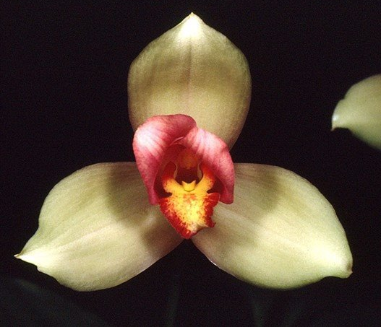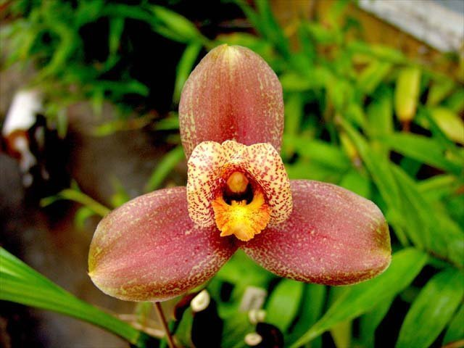
Similarly, There is the effort to put back virginalis for fuller shape with more color variation is evident in the subsequent hybrids: Lycaste Koolena (Auburn x virginalis), Lycaste Shoalhaven (Koolena x virginalis), Lycaste Sunray (Shoalhaven x virginalis), Lycaste Sunrise (Imschootiana x virginalis). These are highly awarded with multiple AM and some FCC in the mix
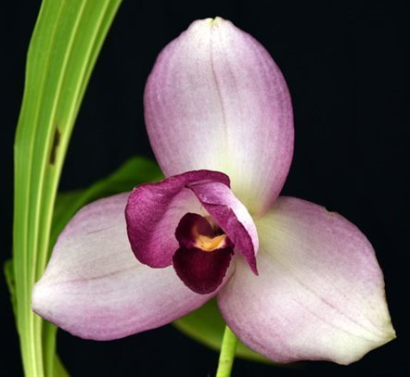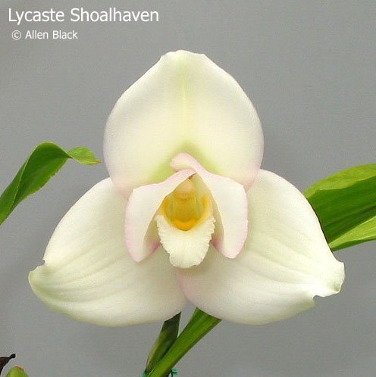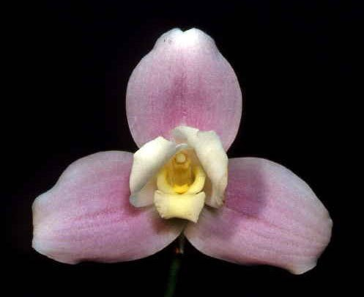
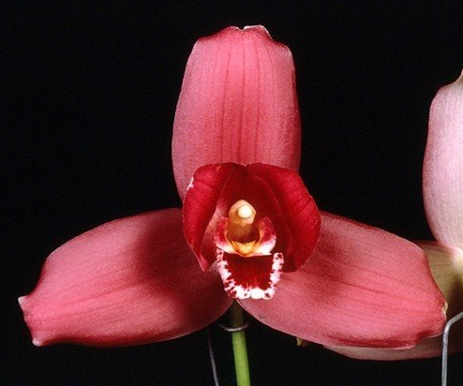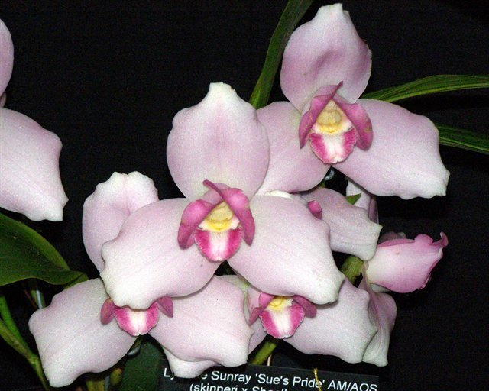
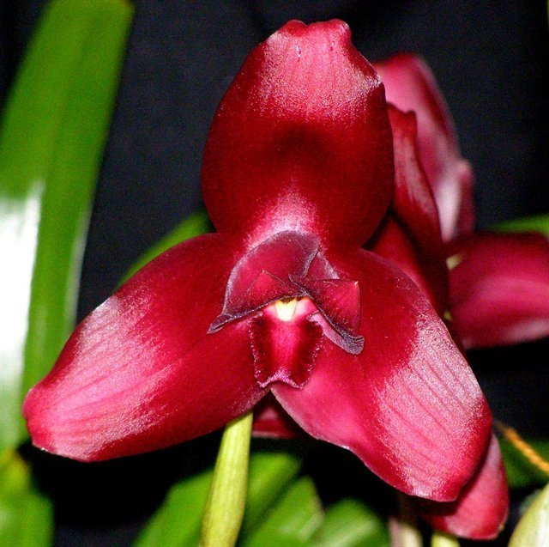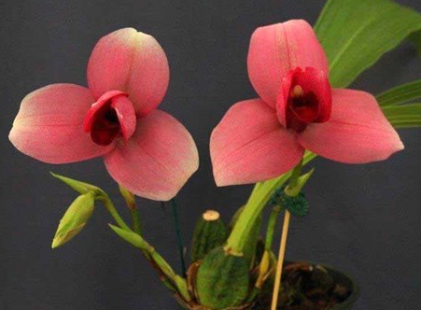
Lycaste Jackpot is the result of an effort to breed red Lycaste. It is definitely one of the most stunning hybrid with several FCC under its belt. The majority of its genetic makeup is Lyc. virginalis but the color was intensified by generations of selective breeding and color gene from the other species in the background (Lyc. cruenta, Lyc. macrophylla, Lyc. lasioglossa)
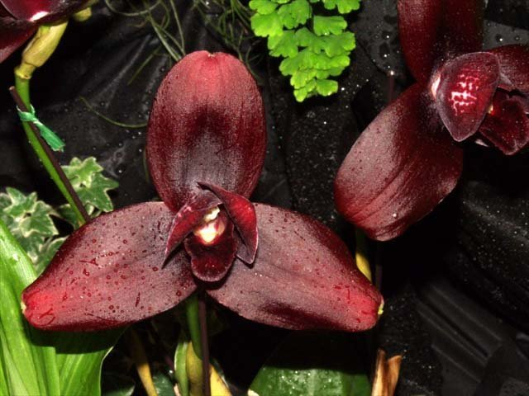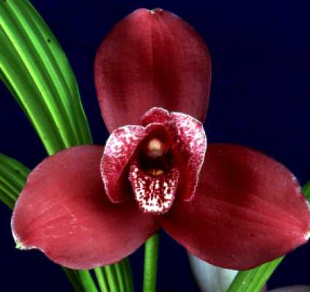
Beside red, there is also a demand for yellow Lycaste. By adding more of the yellow macrobulbon and cruenta in the mix, we result in fine hybrid like Lyc. Florida Gold, Lyc. Golden Emperor, Lyc. Concentration. The role of Lyc. virginalis here is to round out the sepals and increase flower size
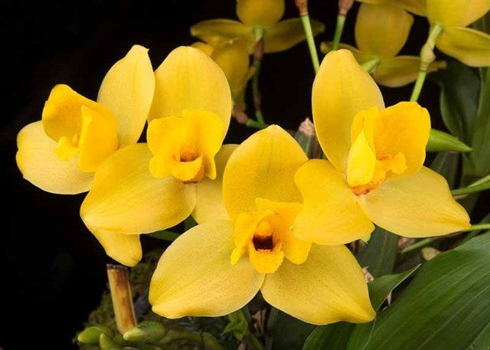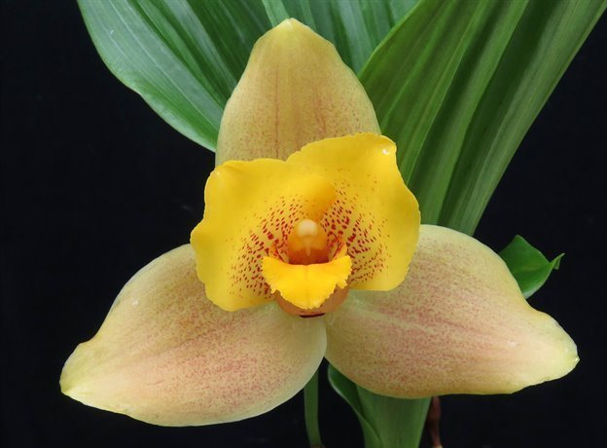
Intergeneric hybrids with Lycaste are also exists. Anguloa are most often added for the yellow color and the curious tulip shape. There are others includes the genus Sudamerlycaste, Bifrenaria, Zygopetalum, etc… but they are not as well known. Angulocaste contains some of the easiest orchids to grow. Flowers malformation is relatively common. Fusion of sepals at the base and fusion of petal and lip are typical and can make the not open of display completely. The flowers are generally cupped but not fully tulip-shaped like those of Anguloa. This is not necessarily a bad thing. It does enhance the fullness of the appearance of these flowers.
Angulocaste Apollo (Ang. Clowesii x Lyc. Imschootiana) creates a sensation when first exhibited. It is bright yellow, sometimes with red spots, sometimes with the open shape of Lycaste. Flowers are well-displayed on multiple upright scape. It is a sight to behold. Interestingly, the red spots occasionally come through to the offsprings.
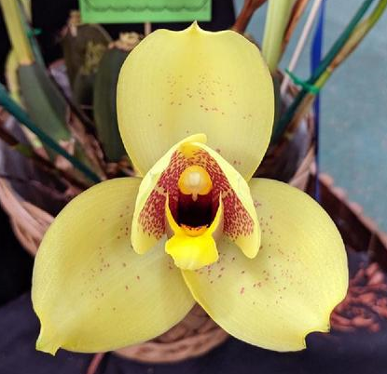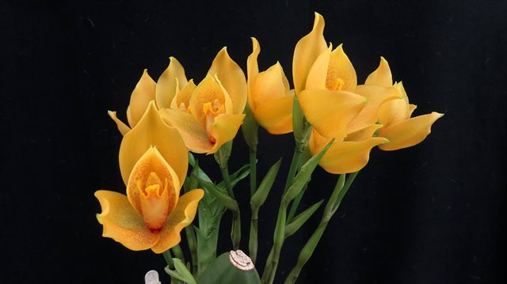
Angulocaste Olympus (Angcst. Apollo x Lyc. Sunrise) is one of the most highly awarded and hybridized of the Angulocaste. The clone ‘Chadds Ford’ is a beautiful example. It has gotten an FCC and multiple cultural award including a CCM of 99 points. Color of various clones can range from a beautiful soft yellow to white, pink, apricot, spotted.
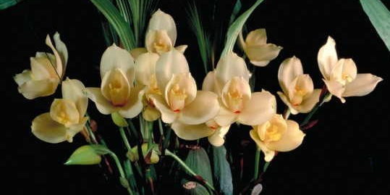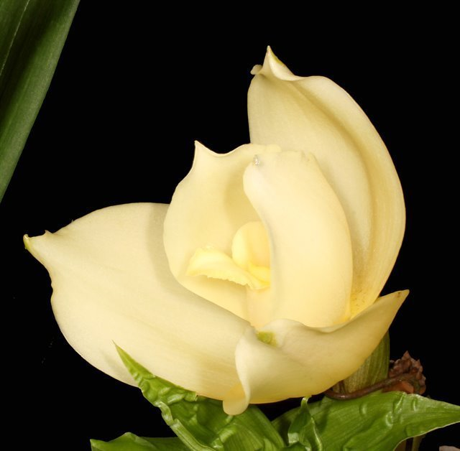
Many other fine examples of Angulocaste includes: Angcst. Paul Gripp, Angcst. Nowra, Angcst. Jupiter, Angcst. Santa Barbara, etc…, many common traits of the offsprings are full shape, multiple well-displayed flowers.
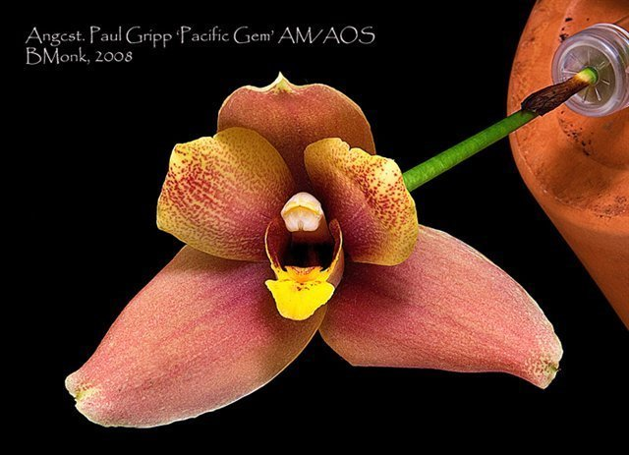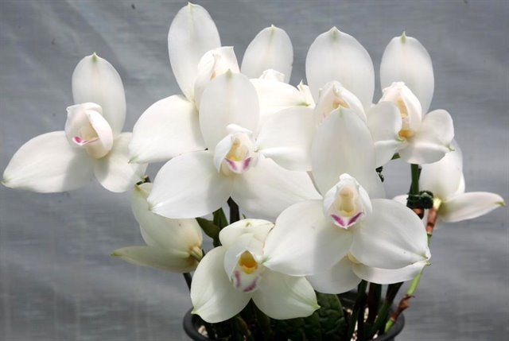
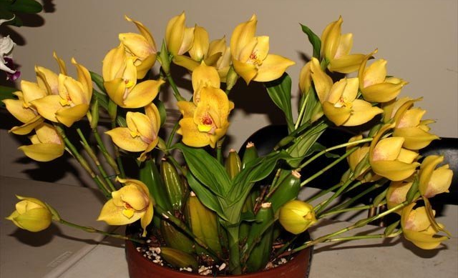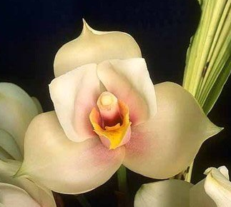
Another major genus commonly bred with Lycaste is with Sudamerlycaste. These used to be the green Lycaste. Notably, Sud. locusta and its unusual and eye-catching emerald green flowers with petals only slightly smaller than sepals (an improvement over Lycaste) and are fully open (an improvement over Anguloa). When hybridize with Lyc. virginalis, the green color appears to be washed out, more importantly, it also suppresses the pink coloration of Lyc. virginalis. The results of these tend to be pale green to white open flowers with improved proportion between sepals and petals. Example: Lycamerlycaste Queen Elizabeth (Sud. locusta x Lyc. virginalis), Lmc. Kool Customer (Lyc. Koolena x Sud. locusta), Lmc. Shimayuki [(Sud. costata x Lyc. virginalis) x Lyc. virginalis]. Occasionally saturated color does appear: Lmc. Mark (Sud. costata x Lyc. Wyld Velvet)
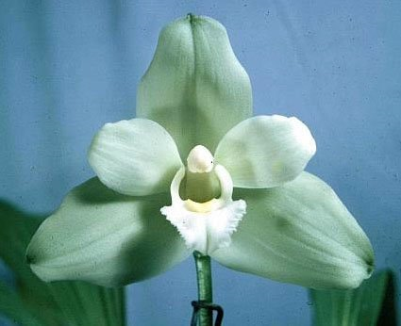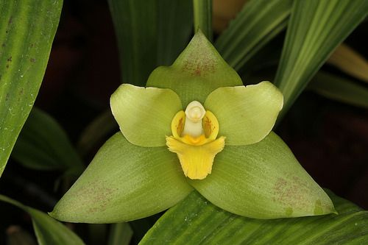
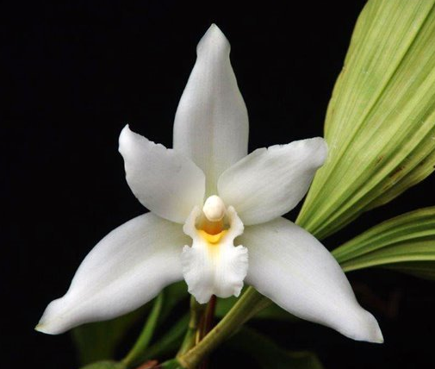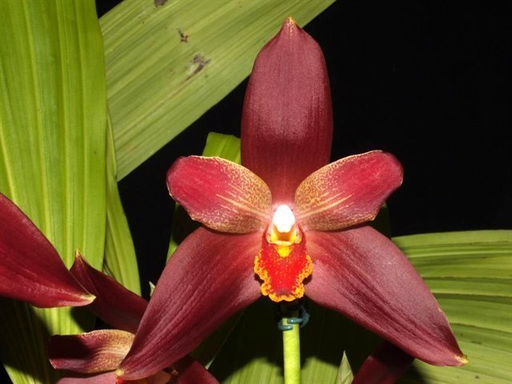
Finally Lysudamuloa (Lyc x Sud x Ang) combines the best of the 3 parents with an emphasis on Lyc. virginalis, greatly improves the form and color of the original species. Example: Lys. Jim Riopelle and Lys. Yi-ying Sakura
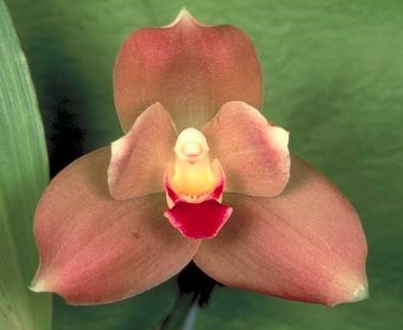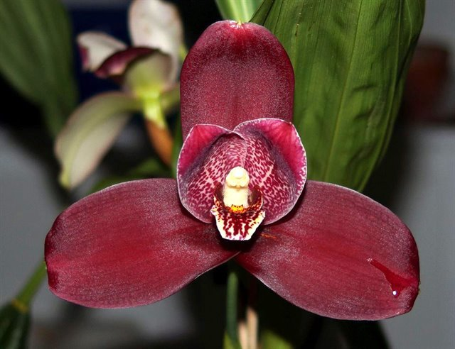
Reference:
Internet Orchid Species Photo Encyclopedia
http://www.orchidspecies.com/
OrchidWiz Encyclopedia version 9.1
Orchid Plus Online
Wikipedia Encyclopedia
https://en.wikipedia.org/wiki/Lycaste
Orchid Magazine
Angulocastes: Intergeneric Hybrids Offering Handsome Foliage and Outrageous Flowers, Issue Dec 1991, page 22-27
Lycaste Hybrids Old and New, Issue Apr 1984, page 22-35

