The Genus Maxillaria
Ruiz and Pavon 1794
Type species: Maxillaria platypetala
Maxillaria is one of the largest genera of New World orchids. The generic name is derived from the Latin maxilla (jawbone) since the lip and column resemble the jaws of insects. There are around 650 species spread throughout the tropical and sub-tropical Americas at elevations of sea level to 3500 meters and are. Most species of Maxillaria have only one leaf but some species have up to four. Rhizomes can be creeping, ascending of suberect with papery sheaths covering. The inflorescence is one flowered with some species producing clusters of inflorescences from the base of each individual pseudobulb. Flower size ranges broadly from ½ inch to over 6 inches in diameter. Regardless of the size, all flowers of the different species have 3 sepals, similar in size, color and triangular shape and two petals, much smaller than the sepals, an adnate lip with three inconspicuous lobes and an entire and distinct callus on the disc and has 4 waxy pollina. Some Maxillarias are fragrant, such as the popular M. tenuifolia, now Maxillariella tenuifolia, commonly known as the coconut orchid because of its coconut-like fragrance, is most widespread and often found even in beginners’ collections because of its beautiful fragrance and ease of growth.
Most species do well under intermediate temperatures with a few exceptions from high elevation species which require cooler temperature and those from lowlands warmer. Grows in bright filtered light and allows to dry somewhat in between watering. High humidity should be maintained year round. Avoid repotting unless necessary due to the sensitive nature of many species
Despite the size of the genus, Maxillaria is not popular in cultivation, but some species are nevertheless sought by collectors. Hybridizing in this group is rather limited as well, mostly done on big flower species, and is mostly bred within the genus. A few intergeneric crosses are available with Lycaste and Anguloa.
A high proportion of awards given to this genus are cultural awards (e.g. M. tenuifolia, M. triloris, M. sanguinea…) due to the ability to form specimen sized plants quickly. Exception in this case are a few of the large flowered species (e.g M. sanderiana, M. triloris, M. striata,…), which gathered more flower quality awards. Compare to the size of the genus, only 794 awards are given with the highest number went to M. tenuifolia (69). Flower quality awards can be determined using General Scale or Cymbidium scale.
There are 2 groups of species that can be distinguished by the way the lip is attached to the column foot the first has the lip totally united with the column and usually has small flowers such as Maxillaria ramosa, the other which is the largest, has the lip articulated to the column and larger flowers refers to the base of the lip which appears to be a protruding chin and jaw
There are also two major groups in the genus based on how the pseudobulbs are arranged. One group consists of species with tightly clustered tufts (e.g. M. cucullata).The other group is made up of species with longer internodes and rhizomes of varying lengths (e.g. M. tenuifolia).
Through molecular studies, scientists determined that Maxillaria contains groups that are not closely related to each other. Many of the species once considered belonging to Maxillaria have been moved to other genera including Camaridium, Heterotaxis, Ornithidium, Brasiliorchis, Christensonella, Nitidibulbon, Sauvetrea, Inti, Mapinguari, Maxillariella, Rhetinantha, Mormolyca in the new classification system proposed by Mark Whitten PhD and Mario Blanco in the February 2011 issue of ORCHIDS should lend clarity to what was once a large and diverse genus

SPECIES DATA SHEET
Maxillaria striata Rolfe 1893
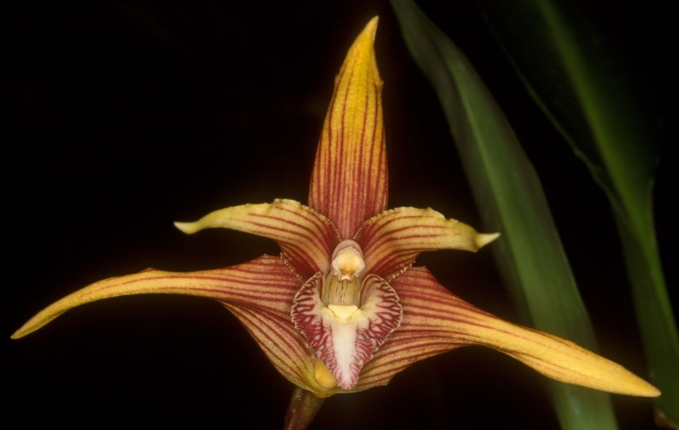
Synonym: n/a
Found in Peru, Ecuador and Colombia in very wet montane forests as a medium sized epiphyte with a solitary leaf occuring at elevations of 700 to 2200 meters on the eastern edge of the Andes that has clustered, egg-shaped to oblong compressed pseudobulbs on short papery sheath covered rhizomes. Single flowered inflorescence arising on a mature pseudobulb that holds its large, showy flower above the leathery leaves and occurs in the late summer and fall. Flower are large, up to 5 inches with petals and sepals ranging from yellow to reddish brown with numerous dark red/brown longitudinal stripes extending beyond halfway but do not touch the tip of the petals/sepals. The lip is white with reddish purple veining on the lateral lobes. Plants are grown in moderately bright diffused light in the intermediate to cool temperature range and very high humidity and moisture year round and should not be dried out completely due to heavy rainfall year round in their natural habitat. Medium should be well drained, open, and plant should only be repotted when grown out of container or when medium starts to breakdown.
Varieties: v. xanthina
Awards: 1 FCC (‘Esperanza Mejia’ with 90 pts in 2001), 6 AMs, 1 HCC, 2 cultural awards and 1 other from AOS. An additional 5 awards are given internationally.
Hybrids: This is one of the most hybridized species in the underutilized genus along with M. sanderiana. There are 7 hybrids listed on Orchidwiz and all of them are first generation, almost all are dated within 15 years back.

Reference:
OrchidWiz Encyclopedia version 3.3
Jay Pfahl’s Internet Orchid Species Photo Encyclopedia:
http://www.orchidspecies.com/maxstriata.htm accessed 6/5/2017
SPECIES DATA SHEET
Maxillaria sanderiana Rchb. f. ex Sander 1888
Synonym: n/a
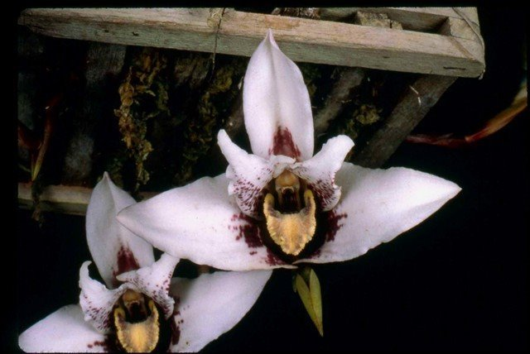
This medium sized, robust, epiphyte, lithophyte or terrestrial is from Ecuador and Peru on steep slopes with decomposing leaf litter or on trees in extremely wet cloud forests at altitudes around 1200 to 2500 meters with abundant fine roots that form a "bird's nest" and ovoid, subglobose or oblong-ellipsoid pseudobulbs with the base concealed by several pairs of sheaths and carrying a single apical, oblong-elliptical leaf that is sharply pointed. The fragrant long-lasting flower is held lateral from the psuedobulbs base by a basal inflorescence with imbricating bracts that conceal the peduncle that extend out and curve upward in the summer and fall. Flower is pinkish white with dark red/maroon blotches and spots at the base of the petals and sepals. Lip is dark purplish red underneath a creamy white to yellow over the entire lip with a more pronounced yellow border. Plants are grown in moderately bright diffused light in the intermediate to cool temperature range and very high humidity and moisture year round and should not be dried out completely due to heavy rainfall year round in their natural habitat. Medium should be well drained, open, and plant should only be repotted when grown out of container or when medium starts to breakdown.
Varieties: v. atropurpurea, v. xanthine, v. xanthoglossa
Awards: 3 AMs, 2 HCCs, 5 cultural awards and 1 other granted by the AOS, 8 other awards are given internationally.
Hybrids: This is one of the most hybridized species in the underutilized genus along with M. striata. There are 8 hybrids listed on Orchidwiz. One hybrid has received an Award of Distinction in 1996, Maxillaria Big Red, introducing new breeding line for large flowered red Maxillarias.
Reference:
OrchidWiz Encyclopedia version 3.3
Jay Pfahl’s Internet Orchid Species Photo Encyclopedia:
http://www.orchidspecies.com/maxsanderiana.htm accessed 6/5/2017

