The Genus Pescatoria
Rchb.f. 1852
Type species: Pescatoria cerina
These are bulbless epiphytes with fan shape leaves and fleshy, showy/colorful flowers including shades of blue, and violet. Basal inflorescences bear solitary flower close to the base of the plants. This genus is ranging from Costa Rica to Ecuador and Colombia at elevations of 500 to 1200 meters in extremely wet cloud forests at the base of trees as epiphytes with their roots in abundant moss in deep shade. This genus is best grown cool and wet with moderate shade and even conditions year round. The genus is characterized by having no pseudobulbs, but the leaves are arranged in a fan shape and is indistinguishable from plants in Bollea a close relative. The differences are that the callus is more slender, and arched and they have a pair of basal lobes laterally embracing the long, slender, terete column. The genus is subdivided by two groups, one has a downy apex of the lip such as Pescatoria coronaria and the other has a smooth lip such as Pescatoria dayana
Pescatoria received 128 awards. The major awarded species includes P. coelestis (33), P. lehmannii (24), P. cerina (11), P. klabochorum (10). The modified General Scale is best used to judge Pescatoria.
Hybridizing in this group is aiming to impart color and improve flower presentation, Pescatoria is commonly bred with Zygopetallum, Warczewiczella, and less so Kefersteinia. There are 70 hybrids registered with Pescatoria in the background.
The following species and natural hybrids are accepted as of May 2014:
Pescatoria backhousiana Rchb.f. - Ecuador
Pescatoria × bella Rchb.f. - Colombia (P. coelestis × P. klabochorum)
Pescatoria cerina* (Lindl. & Paxton) Rchb.f. - Costa Rica, Panama
Pescatoria cochlearis Rolfe - Ecuador
Pescatoria coelestis* (Rchb.f.) Dressler - Colombia
Pescatoria coronaria* Rchb.f. - Colombia
Pescatoria dayana Rchb.f. - Colombia, Ecuador
Pescatoria dormaniana Rchb.f. - Colombia
Pescatoria ecuadorana (Dodson) Dressler - Ecuador
Pescatoria fimbriata Regel - Colombia
Pescatoria × gairiana Rchb.f. - Ecuador (P. klabochorum × P. lawrenceana)
Pescatoria hemixantha (Rchb.f.) Dressler - Roraima, Guyana, Venezuela, possibly Suriname
Pescatoria hirtzii (Waldv.) Dressler - Colombia, Ecuador, Peru
Pescatoria klabochorum Rchb.f. - Ecuador
Pescatoria lalindei (Rchb.f.) Dressler ex P.A.Harding - Colombia
Pescatoria lamellosa Rchb.f. - Colombia
Pescatoria lawrenceana (Rchb.f.) Dressler - Colombia, Ecuador
Pescatoria lehmannii* Rchb.f. - Ecuador
Pescatoria × pallens (Rchb.f.) P.A.Harding - Colombia
Pescatoria pulvinaris (Rchb.f.) Dressler - Colombia
Pescatoria russeliana Rchb.f. - Colombia
Pescatoria schroederiana (Sander) Rolfe - Colombia
Pescatoria triumphans Rchb.f. & Warsz. - Colombia
Pescatoria violacea* (Lindl.) Dressler - Venezuela, Guyana, Suriname, French Guiana, northern Brazil
Pescatoria wallisii* Linden & Rchb.f. - Ecuador
Pescatoria whitei (Rolfe) Dressler - Colombia

SPECIES DATA SHEET
Pescatoria coelestis (Rchb. f.) Dressler 2005
Synonym: Bollea coelestis Rchb.f 1876; Zygopetalum coeleste [Rchb.f] Rchb.f 1877
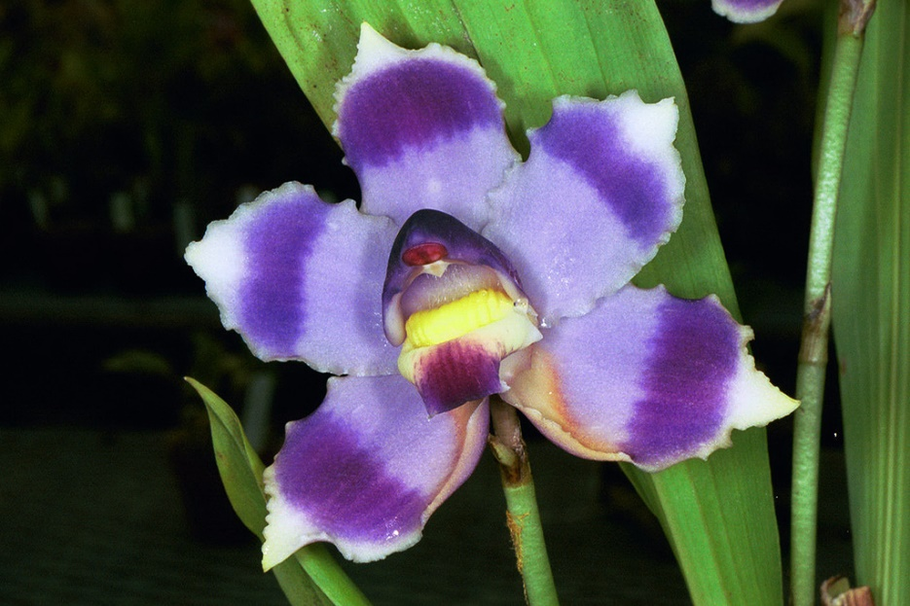
This epiphytic species is found I Columbia cloud forest at the elevation of 900 - 1900 meters with growths to about 12 inches tall without pseudobulbs. Acuminate leaves arranged in fan shape plants. Inflorescence is shorter than leaves, stout and somewhat nodding bearing one solitary flower sometimes simultaneously on multiple scapes in spring and summer. Flower is strongly fragrant, fleshy, and long-lived with color ranging from sky-blue to deep blue/violet. Petals and sepals are wide spreading and curved forward at the tip. Plants are found in extremely wet forests with a heavy night fog that requires humid, bright shade, well watered with good air circulation conditions in cultivation. Plants should never be allowed to dry out. Grow in decay resistant medium because plant is notoriously difficult to recover when the roots are disturbed. The semi-dry period are in summer and again in late winter when water maybe reduced somewhat.
Varieties: v. albescens, v. rosea, v. tipo
Awards: The spectacular species received 33 awards (highest amount within the genus itself), 20 of which is from AOS. Amongst those are 5 FCCs (most recent is the clone ‘San Isidro’ that received 94 pts in 2015, the highest of the species to date), 7AMs, 1 HCC, 5 cultural awards, and 2 others.
Hybrids: a total of 12 hybrids with P. coelestis in the background. Hybridizing effort is to intensify the blue/violet color and improve flower presentation. The showy P. coelestis is underutilized in hybridization partially due to its rarity and its specific cultural requirement
Reference:
OrchidWiz Encyclopedia version 3.3
Jay Pfahl’s Internet Orchid Species Photo Encyclopedia:
http://www.orchidspecies.com/bolcoelestis.htm accessed 6/5/2017

SPECIES DATA SHEET
Pescatoria lehmannii Rchb. f. 1879
Synonym: Bollea lehmanni Rchb.f 1879; Zygopetalum lehmannii Rchb.f 1879; Pescatorea fimbriata Regel 1879
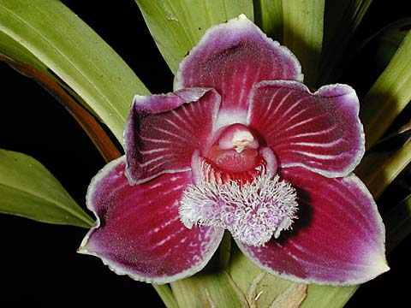
A medium sized species found in Ecuador and Colombia at elevations of 500 to 1350 meters in extremely wet, humid cloud forests near water on moss covered, horizontally growing tree limbs. Plants bloom in the spring through the fall, often more than once a year on a short, axillary, single flowered inflorescence with a very fragrant, waxy, long-lasting flower that is set low within the long narrow leaves. Flower is white with thick lines of plum/purple extending to almost the entire length of the petals/sepals to almost hide the white base color. Lip is white to deep mauve with long hairs. Overall shape is slightly cupped. Grow plants in cool, bright diffused light with constant moisture and air movement. Humidity is kept at 85-90% with no rest period. Limit repotting to only when necessary.
Varieties: v. coerulea
Awards: The species received 6 AMs, 3 HCCs, 2 cultural awards, and 1 other by the AOS in addition to 12 other awards granted internationally.
Hybrids: There are high potentials when hybridizing with P. lehmannii due to its strong and saturated color and contrasting stripes, and its round segments of petals and sepals. There are a total of 15 hybrids with P. lehmannii in the back ground and 11 awards has been given to 5 of its first generation hybrids
Reference:
OrchidWiz Encyclopedia version 3.3
Jay Pfahl’s Internet Orchid Species Photo Encyclopedia:
http://www.orchidspecies.com/pesclehmani.htm accessed 6/5/2017

