The Genus Promenaea
Lindley 1843
Type species: Promenea lentiginosa
This genus is named after the ancient Greek priestess Promeneia. There are 14-18 species in this genus depending on the sources. They are found as smaller epiphytes in moist forests from central and southern Brazil. They are small plants and have slightly 4 angled pseudobulbs with rather soft grey-green leaves, 2 emerging from either side of the base and 2 from the apex. The pseudobulbs give rise to a basal inflorescence that are the length of the leaves or shorter. Flower size is proportionately large for the size of the plant. Flower color range from cream to yellow to chartreuse with various spots and bars depending on the species. Most species and hybrids flower during the summer months.
Promenaeas are easy to grow in bright shade, warm to intermediate conditions with plenty of water, high humidity and good air movement in the growing season similar to their natural habitat.
Interest in this genus has increased over recent years and this is reflected in the number of hybrids that have been registered during this time. The following list reveals that a relatively small number of species have been used in the background of these hybrids. This probably reflects limited availability rather than an absence of horticultural merit. The most prominent species in this genus are P. xanthina with its strong golden colored flower and P. stapelioides with spots and bars and very dark purple lip.
There are 79 Intergeneric hybrids with Promenaea in the back ground, most with Zygopetalum and Pabstia. Within Promenaea, there are around 50 hybrid registered. There are 157 awards given for the genus, many of which are cultural awards given the floriferous nature of the genus. General Scale or Dendrobium scale should be utilized for judging this genus.
These commonly used species along with those yet to be used in breeding and their potential contribution to a breeding program are outlined in the following table. (http://www.ssos.org.au/Promenaeas.htm )
Promenaea Species | Desirable Potential Attribute
xanthina | Strong yellow colour  Ease of culture  Floriferous, can have more than one flower per raceme
stapelioides | Almost black labellum  Large flower  Bold purple markings on a green background  'Full' round flowers
rollisonii | Fine spotting on petals  Last to flower - extend the flowering season well into the new year  Ease of culture
ovatiloba | Clear pale yellow  Large, but open, flowers  Prominent labellum
guttata | Brown barring on a yellow background  Prominent gold labellum  Floriferous , can have more than one flower per raceme
paulensis | Erect raceme  Strong yellow colour  Broad petals  First to flower - could extend the flowering season into spring

The 15 species is divided into 3 section by Pabst & Dungs
- The rollinsonii section includes: P. rollinsonii*, P. lentiginosa, P. riograndensis

- The xanthina section includes: P. xanthina*, P. acuminata, P. albescens, P. catherinensis, P. dusenii, P. fuerstenbergiana, P. guttata*, P. malmquistiana, P. microptera, P. ovatiloba*, P. paranensis,

- The stepelioides section includes: P. stapelioides*

SPECIES DATA SHEET
Promenaea xanthina Lindley 1843
Synonym: Eulophia crinita (P.N.Don) G.Don 1850; Eulophia stenochila Steud. 1840; Maxillaria citrina Don 1845; Maxillaria guttata hort 1852; Maxillaria lawrencei Kraenzl. 1895; Maxillaria xanthina Lindley 1839; Promenaea citrina Don 1845; Promenaea xanthina var major Cogn. 1902; Zygopetalum citrinum [D.Don] Nicholson 1887; Zygopetalum xanthinum [Lindley]Rchb.f 1864
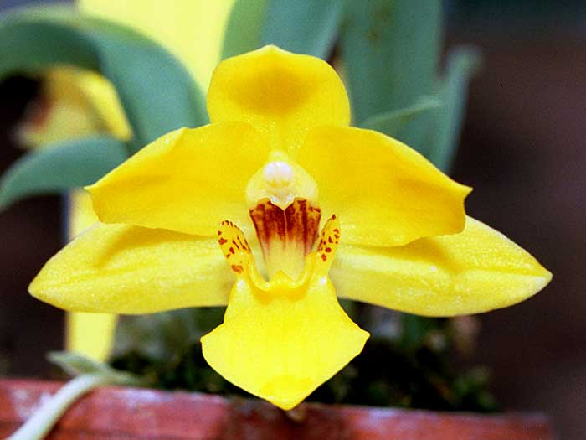
This small size epiphytic species grows in cool mountainous area around 1700 meter in the Southeast coast of Brazil. Pseudobulbs are somewhat compressed, slightly 4-angled cluster along a branching rhizome. 1-2 bright golden-yellow slightly cupped flowers on a short inflorescence is very fragrant, heavily textured and long lasting and usually occurs during spring and summer. Plants prefer fairly shady condition with filtered light, cool temperature and high humidity, on an airy and moist medium. Provides a winter rest with night time temperature in upper 40s, and reduced in watering but should provide high humidity and misting. Repot often as plant resents sour medium.
Varieties: n/a
Awards: P. xanthina has received 17 awards from the AOS along, 7 of which are cultural awards, 1 AM, 4 HCCs, and 5 others. Outside the US there are an additional 5 award granted. Most awarded plants are specimen plants with multiple inflorescences (up to 75!)
Hybrids: up to 109 hybrids that have P. xanthina in the back ground and the hybrid gathered a total of 98 awards with P. Crawshayana (xanthina x stapelioides) being the most awarded (21). Floriferousness, easy of culture, bright golden color are positive attributes that can be passed on to its hybrids
Reference:
OrchidWiz Encyclopedia version 3.3
Jay Pfahl’s Internet Orchid Species Photo Encyclopedia:
http://www.orchidspecies.com/promxanthina.htm accessed 6/5/2017
SPECIES DATA SHEET
Promenaea stapelioides Lindley 1843
Synonym: Cymbidium stapelioides Link & Otto 1828; Maxillaria stapelioides {Link & Otto] Lindl. 1832; Peristeria stapelioides Lindl. 1832; Promenaea stapelioides var heteroptera Rchb.f 1883; Promenaea stapelioides var malmquistiana Schlechter 1921; Promenaea stapelioides var macrantha Hoehne 1952; Zygopetalum stapelioides Rchb. f. 1861; Zygopetalum stapelioides Klotzsch ex Rchb. f. 1863; Zygopetalum stapelioides Nichols. 1901
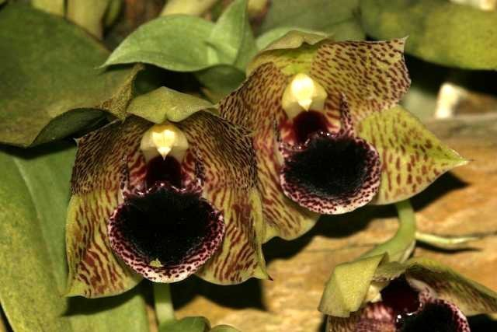
This epiphytic, and occasionally lithophytic species grows in cool moist mountains near the coast in Southern Brazil at 600-1000 meter elevation. Plants are smiliar to P. xanthina and is indistinguisable when not in bloom. Flowers are quite large for the size of the plant, are greenish yellow heavily spotted and barred with marroon/purple. The lip is velvety, dark purple in color and appeared almost black. This is the most interesting aspect of the flower that makes this species very popular. Flowers are waxy, sweetly fragrant, appear from late spring to summer. Grow P. stapelioides in intermediate to cool, moist environment similar to P. xanthina but slightly warmer. Winter rest in the upper 50s.
Varieties: n/a
Awards: Received 15 awards from the AOS including 5 AMs, 2 HCCs, 5 cultural awards, and 3 other awards.
Hybrids: A total of 80 progeny including 21 first generation hybrids. Amongst hybrids with P. stapelioides in the background, 128 awards have been granted. It is utilized for the rounder segment, dark, almost black lip, and interesting markings on the petals/sepals

Reference:
OrchidWiz Encyclopedia version 3.3
Jay Pfahl’s Internet Orchid Species Photo Encyclopedia:
http://www.orchidspecies.com/promenstapelioides.htm accessed 6/5/2017

