TERMINOLOGY
Adnate (adj) fused together with another organ (petals partially fused with column in Gga. fulva)
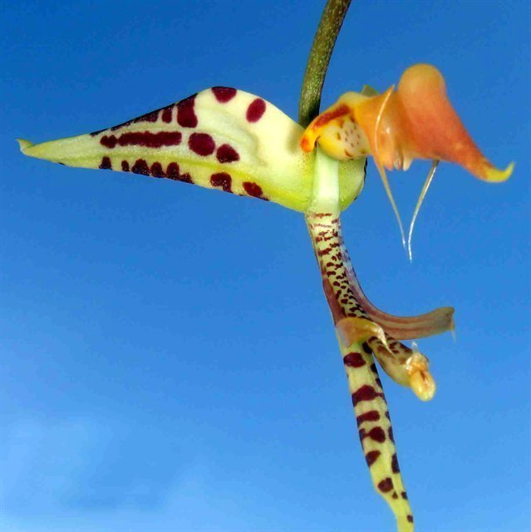
Aliform (adj) Wing-shaped (i.e. Lateral sepals of Coryanthes species)
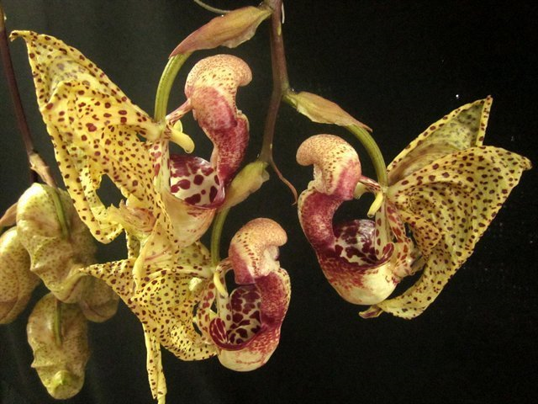
Anguilliform (adj) narrow, shaped like or resemble an eel. (i.e. lip of Gongora species)
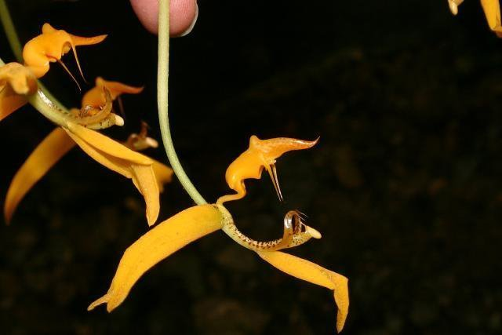
Cephalopodan (adj) squid-like (i.e. lip of Stanhopea tigrina)
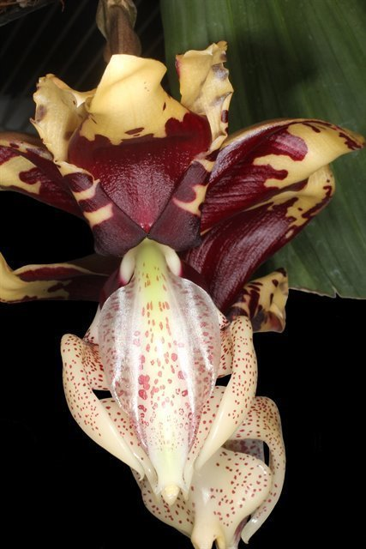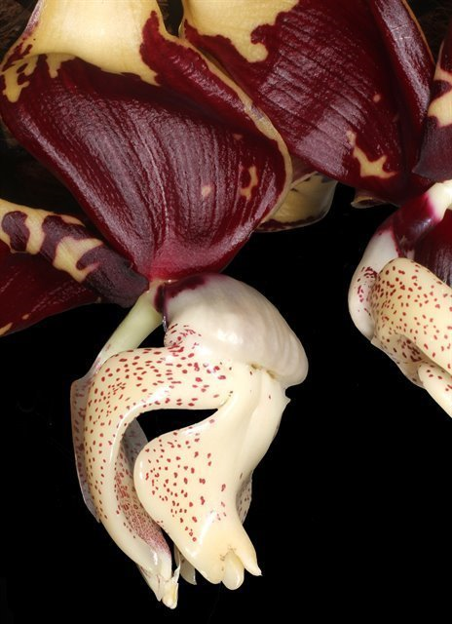
Galeiform (adj) Shaped like a helmet (i.e. hypochile of Coryanthes speciosa)
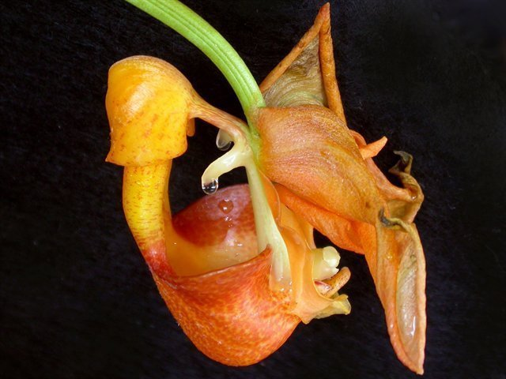
Obovate (adj) ovate with the narrower end at the base

Ocellus (n) eye spot (i.e. dark round spot on the structure of hypochile of Stanhopea)
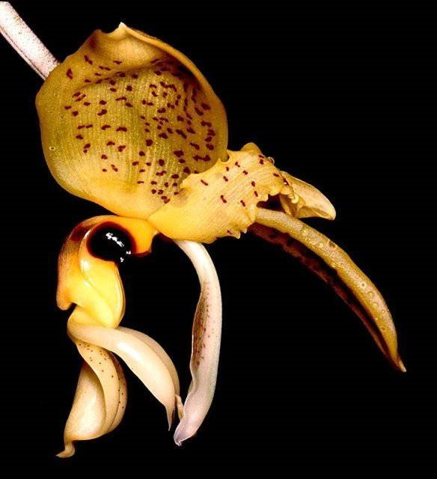
Seta/setae (n) Bristle like structure (i.e. structures protruding out of mesochile in Gongora species)
Vestigial (adj) atrophied. A nonfunctioning structure that is the remnant of an organ or appendage that was once functional in previous generations or earlier stages of development. (petals of Gongora)
- One hundred flowers and 10 buds on five inforescence plus three emerging inflorescence gracefully spilling out in a waterfall fashion on a well grown, immaculate plant in at 10 inch basket. Sepals are dark chocolate brown with barred yellow distally, segment are flat for the species. Vestigial petals are adnate halfway to the column, light chocolate, incurved distally. Column cream peppered with maroon with two horns distally. Lip is complex, anguilliform, spotted dark red with protruding setae bilateral of mesochile. Substance medium; texture velvety, lip is glossy.

- Four very large slightly reflexed flowers and one bud on two completely pendent inflorescences. Petals and sepals are pale yellow finely spotted maroon. Hypochile saccate, densely spotted plum, spots suffused distally into dark plum. Mesochile and epichile cream densely spotted with plum, bilateral horns are falcate, protruding from mesochile. Winged column cream with plum spotting more densly toward the pollinia. Substance is firm, lip is cardboard; texture matte, lip glossy. Flowers are sweetly fragrance reminiscent of delicious vanilla and mint.

- 3 sumptuous flowers and 3 buds on 2 pendent inflorescence. Prominent aliform lateral sepals are strongly reflexed with slightly rolled margin, buttercup yellow background with dark red spots over the entire inner surface. Dorsal sepal and petals with same coloration hidden behind the bucket-shaped lip. Galeiform hypochile is pale yellow finely spotted with dark red, mesochile cream, smooth, suffused with red on the outside and large burgundy spotting on the inside. Epichile is bucket shaped, coarsely spotted burgundy with outer margin solid burgundy. Glandular faucet continually dripping liquid. Substance papery, texture matte.

- Ten flowers on two pendent inflorescence. Petals and sepals light yellow with tangerine centrally peppered with fine burgundy spots. Lip hypochile is golden yellow fading to butter yellow distally. Two dark purple ocelli bilaterally. Winged column is ivory colored with finely and evenly spotted burgundy, substance is firm, texture glossy.

- Three hundred non-resupinate flowers and one hundred buds on forty inflorescences beneath a flawless canopy of pleated medium green foliage on a circular specimen plant about 50cm in diameter. Flowers are arranged pleasingly. Sepals are pumpkin color with finely spotted mahogany, petals are vestigial, attached midway to column. Lip is pale orange, margin is brilliant tangerine orange. Finely spotted with burgundy centrally.

