The Genus Coryanthes
Hooker 1831
Type species: Coryanthes maculata
Coryanthes, commonly known as bucket orchids, is a genus of tropical epiphytic orchids. This genus of about 60 species is abbreviated as Crths in horticultural trade. They are native to South America, Central America, Mexico and Trinidad. In nature, these orchids are encountered in so-called ant gardens. The symbiotic occurrences provides benefits for both; ants get nectar from extrafloral nectaries and can use the root ball for construction of their nests, the Coryanthes plant is protected and fertilized by the ants. The genus could be divided into 2 sections: Section Coryanthes with a smooth mesochile (middle part of the lip) and Section Lamellunguis with warts or lamellae on it. Most species have pendulous inflorescences, some of them have upright ones. Coryanthes has the heaviest flowers in orchidaceae, the biggest one C. bruchmuelleri have a weight of more than 100g.
Bucket orchids are an excellent example of coevolution and mutualism, as the orchids have evolved along with orchid bees (the tribe Euglossini of the family Apidae) and both depend on each other for reproduction. One to three flowers are borne on a pendant stem that comes from the base of the pseudobulbs. The flower secretes a fluid into the flower lip, which is shaped like a bucket. The male orchid bees (not the females) are attracted to the flower by a strong scent from aromatic oils, which they store in specialized spongy pouches inside their swollen hind legs, as they appear to use the scent in their courtship dances in order to attract females. . Trying to collect fragrance compounds below the upper part (hypochile) of the lip, the male Euglossine bee falls in the liquid filled bucket of the apical part (epichile). As they are trying to escape, they find that there are some small knobs on which they can climb on, while the rest of the lip is lined with smooth, downward-pointing hairs, upon which their claws cannot find a grip. The knobs lead to a spout but as the bee is trying to escape, the spout constricts. At that same moment, the small packets containing the pollen of the orchid get pressed against the thorax of the bee. However, the glue on the pollen packets does not set immediately, so the orchid keeps the bee trapped until the glue has set. Once the glue has set, the bee is let free and he can now dry his wings and fly off. His ordeal may have taken as long as forty-five minutes. Hopefully, the bee will go to another flower, where, if the flower is to be successful at reproducing, the bee falls once again into the bucket of the same species. This time the pollen packets get stuck to the stigma as the bee is escaping, and after a while the orchid will produce a seed pod.
Coryanthes has large ribbed pseudobulbs with 2 or 3 thin veined leaves. The inflorescence arises from the base of the pseudobulb and hangs straight down through the medium. For this reason a wire basket or mounting on a slab of tree fern is mandatory to accommodate the bloom spike. One of the most complex flowers of the orchid family is seen in the genus Coryanthes. The flower bud of Coryanthes is quite interesting and has the appearance of the man in the moon. Coryanthes grow in ant nests in lowland humid and wet forests up to 1200m. The genus is found in conjunction with mud ant nests, of the ant genera Camponotus and Azteca, which resemble hornet’s nests around a branch of a large tree. They are also normally found with Epidendrum Imatophylum Lindl and the non-orchidaceous Peperomiaceae and Gesneriaceae to list a few.
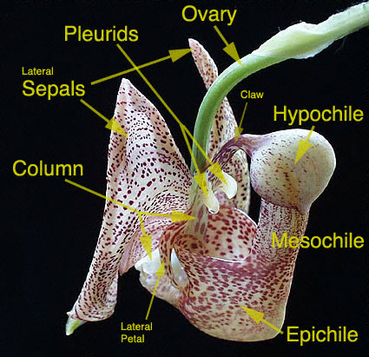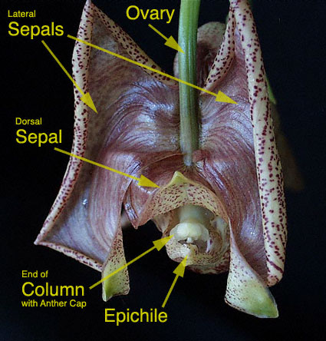
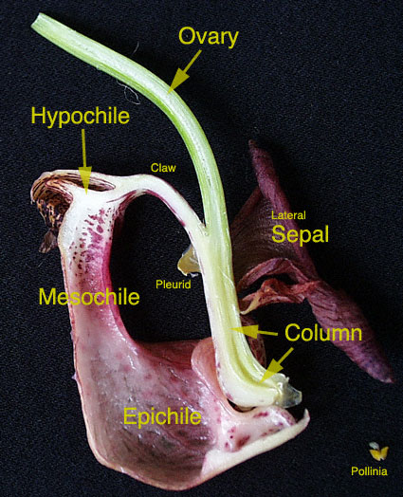

Judging is done using general judging scale. The unique shape of characteristic of the flower and the inflorescent is incomparable to other orchid genera.
As with Stanhopea and Gongora species, hanging baskets accommodates the pendent flower spike that emerges from the base of the plant. A very acid, water-retaining medium is recommended. In his 1978Orchid Digest article, George Kennedy reported that Dr. Fowlie found that Coryanthes plants grew extremely well when potted in Palco wool (shredded redwood bark) and kept exceedingly wet. The ants' nests on which the plants grow in nature contains a large amount of formic acid and have a pH of about 3. Redwood bark, also with a pH of about 3, is the only commonly available potting medium with a pH low enough to meet this requirement.
Like a few other species, most Coryanthes and some Gongora seedlings have a growth habit that is quite different from the older plants. This makes them somewhat perplexing and a bit challenging to grow if you don't know what to expect. Rather than a vertically-oriented growth habit with pseudobulbs forming side-by-side on a short rhizome, the seedlings begin with a very long, spindly, vine-like horizontal growth. They make rhizome for quite a while, putting out roots along it, then eventually get serious about producing leaves. The pseudobulbs develop after that, and finally the seedlings no longer looks at all vine-like. A theory about this is that perhaps they are adapted to having ants carry the seeds deep into their nests, and the plant need to be "long" for a while until it can reach the exterior surface of the nest, while rooting into the compost of the nest along the way.
Significant species | Offsprings/Progeny | Awards | Bloom time | Location | Temp
Crths. macrantha | 8/9 | 8 AMs, 3 HCCs, 1 CBM | Late Su | Venezuela, Trinidad, British Guiana, Colombia, Peru, ~600m elevation | W-H
Crths. mastersiana | 3/5 | 2 CCM, 1 CBR | Late W – Early Su | Colombia and Ecuador 0-700m. In mangrove swamps, bank of small stream | W-H
Crths. bruchmuelleri | 3/4 | 1 FCC, 2 AMs, 1 CHM, 1 CBR | Su | Venezuela, Brazil, Peru, Colombia. 900-1000m elevation | W-C
Crths. speciosa | 3/3 | 2 HCCs, 1 JC | Su | Mexico, Venezuela, Peru, Brazil, Colombia, Trinidad. Low-lying regions | H
Crths. senghasiana | 0 | 1 AM, 1 CHM | ? | Colombia, Southern Venezuela, Peru. ~200m elevation | H

SPECIES DATA SHEET
Coryanthes macrantha Hooker 1831
Synonym: *Gongora macrantha Hooker 1831; Panstrepis paradoxa Raf. 1836

The Bucket Orchid or Monkey Throat Orchid is a large sized, hot growing epiphyte found from Trinidad, French Guiana, Surinam, Guyana, Venezuela, Colombia, Peru and Brazil in wet lowland rain forests, that has narrowly ovoid, sulcate, bifoliate pseudobulbs with lanceolate, plicate, ribbed leaves with a channeled petiole which blooms on a basal, pendant, 12" [30 cm] long, bracteate, 1 to 2 flowered, racemose inflorescence arising on a mature pseudobulb that carries a large, waxy, short lived, fragrant flower smelling strongly of mint held well below the plant and occurring in summer.
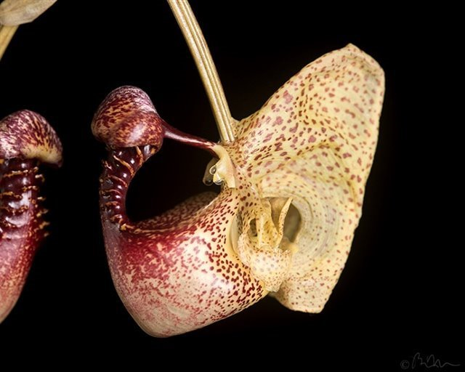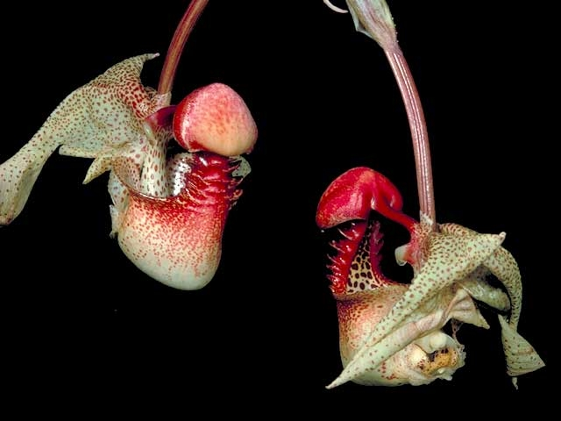

Varieties: N/A
Awards: 8 AMs, 3 HCCs from the span of 1992 – 2016 and 1 CBM in 1975
Hybrids: 8 first generation hybrids and 1 second generation. Most well-known is the Intergeneric hybrid Coryhopea Off the Wall (Stanhopea wardii x Coryanthes macrantha) which has received 1 AM, 1 HCC and an AD/AOS in 2002 for representing a new direction in breeding that improves in form and size over both parents

Reference:
OrchidWiz Encyclopedia version 4.0
Orchid Plus Online
American Orchid Society - Coryanthes
http://www.aos.org/orchids/orchids-a-to-z/letter-c/coryanthes.aspx - accessed 11/6/2017
Wikipedia Encyclopedia
https://en.wikipedia.org/wiki/Coryanthes - accessed 11/6/2017
Jay Pfahl’s Internet Orchid Species Photo Encyclopedia:
http://www.orchidspecies.com/coryanthesmacrantha.htm - accessed 11/6/2017
The genus Coryanthes: Munich Botanical Garden
http://www.botmuc.de/en/about/guenter_gerlach/genus_coryanthes.html - accessed 11/6/2017
Pollination of Orchids in the Genus Coryanthes: Troy Meyers
https://lab.troymeyers.com/flasking/article.php?about=Coryanthes-Pollination – accessed 11/6/2017
Early Growth Habit of Coryanthes Seedlings: Troy Meyers
https://lab.troymeyers.com/flasking/article.php?about=Coryanthes-Seedlings –accessed 11/6/2017

