The Genus Gongora
Ruiz and Pavon 1794
Type species: Gongora quinquenervis
Gongora is an epiphytic genus of sympodial orchids that are usually found between 0 and 1000m in wet tropical forests. The 76 species of this genus are spread from Mexico to Bolivia and Brazil. Pseudobulbs are ovoid, strongly ridged, with two-three plicate leaves. The pendulous inflorescences arise from the base of the pseudobulbs, are more than a meter long in some species, and bear many intricately-shaped, flowers that are often scented. In general, Gongoras are easy to grow into large and showy plants. This genus was named for Sr. Don Antonio Caballero y Gongora, Viceroy of New Granada (Colombia and Ecuador) and later Bishop of Cordoba; Governor of Peru during the Dombey, Ruiz & Pavon expeditions. The type species is Gongora quinquenervis, described by H. Ruiz & J. Pavon in 1794 in their Prodromus Florae Peruvianae et Chilensis.
Gongora was one of the first orchids described by a western man. Several new Gongora orchids have been discovered in the last ten years, while many others have been assigned under another specific name. Yet there is still some confusion. Many species lack the right description. Some species, such as Gongora portentosa and Gongora superflua, are very rare. DNA fingerprinting will in time contribute to an exact taxonomy of this genus.
The conical pseudobulbs are ridged and are about 8 cm long. In some species, such as Gongora similis, the pseudobulb can produce up to six inflorescences in succession. Two alternate leaves originate from the end of each pseudobulb. The leaves are rather leathery and heavily veined, growing to a length of about 30 cm. The racemose inflorescence grows from the base of the pseudobulbs. The stem first grows upright, but bends early in development and becomes pendulous. The numerous flowers hang upside down, with the lip upwards. The almost circularly bent pedicels are characteristic of this genus. There are two lateral sepals and one dorsal sepal. The blooms of several species are waxy. The flowers of many species have distinctive fragrances. Some smell like unburned candle wax, others like nutmeg, cardamom, or cinnamon.
Gongora is a genus of tropical American orchids pollinated by fragrance-collecting Euglossine bees. Gongora flowers are pedant on long inflorescences. In most (but not all) Gongora species, the pedicels are turned so that the flowers face the central axis of the inflorescence. The lip, the Gongora's largest petal, is positioned above the column. The other two petals are attached to the sides of the column like small wings, forming a chute. When the bee lands on top of the lip, he begins searching for fragrance. He then crawls to the source of the fragrance on the underside where he scratches to collect the liquid fragrance. In order to transfer the fragrance to his hind legs, the bee releases his hold on the lip. He then slides down the column back end first, and through the chute formed by petals and column. At the end of the column, the bee first passes the concave stigmatic surface and then the anther cap. On his first trip to the Gongora flower, the bee picks up the pollinarium. At a subsequent flower the pollinia are deposited on the sticky stigmatic surface, thus achieving pollination. Orchid flowers employing this kind of mechanism to achieve pollination are called 'fall-through' flowers.
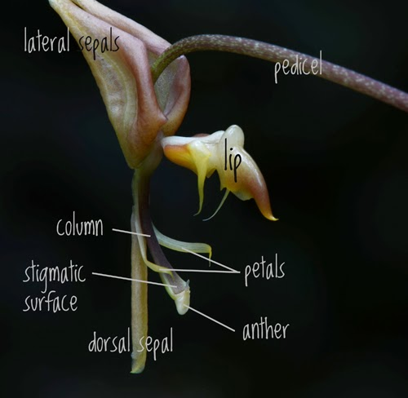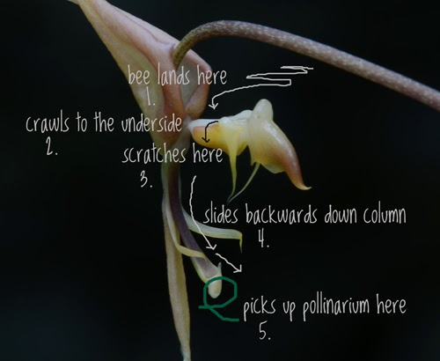
They are part of the Stanhopea subtribe and grow from sea level up to 1000 meters in elevation. Gongora is related to Stanhopeas and Coryanthes mainly through the general shape of their flowers. Gongoras have in common with some other orchids; such as Dendrobium speciosum and Catasetums, the habit of producing masses of vertical roots which may reach a height of 10 to 15cm.above the crown of the plant. In the growing season these roots are tipped with a green point. As some observers have remarked, at times these tips glisten with drops of condensation or dew. When these plants approach dormancy the tips seal off and turn white; a sure indicator that the plant requires less moisture until they again become green in the growing season. It is quite obvious if the plants are grown as epiphytes that they develop this system and it becomes a food trap. In the dormant season, they also turn white and seem inactive returning to a green tip again in the growing period. Gongoras should be grown in the same way and in similar temperatures as Stanhopeas and Coryanthes. Gongoras, however, may be pot grown, as their spikes, even though pendulous, do not force their way downward into the potting material. They travel horizontally until they reach the edge of thepot or container then hang. They also do not like to dry out so water and fertilize regularly and grow under intermediate to warm conditions. All of these orchids are hungry feeders and should be fed with nutrient liquids in a weak form. Mostly the flowers appear on new growth and it is unlikely that they will come from the older parts of the plant. The usual pests, such as scale, aphids and red spider will attack the young growths and they shouldbe kept under control by your usual methods. From time to time the leaves should be turned andexamined underneath to see that pests do not get a foothold. Generally the flowering season is spring to autumn. When in bud, provide a brief rest by withholding water and relocating to a cooler, shadier spot.
According to Rod Rice in Infragen. Rev. Gen. Gongora (2002, 2003) the genus Gongora can be classified into subgenera and sections as follows:

- Subgenus Gongora
  - Section Aceras with four species
  - Section Gongora with about 30-33 species [G. atropurpurea, G. catilligera, G. latisepala, G. odoratissima, G. rufescens]
  - Section Gratulabunda with four species
  - Section Grossa with five species
  - Section Truncata with nine species [G. charontis, G. dressleri, G. longipes, G. tracyana]
- Subgenus Portentosa
  - one section with at least five species [G. escobariana, G. garayana, G. portentosa, G. sanderiana]
- Subgenus Acropera
  - Section Acropera with one species
  - Section Armeniaca with two species and one to two subspecies
  - Section Cassidea with four species [G. amparoana, G. cassidea, G. galeata, G. tridentata]
Judging is done using general judging scale. The unique shape of characteristic of the flower and the inflorescent is incomparable to other orchid genera.
Significant species | Offsprings/Progeny | Awards | Bloom time | Location | Temp
Gga. galeata | 9/10 | 1 CCE, 3 CCMs, 1 CHM 1 CBM | Su-F | Southern Mexico in mountain rainforests and cloudforests 600 – 1800 m elevation | C-W
Gga. fulva | 5/6 | 4 AMs, 2 HCCs, 1 CCE, 2 CCM | Sp-F | Panama (up to 650 m elevation) to Colombia (yp to 1200 m elevation). No direct sun | H
Gga. scaphephorus | 1/1 | 2 AMs, 2 HCCs, 1 CCE, 3 CCMs | F | Ecuador, Colombia, Peru in wet montane forests, 550-1200 m elevation | W-C
Gga. quinquenervis | 5/6 | 1 AM, 2 CCMs, 1 CBM | Late Sp - F | Peru, Ecuador, Colombia, Venezuela, Guyana, Trinidad 1200 – 1800 m elevation | H-C
Gga. truncata | 7/7 | 1 CCM, 1 CBM | Late Sp- Early Su | Southern Mexico, Belize, Guatemala up to 850 m elevation in moist, moderately dense wood | H-W
Gga. maculata | 2/2 | 1 AM, 2 CCMs, 1 CBM, 1 CHM, 1 JC | F-Sp | Trinidad, Guyana, Peru | H-W
Gga. pleiochroma | 2/2 | 1 HCC, 3 CHM, 1 CBR | W-Sp | Panama, Venezuela, Guyana, Peru, Brazil, Ecuador in tropical and montane wet forests 400-1800 m elevation | H-C
Gga. chocoensis | 7/8 | 1 HCC, 1 CHM | ? | Western Colombia in mangrove swamps near sea level | H-C
Gga. horichiana | 5/5 | 3 CHM, 1 CBR | Sp-F | Costa Rica, Panama 800-1000ml, small sized | W

SPECIES DATA SHEET
Gongora galeata [Lindley] Rchb.f. 1854
Synonym: Acropera atropurpurea hort ex Heynh. 1841; Acropera citrina Rchb.f. 1854; Acropera flavida Klotzsch 1851; Acropera fuscata Heynh. 1846; Acropera loddigesii Lindley 1833; Acropera luteola Heynh. 1846; Acropera luteola Drapiez 1840; Acropera pallida Heynh. 1846; Acropera purpurea Heynh. 1846; Acropera sulphurea Heynh. 1846; Gongora fuscata (Heynh.) Gentil 1907; *Maxillaria galeata Lindley 1842

This is a medium sized, Mexican epiphytic, rarely lithophytic or terrestrial species found in mountain rain and cloud forests with liquambar at altitudes of 600 to 1800 meters that grows warm to cool growing epiphyte with ovoid-pyriform, longitudinally sulcate (parallelly grooved) pseudobulbs with 2 apical, plicate, petiolate, elliptic, acuminate, leaves that blooms in the summer and fall with basal, 6 to 8" [15 to 20 cm] long, pendant, many flowered, racemose inflorescence arising on mature pseudobulbs and having a short to long-lived, fragrant flower with a fragrance akin to oranges. It is an evergreen species and requires a semi dry rest in the winter and is suited for wire basket culture with sphagnum and woodchips.
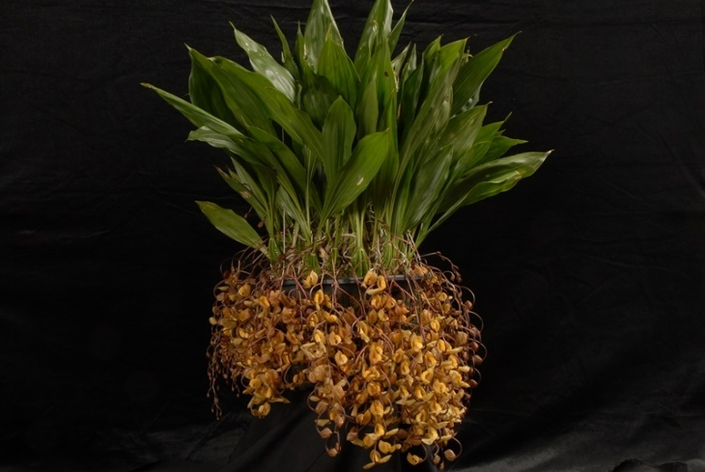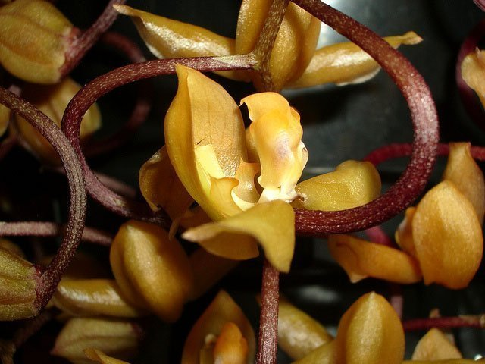

Varieties: var. alba, var. luteola, var. flava
Awards: most awards are cultural with the highest of 91 points. (Gga. galeata ‘Brooklyn Botanic Garden’ CCE/AOS in 2001 with 580 flowers/58 buds on 97 inflorescence). However, the CBM was awarded in 1977 with 924 flowers on 66 inflorescence
Hybrids: 9 first generation hybrids and 1 second generation. Only one award (AM/AOS of 81 points) given in 2012 for Gga. Clown (galeata x fulva) (2011)

SPECIES DATA SHEET
Gongora fulva Lindl. 1839
Synonym: Gga. tricolor
A warm to intermediate growing compact species native to lowland Columbia and Panama. Long sprays of 15-20 flowers emerge anywhere between spring and fall bearing 2 to 2.5 inch flowers colored in yellow, white and mahogany spots. Easy to grow and flower. Likes New Zealand sphagnum moss as a potting media. It is best to keep them in plastic pots when small and then transfer them to baskets.
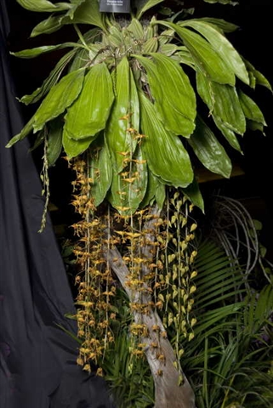 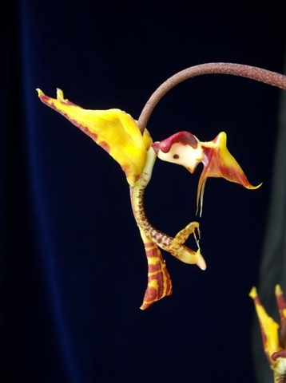i
Varieties: N/A
Awards: 4 AMs, 2 HCCs, 1 CCE, 2 CCM ranging from 1998 to 2014. Prior to that it was known as Gga. tricolor. Award quality given to those with highly contrasting brown/mahogany on gold background.
Hybrids: 5 first generation hybrids and 1 second generation. All of the first generation hybrids are awarded with AMs: Gongora Parakeet (x horichiana) has 3 AMs; Gongora Golden Condor (x scaphephorus) with 1 AM, 1CCM, 1 HCC, Gongora Colibre (x chocoensis) with 1 AM, 1 CCM; Gongora Clown (x galeata) with 1 AM; Gongora Mem Maria Teresa Fighetti (x flaveola) with 1 AM. Breeding goal is to improve flower segments while maintaining Gge. fulva’s color.

Reference:
OrchidWiz Encyclopedia version 4.0
Orchid Plus Online
American Orchid Society - Gongora
http://www.aos.org/orchids/orchids-a-to-z/letter-g/gongora.aspx - accessed 11/6/2017
http://www.aos.org/orchids/collectors-items/gongora.aspx - accessed 11/6/2017
Wikipedia Encyclopedia
https://en.wikipedia.org/wiki/Gongora - accessed 11/6/2017
Jay Pfahl’s Internet Orchid Species Photo Encyclopedia:
http://www.orchidspecies.com/gonfulva.htm - accessed 11/6/2017
http://www.orchidspecies.com/gongoragaleata.htm -accessed 11/6/2017
Gongora Orchids – Bribie Island Orchid Society
http://www.bribieislandorchidsociety.com/wp-content/uploads/file/orchidgrowing/Gongora%20Orchids.pdf – accessed 11/6/2017

