The Genus Stanhopea
Frost ex Hooker 1829
Type species: Stanhopea insignis
Stanhopea is a genus of epiphytic, sympodial orchids with pendant inflorescences. It was first described by Sir William Hooker in 1829, through publication of Stanhopea insignis in the Botanical Magazine. The genus is named for the Rt. Hon. Philip Henry Stanhope, Earl of Stanhope, President of the Medico-Botanical Society of London 1829-1837.
Stanhopeas are found growing from sea level to about 4000m elevation. They have plicate, dark-medium green leaves with distinct, grooved petioles. The The ovoid, dark green pseudobulbs range in size from small walnuts to large pears. The plants are medium-sized and can grow into very large clumps. The necessity of growing in baskets makes them best suited for outdoor cultivation or the greenhouse collection, rather than windowsill or under artificial lights.
Inflorescence arises from the base of the pseudobulb and grows directly downward and for this reason they must be cultivated in a wire basketThe genus is characterized by the ovoid, dark green pseudobulbs carrying a single apical, plicate, petiolate base leaf that blooms on a basal, pendant, 2 to many flowered inflorescence with free sepals and petals with the lateral sepals connate at the base, a lip usually with a hypochile, a horned mesochile and an epichile with a winged column carrying 4, hard pollina attached to an elongate stipe and united to form a cordiform viscidium. Most species produce a pendant raceme of medium to large spiral flowers, often pleasantly to voluptuously fragrant, and pollinated exclusively in nature by male Euglossine bees. The lip structure is very complicated, divided into three parts called the hypochile, mesochile, and epichile. Most Stanhopea flowers flash prominent, elegant horns on the epichile. The exception are the species; S. annulata, S. avicula, S. cirrhata, S. ecornuta and S. pulla. A second group have short or truncated horns, they include the species; S. candida, S. grandiflora, S. reichenbachiana, S. tricornis and the natural hybrid S. x herrenhusana. The structure of the labellum of this group is in general, not as complex as other members of the genus.
With most Stanhopea flowers lasting three days or less, the flowers must attract pollinators very quickly. These chemical attractants are generated in the hypochile, attracting the male euglossine bees to the flower. Their large waxy flowers offer no food or reward for bees other than powerful fragrances containing compounds like 1, 8-cineole, methyl salicylate, benzylaldehyde and methyl benzoate. Each Stanhopea species has a fairly unique fragrance mixture. Individual plants of a particular species are often widely scattered in the forest. Euglossine bees are large tropical bumblebee relatives, often iridescent blue, green or bronze. They are fast fliers, capable of covering long distances in search of a particular fragrance. They feed on nectar from a variety of tubular flowers. The males also gather scent by scratching flowers and mopping up the liquid fragrance with the feathery brushes on their front tarsi. They transfer the liquid to their hind legs and carry it in their inflated hind tibiae. The fragrance is believed to play some role in mating.
Stanhopeas like S. jenischinana have ‘fall-through flowers.’ Their flowers point downward. The bee flies directly to the source of the scent at the center of the flower, entering through the side and alighting on the base of the lip (the hypochile). The bee falls either when he loses his grip on the slippery surface of the lip, or when he attempts to launch into the air. He then falls backwards with his back tracing the length of the column. The horns on either side of the flower’s lip channel him past the tip of the column, where the pollinarium with its adhesive disk is deposited on his back. At a subsequent flower the pollina are pressed against the sticky stigmatic surface as the bee falls through the flower.
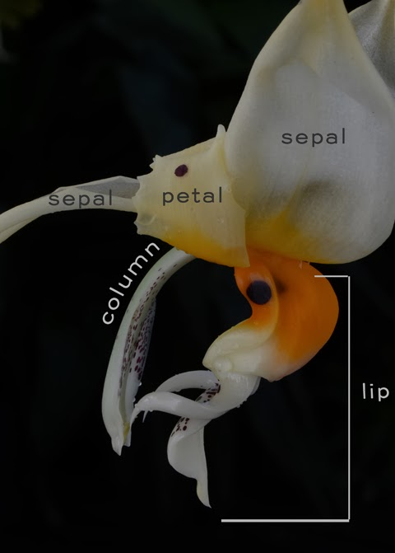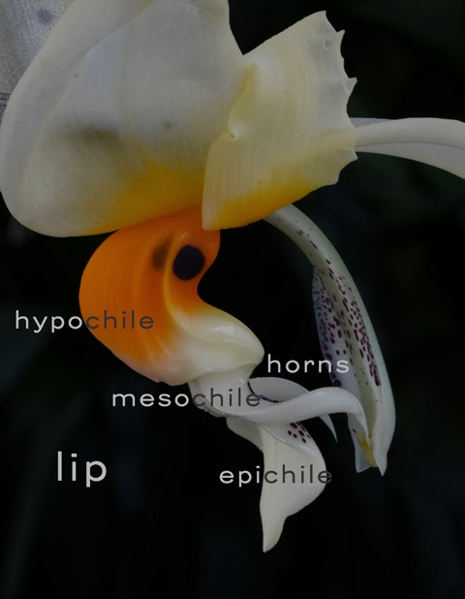

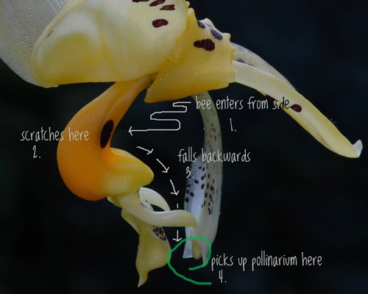

Significant species | Offsprings/Progeny | Awards | Bloom time | Location | Temp
Stan. tigrina | 42/60 | 5 FCCs, 22 AMs, 7 HCCs, 1 CCE, 4 CCMs, 1 CHM | Sp, F | Mexico, on oak trees in the well-watered thick forests up to 2000m elevation | W-C
Stan. wardii | 12/18 | 9 AMs, 4 HCCs, 9 CCMs, 1 JC | Su, F | Southern Central America to Northern South America 550 -2700m elevation in humid cloud forests | W-C
Stan. oculata | 13/15 | 7 AMs, 5 HCCs, 1 CCM, 2 JCs | Su | Mexico, Guatemala, Belize, El Salvador, Honduras, Nicaragua, Colombia, Venezuela 1000-3000m in altitude | W-Cold
Stan. ruckeri | 14/14 | 6 AMs, 2 HCCs, 1 CCM, 2 CHMs | F | Mexico and Nicaragua from 450 – 1300m elevation | W-H
Stan. graveolens | 10/10 | 8 AMs, 4 HCCs, 1 CCM, 1 CHM, 1 CBM | Sp-Early Su | Mexico southward to Honduras and El Salvador, Belize up to 2700m elevation | W-C
Stan. insignis | 14/16 | 2 HCCs | Su-Early F | Brazil and Ecuador in dry montane forest up to 500m elevation | W-H
Stan. platyceras | 8/8 | 1 FCC, 7 AMs, 1 CBM | F | Colombia in wet humid condition in 1000-1500m elevation | W-C
Knowing the proper care provided to the species of Stanhopea you are growing often leads to an increase in flower production. Some species such as S. annulata, S. avicula, S. candida, S. cirrhata, S. ecornuta, and S. grandiflora (including several others) require more tropical night temperatures throughout the year and bloom best when winter night temperatures do not drop below 65F (18C). Other Stanhopeas inhabit areas where they receive less water and more sunlight during the winter months. These Stanhopeas that require a rest period include S. hernandezii, S. insignis, S. jenischiana, S. leitzei, S. maculosa, and S. martiana. I usually place these Stanhopeas under a roof overhang or under a plastic roof during the winter so that no rainfall can penetrate the growing medium. I then keep these sparingly moist, but never let them completely dry. I start regular water of these species in mid spring, when growth starts. For these Stanhopea, the dryer conditions and increased light during the winter tend to force them to enter into a rest period that they require in order to flower well in the following spring/summer. Some species of Stanhopea bloom more profusely with a 20-30F (approximately 10-15C) degree shift between day and night temperatures. These shifts in temperature are best achieved by growing the orchids outdoors in the spring and summer.
Intergeneric hybrids include Aciopea (x Acineta), Cirrhopea (x Cirrhaea), Coryhopea (x Coryanthes), Stangora (x Gongora), and Stanhocycnis (x Polycynis). Judging is done using general judging scale. The unique shape of characteristic of the flower and the inflorescent is incomparable to other orchid genera.
Cirrhopea hybrids combined the size of Coryanthes to the better shape of Stanhopea, a few well known hybrids are Crhpa. Cutucu (Crths. speciosa x Stan. florida)(top picture) and Crhpa. Off the Wall (Stan. wardii x Crths. macrantha) (bottom picture)
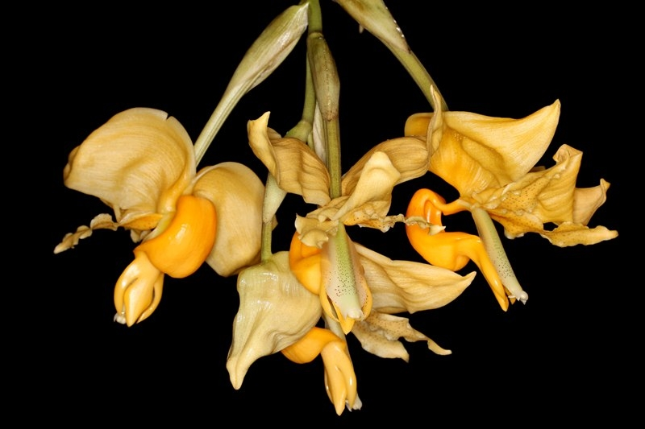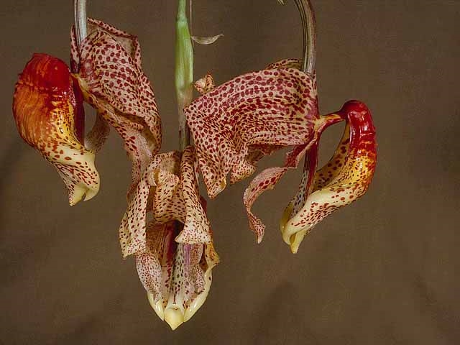

SPECIES DATA SHEET
Stanhopea tigrina Hooker 1831
Synonym: Epidendrum fragrantissimum Sessé & Mocino 1887; Maxillaria lyncea Lindl. 1842; Stanhopea expansa P.N.Don 1845; Stanhopea nigroviolacea Morren ex Beer 1854; Stanhopea tigrina var. atrata hort. ex Loddiges 1844; Stanhopea tigrina var. aurea hort. ex Stein 1892; Stanhopea tigrina var. aureo-purpurea Ch.Morren 1845; Stanhopea tigrina var.grandiflora hort.ex Hennig; Stanhopea tigrina var. grandiflora hort. ex Stein 1892; Stanhopea tigrina var. grandiflora hort. ex De Duren 1884; Stanhopea tigrina var. grandiflora superba hort.ex Cogniaux 1902 ; Stanhopea tigrina var. latimaculata hort. ex Dietrich 1855; Stanhopea tigrina var. luteolo-violacea Ch. Morren 1845; Stanhopea tigrina var. lutescens B.S.Williams 1851; Stanhopea tigrina var.major hort. 1861; Stanhopea tigrina var. major superba hort. ex Josst 1851; Stanhopea tigrina var. nigropurpurea hort 1861; Stanhopea tigrina var. purpurea hort. ex Loddiges 1844; Stanhopea tigrina var. speciosa hort. 1855; Stanhopea tigrina var. splendens Kraenzlin 1907; Stanhopea tigrina var. superba hort. ex Henshall 1845; Stanhopea tigrina var. superba hort ex Planchon 1858; Stanhopea tigrina var. superba van Houtte 1851; Stanhopea violacea Hort. ex Beer 1863

A cool to warm growing, Mexican, medium sized, epiphytic species found at elevations of 600 to 1700 meters with ovoid, slightly compressed, dark green pseudobulbs carrying a single, apical, plicate, elliptic, petiolate, dark green leaf that blooms on a pendulous, 2 to 8 flowered, 6" [15 cm] long inflorescence that is subtended by large, chartaceous bracts, and carries large, fragrant flowers occuring in the summer and fall. Flowers are extremely fragrant filling the greenhouse with the “mouth-watering fragrance of chocolate and vanilla”. Color is highly variable, usually orange to yellow with wine red blotches near the base of the petals and sepals; hypochile gold-orange with two larger eyes bilaterally, mesochile brownish white with a few purple spots, epichile is brownish white with minute purple dots. Column cream with finely reddish speckles
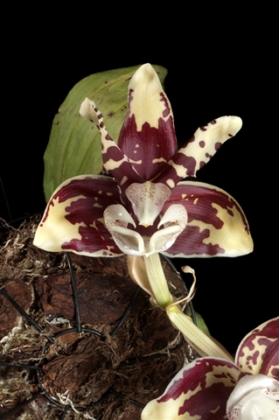 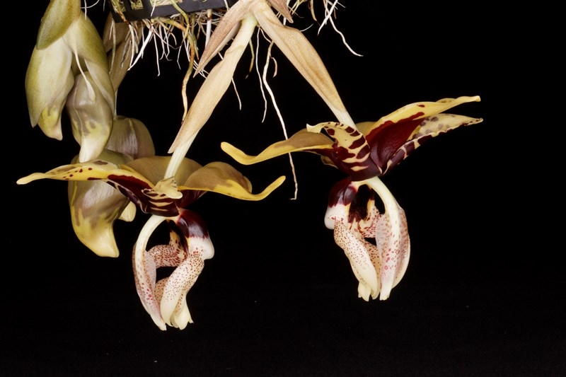

Varieties: var. nigroviolacea is predominantly maroon petals and a deeper colored hypochile (Right)
Awards: 5 FCCs, 22 AMs, 7 HCCs, 1 CCE, 4 CCMs, 1 CHM. All FCC awards are given to the variety nigroviolacea
Hybrids: 42 first generation offspring, and 60 total progeny. The most widely grown is Stanhopea Assidensis (tigrina x wardii) (Below Left), an older hybrid registered in 1922 with a recent surge in population in the recent years and garner 7 AOS award since 2010. Newer hybrid like Stanhopea Lydia Bush (tigrina x grandiflora) (Below Right) registered in 2007 had received 8 AMs since 2011. The variety nigroviolacea (Bottom picture) is used predominantly to provide darker/bolder coloration to its hybrid.
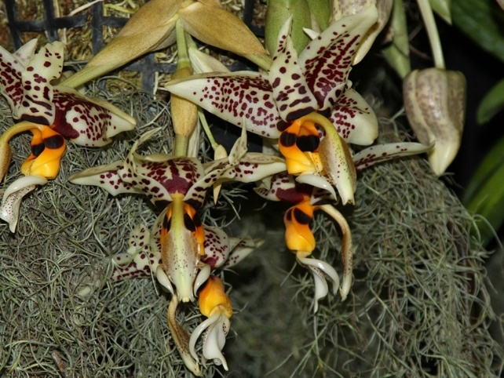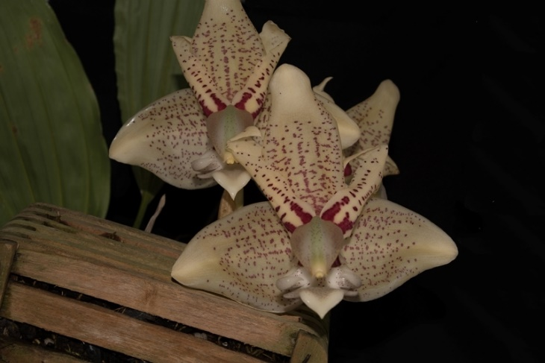
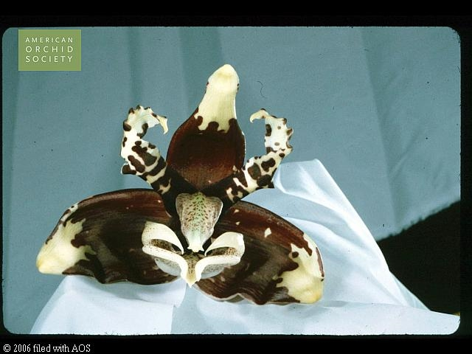

SPECIES DATA SHEET
Stanhopea wardii Lodd. Ex Lindley 1838
Synonym: Stanhopea amoena Klotsch; Stanhopea anfracta Rolfe; Stanhopea aurea Lindley; Stanhopea inodora var. amoena (Klotzsch) Lindley 1852; Stanhopea peruviana Rolfe; Stanhopea wardii var.aurantiaca hort.ex Hennig; Stanhopea wardii Lodd. Ex Lindley var aurea Lindley; Stanhopea wardii var. aureum hort. ex Henshall 1845; Stanhopea wardii var. flavescens Klinge 1899; Stanhopea wardii var.stenoptera Rchb.f. 1858; Stanhopea woodii Lindley 1950
Found from Nicaragua, El Salvador, Nicaragua, Costa Rica, Panama, Colombia and Venezuela as a medium sized, hot to warm growing epiphyte occuring on trees and on rocks in humid cloud forests from 800 to 2700 meters in altitude, it can fill an entire house with its pleasing scent. This species has pyriform to ovoid, sulcate psedobulbs with a single, apical, coriaceous, plicate, ribbed, elliptic-obovate, gradually narrows below into the elongate, petiolate base leaf. They bloom in the summer and fall on a pendant, 3 to 10 flowered, 6 to 7 1/4" [15 to 18 cm] long, crowded inflorescence arising on a mature pseudobulb and last from 2-4 days. The major characteristic of this species is its bright golden-orange flower and 2 prominent dark purple contrasting eyes bilateral of the acutely bent hypochile.
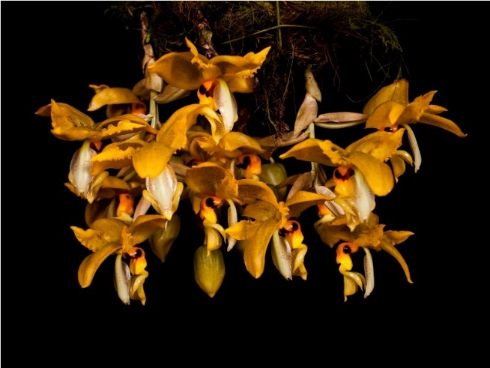 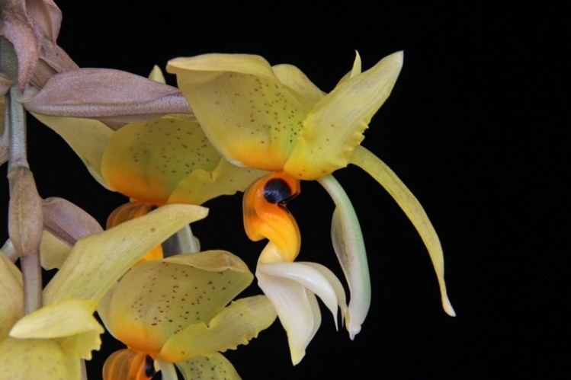
Varieties: N/A
Awards: 9 AMs, 4 HCCs, 9 CCMs, 1 JC. The majority of flower quality award is given after the year 2005. Prior to that this species is known with multiple CCM awards for its vigor.
Hybrids: 12 first generation hybrids and 18 total progeny in 2 generations. The most popular is is Stanhopea Assidensis (tigrina x wardii), an older hybrid registered in 1922 with a recent surge in population in the recent years and garner 7 AOS award since 2010. Next is Stanhopea Ronsard (wardii x oculata) registered in 1989 but only really getting attention after the year 2000 and garners 6 AMs, 3 HCCs, 2 CCMs. Most well-known Intergeneric hybrid is Coryhopea Off the Wall (Stanhopea wardii x Coryanthes macrantha) which has received 1 AM, 1 HCC and an AD/AOS in 2002 for representing a new direction in breeding that improves in form and size over both parents

SPECIES DATA SHEET
Stanhopea oculata [Lodd.] Lindley 1832
Synonym: *Ceratochilus oculatus Lodd.; Dendrobium grandiflorum Sw. 1829; Epidendrum cornutum Sessé & Moc. 1887; Stanhopea aurantia Lodd. ex P.N.Don 1845; Stanhopea aurea Hort. 1892; Stanhopea bucephalus Lindley 1832; Stanhopea cymbiformis Rchb.f 1865; Stanhopea guttata K.Koch 1858; Stanhopea lindleyana Zuc. ex Josst 1851; Stanhopea lindleyi Zuce 1835; Stanhopea maleolens Heller ; Stanhopea minor Schltr. 1917; Stanhopea oculata ssp. ornatissima (Lemaire) Dodson 1967; Stanhopea occulata var aurea Hort. 1892; Stanhopea oculata var. barkeri Heynh. 1846; Stanhopea oculata var. aureum Henshall 1845; Stanhopea oculata var. barkeriana Lindl. 1839; Stanhopea occulata var barkeriana Hort. 1843; Stanhopea oculata var. cinnamomum Henshall 1845; Stanhopea oculata var. conspicua Regel 1855; Stanhopea oculata var. constricta Klinge 1898; Stanhopea oculata var. crocea Regel 1856; Stanhopea oculata var. flava Planch. 1858; Stanhopea oculata [Lodd.]Lindley var genticulata Klinge; Stanhopea oculata var. lindleyi (Zuccarini) Lindley 1852; Stanhopea oculata major Lodd. 1844.; Stanhopea oculata var. meleagris Hort 1851; Stanhopea oculata var. mexicana Fowlie; Stanhopea oculata var. minor Heynh. 1846; Stanhopea oculata var. nicaraguensis Fowlie; Stanhopea oculata pallida Lodd. 1844; Stanhopea oculata var. pallida Hort. 1858; Stanhopea oculata var. viridi-aurea Hort 1942; Stanhopea ornatissima Lem. 1962; Stanhopea purpusii Schlechter 1916
This species is native to Mexico and Central America (perhaps south to Brazil) from elevations of 3,280-9,842 feet (1000 to 3000 m). It is found in foothill and mountain forests and it grows in intermediate to cool conditions. This is one of the Stanhopea that can easily grow outdoors in coastal southern California and requires shade and high humidity to perform well. The flowers are moderate sized 4.3-4.5 inches (10.8-11.4 cm) wide, and there are many forms that are buff colored to bright yellow. There is a considerable amount of variation in color and quantity of spots on the petals and sepals with most having a torus shaped (like the letter O) red to purple colored spots. Several forms have a plethora of intense red to purple spots on the upper hypochile and the epichile
The best known characters used to identify this species is the narrow hypochile that is bent at a 90 degree angle, and several dark red eye spots along the hypochile and base of the petals. The eye spots are what provide us with the epithet “oculata” meaning eyes in Latin. The most common form of S. oculata sold in southern California has two eye spots on each side of the hypochile and also two eye spots on each petal. The inflorescences are up to 25 cm long with 5 to 9 flowers per inflorescence
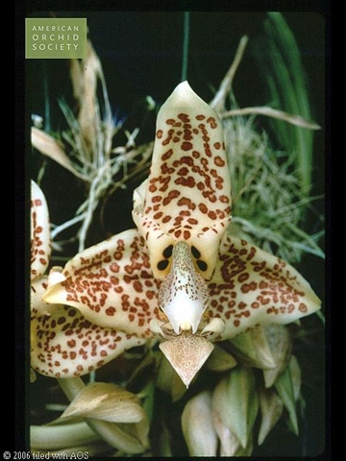 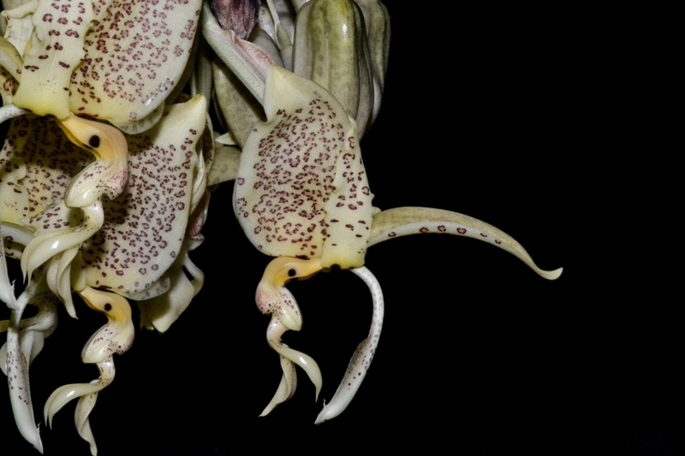
Awards: 7 AMs, 5 HCCs, 1 CCM, 2 JCs ranging from 1974 to 2017
Hybrids: 13 first generation hybrids and 15 total progeny in 2 generations. Stanhopea Ronsard (wardii x oculata) registered in 1989 but only really getting attention after the year 2000 and garners 6 AMs, 3 HCCs, 2 CCMs.

Reference:
OrchidWiz Encyclopedia version 4.0
Orchid Plus Online
American Orchid Society - Stanhopea
http://www.aos.org/orchids/orchids-a-to-z/letter-s/stanhopea.aspx - accessed 11/6/2017
http://www.aos.org/orchids/culture-sheets/stanhopea.aspx - accessed 11/6/2017
Wikipedia Encyclopedia
https://en.wikipedia.org/wiki/Stanhopea - accessed 11/6/2017
Jay Pfahl’s Internet Orchid Species Photo Encyclopedia:
http://www.orchidspecies.com/stantigrina.htm - accessed 11/6/2017
http://www.orchidspecies.com/stanhopeawardii.htm - accessed 11/6/2017
http://www.orchidspecies.com/stanhopeaoculata.htm - accessed 11/6/2017
Stanhopea Culture: Stanhopea oculata
http://stanhopeaculture.blogspot.com/2013/07/stanhopea-oculata.html - accessed 11/6/2017

