Cypripedium breeding

Cypripedium are known to have spectacular showy display of flowers during their blooming season and the ability to withstand the cold. It is no wonder that these orchids are among the most desired to be cultivated by gardeners in temperate climates. However, Cypripedium has notoriously been a challenging genus to grow let alone hybridize. The first true Cypripedium hybrid to be registered is Cyp. Genesis (1987) (reginae x pubescens). There were a dozen or so hybrids were made in Iowa. Of the 90 seedlings transplanted, 2 survived. Mortality rate for the seedlings are exceedingly high. Regardless, the result was a similar looking flower to Cyp. pubescens with additional purplish striations. The effort of creating a Cypripedium hybrid centers on creating adaptable, easy to cultivate plants that can be used in a garden setting in both cooler and warmer climate.
In the most recent timeline, this genus enjoy an explosion in popularity. The reason behind the increase trajectory is the advance of propagation technology making species and hybrids of Cypripedium more available to the enthusiasts. Hengduan Mountain Biotechnology operates two nurseries in China housing thousands of seedlings and adult stud plants. Wenqing Perner, founder of the company continues the Cypripedium breeding and cultivation. Their hybrids mostly involved native species of China in the background including Cyp. tibeticum, Cyp. farreri, Cyp. calcicola, Cyp. x ventricosum, etc... Michael Weinert of Frosch Exclusive Perennials in Germany is also an important figure in Cypripedium hybridizing since the early 1990s. He has registered many important Cypripedium hybrids including Cyp. Gisela (parviflorum x macranthos), Cyp. Sabine (fasciolatum x macranthos), Cyp. Philipp (macranthos x kentuckiense). Notably, Cyp. macranthos are used often to overwrite the earthy color of the other parent to great effect. Similar species for the purpose is Cyp. tibeticum, Cyp. calcicola, Cyp. yunnanense.
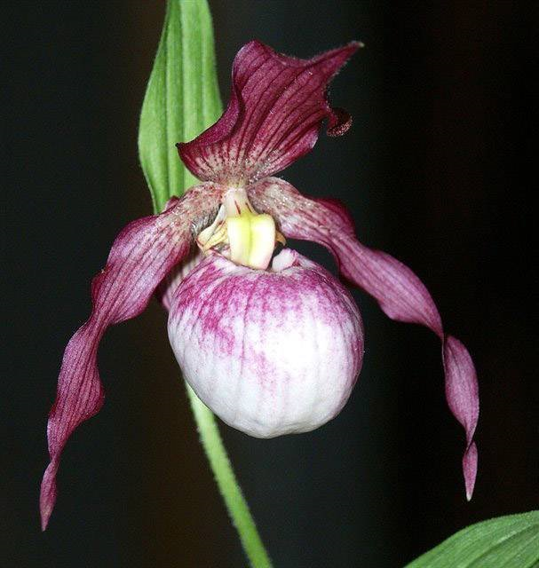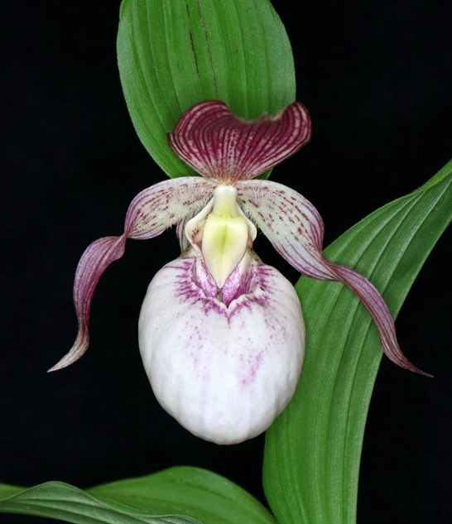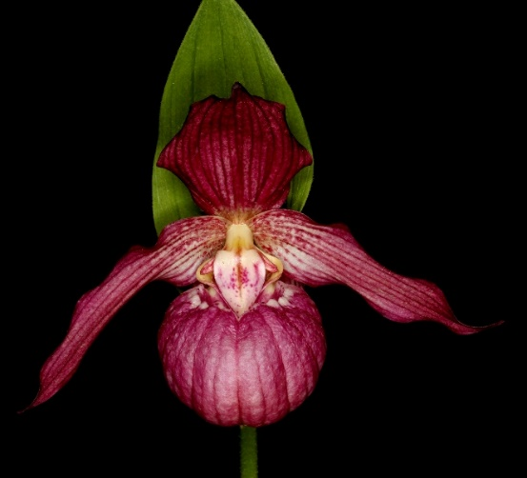
Cyp. Philipp
Cyp. Sabine
Cyp. Gisela

Hybrids of Cypripedium often shows hybrid vigor but it is not true for all hybrids. Out of all 12 sections in the genus, only section Cypripedium (including subsection Cypripedium and subsection Macrantha) demonstrates potential for long-term garden success. Subsection Cypripedium are those with cream/yellow pouches, brown/maroon petals that often twists. Subsection Macrantha are those with pink/purple/dark red coloration and they can be quite dark or very striking stripes with broader segments. An overview of all the hybrids to date, the vast majority are hybrids with section Cypripedium. It is hypothesized that hybrids between sections are more difficult to cultivate possibly due to their mismatch genomes
The accessibility of Cypripedium for the enthusiasts are very much palpable. There has been a steady stream of hybridizing effort pouring into making hybrids with improved vigor and more horticultural tolerance for the garden settings. It is evidenced by the constant numbers or new hybrids registered every year. You will start to notice with a quick search that there are quite a handful of commercialized nurseries offering Cypripedium for sale within the dormant shipping season similar to the like of tulips and daffodils. In the year 2016-2019, you can also see an increased in Cypripedium being awarded in a quick search of AOS award registry. It is an indicator for the gain in popularity of the genus. It is, however, still rare in cultivation especially in the south because of our heat and humidity unsuitable for most Cypripediums.
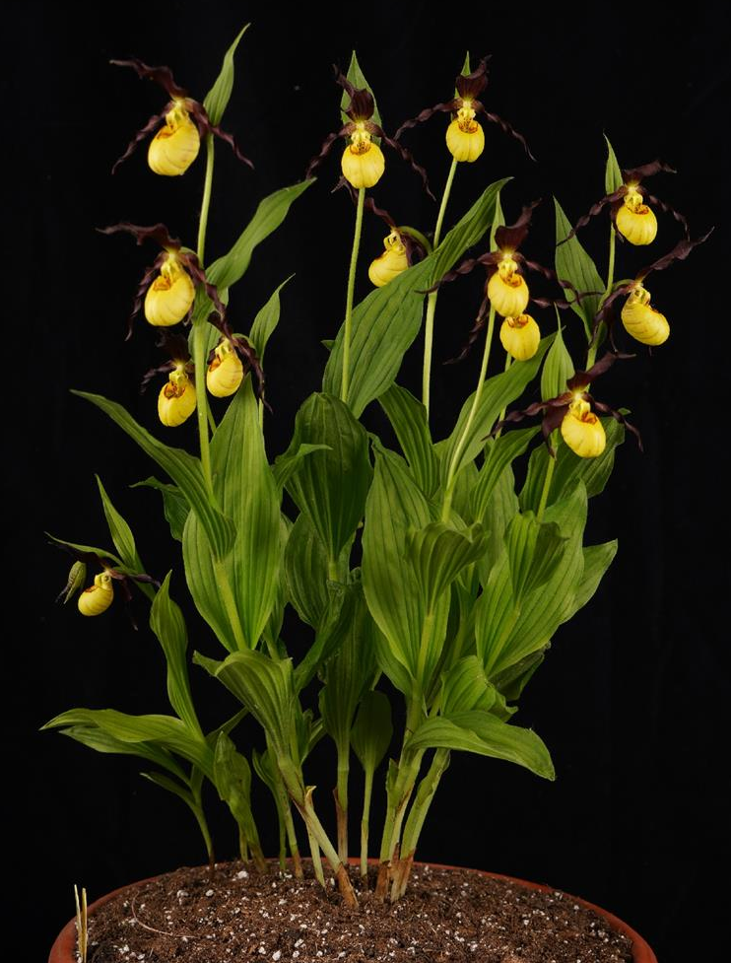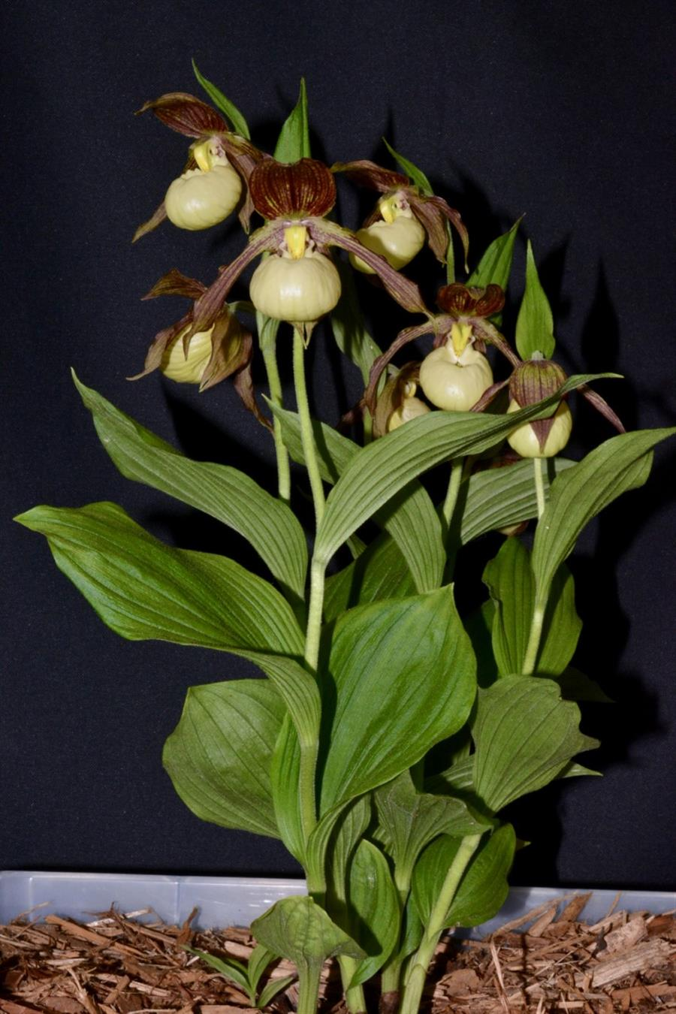
Cyp. Kathleen Anne Green ‘Katydid’
82pts AM/AOS (2021)
Cyp. Emil ‘Bright Eyes’ 81pts CCM/AOS (2023)

Reference:
OrchidWiz Encyclopedia version 9.1
Orchid Plus Online
The Orchids Magazine -May 2022 Issue 91 page 46-53
https://secure.aos.org/digital-library/202105orch_91-05/46/index.html#zoom=z
-August 1988 Issue 57 page 20-23
https://secure.aos.org/digital-library/198808orch_57-8/20/index.html#zoom=z
Cypripedium hybrids – jewels of the shaded garden
https://www.isu-perennials.org/en/reports.html?file=files/cto_layout/download/member_contribution/405_michaelweinerteng.pdf

