The Genus Cypripedium
Lindley 1753
Type species: Cypripedium calceolus
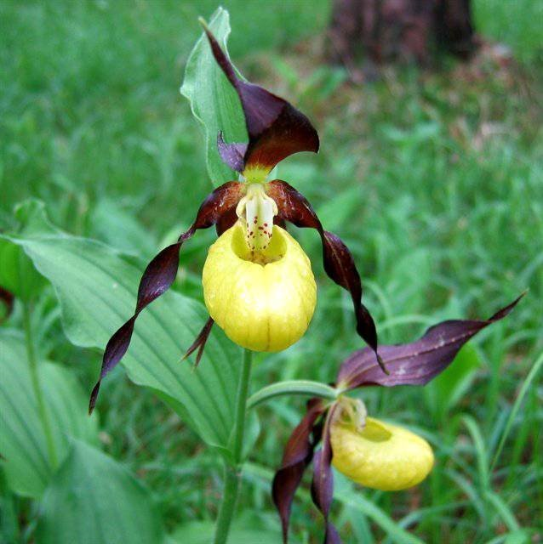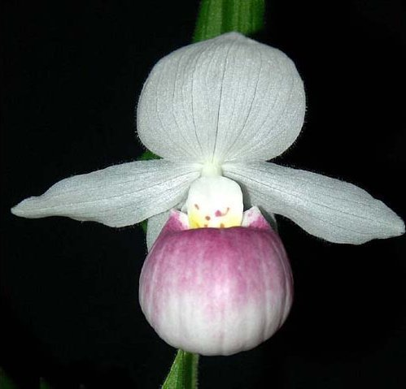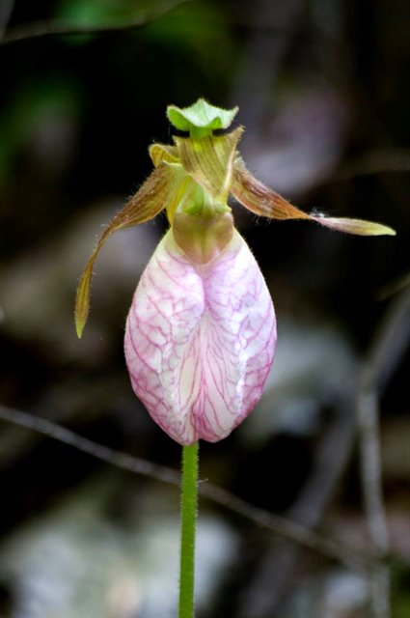
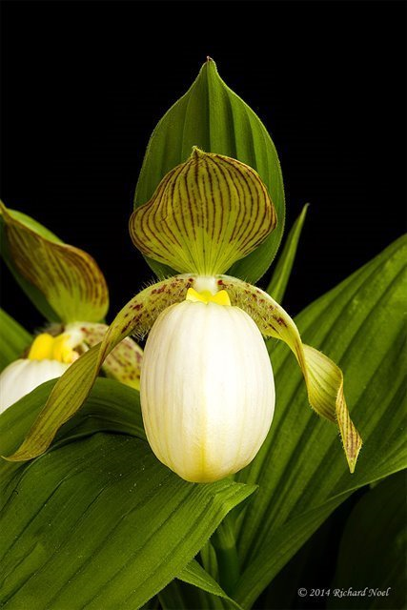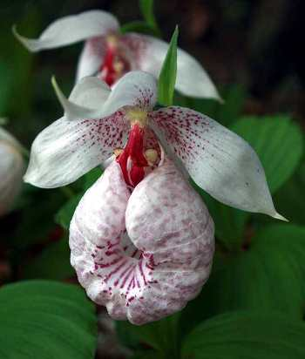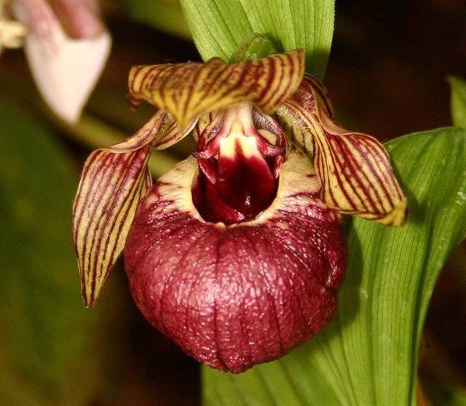
Significant species | Offspring/Progeny | Awards | Bloom season
Cyp. parviflorum* | 55/86 | 4 AMs, 2 HCCs, 4 CCMs, 3 CHMs | Mid Spr to Mid Su
Cyp. kentuckiense | 24/35 | 3 AMs, 1 HCC, 2 CCMs, 3 CHMs, 2 JCs | Late Spr
Cyp. macranthos* | 63/91 | 4 CHMs | Late Spr, Early Su
Cyp. formosanum | 8/8 | 1 AM, 1 HCC, 2 CCMs, 1 CBM | Spr
Cyp. reginae | 25/31 | 1 AM, 2 CHMs | Spr to early F
Cyp calceolus | 25/37 | 3 CCMs | Spr to early Su
Cyp. acaule | 4/4 | 1 HCC, 1 CBM | Spr to early Su
Cyp. tibeticum* | 38/42 | 1 AM, 2 CHMs | Spr to early Su
Cyp. fasciolatum* | 27/46 | 1 AM, 1 CHM | Spr

These are the temperate American or Asian 'Lady's Slipper' orchids that are related to the Paphiopedilum that may be growing in a forest near you. There are 58 species in the United States, Canada and eastern Asia with a few that are found as far south as Guatemala. They are one of the most primitive of the Orchidaceae and other than, Paphiopedilum, Phragmepidilum and Selenipedium, have no other common ancestors or links and as such will not procreate with other orchids outside of its Subfamily. They are almost always terrestrials but they can be found on rocks or low tree trunks if they are very mossy.
The genus is characterized by being small to large, rhizomatous terrestrials with 1 to several, plicate, deciduous, reniform-ovate to lanceolate leaves and bloom on a terminal, 1 to several flowered inflorescence with leafy floral bracts holding showy flowers. The sepal is erect to porrect (extend out) over the lip and the lateral sepals are united to form a synsepal. The petals are spreading, linear-lanceolate and sometimes twisted. The deeply saccate lip has the margins inrolled, the column is porrect, the staminode pelate-ovate to trowel shaped. There are 2 anthers that are behind the staminode.
Pollinators are attracted to flowers by their lovely colors, but most flowers, despite exuding oils from internal pouch hairs, are most likely engaging in deception. The pouch is actually a rather passive-aggressive structure, temporarily trapping the insects and directing them to small openings near the staminode that bear pollen
For centuries Cypripedium species have been sought after and collected not only for their unique beauty but also for the medicinal trade. Widespread collection, attempts at transplantation, and loss of habitat have drastically reduced their numbers.
Unfortunately, wild plants virtually never fare well in cultivation, as their environmental needs, particularly the need for symbiosis such as mycorrhizae and even bacteria, are rather specific. All cypripediums are not the same. Distributed widely throughout temperate regions of the Northern Hemisphere, cypripediums have specific requirements, seasonally deciduous; plants are usually winter dormant, retreating underground during the cold or excessively dry periods of local seasonality. Even among just the North American species, ecological conditions vary wildly.
Hybridizing Cypripedium is a challenge especially getting them to grow from seed to flowering size due to difficulty in culture. Another challenge is to produce plants that will grow in a variety of condition. Hybridizers are trying to breed plants from different region to improve tolerance of growing conditions with the primary goal is to adapt to garden culture.
SPECIES DATA REPORT
Cypripedium calceolus Lindley 1753
Synonym: Calceolus alternifolius St.-Lag. 1880; Calceolus marianus Crantz 1769; Cypripedium alternifolium St.-Lag. 1880; Cypripedium atsmori C.Morren 1851; Cypripedium boreale Salisb 1796; Cypripedium calceolus f. biflorum Rouy 1912; Cypripedium calceolus f. triflorum Rouy 1913; Cypripedium calceolus var. citrina B.Hergt 1899; Cypripedium calceolus var. viridiflora M.Schulze 1902; Cypripedium cruciatum Dulac 1867; Cypripedium ferrugineum Gray 1821; Cypripedium guttatum subsp. microsaccos (Kraenzl.) Soó 1969; Cypripedilon marianus (Crantz) Rouy 1894; Cypripedium microsaccos Kraenzl. 1913
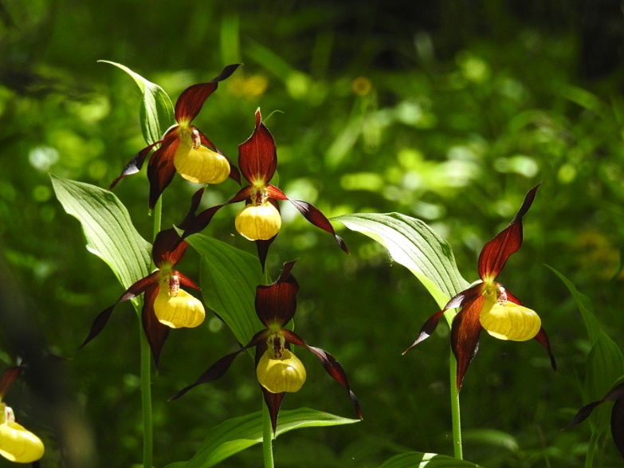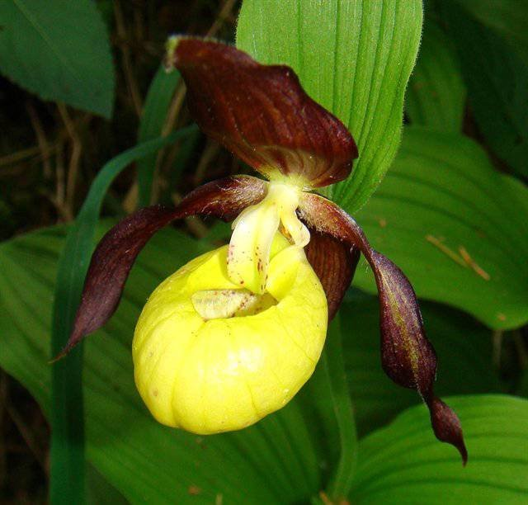
Cypripedium calceolus is the type species of the entire genus and is wide spread from Western Europe (England) over the entire northern part of Eurasia to Japan and northeast China. It does not occur in North America. Donovan S. Correll, PhD, (1908 - 1983) r educed the North American Cyp. parviflorum (including its varieties) to a synonym of Cyp. calceolus, obviously misled by the superficial similarity in shape and color of the flowers. However, Cyp. calceolus is not closely related to Cyp. parviflorum and is easily distinguished by its white canaliculated (u-shaped in cross-section) staminode while Cyp. parviflorum has a yellow conduplicate (folded like a book cross-section) staminode. It is even more obvious with DNA analysis. It grows in part shade on moist alkaline substrates in scrub and open to dense woodlands at elevations up to 2000 meter as a small to medium sized, cold growing terrestrial with a pubescent stem carrying 3 to 5, oval-lanceolate, slightly plicate, obtuse leaves that blooms in the spring and summer on a terminal, 14" [35 cm] long, 1 to 2, rarely 3, flowered inflorescence
Awards: 3 CCMs
Hybrids: 25 Offsprings/ 37 Progeny. Most notable is Cyp. Pixi (x C. tibeticum) with 3 AMs given
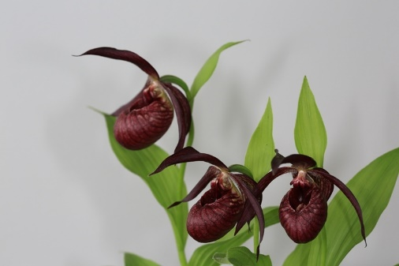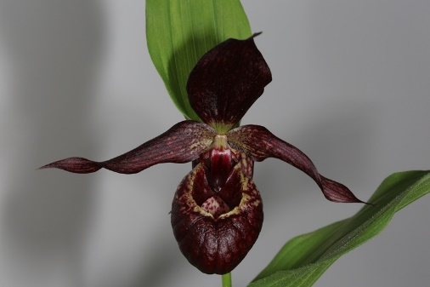
SPECIES DATA REPORT
Cypripedium acaule Aiton 1789
Synonym: Cypripedium acaule f. albiflora E.L.Rand & Redfield 1894; Cypripedium acaule f. biflorum P.M.Br. 1995; Cypripedium acaule f. lancifolia House 1924; Cypripedium catesbianum Raf. 1833; Cypripedium hirsutum Mill. 1768; Cypripedium humile Salisb. 1791; Cypripedium vittatum var. planum Raf. 1833; Fissipes acualis (Aiton) Small 1789; Fissipes acaulis f. lancifolia House 1920; Fissipes hirsuta f. albiflora (E.L.Rand & Redfield) Farw. 1938
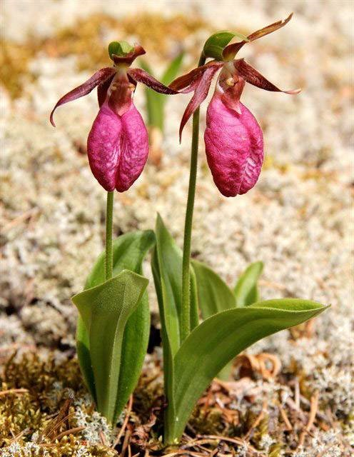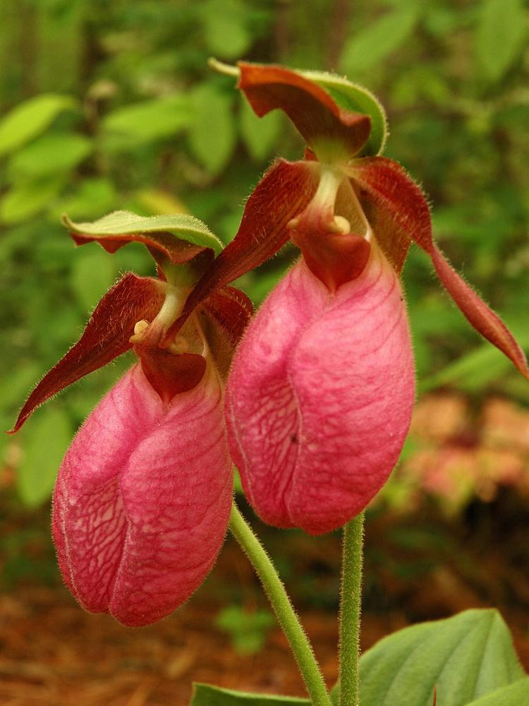
The moccasin flower, or pink lady’s slipper , are found in the eastern USA and Canada and south to Georgia and Alabama in hardwood and conifer forests, in swamps and bogs, dense woods along streams and in coastal dunes as a large sized, cold growing, erect, terrestrial plant from the higher and drier deciduous forests. Cypripedium acaule has two basal leaves from which emerge the flowering stem carrying a single flower. The pouch is mauve to magenta and has a split in the front instead of the usual round opening and is unique to this species
Cypripedium acaule grows in mixed hardwood coniferous forests of pine and hemlock on rocky/mossy slopes in semi-open or in deep humus and acidic but well-drained soil under birch and other deciduous trees of eastern United States forests.
Native Americans have historically used an extract from this species as a sedative and treatment for nervous disorders.
Varieties: f. albiflorum, and a lighter color form
Awards: 1 HCC, 1 CBM
Hybrids: 4 primary, no progeny, no notable hybrid

Reference:
OrchidWiz Encyclopedia version 5.2
Orchid Plus Online
Wikipedia Encyclopedia
https://en.wikipedia.org/wiki/Cypripedium
The Orchids Magazine -March 2016 Issue 85 page 38-45
https://secure.aos.org/digital-library/201603orch_85-3/files/assets/basic-html/page-38.html#
-December 2002 page 30-33
https://secure.aos.org/digital-library/200212orch_71-12/files/assets/basic-html/page-30.html
-September 2007 page 40-47
https://secure.aos.org/digital-library/200709orch_76-9/files/assets/basic-html/page-40.html
United States Department of Agriculture – Forest Service
https://www.fs.fed.us/wildflowers/beauty/cypripedium/cypripedium_acaule.shtml
Jay Pfahl’s Internet Orchid Species Photo Encyclopedia:
http://www.orchidspecies.com/cypacaule.htm
http://www.orchidspecies.com/cypcalceolus.htm

