Mexipedium xerophyticum
V.A. Albert & M.W. Chase 1992
Type species: Mexipedium xerophyticum
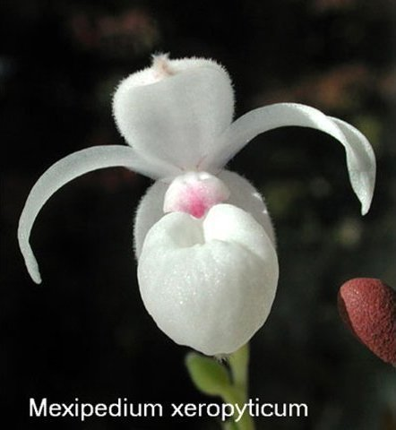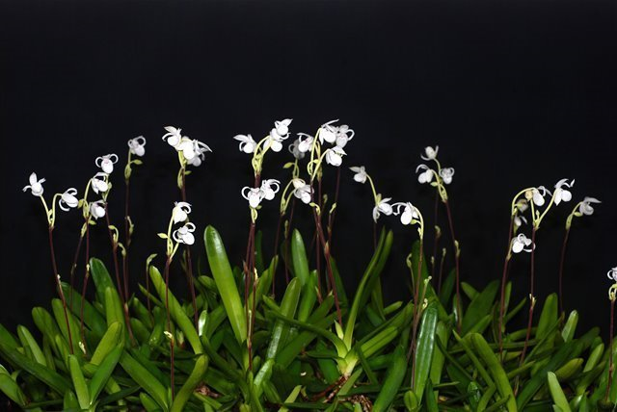
Synonyms: Paphiopedilum xerophyticum (Soto Arenas, Salazar & Hágsater) V.A.Albert & Börge Pett. 1994; *Phragmipedium xerophyticum Soto Arenas, Salazar & Hágsater 1990
Found in southern Mexico on limestone outcrops with xerophytic vegetation surrounded by rainforests and warm oak forests at an elevation of 350 meters as a small sized, hot to warm growing lithophyte occuring on eastern facing slopes that has moderate water in midspring, and heavy water through the summer, then a 3 month dry period from mid winter until spring. This species has a conspicuous, erect, scarious sheathed rhizome with 1.2 to 8" [3 to 20 cm] between each growth consisting of a short stem completely enveloped by a few to several, imbricate (overlapping like roof tiles), distichous (arranged opposite vertically), linear, carinate (boat shaped), basally conduplicate (folded lengthwise) and clasping leaves that blooms in the fall on a pubescent, 2 1/2 to 5 1/2" [6.75 cm to 13.75 cm] long inflorescence arising from the leaf axils and carries one or 2 short-lived, small flowers.
The rediscovery of the species is one of the most notable find in the neotropical orchid flora in the past decades because it changed the idea that was held about the phylogenetic and biogeographic relationship of the subfamily Cypripedioidae. Since its publication, the species has also been placed in two other genera: Paphiopedilum and Phragmipedium.
The habitat of this species is less than 2 hectares in length located in the limestone outcrop in the region of Oxaca, Mexico at 300 meter above sea level. They are currently all found on vertical rock walls with northen exposure, during part of the year, these plants do not receive direct sunlight. However, situation changes drastically in the rainy seasaon; therefore, this species has so many adapation s to capture light on its leave such as a very xerophytic morphology. Due to both its demographic rarity and restriction in habitat, it is categorized as a species in danger of extinction.
Awards: 1 FCC, 3 AMs, 3 HCCs, 3 CCMs, 2 CCEs, 1 CBR

Reference:
OrchidWiz Encyclopedia version 9.1
Orchid Plus Online
Wikipedia Encyclopedia
https://en.wikipedia.org/wiki/Mexipedium
The Rediscovery of Mexipedium xerophyticum
http://lankesteriana.org/lankesteriana/Vol.9(3)/31%20Perez-Garcia.pdf?fbclid=IwAR3RMl5MfHsbLDJXhjGji9uVD2Q7pRSkX-suPuVNADiu3lnG35kZTyktJKg (original article)
https://m.facebook.com/notes/asociacion-mexicana-de-orquideologia/the-rediscovery-of-mexipedium-xerophyticum/749835665044123/ (translated article)
Internet Orchid Species Photo Encyclopedia
http://www.orchidspecies.com/mexxerophyticum.htm
IUCN Red List
https://www.iucnredlist.org/species/43316959/43327764

