The Genus Selenipedium
Rchb.f. 1854
Type species: Selenipedium chica
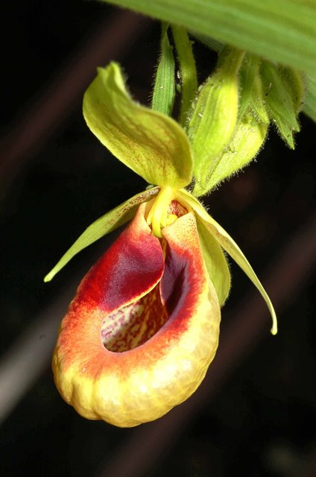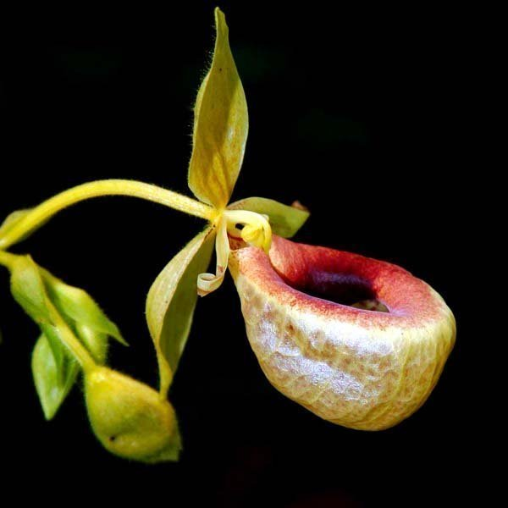
There are about five or six accepted species at this time in this terrestrial, tall growing, bamboo-like genus with reedy stems and prominent plicate leaves that bear small, non-descript flowers in a terminal raceme. These orchids are rarely seen in cultivation. Many orchids bearing the name Selenipedium are actually from the genus Phragmipedium. The genus is comprised of long-stemmed terrestrials, some growing as tall as 3 meters, with narrowly lanceolate [grass-like], plicate leaves, alternating on either side of the stem. The terminal, racemose, successively flowering inflorescence with small flowers that have the lateral sepals fused together and the lip is a slipper shape. The column has two fertile anthers one on each side and a shield-shaped staminode sitting in the center and protrudes over the top of the column.
Of all the slipper orchids the least known is the genus Selenipedium. There are probably several causative factors for the dearth of knowledge. None of the species is particularly attractive and so are not sought by collectors. Out of flower they appear very much like the palms, bamboos, and tall grasses with which they grow, seeming to hide within the subtle camouflage. The species exhibit even more patchy distributions than their counterparts and so are difficult to locate. As with so many orchids, they are usually found when looking for something else. These orchids were originally used for vanilla flavoring in their native South America, but this practice fell out of favor due to the difficulty level of cultivating these orchids and its small flower size.
There are no hybridization noted with the genus. Due to rarity, difficulty to cultivate, huge plant size with small flower, there are an absence in general within the collections and judging table. Attempts have been made to cultivate plant outside of their natural habitat. However, high failure rate prevent this genus to be more widely cultivated

Reference:
OrchidWiz Encyclopedia version 9.1
Orchid Plus Online
Wikipedia Encyclopedia
https://en.wikipedia.org/wiki/Selenipedium
http://www.scielo.sa.cr/scielo.php?script=sci_arttext&pid=S1409-38712015000300179
Kew’s Science – Plants of the World online
http://powo.science.kew.org/taxon/urn:lsid:ipni.org:names:30658-1
Oak Hill Gardens
https://www.oakhillgardens.com/blog/selenipedium

