Subgenus Parvisepalum
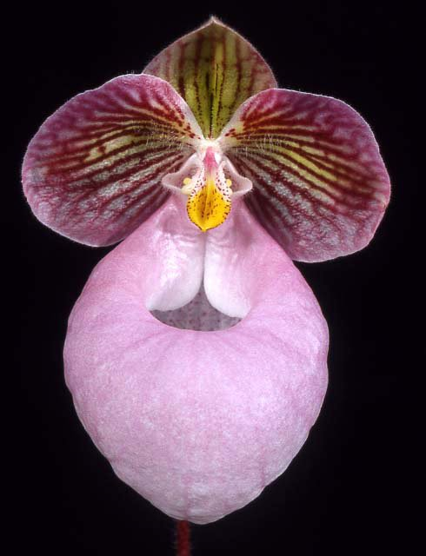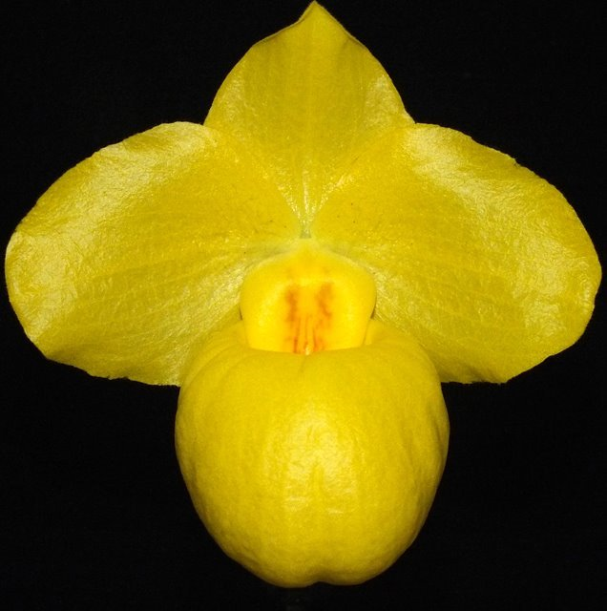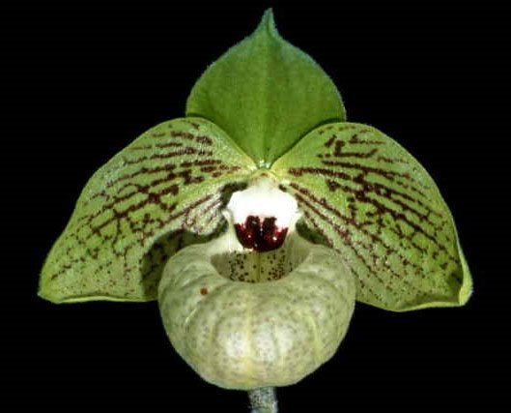
Significant species | Offspring/Progeny | Awards | Bloom season
Paph. delenatii* | 237/482 | 4 FCCs, 75 AMs, 72 HCCs, 3 AQs, 2 CCEs, 11 CCMs, 1 JC, 2 CHMs, | Late W-Spr
Paph. armeniacum* | 156/329 | 19 FCCs, 60 AMs, 35 HCCs, 4 CCMs, 1 JC, 1 CHM, | W-Early Spr
Paph. malipoense* | 139/287 | 2 FCCs, 51 AMs, 36 HCCs, 1 CCE, 2 CCMs, 1 CHM | W - Spr
Paph. micranthum* | 117/207 | 15 FCCs, 119 AMs, 59 HCCs, 3 CCEs, 3 CCMs, 4 JCs, 1 CHM | Spr - Su
Paph. hangianum | 79/118 | 2 FCCs, 7 AMs, 4 HCCs | Spr
Paph. emersonii | 75/125 | 1 FCC, 21 AMs, 6 HCCs, 1 CCM, | Late Spr
Paph. vietnamense | 42/68 | 9 AMs, 2 HCCs, 1 CHM | W - Spr
Paph. jackii | 15/17 | 2 HCC, 1 CHM | Spr

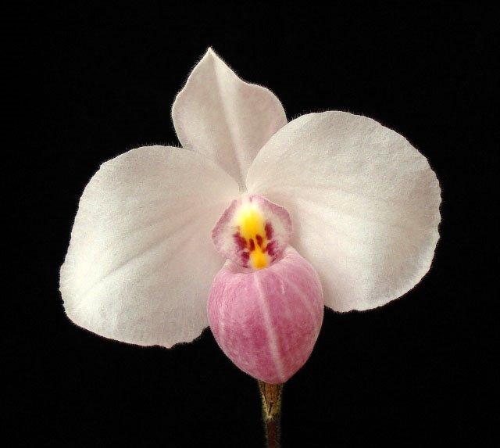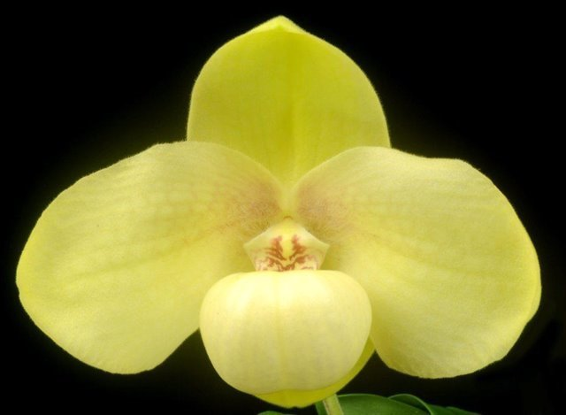
Parvisepalums are known for their vibrant flowers with large baloon type pouch unlike what typically seen in paphiopedilums. The species in this subgenus are very distinctive from each other in appearance, and some even have pronounced fragrance. These species are fertile and bred readily outside of their subgenus. The exaggerated pouch are a dominant trait, color are also tends to be prorminent creating hybrids that are unique in appearance compared to the parents. This is most notable when bred with paphs that are typically not colorful to create some of the most spectacular flowers with novelty shapes and color
Paph delenatii is used to made soft pink hybrids. It does not actually just lend pink color to the hybrid. Rather, it suppresses expression of green and yellow coloring in the sepals and petals of hybrids similarly to Paph. niveum. Therefore progenies tend to be white and pink. Staminodal color is independent from this influence however. Example is Paph. Armeni White (x armeniacum). When crossed with section polyantha, it broaden the segment making very large and colorful flowers while, at the same time, suppressing yellow and bring out anthocyanin gene. Example: Paph. Delrosi (x rothschildianum), the lack of yellow coloration in the background is creating a red/pink coloration vs the maroon/brown coloration that rothschildianum starts out with.
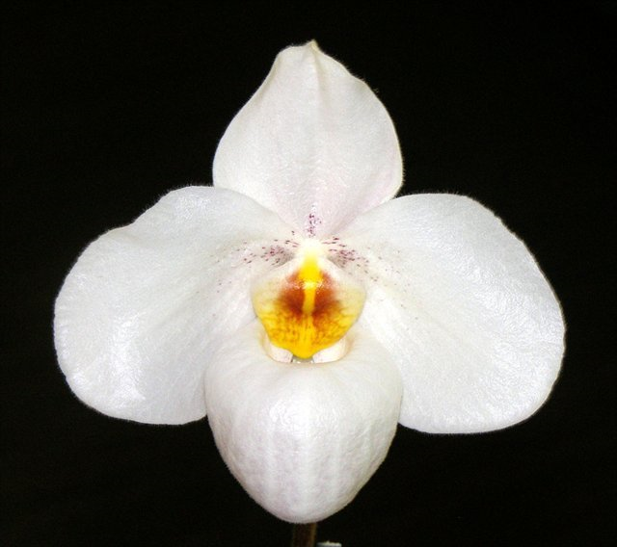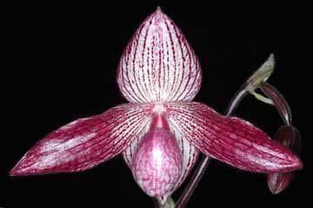
Paph armeniacum is the only paph with a brilliantly yellow color versus the more subdued yellow of the other yellow species (Paph. godefroyae, paph. concolor, Paph. primulinum). Naturally, hybridizer expected to intensify the yellow and possibly make an orange paphiopedilum but it is impossible due to the yellow suppressing affect of the paph delenatii. However, it has been a success when the other parents are also yellow or green. Example: Paph. Golddollar (x primulinum) inherited both the brilliant yellow and the sequential blooming habit making this hybrid a great pot plants. Paph. Fumi’s Gold (x concolor) has created some of the most intense yellow among all the Paphiopedilums. Similar to other parvisepalums, when bred with polyantha, has created some truly magnificent flowers. Example: Paph. Dollgoldii (x rothschildianum) with its brilliant gold color with striking stripes inherited from its polyantha parent.
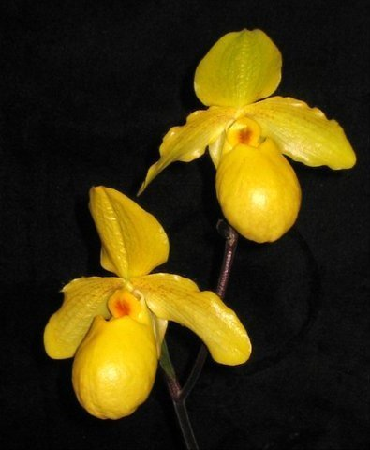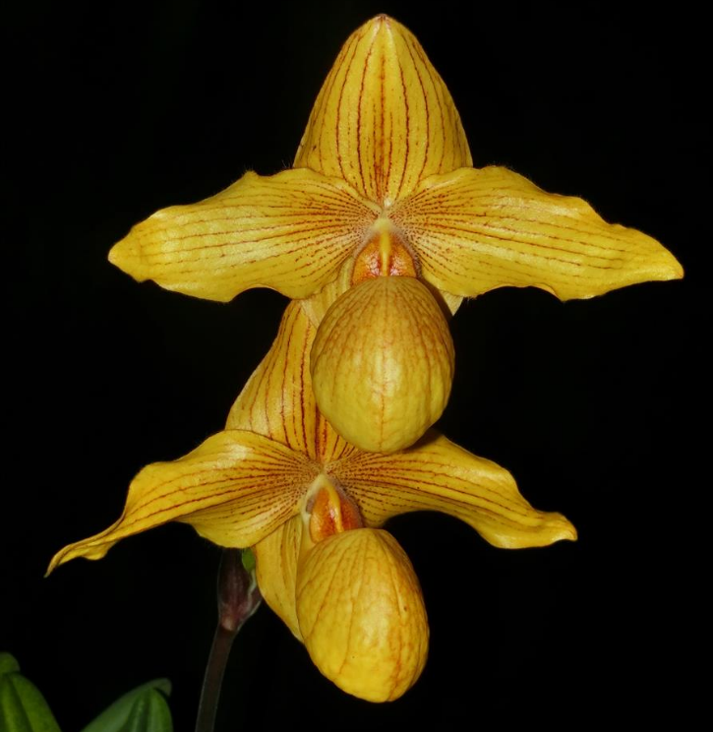
Paph. micranthum is impressive not only for its oversized pouch but also the intense tessellation/veining on the petals. It has the most variation among all the parvisepalums. It also is different from other pink parvies because it does not suppress yellow color. Apricot/orange colored parvies are created with a mix of micranthums and yellow colored paphs. Example: Paph. Fumi’s Delight (x armeniacum). Additionally, micranthum tends to inflate the pouch of its hybrid making very dramatic and full flowers. Hybridizers also took advantage of the natural tessellation of the sepals and petals and created some dark and contrasting flowers. Example: Paph. Gloria Naugle (x rothschildianum). The combination of intense tessellation and spots can sometimes create very dark flowers. For example: Paph. Kevin Porter (x bellatulum), some clones are almost solid deep pink/red with spots and tessellation. Lets also not forget the traditional pink bubblegum paph that was insanely famous due to its large size flowers and ease of growth: Paph. Magic Lantern (x delenatii)
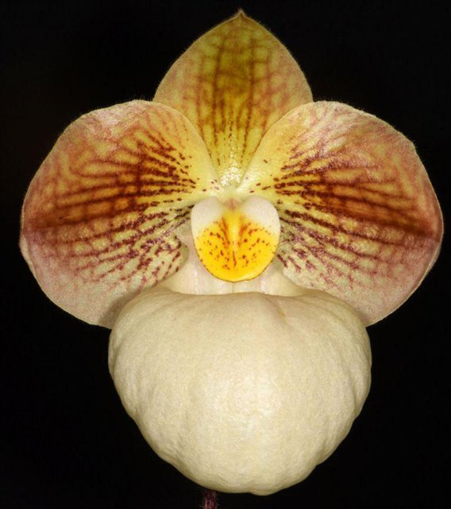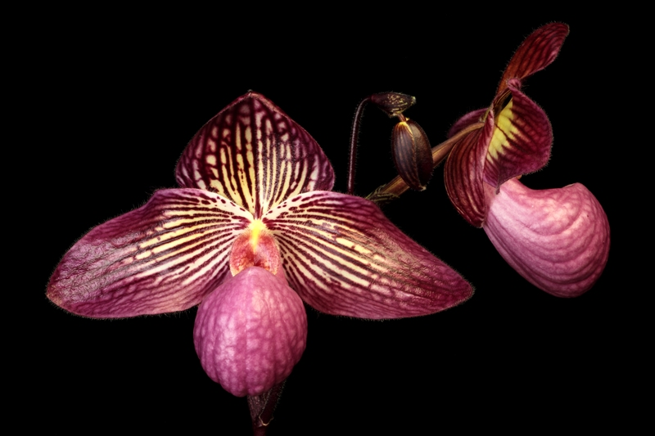
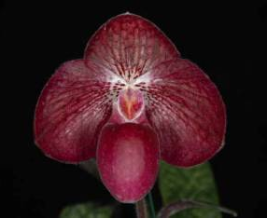
Paph malipoense is also very interesting not only because it has large flowers; the shape of the flower (pointed petals), the bold striping, and the purple staminode often comes through to its hybrid (Ex. Lynleigh Koopowitz (x delenatii). Most of all, it lends a special mint green to its hybrids and a potential for fragrance. A combination of mint green flowers with bold stripes from micranthum is a sight to behold. Example: Paph. Fanaticum ( x micranthum)
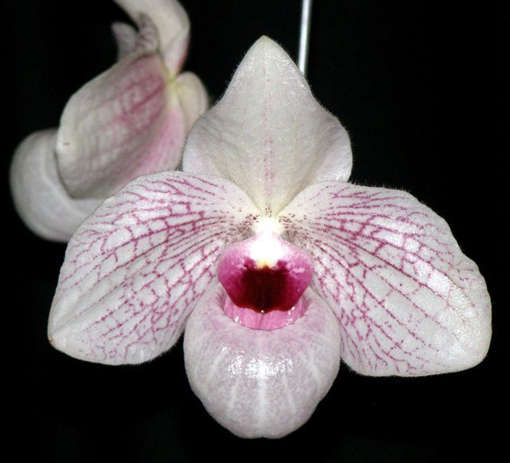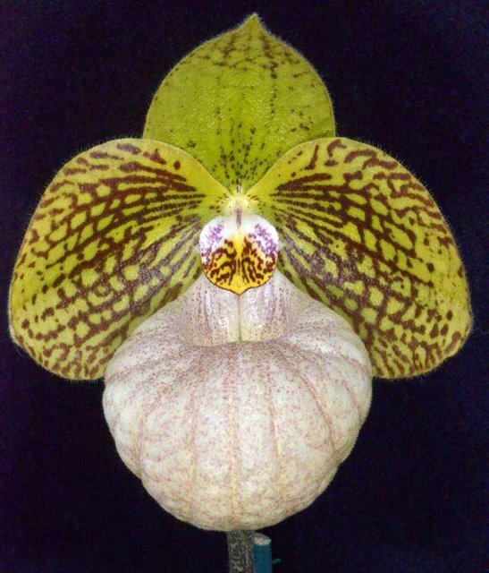
Other less popular but also incredibly remarkable species in this subgenus is unique in their own way and to a lesser extend, contribute to the breeding program. Paph. emersonii is known to have very large size flower and is used as a short cut to big white paphiopedilum. Example: Paph. Sugar Suite (x niveum). Similarly, Paph. hangianum is used to increase the size of yellow Paphiopedilum due to its large sized pastel yellow flowers, with a potential to create interesting maroon “eyes”/tesellation at the base of the petals
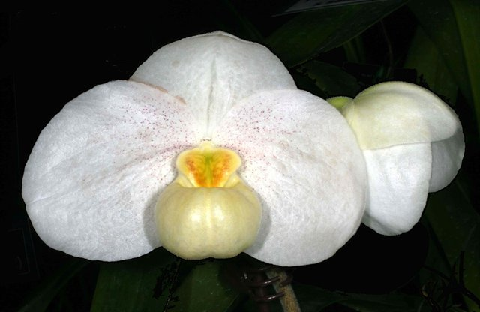
Paph. vietnamense lends more intense pink coloration at the expense of flower longevity and floppy petals. Example: Paph. Wossner Vietnam Love (x micranthum) is a more intense version of Magic Lantern. Interestingly, Paph. vietnamense has a lesser extend of yellow suppression than paph. delenatii making creamy yellow and light greens instead of ivory white. The floppy petals make it less desirable for hybridizing because it tends to create a less shapely flowers. Example: Paph. Wossner Vietnam Star (x rothschildianum) is a darker but less shapely version of Paph. Delrosi
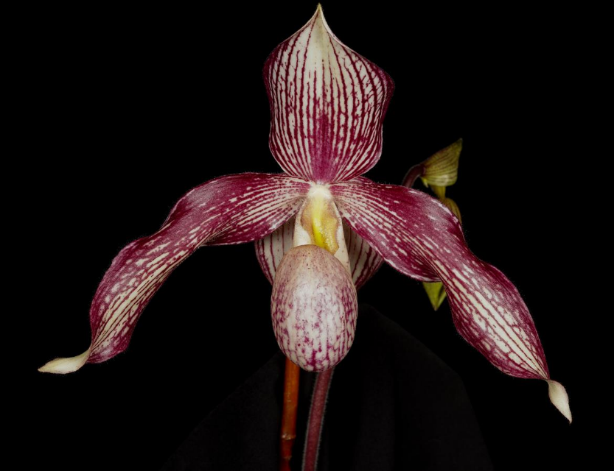
As you can see, Parvisepalum bred well outside of their subgenus. Some of the most spectacular novelty hybrids are purposefully done this way. However, breeding outside their subgenus increase the risk for genetic incompatibility potentially creating infertility, deformities, and color breaks. It’s extremely rare to see more than 2 generations or more than 2 other subgenus in parvis breeding. As mentioned above, Parvies are often breed with Cochlo and polyantha to increase flower counts and create colorful multifloral hybrids. By broadening of the petals, it create more interesting shape, but it can also create deformities due to the tendency of the petals to twist. Parvies can be used again in a cross section hybrid to reinforce the full round form and the coloration of its hybrids. For example: Paph. Dong Thi Luan (Delrosi x vietnamense)
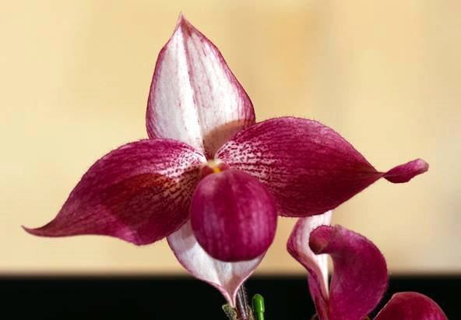
Reference:
OrchidWiz Encyclopedia version 9.1
Orchid Plus Online
Marriott Orchids
New Perspectives on Novelty Slippers
https://marriottorchids.com/2018/02/18/new-perspectives-on-novelty-slippers/
The Orchid Magazine
https://secure.aos.org/digital-library/199105orch_60-5/39/index.html#zoom=z
https://secure.aos.org/digital-library/199901orch_68-1/8/index.html#zoom=z

