The Genus Phragmipedium
Rolfe 1896
Type species: Phragmipedium caudatum
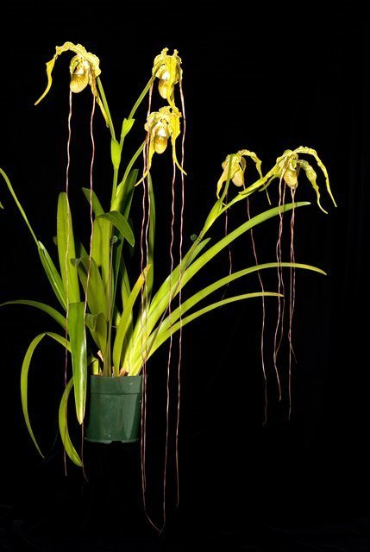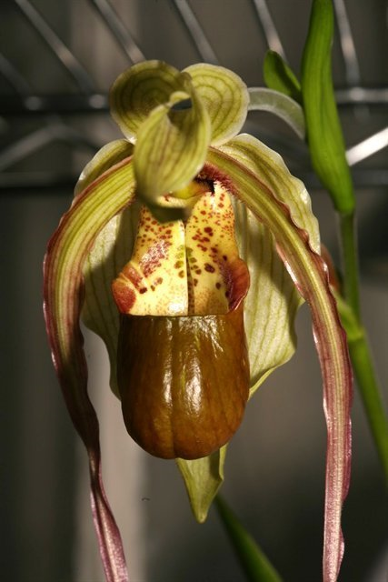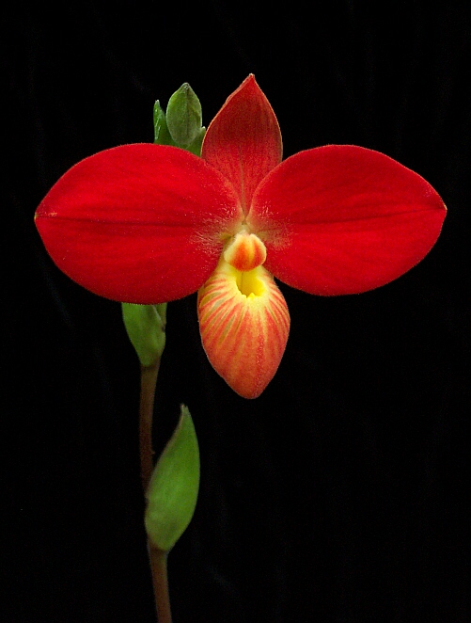
Significant species | Offspring/Progeny | Awards | Bloom season
Phrag. besseae* | 143/899 | 8 FCCs, 77 AMs, 44 HCCs, 2 CCEs, 1 CCM, 1 AQ | Late W - Spr
Phrag. kovachii* | 97/233 | 8 FCCs, 13 AMs, 1 HCC, 1 CHM | Spr
Phrag. schlimii* | 65/563 | 1 FCC, 12 AMs, 7 HCCs, 2 CCEs,9 CCMs, 1 CBM, 3 JCs | Mostly F
Phrag. longifolium* | 83/779 | 15 AMs, 8 HCCs, 1 CCE, 8 CCMs, 6 CHMs, 2 CBMs | Mostly F
Phrag. pearcei | 45/153 | 3 AMs, 12 HCCs, 1 CCE, 7 CCMs, 1 CBM | Su
Phrag. caudatum | 75/188 | 1 FCC, 43 AMs, 23 HCCs, 2 CCEs, 16 CCMs, 1 CBM | W - Su
Phrag. warszewiczianum (wallisii) | 59/92 | 5 FCCs, 16 AMs, 12 HCCs, 2 CCMs, 1 CBR, 2 CHMs | Year round
Phrag. humboldtii | 45/169 | 12 AMs, 1 HCC, 1 CCM, 1 CCE, 1 CBR, 1 CHM | ?
Phrag. boissierianum | 28/164 | 3 AM, 3 HCCs, 1 CCM, 1 CBM | F -Spr
Phrag. lindleyanum | 41/127 | 2 AMs, 2 HCCs, 1 CCM, 2 CBM | F - early Spr
Phrag. dalessandroi | 48/156 | 2 AMs, 1 CHM | ?
Phrag. sargentianum* | 39/465 | 1 HCC, 2 CCMs, 1 CBM | Late W - Spr
Phrag. fischeri* | 34/217 | 1 AM, 2 HCC, 1 CHM | ?
Phrag. caricinum | 39/83 | 1 AM, 4 HCCs, 5 CCMs | Late W - Early F

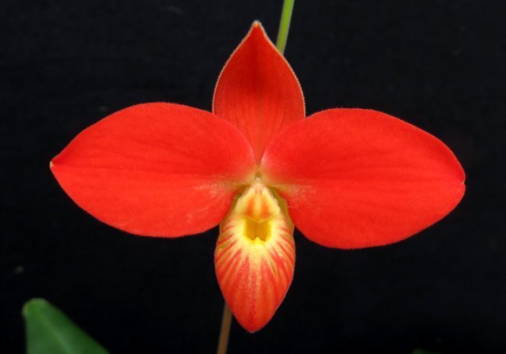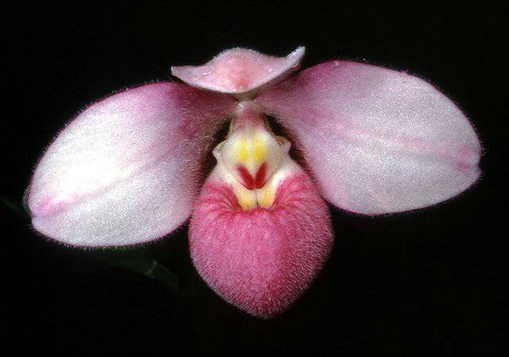
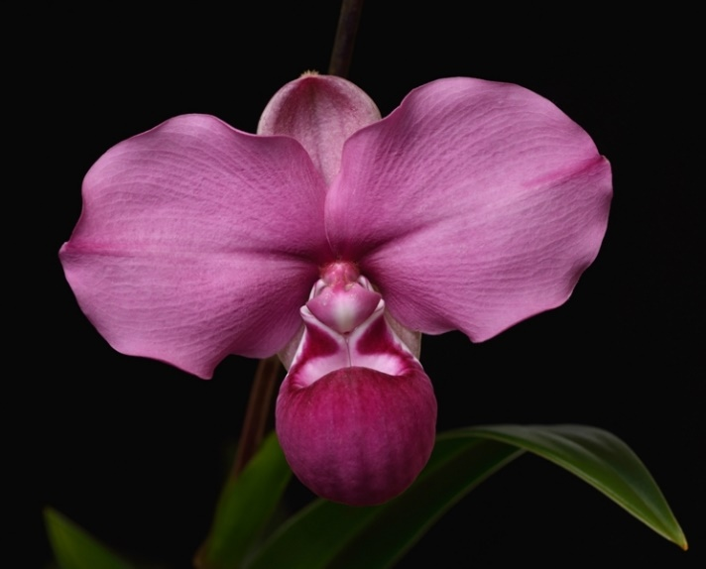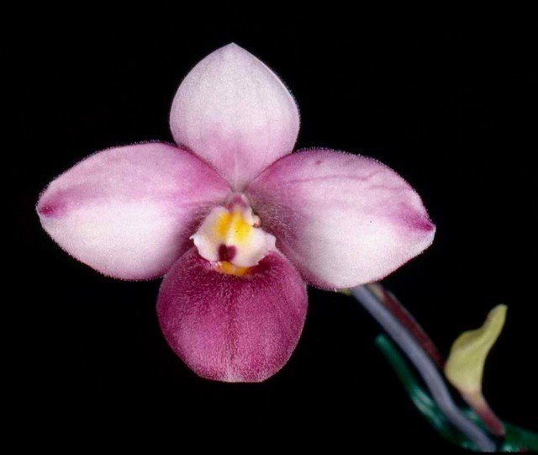
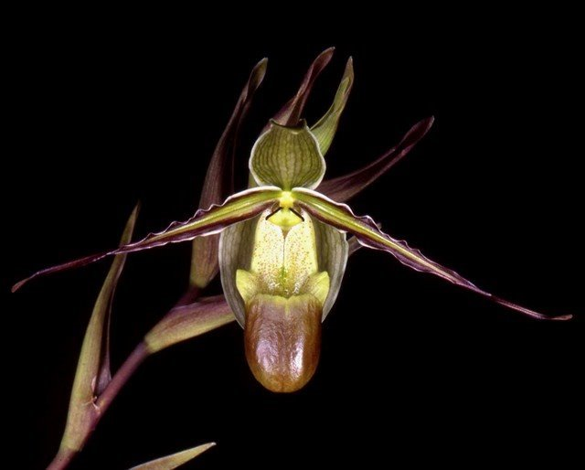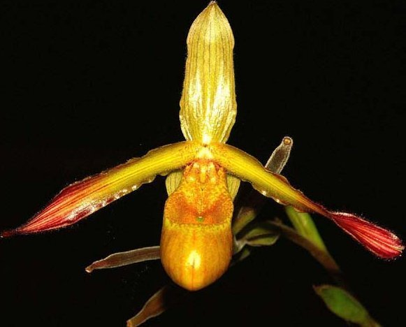
Phragmipediums are new world ladyslippers that grow from Mexico through the central and northern parts of South America. They can be found growing on rock outcroppings (Mexipedium xerophyticum), in forks of trees (caudatum), or volcanic clay (boisserianum and wallisii). Some plants such as longifolium, ecuadorense, pearcei, or klotzscheanum grow submerged underwater through periods of heavy rainfall. The flowering season is heaviest in the spring. However many species can bloom for 6-11 months at a time, often one flower consecutively after another.
Similar in many ways to the other slipper orchids, the paphiopedilums, selenipediums and cypripediums, Phragmipedium is a very popular genus that was established by Robert Rolfe in 1896 when he revised all the slipper orchids. Those species native to the tropical Americas were placed in either Selenipedium or Phragmipedium. Rolfe named the genus, using the Greek words phragma (fence) in reference to the division of the ovary and pedilon (slipper). As with the other slipper orchids, the species of this genus are sympodial in growth habit and form tight fans instead of pseudobulbs. All species are either epiphytic or terrestrial and grow at elevations between 1300-7200 feet (400 to 2,200 meters). Inflorescences can be up to 3 ft. (90 cm) long and can bear up to 15 flowers. The flowers themselves can measure 30 inches (75 cm) or more from the tip of the dorsal sepal to the tip of a lateral petal. The flowers, once thought to consist mainly of yellows, greens and browns, some with yellow and purplish patterns, now include orange, red (P. besseae) and even magenta (P. kovachii). The genus is divided into the following sections
Section Phragmipedium (long droopy twisted petals): P. caudatum, P. warszewiczianum, P. lindenii, P. humboldtii…
Section Micropetalum (full, round, colorful flowers): P. besseae, P. andreettae, P. schlimii, P. fischeri…
Section Schluckebieria: P. kovachii
Section Lorifolia (prominent synsepal, twisted petals and “horns” on either side of the pouch): P. longifolium, P. boissierianum, P. hirtzii…
Section Himantopetalum (small flower, grass-like leaves, twisty petals): P. pearcei, P. caricinum, P. klotzchianum…
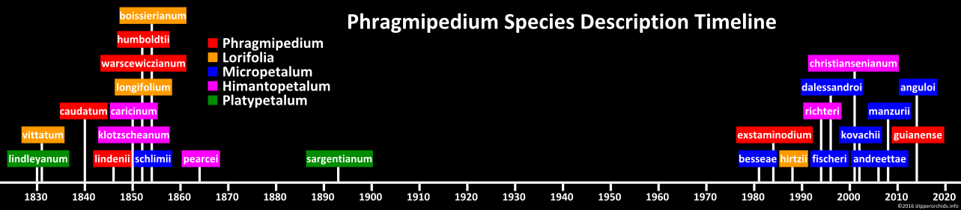
Section Platypetalum (widen petal tips, almost spade-shaped): P. sargentianum, P. kaieteurum, P. lindleyanum…

Prior to the discovery of P. besseae in 1981, Phragmipedium is limited in color palette with green and dull brown are predominant. P. besseae came along and the popularity of Phragmipedium soar as newer hybrids of orange, red and everything in between hit the market. In 2003, Phragmipedium kovachii is discovered and suddenly once again the world of Phragmipedium becomes exciting with P. kovachii adding size and purple shades to its hybrid.
The green, brown, maroon colored Phragmipedium species (section Phragmipedium, Himantopetalum, Lorifolia) with aphid-like spots above the lip entrance pollinated primarily by female flower flies that lay their eggs in aphid colonies with exception of 3 species that are able to self-pollinate (P. lindenii, P. boisserianum, P. longifolium.) The right sized flower flies will approach the flower attempting to investigate the spots around the lip entrance, fall into the lip and are forced to crawl out through an escape hatch on the side of the staminode that bears pollinia. Phrag. besseae was once thought to be pollinated by hummingbird because of the color. However, there is no nectar and so they wouldn’t hang out long enough to pollinate the orchids. It is insect that are presumably attracted by the color, trapped inside the pouch. The translucent windows signature the direction for the insect to escape, The rim of P. besseae’s lip is deeply folded extended down inside the pouch, and the small size of the windows making it impossible for the insect to crawl back out through the lip entrance and is forced to go through the escape hatch lined with hair pointing upward.
Phrags like clean water such as rain water, distilled, or reverse osmosis (R.O.) system water. Almost all of the Phrags in nature grow slightly on the acid side with a pH ranging from 5.5 and lower. Municipal well water usually has limestone added to prevent pipeline corrosion. If the pH of the city water is 7.5 or lower, the following Phrags will do O.K. potted in bark/peat mix: Phrag. caudatum, wallisii, lindenii, pearcei, Mexipedium xerophyticum, longifolium ecuadorense and amazonicum. Phrag. boisserianum and besseae require clean water to do best. Water should be applied copiously as the plant approaches dryness. Plants which like somewhat drier conditions at the roots include caudatum, lindenii, wallisii, and Mexipedium xerophyticum.
The flowering seasons are various but the best flowers are produced during the spring season. Phrags can bloom wonderful colored flowers that can continue to bloom for several months. It is very common for Phrags to drop their flowers within one week of opening or when they are still appear in good condition. Do not remove the flower spike as it will produce another bud and continue to flower. Once the flower spike has finished, it will eventually turn brown. If the plants are not flowering, they either are not big enough to bloom or they are not receiving enough light cool temperature at night to initiate blooming. Clean water is also very critical in producing good blooms.
The Phragmipedium genus has made some tremendous leaps forward in term of flower, color, size, and shape especially in the past decade. Phragmipedium can produce plants that grow rapidly and flower multiple times a year. Modern Phragmipedium hybrids are very grower friendly and with continuing efforts of commercial growers and hybridizers, Phragmipedium will one day be as commercially available as the Phalaenopsis.
Judging and Hybridizing:
When a plant from the section Phragmipedium is crossed to one from sections Platypetalum, Himantopetalum or Micropetalum, expect fairly large flowers, droopy sepals, long petals, flowers that all open at once, and straight edges on the rim of the pouch.
Section Platypetalum produces fairly vigorous offspring (Phrag. sargentianum in particular passes on tall inflorescences). Expect somewhat wider, more horizontal petals with slightly undulating edges, often with orange tones on the good-size flowers, and straight edges along the pouch rim.
From section Himantopetalum, offspring will have smaller plants and flowers, some twisting on the petals, and an even edge around the rim of the pouch.
Parents from section Micropetalum will reduce plant size, but yield wider leaves and brightly colored, rounded, often velvety flowers (pink shades from Phrag. schlimii and red-orange tones from Phrag. besseae). If an albinistic or flavistic parent was used in the hybrid, the resulting colors will be much lighter. The pouch rims will be smooth.
Section Lorifolia shows in its F1 hybrids (and often beyond that) more foliage (again, varieties of Phrag. longifolium will produce larger plants; hybrids with the diminutive Phrag. hirtzii will be smaller). Lighter colors can be expected of crosses with Phrag. hirtzii var. hartwegii. With Phrag. boissierianum, darker flowers may show the influence of var. roezlii. The stems will have very heavy bracts, the flowers stiffer petals and dorsal sepals. All of these plants will show gentle flanges on the pouch sides; they will not be as large and prominent as in the species, but always noticeable.
The differences between Paph and Phrags:
- Geological distribution: Paphs are from South East Asia (hence “Old World”) and surrounding Islands, Phrags are from Central to South America (hence “New World”)
- Plant morphology: Phrags have grassy, strappy, or broadly lanceolate leaves, light green, never mottled, and tends to form a tight fan. Paph foliage varies depending on the sections, some can be mottled. Paph foliage tends to be thicker and stout, some are darker green.
- Flower habit: Most Phrags are sequential bloomer except for section Phragmipedium with the long petals, they are multifloral. Paph has various flowering habit ranging from single flower per inflorescence, to sequential and multifloral.
- Flower: Phrags do not typically have spots on the sepals and petals while paph absolutely can.\
- Cultural: Phrag tends to require more moisture at the root and some can even be flooded occasionally. Phrag also tend to grow faster than Paph and bloom easier as well. In cultivation, Phrag often require more light as well as cooler growing condition.

SPECIES DATA REPORT
Phragmipedium vittatum (Vell.) Rolfe 1896
Synonym: Cypripedium binotii auct. 1887; Cypripedium paulistanum Barb.Rodr. 1877; *Cypripedium vittatum Vell. 1831; Cypripedium vittatum var breve Rchb.f 1881; Paphiopedilum paulistanum (Barb.Rodr.) Pfitzer 1894; Paphiopedilum vittatum (Vell.) Stein 1892; Selenipedium paulistanum (Barb.Rodr.) Rolfe 1893; Selenipedium vittatum Rchb. f. 1876
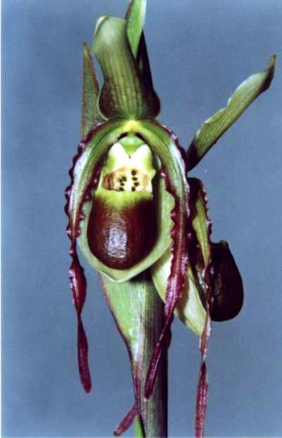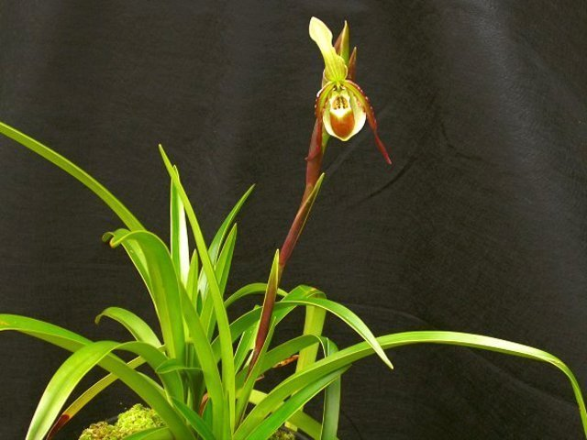
Found in Minas Gerais, Tocantins, Goias and Brasilia DF states of Brazil at elevations of 600 to 1400 meters in swampy areas prone to fires in full sun and partially shaded places within hillside jungles with rocky outcrops or along rivers and in areas prone to flooding as a medium to large sized, warm to cool growing terrestrial with a fan of light green, linear leaves that are lightly marginated with yellow and blooms in the summer and fall on an erect, greenish brown, to 3'4" [1 meter] long, 1 to 13 flowered inflorescence with 1 to 3 successive flowers at once, arising through the bracts.
Awards: 1 HCC, 1 CBM with its only quality award given to ‘Fox Valley’ in 1996 with 77 points.
Hybrids: 9 Offspring/ 12 Total progeny. Most notable is Phrag. Caroline Miller Ott (x Eric Young) with 1 AM and 1 HCC. The red color in the petals of this species is used to reinforce the red on its progeny.
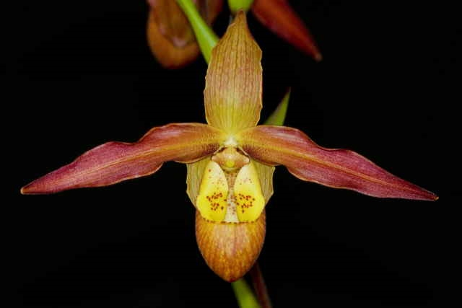 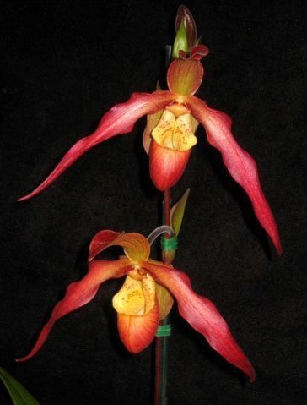
SPECIES DATA REPORT
Phragmipedium christiansenianum O.Gruss & Roeth 2001
Synonym: N/A
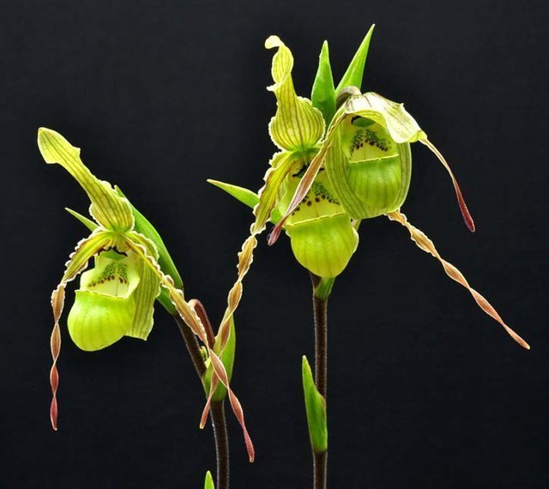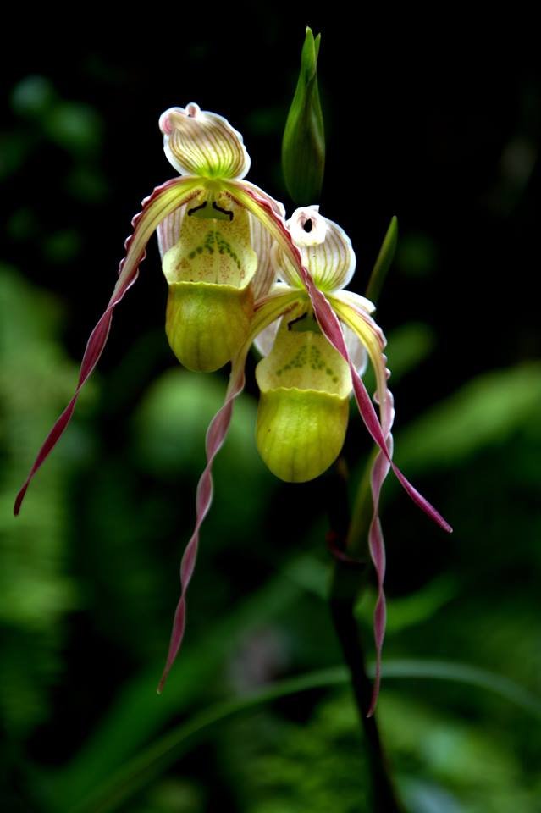
Found in Colombia or Brazil and often cited as a synonym of P longifolium as a large sized terresral with a short stem carrying in a fan shape, 6 narrowly oblong, long-acuminate, coriaceous, obliquely upright, midrib recessed, underside keeled, upper side dark green, yellowish-green beneath, glabrous leaves that blooms in the spring through early summer on an erect, to 18" [45 cm] long, erect, red-brown, glabrous, successively1 to 2, 3 to 6 flowered inflorescence with a shorter than the ovary, lanceolate-narrow ovate, shortly bicuspidate floral bract
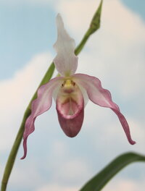
Awards: None
Hybrids: 1 Offsprings/ 1 Total progeny: Phrag Elfin’s Pearl (x schlimii)
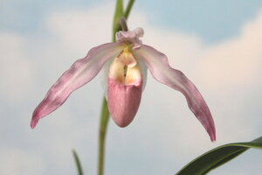
SPECIES DATA REPORT
Phragmipedium x tetzlaffianum O.Gruss 2000
Synonym: N/A
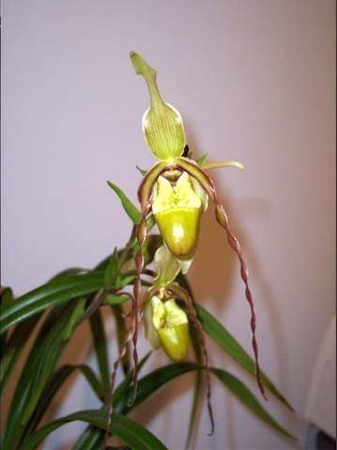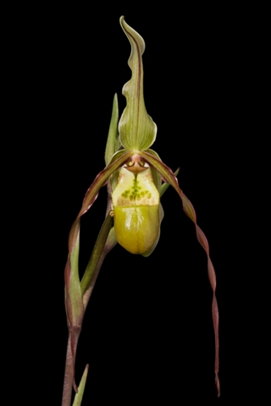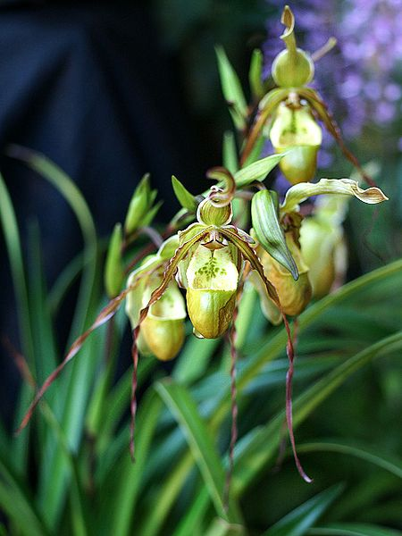
There is a controversy with this species. Originally identified by Olaf Gruss but there are speculation that it could be the hybrid between P. Nitidissimum and P. ecuadorense. It is proven to be false according to Olaf because selfing of the species display minimal variations amongst seedlings. This is one of the rarest Phrag species out there with its impressive twisting petals
https://www.slippertalk.com/threads/phrag-tetzlaffianum.22453/
Awards: 2 CHM
Hybrids: 5 Offsprings/ 5 Total progeny. Hybrids inherited the twisting petals made for a very interesting presentation. Below is picture of P. Memoria Jack Stoddard (x P. Barbara LeAnn)
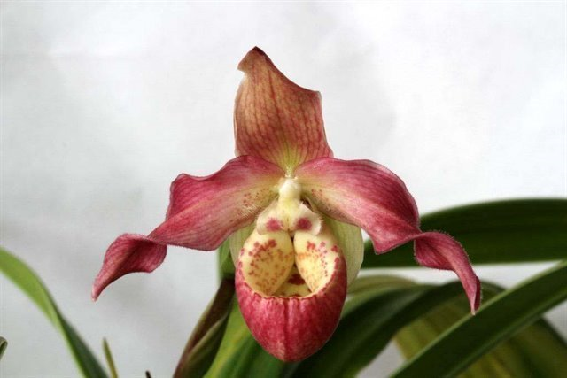

SPECIES DATA REPORT
Phragmipedium lindenii (Lindl.) Dressler & N.H. Williams 1975
Synonym: Cypripedium caudatum var. lindenii (Lindl.) J.H. Veitch 1889; Cypripedium caudatum var. uropedium Kraenzl. 1897; Cypripedium lindenii (Lindl.) Van Houtte 1870; Paphiopedilum caudatum var. lindenii (Lindl.) Brongn. ex Stein 1892; Paphiopedilum lindenii (Lindl.) Alberti & Borge Pett. 1994; Phragmipedium caudatum var. lindenii (Lindl.) Pfitzer 1903; Phragmipedium lindenii (Lindl.) Dressler & N.H. Williams 1975; Selenipedium caudatum var. lindenii (Lindl.) Chapm. 1901; Selenipedium lindenii (Lindl.) G. Nicholson 1887; *Uropedium lindenii Lindl. 1846;
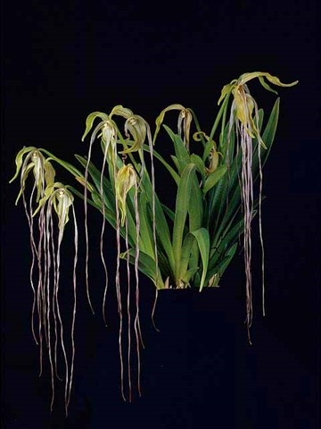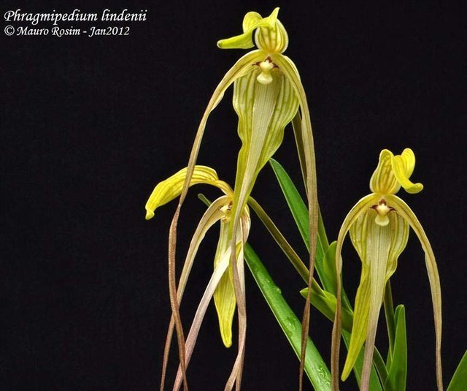
Found in Venezuela, Colombia, Ecuador and Peru on roadside banks at elevations of 1200 to 2850 meters as a large sized, cool to cold blooming in the late fall and early winter, growing lithophyte or terrestrial. The species is similar to P. caudatum but with no pouch. It has a third long petal instead. It is the only slipper orchid without a slipper. These plants are found on open savannas and under shrubs, tall ferns, tall trees, and on fallen log. Flowers open simultaneously.
Awards: 1 AM, 3 HCCs, 2 CCMs, 2 CBM
Hybrids: 8 Offsprings/ 9 Total progeny. Children of P. lindenii has proper lip, therefore the petaloid lip is considered a recessive trait
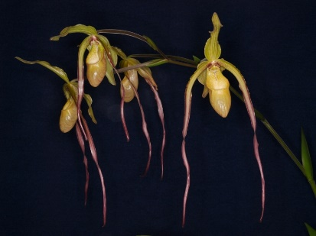

BUILDING BLOCK REPORT
Phramipedium kovachii J.T.Atwood, Dalström & R.Fernández G. 2002
Synonym: Phragmipedium peruvianum Christenson 2002
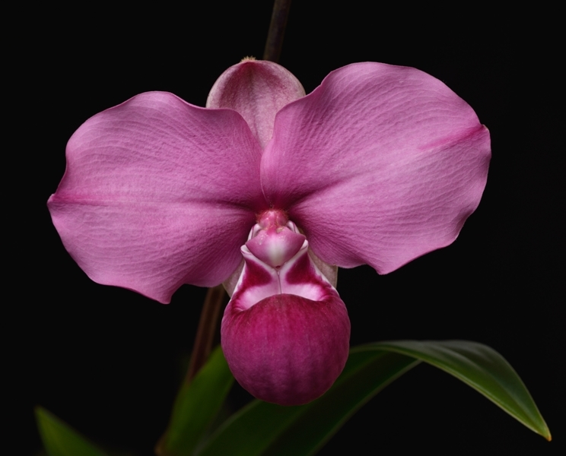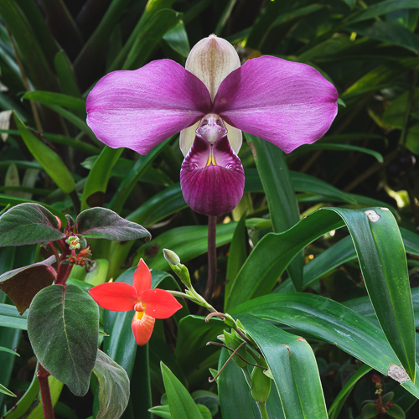
In 2003, Phragmipedium kovachii was discovered in Peru, creating a lot of excitement and controversy in the orchid world. It is known as the discovery of the century in the orchid world because it revolutionize the breeding of Phragmipedium and bring the genus closer to the public eyes. This species is so distinct that it is placed in its own section, Schluckebieria, by taxonomist Guido Braem, PhD. This is one of the largest-flowered Phragmipedium in terms of petal width and overall flower size. The entirely new palette of rich velvety purple color also contributes to its popularity.
The story behind the discovery of this species is a whirlwind of controversy. Mr. Michael Kovach, a Virginia nursery owner, stumble upon a roadside orchid stand where an Indian family was selling orchids they had collected, and the daughter came out with this species in bloom. Kovach recognized the potential of this new species. When he returned to buy more plants, he found that what had been a mossy slope of 500 of the new orchids had been stripped clean, even of inch tall seedlings. He smuggled the orchid back to the US to have it catalogued by Selby Botanical Gardens Orchid Identification Center. Two Selby staff members recognized the importance of the discovery, rushed out a description of the flower without follow proper protocol. They published a special issue of its own scientific journal, Selbyana, using e-mail messages to conduct peer reviews, and the species get published in 8 days with the brand new name Phragmipedium kovachii. This caught the attention of the Peruvian government, which pressed the US authorities to investigate. Eventually, criminal charges were brought against Kovach, Selby Gardens, and its chief horticulturalist, Wesley Higgins.
Culture: These plants were difficult to grow from seeds, when they came out of flask, they grow very slowly and required specialized water and fertilizing routines to thrive. Chuck Acker is the first to flower the species from seed in February 2009. In the native habitat, the plant received cloud-filtered sun light from noon until sunset. The average temperature during summer is 79 F and the winter is 64 F. It rains almost daily in the afternoon and good air movement because high winds of 60 mph can be present. It is found growing on limestone crop. The habitat soil is composed of crushed limestone mixed with organic matter. PH is slightly alkaline at 7.9. When growing P. kovachii remember to provide extra calcium in the potting mix in the form of calcium chips or cracked oyster shells. It is also important to provide them with pure or RO water or rain water. Medium should be moist to almost wet at all times. Provide night time cooling to the plants because this is high elevation orchid. Also cooling the temperature will also intensify the color of this species and its hybrids as in the case of P. besseae.
Awards: 6 FCCs, 11 AMs, 1 CHM.
P. kovachii will continue to enlarge its petals after opening, the picture on the left illustrate this. Flowers will be smaller with a darker color when first opened. It will continue to lighten up and becomes wavier as the flower mature. At the peak of maturity, flower size can be twice larger but with a much poorer form (according to AOS judging standard) and much less intense color. All P. kovachii will display this behavior. When judge for the first time, the judging team at the 5th International Orchid Exposition organized by the Club Peruano de Orquideas were presented with the three flowers from three different clones in three different stages of development as seen in the above picture. After a lengthy discussion, the largest flower was awarded a CHM because it was more representative of the species in full development. Although the intermediate plant have better form and color, it was apparent that it has yet to attain its full maturity and so by AOS judging standard of flower maturity it was not in a condition to judge yet. Therefore, only the characteristic of the flower at maturity would be able to tell us whether the flower would retain these apparent superiorities or if it would devolve into the typical and common characteristic (folding of the petals and lightening of the colors) of the species.
Hybrids: Initially, two Peruvian growers, Alfredo Manrique and Manolo Arias, applied for and received permission to collect five plants each to attempt to reproduce and introduce the species to the public. Glen Decker in New York formed partnership with Fritz Schomburgh to hybridize P. kovachii. The breeding program involving P. kovachii skyrocket and within 15 years, 71 offspring and 125 total progeny were produced and several third generation hybrids were created. Glen Decker was the first to flower the first P. kovachii hybrid which he named after his daughter Haley Decker (flowered 14 months after flask). First generation primary hybrid with P. kovachii produced the most seeds. Crosses made with the primary or near primary hybrids produce little amount of seeds similarly to the situation with P. besseae hybridizing. The goal for hybridizing with P. kovachii is to create bigger flower with shorter inflorescence on a smaller plant than P. kovachii that clump instead of climb (unlike some of P. besseae hybrids)
P. kovachii hybrids have large flowers (4-7 inch) sometimes even larger. They have tall strong stems, three or more flowers on average. They flower sequentially and can branch. The best hybrids to date is Phragmipedium Fritz Schomburg (x besseae) with 46 awards total (1 FCC, 30 AMs, 12 HCCs, 2 CCMs, 1 JC), P. Fritz Schomburg flowers are typically colorful, large, and round. Color ranging from soft pink to purple, coral, orange, to bright red and every shade in between.
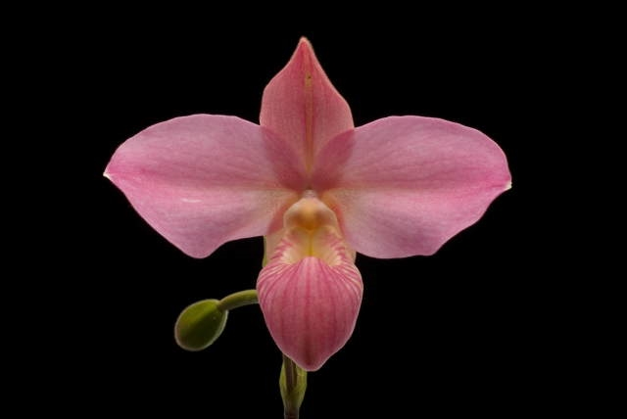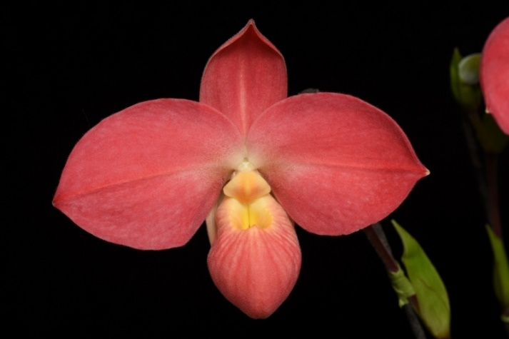
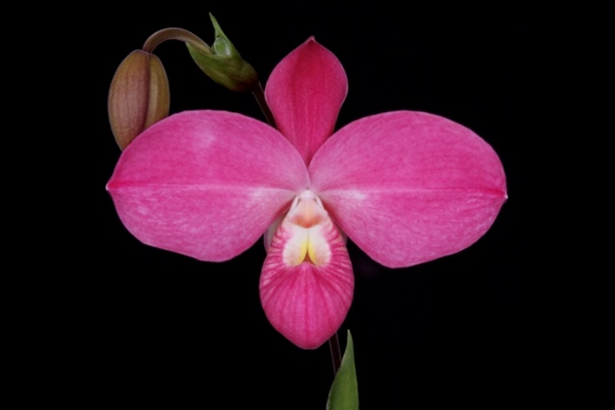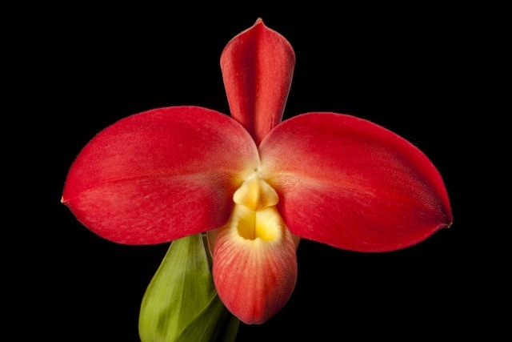
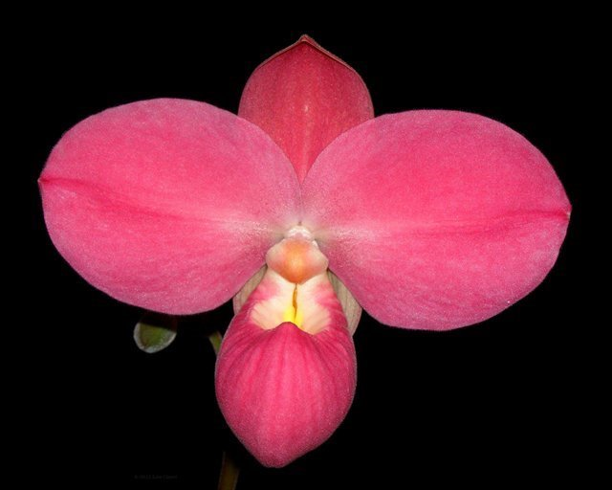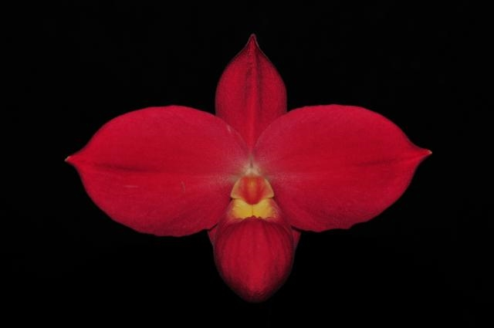

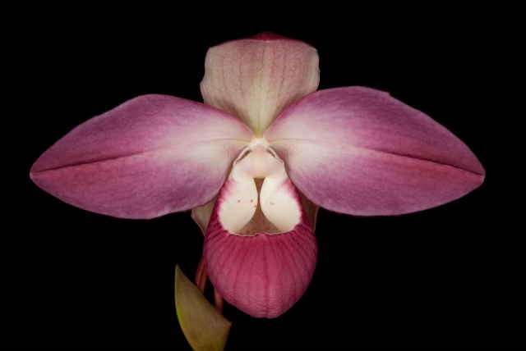
Second best is Phrag. Suzanne Decker (x Cape Sunset) for its uniform color pattern of dark pink flushed white at the base of the petals. It has received 17 AMs, 3 HCCs, and 1 CCM since introduction in 2007. P. schlimii is one of the grandparents and seem to dominate the color of this hybrid with P. besseae providing good shape, P. longifolium for vigor, and P. kovachii for size, this is a perfect combination and the judges agree.
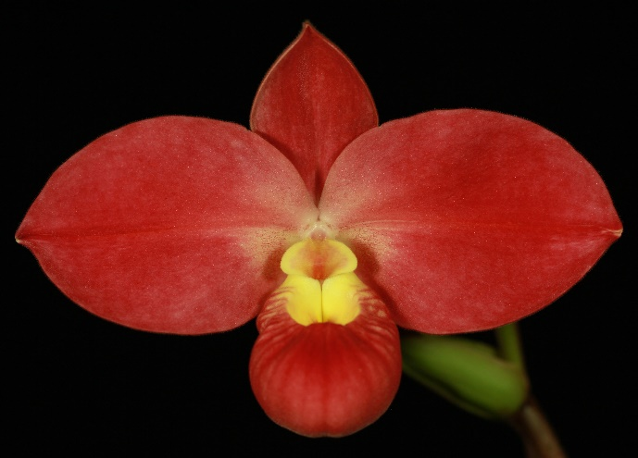
The next big hybrid is P. Peruflora’s Cirila Alca (x dalessandroi) , a very similar hybrid to Fritz Schomburg but with more color variation in flower. The similarity in flower is because P.dalessandroi is very similar to P. besseae with only a few different characteristics. This hybrid has received 7 AMs, 10 HCCs

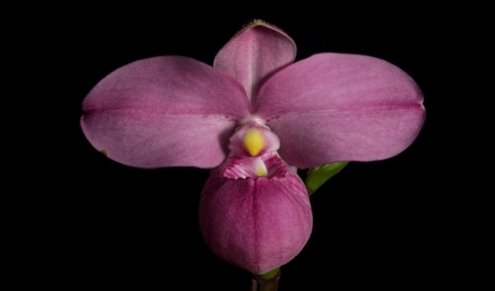

Phrag Eumelia Arias (x schlimii) is another interesting primary hybrid because it looks like P. schlimii on steroid with slightly darker color and bigger flower on a bigger plants. However, color pattern of P. schlimii is dominant and has shown through to this hybrid. This hybrid has received 6 AMs, and 3 HCCs

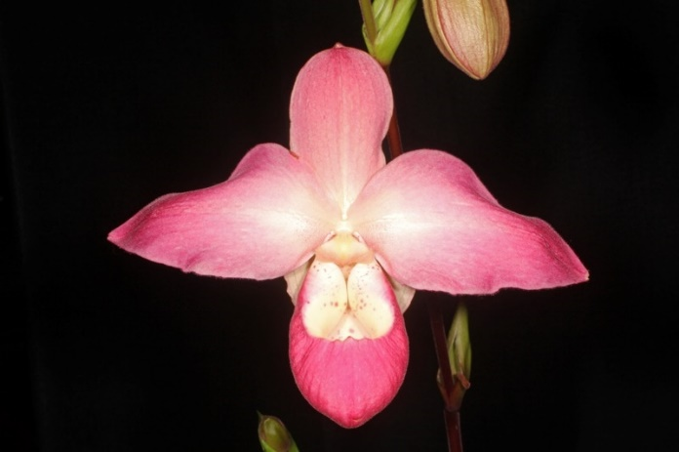
Phrag Peruflora’s Spirit (x Eric Young) is very similar to P. Suzanne Decker without the influence of P. schlimii. Therefore, plants /flowers are bigger and petals are wavier, with a warmer pink thanks to more P. besseae in the background. This hybrid has received 8 AMs, 7 HCCs, and 1 CCM

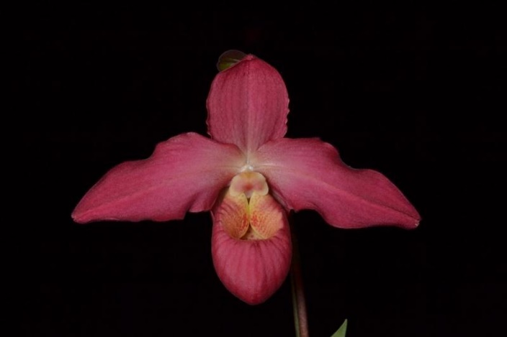
Phrag. Allison Strohm (x Living Fire) brought some big waves to the table. The pink color is warmer thanks to P. sargentianum granparent’s yellow background and color ranging from pink to warm coral tones. Plant is of big statue, petals are commonly wavy. This hybrid has received 6 AMs, 3 HCCs.

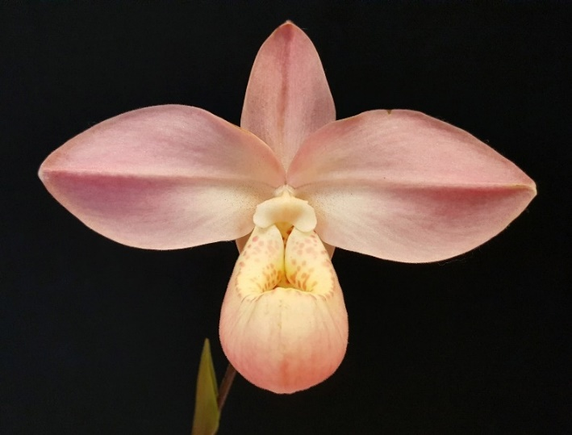

Phrag. Memoria Mariza Rolando (x Hanne Popow) has provided some interesting pale pink like this particular clone ‘Pink Angel’ awarded in 2017. Generally, color are much darker and also similar to P. Fritz Schomburg. This hybrid received 1 FCC, 5 AMs, 1 HCC, 1 AQ, 1 JC

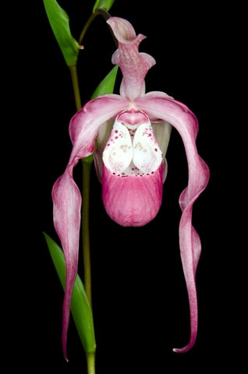

Here are an example of a cross with section Phragmipedium. This is Phrag Frank Smith (x Grande). This has received 5 AMs, 3 HCCs

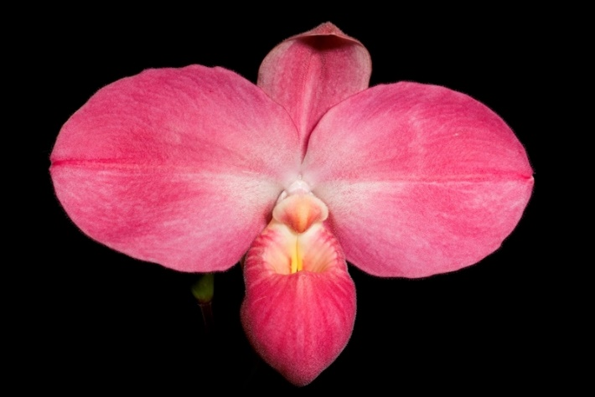
Phrag. Ekolu Quintal (Peruflora’s Spirit x dalessandroi) is the second generation hybrid of P. kovachii and it has shown a lot of potential like this FCC clone ‘Lady Bird QF’ awarded in 2016 with 90 points. It’s a flower of perfection. A work of art! The species has received 1 FCC, 1 AM, and 1 HCC since its release on 2014

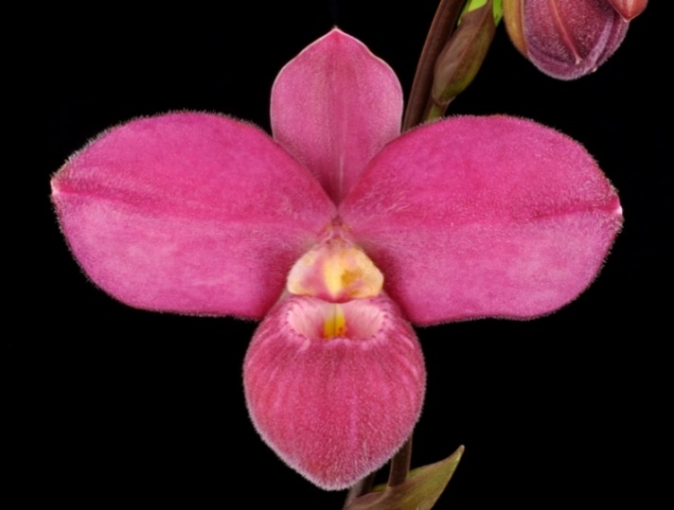

Phrag. QF Agnes Atkinson (P. fischeri x P Haley Decker) reinforce the purple color with Phrag fischeri. This second generation hybrid received 2 AMs, 1 HCCs since its released on 2013

Reference:
OrchidWiz Encyclopedia version 9.1
Orchid Plus Online
The American Orchid Society
Phragmipedium
http://www.aos.org/orchids/orchids-a-to-z/letter-p/phragmipedium.aspx
A Discussion of Phragmipedium Species and their Influence on Hybrids
http://www.aos.org/AOS/media/Content-Images/PDFs/Judges%20Forum/Schmidt-Ostrander_Ingrid_ADiscussionofPhragmipediumSpecies-Word.pdf
The Orchids Magazine
-November 2007 page 30 -37: Phragmipedium kovachii
http://www.aos.org/AOS/media/Content-Images/PDFs/Phrag_kovachii.pdf
-January 2004 page 45 – 47: Judging Phragmipedium kovachii
https://secure.aos.org/digital-library/200401orch_73-1/default.aspx#[object%20Object]
-January 2010 page 18-31: New World Slipper Orchids
https://secure.aos.org/digital-library/201001orch_79-1/default.aspx#[object%20Object]
-June 2011 page 46-49: Pollination Studies in Phramipediums
https://secure.aos.org/digital-library/201106orch_80-6/default.aspx#[object%20Object]
-March 2011 page 34-35: The Wonder of Windows
https://secure.aos.org/digital-library/201103orch_80-3/default.aspx#[object%20Object]
-March 2002 page 18 – 22: A Life with Phragmipediums, practical advice for cultivate these popular slipper orchids.
https://secure.aos.org/digital-library/200203orch_71-03/default.aspx#[object%20Object]
Jay Pfahl’s Internet Orchid Species Photo Encyclopedia:
http://www.orchidspecies.com/phragkovatchii.htm
http://www.orchidspecies.com/phragmlindenii.htm
http://www.orchidspecies.com/phragvittata.htm
SlipperOrchids.info –Phragmipedium Descriptions and Transfers
http://www.slipperorchids.info/phragdescriptions/index.html
Southern Ontario Orchid Society News
http://www.soos.ca/Newsletters/2016/SOOSJune2016print.pdf
The New York Times – New Orchid Species Leaves Admirers Amazed
https://www.nytimes.com/2002/08/13/science/new-orchid-species-leaves-admirers-amazed.html

