BUILDING BLOCK REPORT
Cymbidium insigne Rolfe 1904
Synonym: Cymbidium insigne f. album (O'Brien) O.Gruss & M.Wolff 2007; Cymbidium insigne var. album O'Brien 1917; Cymbidium insigne var sandreae [O'Brien] Hort 1909; Cymbidium insigne subsp. seidenfadenii P.J.Cribb & Du Puy 2007; Cymbidium sanderi O'Brien 1905; Cyperorchis insignis (Rolfe) Schltr. 1924
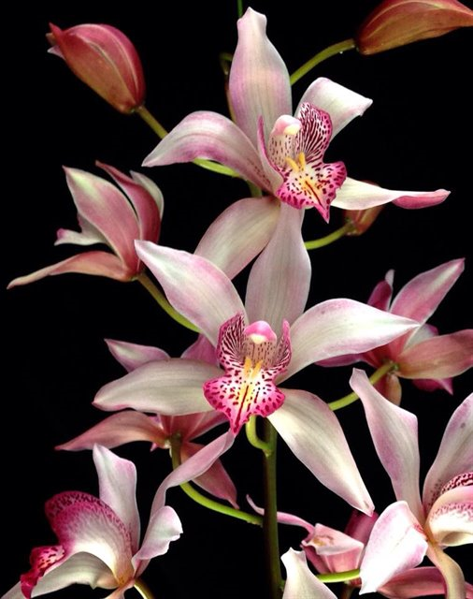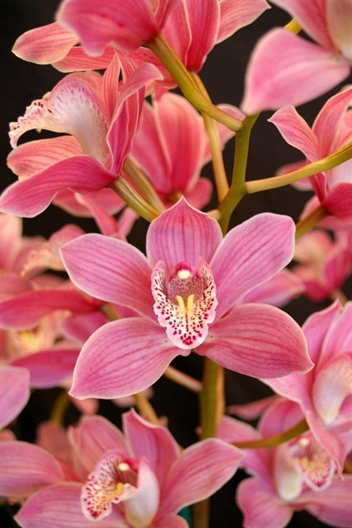
Cymbidium insigne is commonly called the Splendid Cymbidium. Cymbidium insigne is found in southern and central Vietnam throughout most of this mountainous region, particularly the Lang Bian Mountains near Dalat. Seidenfaden (1993) also reported collections from near Chapa in extreme northern Vietnam near the border with China. Plants also occur in the Loei region of northeast Thailand and on Hainan Island, just off the coast of southern China and northern Vietnam. Plants grow in sandy soils of open woodlands at 2,450 to 5,600 feet (750 to 1,700 meters). In Thailand, Cymbidium insigne is found at higher elevations, usually about 4,000 to 5,000 feet (1,220 to 1,520 meters). It blooms in the fall through spring with many flowers. It can have as many as 27 flowers.
This species was first collected in Asia in the year of 1901. Soon after, a finer form of Cym. insigne surfaced and was labeled Cym. insigne Sanderi and was received an FCC. Through the years, Cym. insigne received 9 different RHS awards. The species was almost instantly accepted as the finest among Cymbidiums. The species has exceptionally balanced features without corresponding weaknesses found in other popular Cymbidium species: The colors are pleasing; the shape is relatively full; the inflorescence is unusually long; flowers display well on the upper third of the spike; the substance is good; cut flower with long vase life.
Varieties: Flower with color ranging from nearly white to blush to deep rose.
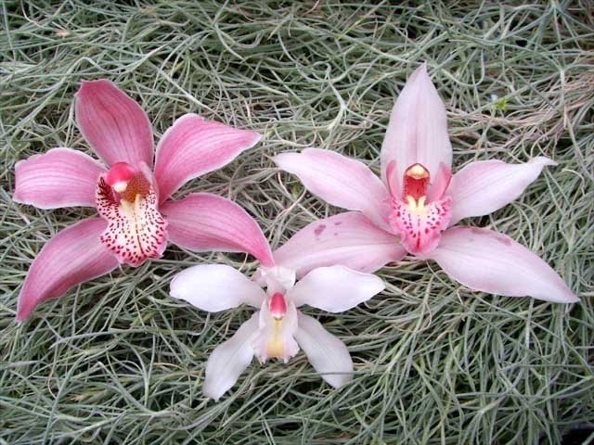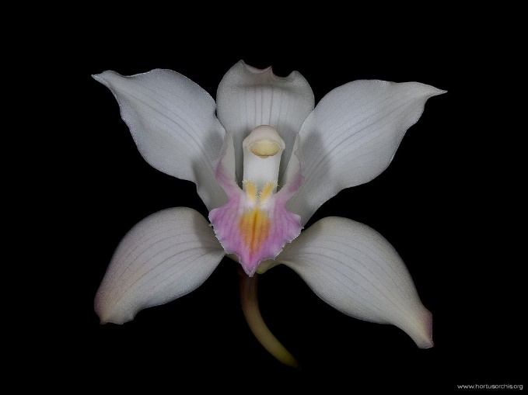
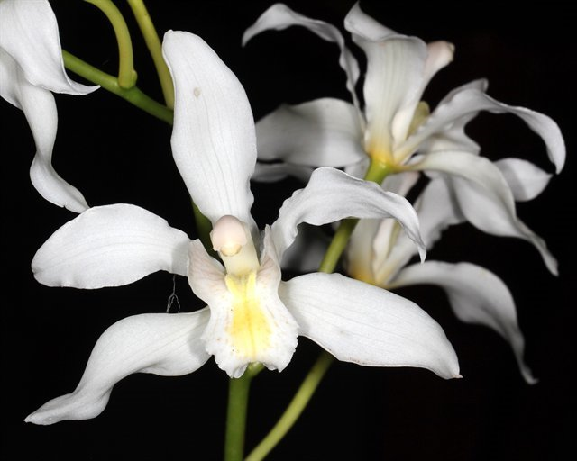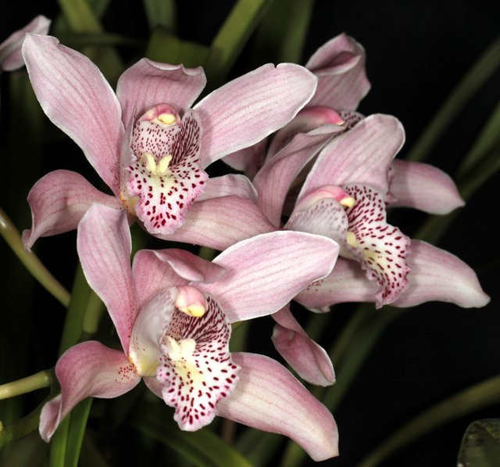
Subspecies seidenfadenii (lip stripped instead of spotted) is now considered a separate species and was not a player in the early hybrids.
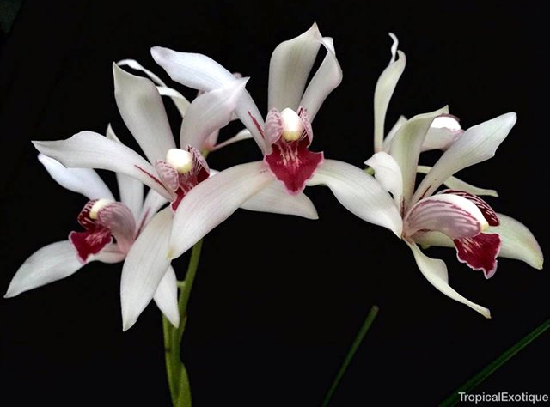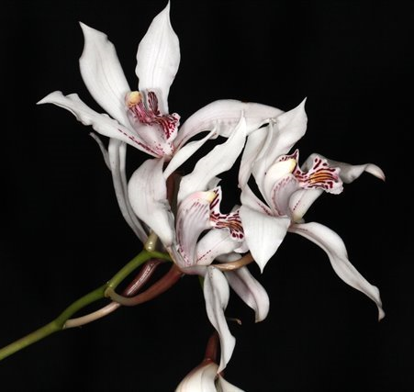
Awards: 1 AM, 4 HCCs
Notable clones including ‘Album’ AM/RHS (1917), ‘Mrs. Carl Holmes’ AM/ RHS (1928), and ‘Bieri’ FCC/RHS (1931). ‘Bieri’ is perhaps the most beautiful of all with remarkable size, richly tinted, thick texture. It is said to be the parent of the famous Cym. Pawwelsii ‘ Comte de Hemptinne’. ‘Bieri’ is a very special plant because it is a naturally occurring triploid that gave rise to
Hybrids: 129 offsprings, 16944 total progeny
Hybrids with Cym. insigne impart many pleasing characteristics without appearing unduly dominant. Primary hybrids with insigne elevate the characteristics of the other parents. Cymbidium insigne hybrids tend to have more compact growth habit with long, narrow, graceful leaves, well displayed erect bloom spike, spotted lip markings, and light floral color. However, there are always exceptions.
The most influential hybrid of Cymbidium insigne is of course, Cymbidium Alexanderi ‘Westonbirt’ FCC/RHS followed by Cymbidium Pauwelsii ‘Comte de Hemptienne’ FCC/RHS. Both are naturally occurring tetraploid. They provided the breakthrough for modern day large many-flowered Cymbidium hybrids in the first half of the 20th century. During the second half, there is a breakthrough of technology to artificially induce tetraploids, more options were available. Still, these two hybrids remains in the background of many modern day Cymbidium.
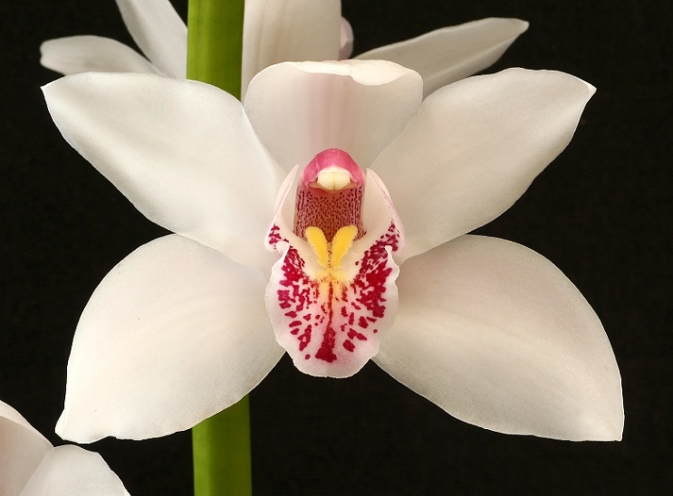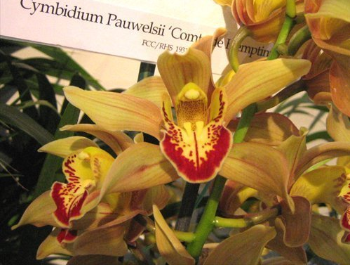
Cym. Pawelsii ‘Comte de Hemptienne’ FCC/RHS
Cym. Alexanderi ‘Westonbert’ FCC/ RHS

Cymbidium Alexanderi ‘Westonbirt’ (Cym. Eburneo-lowianum x Cym. insigne) was considered the finest Cymbidium ever bloomed when it was displayed in 1922. As a parent, it has acted as the perfect dominant parent when it was crossed with other diploids producing beautiful pastel colors. Children of ‘Westonbirt’ generally has free-flowering and free-growing characteristics. During the first half of the 20th century, tetraploid happened by chance. Therefore, ‘Westonbirt’ was one of a kind. Additionally, ‘Westonbirt’ was a tetraploid with double the normal number of chromosomes, resulting in hybrids that are fertile. A notable hybrid of ‘Westonbirt’ is Cymbidium Rosanna ‘Pinkie’ (1926) and it was a tetraploid as well. It makes sense to cross those two tetraploids together. This result in the new standard for the genus: Cymbidium Balkis, particularly the clone ‘Silver Orb’ AM/AOS with its good spike habit, well arranged inflorescences, full flower form, and good flower count. ‘Silver Orb’ as a parent does not dominate so much over the diploid color and often let it come through in the progeny.
Cymbidium Pauwelsii ‘Comte de Hemptinne’ (insigne ‘Bieri’ x lowianum ‘Comte de Hemptinne’) is another of the four great chance tetraploids . It imparts the graceful spike habit of the lowianum parent, and numerous flowers of buff-pink color. Plant is a very vigorous hybrid and has received several cultural awards even recognized by today standard.
Cymbidium Babylon ‘Castle Hill’ FCC/RHS is a chance tetraploid with Cym. Alexanderi as a grandparent and Cym. Pauwelsii as the direct parent. It has medium pink with an exceptionally broad dotted lip, acceptable form (although not as good as Balkis). The main characteristic of this hybrid is the strong vigor often produced large pseudobulbs, strong spikes with long arching sprays of well-arranged blooms. This hybrid is used in breeding where bright colors are desired, especially in the making of reds and dark pinks. When mated with a bright diploids produced light pink to deep red flowers (Cym. La Belle, Cym. Fusilier, Cym. Burgundian, etc…). It also combined well with green and yellow diploids to create exciting colors (Cym. Peach Bloom, Cym. Santa Fe, Cym. Manila, etc…). In addition, Cym. Oriental Legend is a very successful cross between Cym. Babylon ‘Castle Hill’ and a miniature.
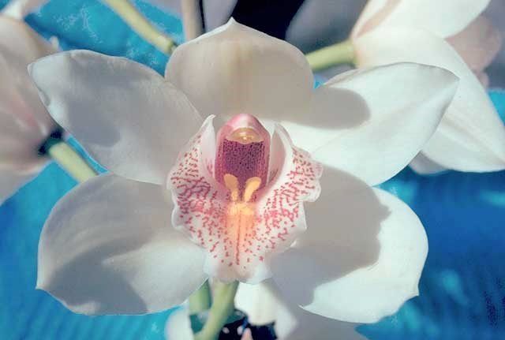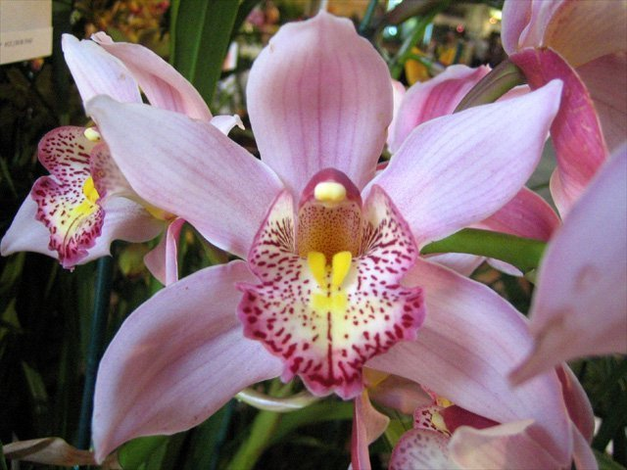
Cym. Babylon ‘Castle Hill’ FCC/RHS
Cym. Balkis ‘Silver Orb’ AM/AOS

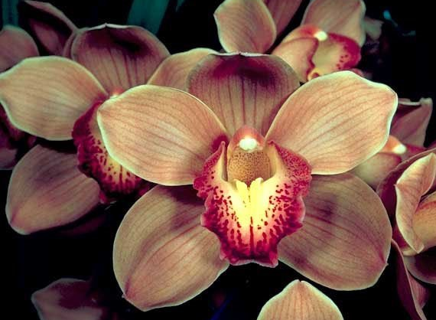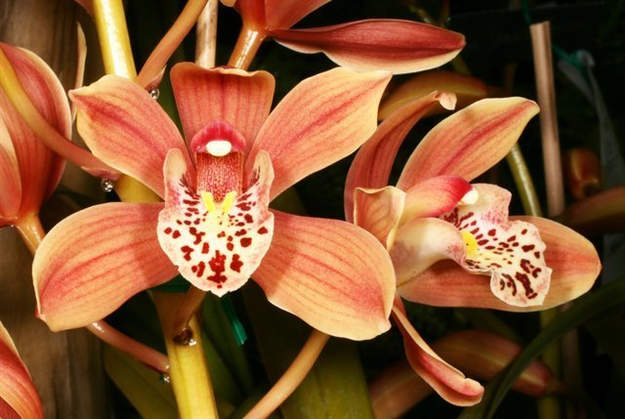
Cym. Burgundian ‘Chateau’ FCC/AOS
Cym. Oriental Legend

Unfortunately, as hybridizing progress, some of the fragrance characteristic is lost as hybridizing continues with the goal of bigger, thicker polyploidy flowers. This does not change the fact that this species is present in almost all Cymbidium breeding lines for a century and the future of this breeding is still continue on until today.
Reference:
OrchidWiz Encyclopedia version 9.1
Orchid Pro Online
http://www.geocities.ws/pennypoint9/pauwelsii.html
Jay Pfahl’s Internet Orchid Species Photo Encyclopedia:
http://www.orchidspecies.com/cyminsigne.htm
American Orchid Society Magazine
Cymbidium Alexanderi ‘Westonbirt’, Issue October 2018, page 2
Cymbidiums – Thoughts on Genetics and Breeding, Issue October 2018, page 42 -47
White Standard Cymbidiums and Charisma, Issue October 2018, page 50-55
Red Cymbidium – A Tale of Three Species, Issue October 2018, page 56-67
The Species of Cymbidium – Cymbidium insigne, Issue February 1952, page 20-22
Seven Cymbidium Stud Plants Every Orchid Grower Should Know, Issue April 1966, page 13-20
Orchid Digest
https://www.orchiddigest.org/cymbidium-insigne/

