BUILDING BLOCK REPORT
Cymbidium sanderae Sander ex Rolfe 1904
Synonym: Cymbidium parishii var. sanderae Rolfe 1904
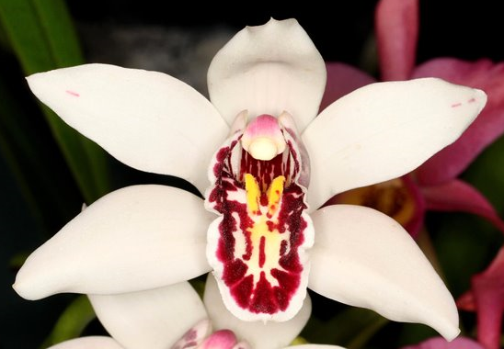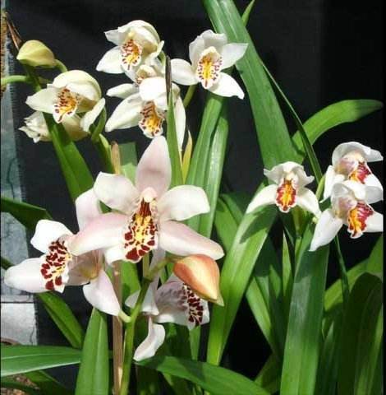
Found in Myanmar in open, humid, evergreen, montane forests on trees as a medium sized, cold to warm growing epiphyte with clustered, ovoid, lightly bilaterally compressed pseudobulbs enveloped basally by several imbricating leaf bases carrying 9 to 15, linear-elliptic, thin textured, tapering to an acute, entire apex leaves articulated to a broad sheathing base, 3.6" [9 cm] from the pseudobulb that blooms on a 12 to 20" [30 to 50 cm] long, sub-erect to arching, 3 to 15 flowered inflorescence with very fragrant flowers occurring in the winter and late spring. It is noted that spikes are formed basally in this species. Upon first discovery at 1904, it was thought to be a superior form of Cym. parishii and was awarded an FCC/RHS and named Cym. parishii var. Sanderae.
This species is often confused with Cym. parishii Rchb.f. 1874. Cym. parishii is often with fewer flower (2-3 instead of 3-15), shorter inflorescences than those of Cym. sanderae. To make matters worse, some of the existing plants might be natural hybrids because of considerable variation when selfed. Furthermore, Cym. parishii is noted to have axial spikes from its pseudobulbs.
Varieties: white with different degree of lip spottings, some are more intense, coalescing into splotches of solid color. There are also varied degree of blushing on the petals.
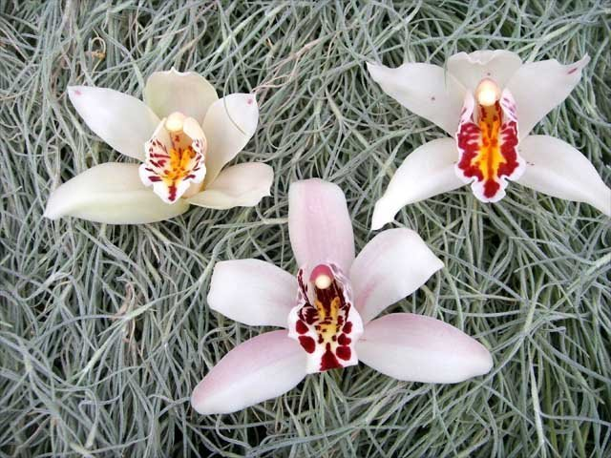

Awards: 1 CHM/AOS in 2022, 2 HCC/AOS (the two HCC award are potentially a hybrids of Cym. sanderae)
Hybrids: 80 offsprings, 13572 total progeny
The original plant collected in 1904 was somewhat an enigma. Despite its unclear origin, it has contribute much in the modern breeding. While the actual number of crosses are small, these small numbers of plants are used again and again to create successful building blocks for future hybrids. The most valuable contributions of Cym. sanderae are the fine form and heavy lip markings. Its form is comparable to those of Cym. insigne but the markings on the lips are far bolder and more pronounced as Cym. insigne could ever be. It seems to breed far more easily to darker colored hybrids in comparing to Cym. insigne which tends to breed pastels. In addition, sanderae hybrids are more vigorous than insigne hybrids. However, it is not without disadvantages, it has fewer flowers than those of Cym. insigne. Cymbidium sanderae is not the most widely influential species in the grand scheme of Cymbidium breeding and only contributes by a small percentage in hybrids genetic makeup. Regardless, one cannot deny the characteristics of sanderae that shows up time and time again even in modern hybrids.
Cym. Dryad (insigne x sanderae) (1914) inherited the best of both parents: good shape, good flower counts, improved lip spottings, good inflorescent habits. This is in the background of many breeding studs in the Cymbidium era including the famous Cym. Rosanna (and subsequently Cym. Balkis), Cym. Miretta in the green breeding lines, Cym. Cym. Sussex Dawn in the yellow breeding lines, and recently Cym. Golden Elf in the majority of the warm tolerant hybrids.
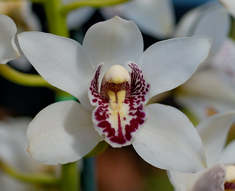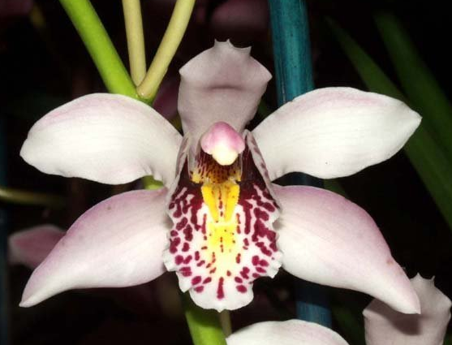
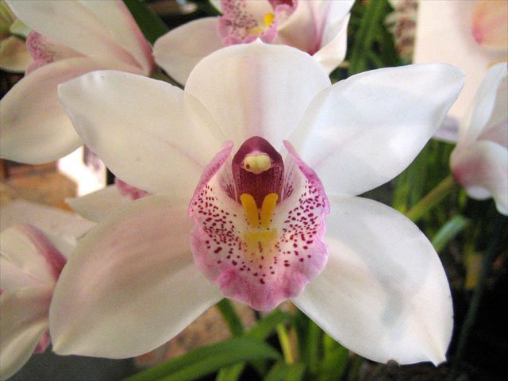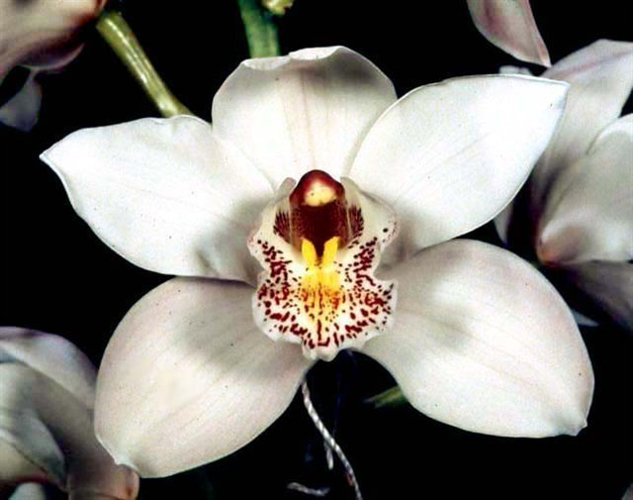
Cym. Rosanna ‘Pinkie’ Cym. Balkis ‘Lovey’
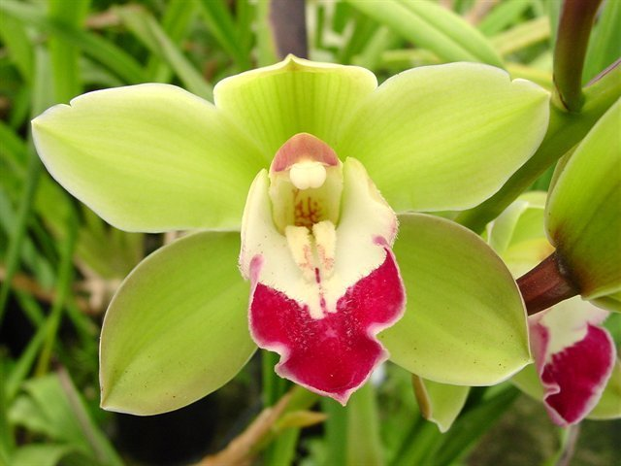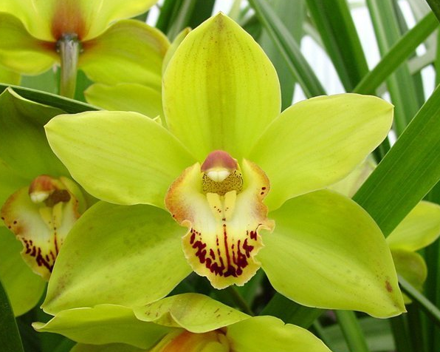
Cym. Miretta ‘Memoria A A McBean’ Cym. Sussex Dawn ‘Dorothy May’
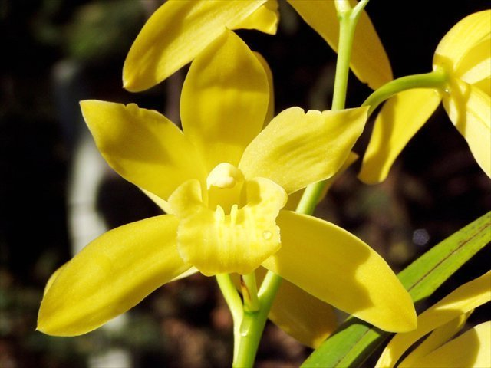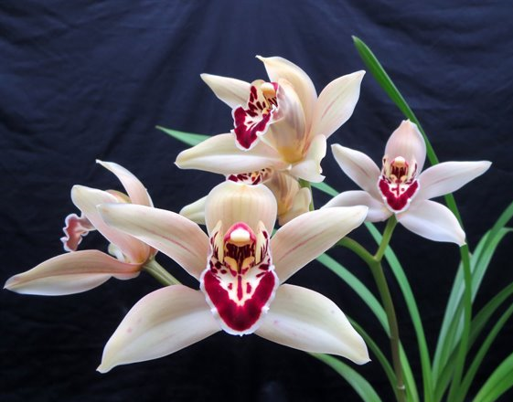
Cym. Golden Elf ‘Sundust’ Cym. Garnet
Similarly, Cym. Garnet (lowianum x sanderae) (1915) improves the shape of the lowianum parent but retain the increased flower counts, good inflorescent habit of lowianum and lend interesting spotting into the solid patch of color of lowianum lip. Cym. Garnet is also in the background of Cym. Miretta, a staple in green breeding line.
Cym. Elfin (sanderae x Pauwelsii) is also very similar to Garnet, giving rise to important building block including the colorful Cym. Cremona which subsequently created Cym. Khyber Pass. Cym. Khyber Pass is an important hybrid because it is in the back ground of Cym. Red Beauty and Cym. Tethys that are used frequently in red breeding lines, Cym. Pinata and Cym. Robin that are used in spotted Cymbidium hybrids.
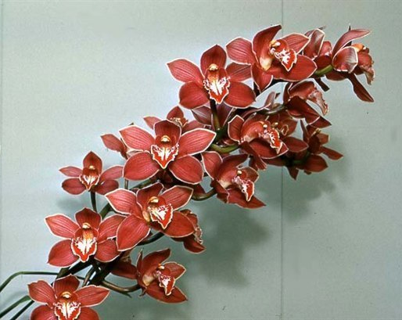
Cym. Cremona ‘Indian Prince’ Cym. Khyber Pass ‘Treva’
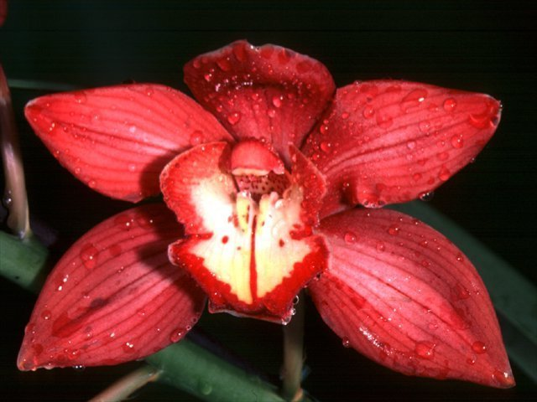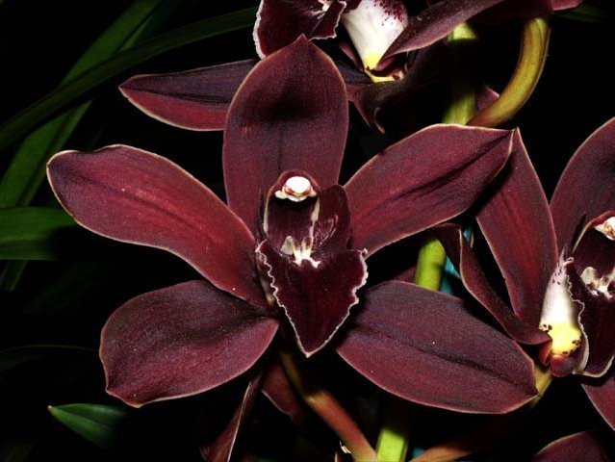
Cym. Red Beauty ‘Evening Star’ Cym. Tethys ‘Brenda Starr’
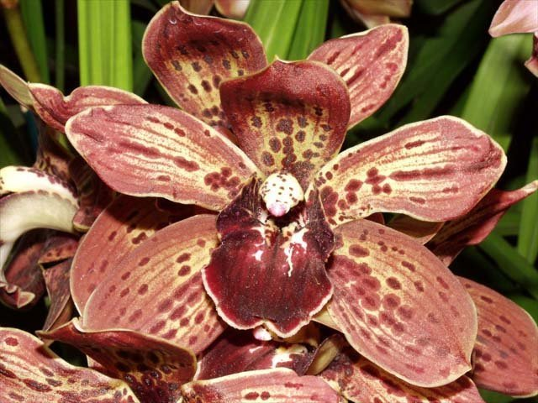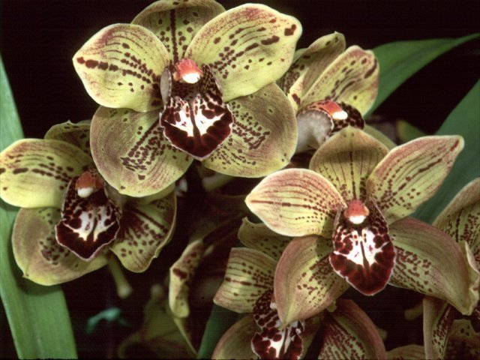
Cym. Pinata ‘Black Hole’ Cym. Robin ‘Freckles’ 4n vs 2n
A surprising non-conventional direction with Cym. sanderae is Cym. Gladys Whitesells (Fifi x sanderae), sought after for the pristine concolor flower of the madidum grandparent and the bold marking of the sanderae parent. New clones continuing to be awarded up until today is proof that this hybrid is a happy marriage of the best qualities of the species in the background.
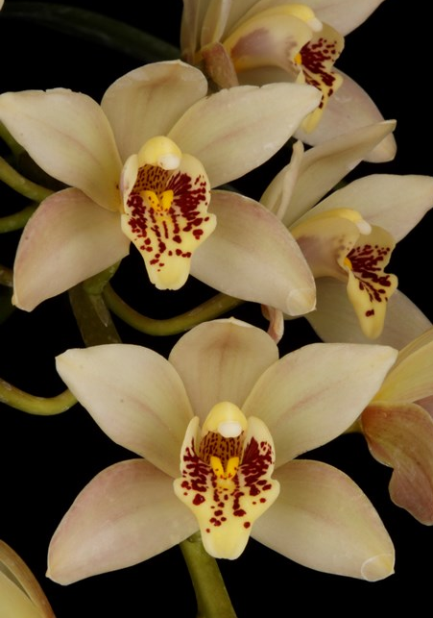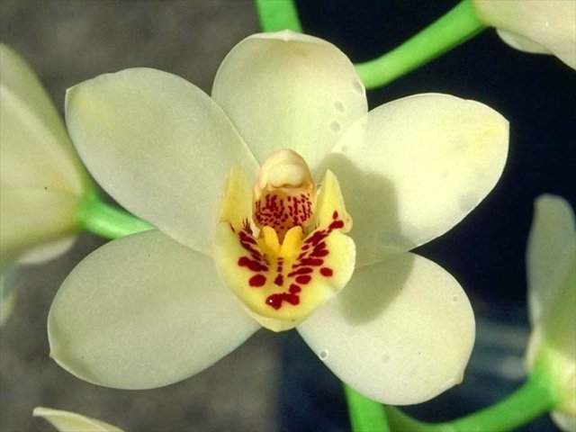
Reference:
OrchidWiz Encyclopedia version 9.1
Orchid Pro Online
Jay Pfahl’s Internet Orchid Species Photo Encyclopedia:
http://www.orchidspecies.com/cymsanderae.htm
American Orchid Society Magazine
Parishii Regained, Issue October 1965, page 18-23
The Species of Cymbidium: Cymbidium Parishii var. Sanderae, Issue April 1952, page 24-25

