SPECIES DATA SHEET
Cymbidium sinense Willd 1805
Synonym: Cymbidium albojucundissimum Hayata 1914 ; Cymbidium chinense Heynh. 1841; Cymbidium fragrans Salisb. 1812; Cymbidium hoosai Makino 1902; Cymbidium hoosai f. hakuran Makino 1902; Cymbidium sinense f. albojucundissimum (Hayata) Fukuy.1932; Cymbidium sinense f. aureomarginatum T.C.Yen 1964; Cymbidium sinense f. pallidiflorum (S.S.Ying) S.S.Ying 1990; Cymbidium sinense f. taiwanianum (S.S.Ying) S.S.Ying 1990; Cymbidium sinense f. viridiflorum T.C.Yen 1964; Cymbidium sinense var. albojucundissimum (Hayata) Masam. 1933; Cymbidium sinense var. album T.C.Yen 1964; Cymbidium sinense var. bellum T.C.Yen 1964; Cymbidium sinense var. margicoloratum Hayata 1916; Cymbidium sinense var. pallidiflorum S.S.Ying 1987; Cymbidium sinense var. taiwanianum S.S.Ying 1987; *Epidendrum sinense Andrews 1802

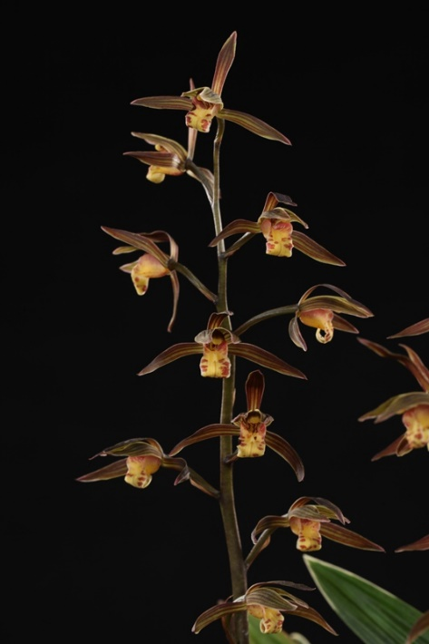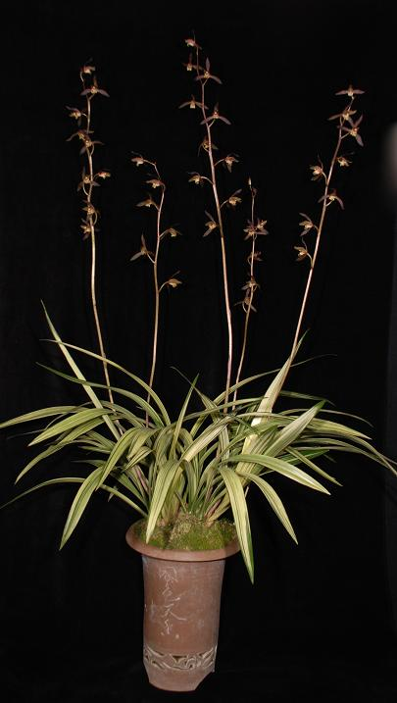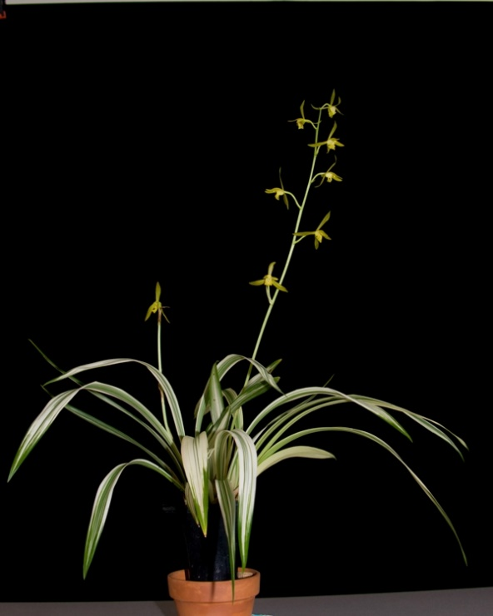
This is a Chinese and northern Vietnam, miniature sized, warm to cold growing, terrestrial, highly variable species occurring in lowland forests in rich humus in damp crevasses or in soils dampened by mists and splash along steep watercourses that is a and has ovoid pseudobulbs carrying narrow-linear, glossy leaves and blooms with a basal, erect, 2' 10" [to 80 cm] long, many [20] flowered, racemose inflorescence with overlapping sheaths and fragrant light sweet floral scented flowers held well above the leaves occurring in the fall through spring.
This species has been known and cultivated more than 2 centuries in the West. However, in Asia, Cymbidium in the Jensoa subsection has become a part of history even before the establishment of the Western civilization. This particular species are called Mo Lan (dark orchid). Plants are praised for its richly fragrant flowers, highly variegated foliage, and elegant, graceful habit. They are typically grown in tall narrow decorated pot. Cymbidium sinense is considered the easiest to grow indoor on the windowsill.
Varieties: var. album. There are also many distinct named variations that are defined by the color of the flowers, postures of the leaves, leaf coloration and variegation. Pure color flower and variegated leaf are the most sought after. Color of the flower can range from almost black (‘San Chuan’) to pure yellow (‘Wu Tsu Tsai’) to almost pure white (‘Pai Mu Su’)
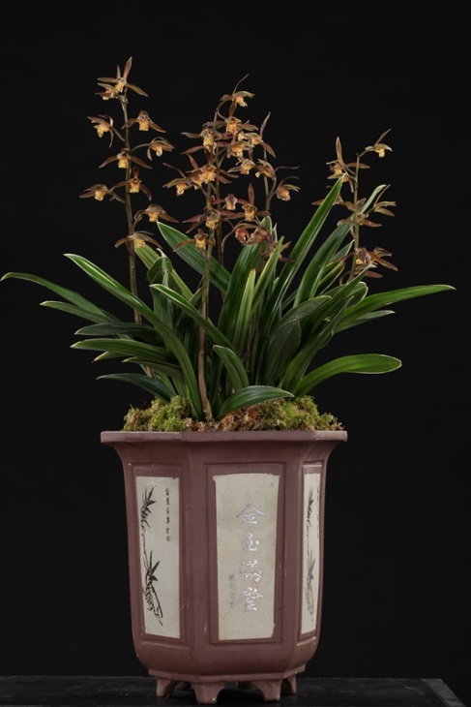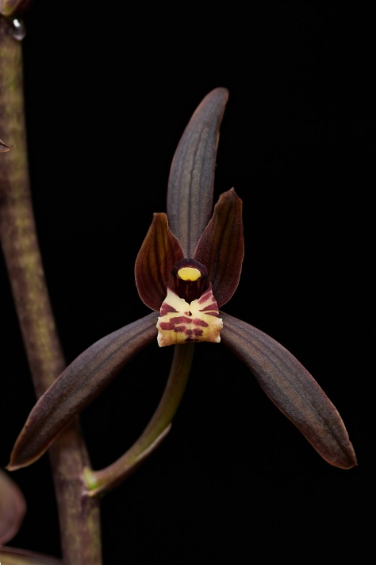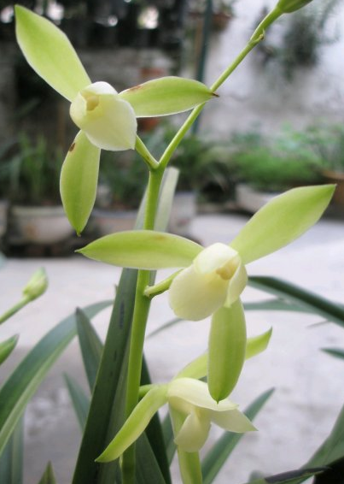
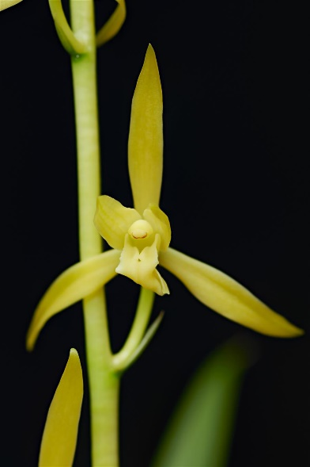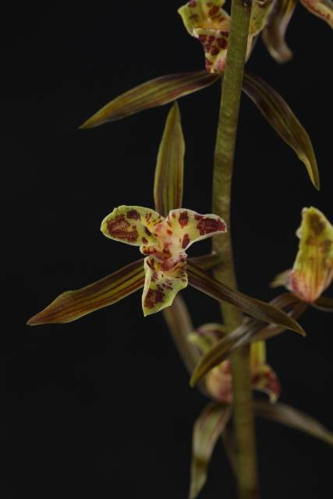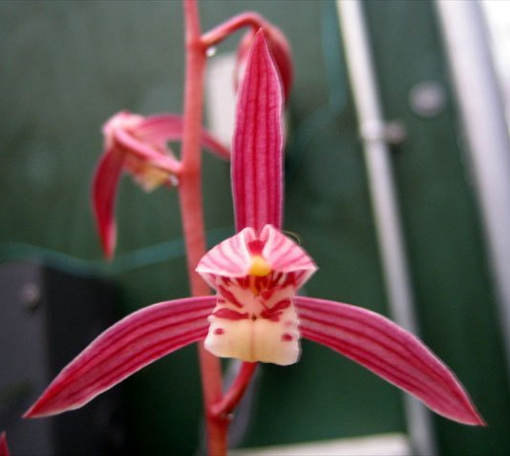
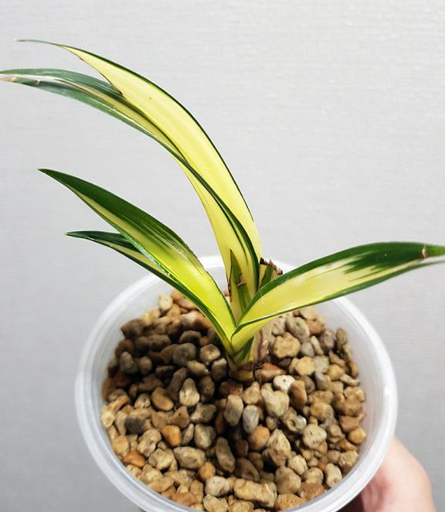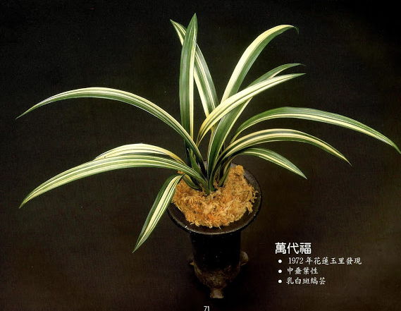
Awards: 4 AMs, 15 HCCs, 1 CCE, 3 CCMs, 9 JCs, 1 CBM, 5 CHMs
Hybrids: 126 offsprings, 294 total progen
Advantage of using Cym. sinense is the longer, upright inflorescence, higher flower count than most of other species in section Jensoa, pleasant fragrance, warm growing characteristic . The blooming of this species is extremely variable. Plant size can vary as large as a standard cymbidium down to half as large. This species can be used to impart warmth tolerance and size reduction to the standard Cymbidium hybrids.
Reference:
OrchidWiz Encyclopedia version 9.1
Orchid Pro Online
Jay Pfahl’s Internet Orchid Species Photo Encyclopedia:
http://www.orchidspecies.com/cymbsinense.htm
American Orchid Society Magazine
Chinese Cymbidium species, Issue July 1999, page 12 - 23
Cymbidium section Jensoa – Its species and some of their hybrids, Issue October 2018, page 30 -41

