The Genus Cymbidium
Swartz 1799
Type species: Cymbidium aloifolium
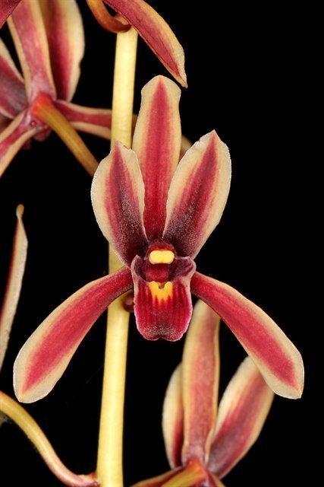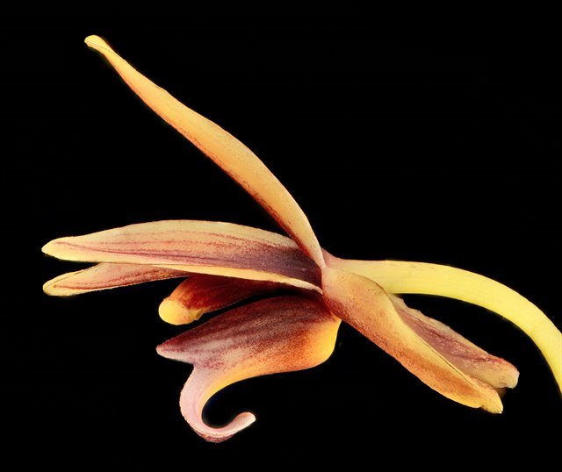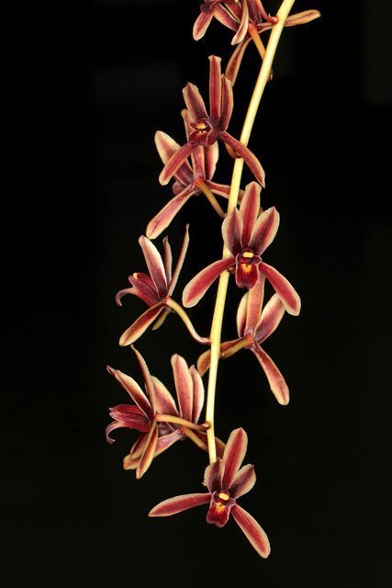
Cymbidium or the “Boat orchid” contains about 86 species, found through Asia and the Pacific Islands. The genus name Cymbidium is derived from the Latin word cymba meaning "cup" "bowl" or "boat" with the diminutive suffix –idium, hence "little boat", apparently in reference to the shape of the labellum in some species. Their hybrids are widely utilized in commercial industry. They are divided into three basic groups. The first group are the large flowered species that are found in the Himalayas and higher elevations of China and they require a pronounced cool period to initiate flowering. The second group grows in cool to intermediate temps year round and does not need a distinct cool snap to flower. The third and last group are the warm growing tropical plants that require year round warm temps and because of their pendant inflorescence are best planted in hanging wire baskets.
Plants in the genus Cymbidium are epiphytic, lithophytic or terrestrial plants, or rarely leafless saprophytes. All are sympodial evergreen herbs. Some species have thin stems but in most species the stems are modified as pseudobulbs. When present, there are from three to twelve long, ribbon-like leathery leaves arrange in two ranks and last for several years. The leaf bases remain after the leaf has withered, forming a sheath around the short and robust pseudobulb. The flowers are arranged on an unbranched flowering stem which arises from the base of the pseudobulb or rarely from a leaf axil. Inflorescences can be erect or pendent
Cymbidium’s often large and showy flowers have free, spreading or erect, fleshy/waxy sepals and petals, a 3 lobed, sessile (immobile, attached directly without a peduncle) lip with a short column foot with the lateral lobes erect around the column, the midlobe recurved and a disc with 1 to 3, glabrous (smooth) or pubescent ridges. The column is elongate, has 2 deeply grooved or 4 subglobose to pyramidal pollinia attached to the broad viscidium by a short caudicle.
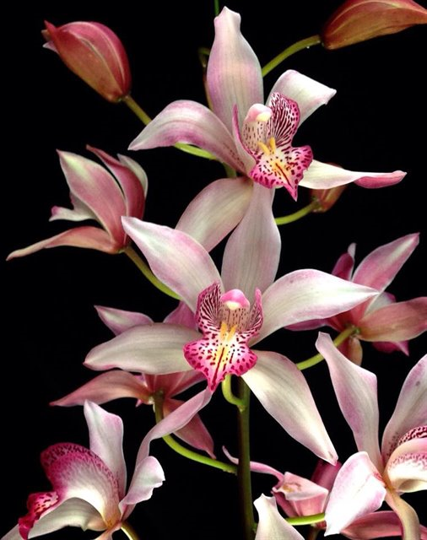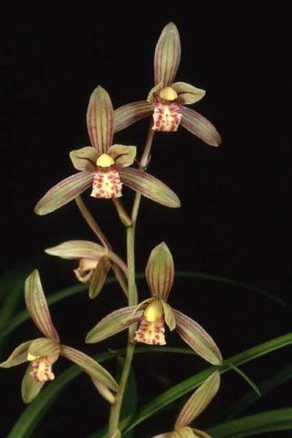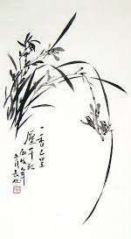
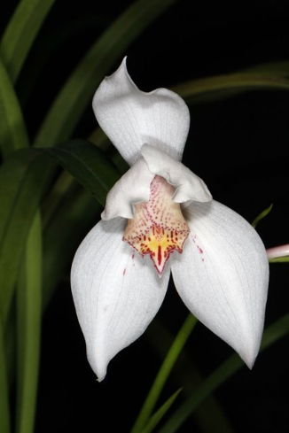
The Sections of Cymbidium according to Cribb & Du Puy 2007
- SECTION Annamaea Hunt 1970
A monotypic section characterized by the short triangular mid-lobe of the lip, an inflorescence that arises on immature growths, long bracts, an erect dorsal sepal, decurved lateral sepals, porrect petals that cover the column, the side lobes of the lip clasp the top of the purple pink column, which has a dense, ventral indumentum having long hairs and lastly the wedge shaped callus ridge structure on the lip.
    - Cym. erythrostylum

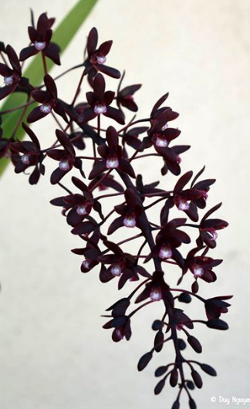
- SECTION Austrocymbidium Schlechter 1924
This section is characterized with difficulty as all three species have only a few of each of these characteristics between them but as a group they share many of the different affinities tying them together. The section has leaves articulated close to the pseudobulb and has many close set, mostly yellowish to greenish flowers on a pendant inflorescence with broad, mostly broader than the petals, obovate to oblong-elliptic, rounded to obtuse apically sepals and a small, narrow side lobed lip with a short column carrying 2 ellipsoidal, parallel pollina.
    - Cym. canaliculatum
    - Cym. madidum
    - Cym. suave

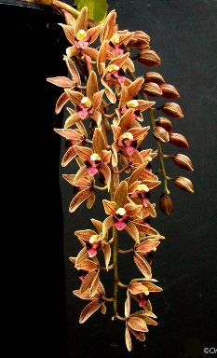
- SECTION Bigibbarium Schlechter 1924
A monotypic section that differs in it leaves that have a broad, elliptic lamina narrowed below into a slender petiole. The petals of the flowers are rhombic and most of the lip has 2 small swellings replacing the callus ridges, and the lip midlobes have a dot each at the base and there is a short column foot
    - Cym. devonianum

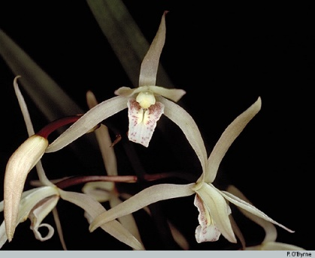
- SECTION Borneense Du Puy & Cribb 1988
Characterized by having elliptical stomatal coverings and narrow, slit-shaped aperatures, coriaceous, acute apically leaves and 4 pollina instead of the normal 2 cleft pollina.
    - Cym. aliciae
    - Cym. borneense

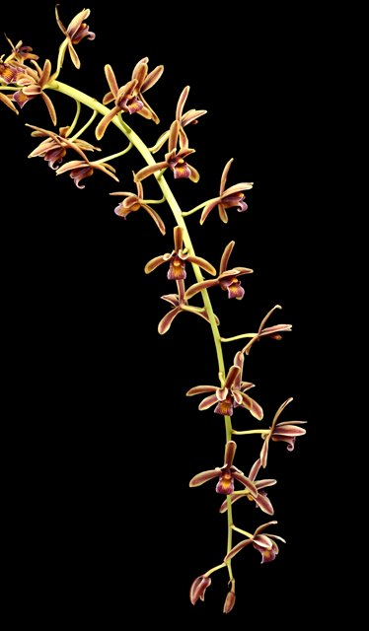
- SECTION Cymbidium Hunt 1970
Characterized by thick, often ligulate leaves with obtuse to emarginate, bilobed apices and pendulous to arching, or rarely suberect inflorescence with small well-spaced flowers. The flowers are cream to greenish with red to brown markings and the leaves have elliptical stomatal coverings and narrow, slit-shaped aperatures.
    - Cym. aloifolium
    - Cym. atropurpureum
    - Cym. bicolor
    - Cym. crassifolium
    - Cym. findleysonianum
    - Cym. rectum

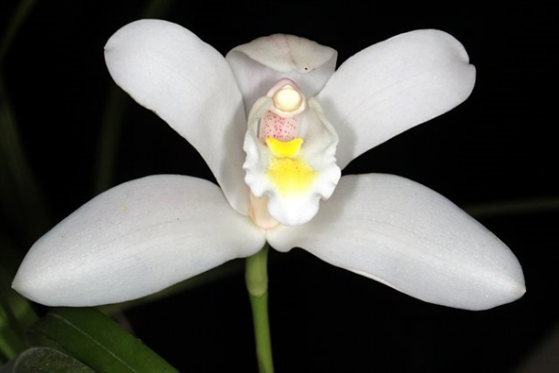
- SECTION Cyperorchis Hunt 1970
The Section is characterized by the narrow, hyaline, incurved, leaf margins that appear acuminate in transverse section, has relatively large flowers with acute sepals and petals,and a porrect dorsal sepal that tends to cover the column which is fused to the base of the lip for about 2 to 6 mm.
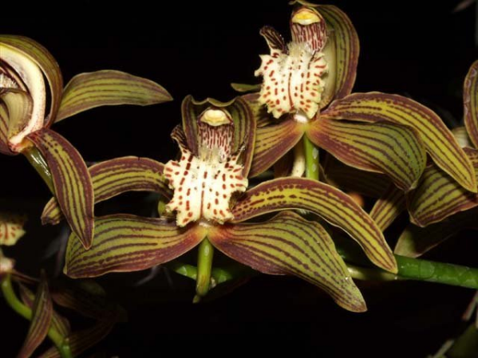
    - Cym. eburneum
    - Cym. erythraeum
    - Cym. insigne
    - Cym. lowianum
    - Cym. parishii
    - Cym sanderae
    - Cym. tracyanum
    - …

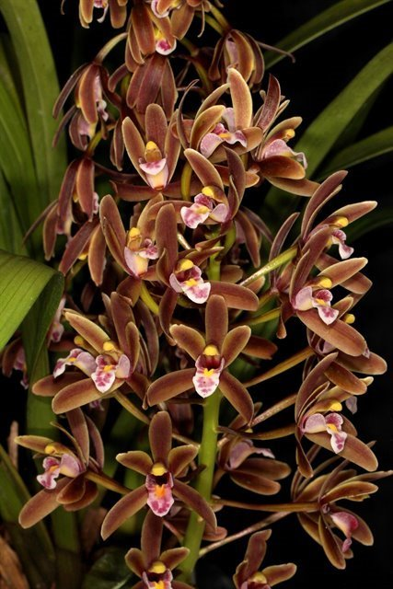
- SECTION Floribundum Seth & Cribb 1984
The Type of this section is Cym. floribundum and the section is characterized by having 15 to 50, closely spaced flowers on short, suberect inflorescence. The flowers have sepals and petals with obtuse apices [except Cym. elongatum whose placement in this section is not secure], the lip has broad side lobes with rounded apices and a broadly ovate mid-lobe. This section has similarities to the section Austrocymbidium such as the coriceous leaves, the close set flowers on short inflorescence, the obtuse sepals and petals with a greenish tint and the ellipsoidal pollina. In fact many of the species in this section [Cym. chloranthum, Cym. hartinahianum and Cym. elongatum] were formerly included in the section Austrocymbidium. Of all the species in this section, Cym. elongatum is the most tentative as it has an elongated monopodial stem and a short lateral inflorescence.

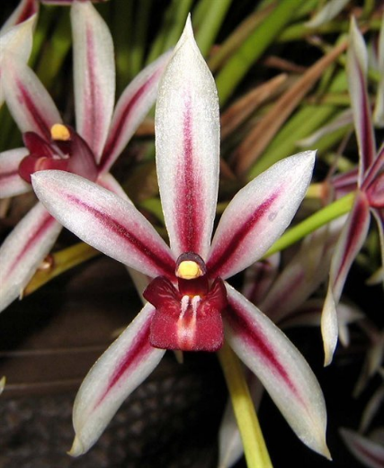
- SECTION Himantophyllum Schlechter 1924
A monotypic section that differs in its slender, acuminate leaves as in C ensifolium of the Section Jensoa but it does not have the acuminate leaf margins in cross-section and has maroon & white flowers with sharply acute sepals and petals, decurved sepals and forward pointed petals somewhat forming a hood over the column which is not fused basally to the lip that also has 2 pubescent callus ridges made up of glandular hairs with swollen tips which is unique to the genus, giving the single species it's sectional status.
    - Cym. dayanum

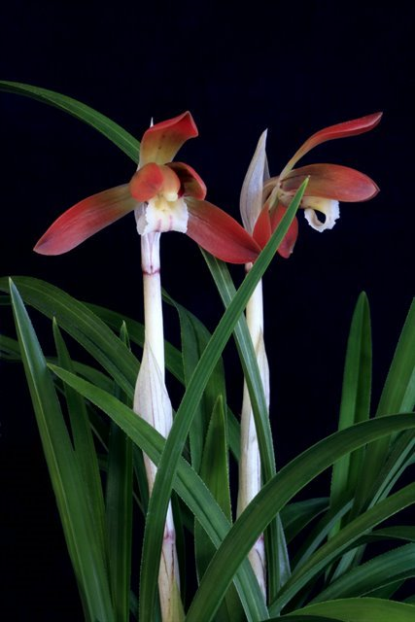
- SECTION Jensoa [Raf.] Schlechter 1924
This section is characterized by terrestrial species with flowers carrying 4 pollina in 2 unequal pairs and a lip with 2 callus ridges converging towards the apex making a short tube at the base of the mid-lobe. The leaves have a papillose on the abaxial, epidermal suface of the leaf and the stomatal coverings are circular and project beyond the surface of the epidermis. The seed is elongate and thread-like and the seed capsules are erect instead of pendulous.
    - Cym. ensifolium
    - Cym. goeringii
    - Cym. faberi
    - Cym. kanran
    - Cym. sinense
    - ….

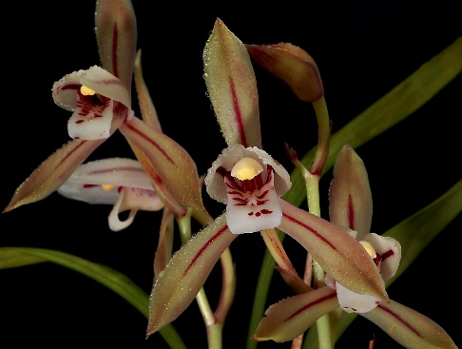
- SECTION Pachyrhizanthe Schlechter 1924
This section includes two species, Cymbidium macrorhizon differs from all the other in the subterranean rhizome, lacking leaves, pseudobulbs or roots, the second member of this section, C lancifolium has pseuodobulbs but has flowers very closely related to C macrorhizon, but related in flower form to Section Jensoa

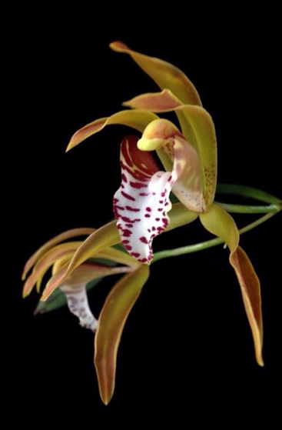
- SECTION Parishiella Hunt 1970
A monotypic section with a very distinctive species characterized by round to broadly ovoid, naked pseudobulbs without leaf sheaths and carrying 2 to 4 apical leaves and blooms on a basal, lateral 2 to 5 flowered inflorescence and spidery appearing flowers with porrect petals and a lip with a rectangular, cuspidate mid-lobe with unusual markings. The lip and column are fused.
    - Cym. tigrinum

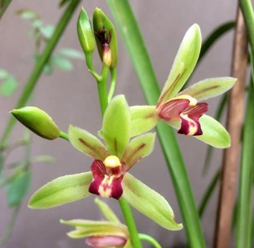
- SECTION Repens
A monotypic section separated because of the vine like rhizome with non-pseudobulbous stems.
    - Cym. repens

Significant species | Offspring/Progeny | Awards
Cym. floribundum* | 285/4241 | 3 CCMs
Cym. devonianum* | 230/1197 | 1 AM, 1 HCC, 2 CCMs, 1 CCE
Cym. insigne* | 129/16944 | 1 AM, 4 HCCs
Cym. tracyanum* | 127/12291 | 1 AM, 9 HCCs, 1 CCM, 3 JCs
Cym. sinense | 126/294 | 4 AMs, 15 HCCs, 1 CCE, 3 CCMs, 9 JCs, 1 CBM, 5 CHMs
Cym. lowianum* | 122/16823 | 1 AM, 3 HCCs, 2 CCMs, 1 CBR, 2 CHMs
Cym. erythrostylum* | 95/8651 | 2 AMs, 2 HCCs, 1 CCM, 1 CBM
Cym. goeringii | 94/205 | 20 AMs, 15 HCCs, 2 CCMs, 2 JCs, 1 CBM, 6 CHMs
Cym. madidum | 85/506 | 3 AMs, 3 HCCs, 1 CCE, 3 CCMs
Cym. sanderae* | 80/13572 | 1 HCC
Cym. ensifolium* | 79/1406 | 5 AMs, 10 HCCs, 5 CCMs, 2 JCs, 2 CHMs
Cym. canaliculatum | 76/108 | 4 AMs, 10 HCCs, 5 CCMs, 2 JCs, 2 CBMs, 1 CHM
Cym. eburneum* | 68/16578 | 1 AM, 2 HCCs, 3 CCMs, 2 JCs
Cym. hookerianum* | 54/14644 | 2 AMs, 3 HCCs, 1 CBR
Cym. iridioides* | 27/6965 | 1 CHM
Cym. parishii | 53/241 | 1 HCC, 1 JC
Cym. tigrinum | 52/220 | 3 HCCs, 2 CCMs
Cym. dayanum | 40/72 | 4 CCEs, 4 CCMs, 1 JC, 1 CHM
Cym. suave | 40/84 | 1 AM, 1 HCC
Cym. mastersii* | 36/1263 | 1 CBR, 1 CHM

Reference:
OrchidWiz Encyclopedia version 9.1
Orchid Pro Online
Wikipedia Encyclopedia
https://en.wikipedia.org/wiki/Cymbidium
Jay Pfahl’s Internet Orchid Species Photo Encyclopedia:
http://www.orchidspecies.com

