WHITE STANDARD CYMBIDIUMS

The breeding of white Cymbidium has come a long way since the world started paying attention to the genus. In fact, the genus notoriety exploded with the conception of the wildly famous hybrid Cym. Alexanderi ‘Westonbert’ FCC/RHS. The most widely grown white Cymbidium grex today is Cymbidium Jungfrau ‘Dos Pueblos’ AM/AOS (1958), direct descendant of Alexanderi ‘Westonbert’. Beside being a success in shows over 60 years ago, it is also the most widely grown commercial hybrid into today. However, Jungfrau is not a successful parent because it is suspected to be either triploid or aneuploid. In order to improve on Jungfrau, it will have to be another breeding line.
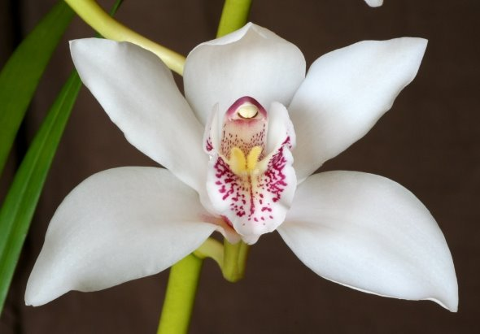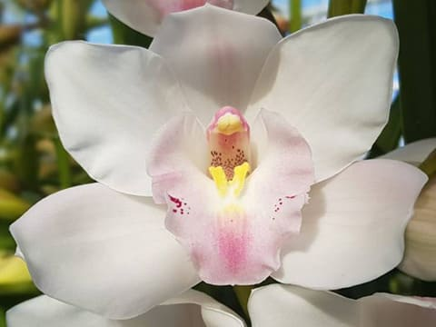
Cym. Alexanderi ‘Westonbert' Cym. Jungfrau ‘Dos Pueblos’
There are several problems that white breeding lines faces: the white color is not exactly white, they are rather cream, off-white, or blush; whites are often sun-tanned readily developing red or pink coloration on the outer sepals; whites are stained, blemished, spotted, bruised easily, and are susceptible to cold temperature. The current expectation of new hybrids in the breeding lines are: flat, non-cupping (especially dorsal), full, very round flowers that open well, with pristine and non-staining white on contrasting lips, preferably with heavy substance resisting bruising and spots, preferably heat-resistant without dropping buds, preferably full-sized flowers on compact plants and long inflorescences that hold flowers well
Species contribution:
Cym. eburneum: Pure white, well-shaped flowers with heavy substance. Some are rosy flush. Lip without any markings except for the bright yellow keels. The flowers of this species has shape that resemble modern hybrids more than any other species. It is also a hard to grow species, tend to lack vitality, small and thin habit with usually 1-3 flowers at most per inflorescence. Only lightly scented. This species tend to reduce flower counts of its hybrids and wash out lip colors if any. It is still widely used to the good shape and heavy substance and the only elusive white Cymbidium flower at the time.
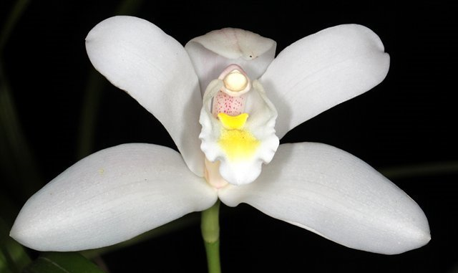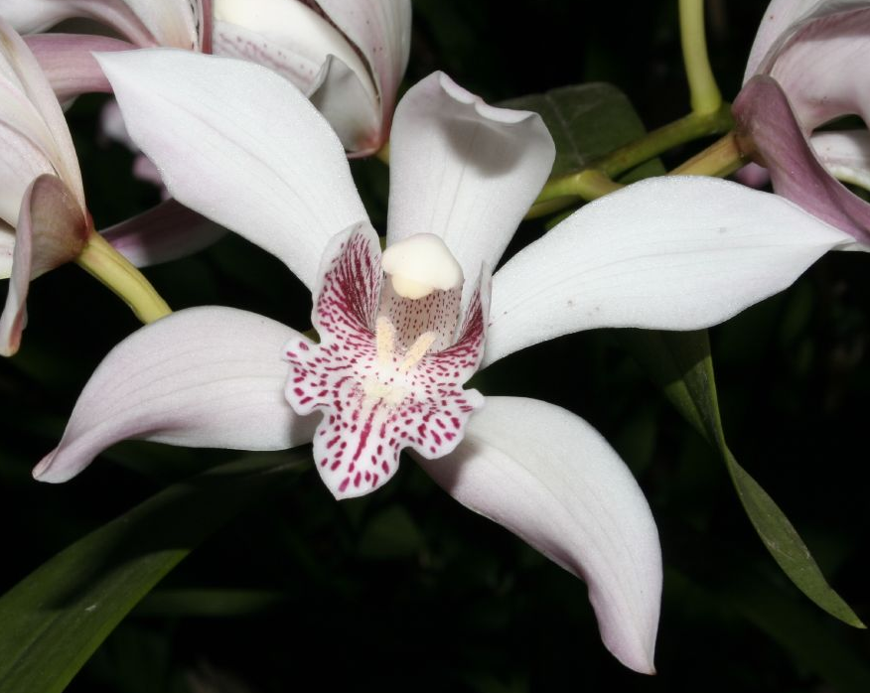
Cym. eburneum Cym. insigne
Cym. insigne: has many color forms including pure alba and white with spotted lip. The species has exceptionally balanced features without corresponding weaknesses found in other popular Cymbidium species: The colors are pleasing, whites are pristine; the shape is relatively full; the inflorescence is unusually long; flowers display well on the upper third of the spike; the substance is good; cut flower with long vase life. Hybrids with Cym. insigne impart many pleasing characteristics without appearing unduly dominant. Primary hybrids with insigne elevate the characteristics of the other parents. Cymbidium insigne hybrids tend to have more compact growth habit with long, narrow, graceful leaves, well displayed erect bloom spike, spotted lip markings, and light floral color.
Cym. sanderae: The most valuable contributions of Cym. sanderae are the fine form and heavy lip markings. Its form is comparable to those of Cym. insigne but the markings on the lips are far bolder and more pronounced as Cym. insigne could ever be. In addition, sanderae hybrids are more vigorous than insigne hybrids. They are also somewhat heat tolerant as well. However, it is not without disadvantages, it has fewer flowers than those of Cym. insigne.
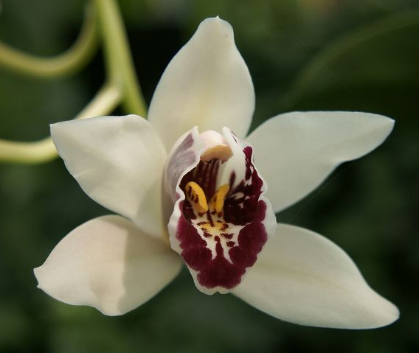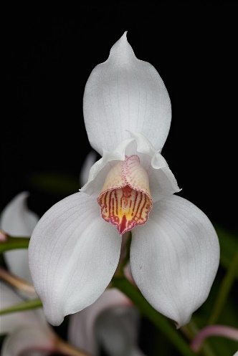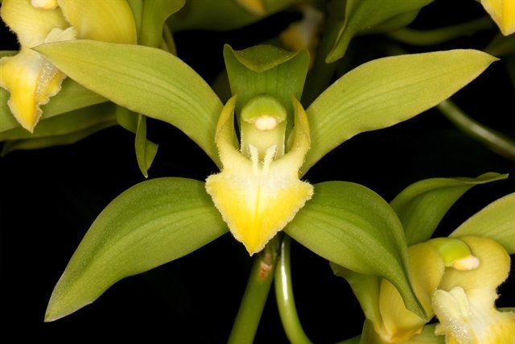
Cym. sanderae Cym. erythrostylum Cym. lowianum var. concolor
Cym. erythrostylum: Has good flower count per inflorescence, unusual porrect petals and down-swept lateral sepals with small labellum. Down-swept lateral sepal are full and well displayed, a useful characteristic that can be used to combat the forward-swept stance of Cym. eburneum. Flowers are pristine white, an important characteristic. Plants are also early blooming, smaller growing, resilient, reliable bloomer on each new growth, unique lip markings; those are useful characteristics in Cymbidium breeding. Disadvantages are small and oddly shaped lips, small and porrect petals that appears closed, lighter substance, smaller flower size and sepals tendency to twist.
Cym. lowianum, while typically not a white flower, it present in many modern white breeding due to the popularity of Cym. Alexanderi ‘ Westonbert’. There are many merits to Cym. lowianum in Cymbidium breedings. It can carry multiple flowers (up to 40) on a spike, free flowering, easy to grow, well-spaced flowers nicely arranged on long arching stems. The green color is not very persistent in breeding, therefore removal of green color in white breeding is the matter of selections. The red V-shape pattern on the lip however persists through multiple generations. Disadvantage: Open form, large plant.
Modern white Cymbidium breeding:
Cymbidium Cronulla ‘Charisma’ is a cornerstone hybrid that present in many of the world show-worthy Cymbidium grexes. This has heavy and tough substance, flat, round shape and non-staining ivory color. Even when it flowers during the dimmest time of the year, it still put out spikes with 20 or so good sized flowers. Plant is vigorous and free flowering and not very large. Those traits make ‘Charisma’ a valuable parent.
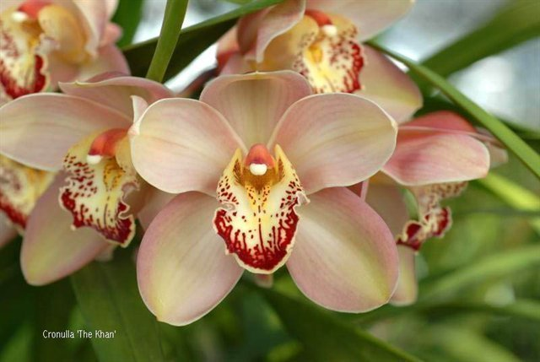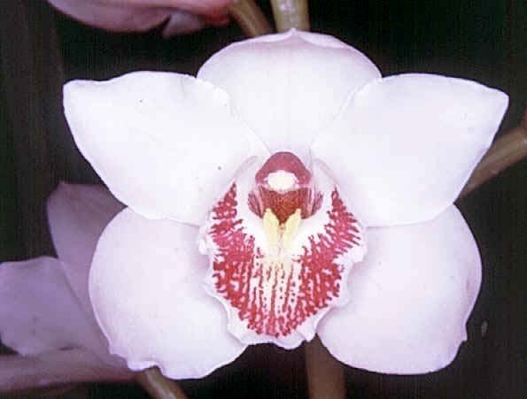
Cym. Cronulla ‘The Khan’ Cym. Joan of Arc ‘White Falcon’
Cymbidium Joan of Arc ‘Olivine May’ is an older variety that is almost entirely line bred from Alexander ‘Westonbert’. It was a beautiful flower but like all tetraploid in the era, it was not very vigorous and only put out roughly 10 flowers per spike. In addition, it also has staining on the sepals, a flaw modern hybrids are heading away from.
Cym. Joan’s Charisma is the perfect marriage between Cronulla and Joan of Arc. From this cross, there was a standout clone ‘Vanity’. It has a perfectly white, crystalline, non-staining sepals and petals with non-cupping shape and good flower size. Flower substance is tough and bruise resistant. It inherits the vigor and flower count of Cronulla making this clone the perfect white Cymbidium for cut flower industry. In Neitherland and New Zealand, it has been widely used as cut flower and rise in popularity rival Jungfrau. To top it off, This is also proved to be a fantastic parent of early to mid season white Cymbidiums. Popular daughters of ‘Vanity’ includes Cym. China Lady, Cym. Joan’s Era, Cym. Vanity Fair, Cym. Kulnura Cherish, etc…

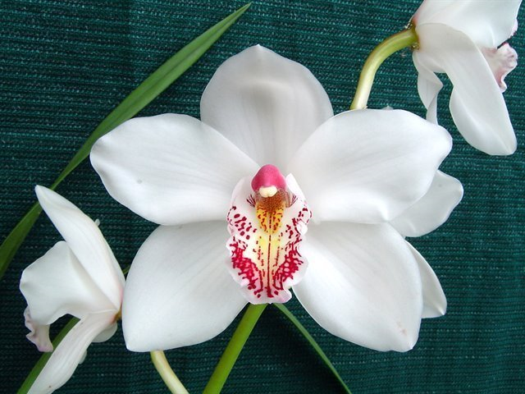
Cym. Joan’s Charisma ‘Vanity’ Cym. China Lady ‘The Pearl’
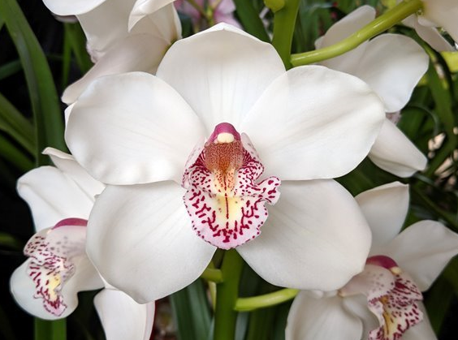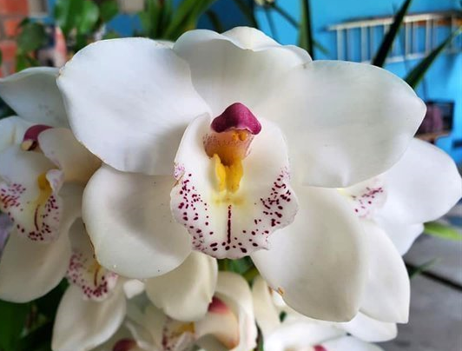
Cym. Vanity Fair ‘Hollywood’ Cym. Kulnura Cherish ‘One’
Second generation of Joan’s Charisma ‘Vanity’ continues to produce spectacular results. These are Laramie Angel, Cronulla Era, Paradise Albany
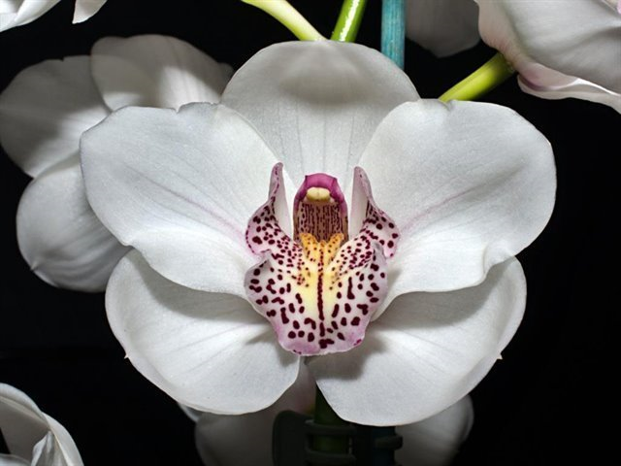
Cym. Paradise Albany ‘Benny’ HCC/AOC Cym. Cronulla Era ‘Kouri’
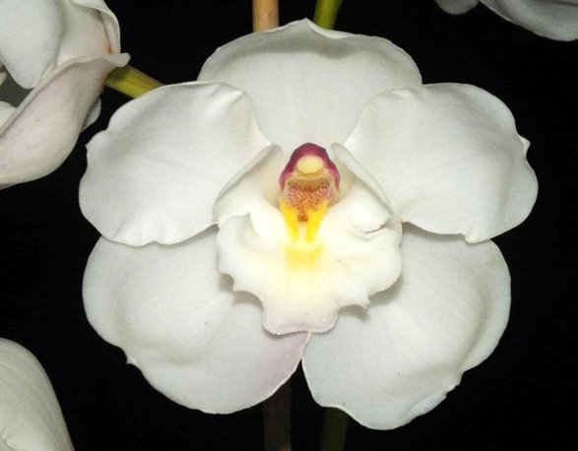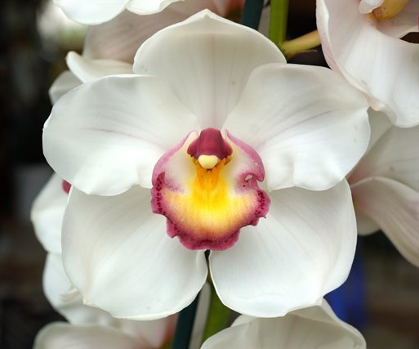
Cym. Kuranulla ‘Meastro’ HCC/AOC Cym. Laramie Angel ‘Tee Pee’ HCC/OSCOV
On an entirely separate breeding line of Cronulla without Joan’s Charisma ‘Vanity’, we have Cym. Kuranulla. ‘Meastro’ was a standout because it has very nice round flowers and nice broad white lips on free flowering, miniature sized plants. However, this clone has flowers that are quite cupped. Cym. Laramie Angel is a fine example of the combination of these two fine lineages. Flowers on these are open, full sized, voluptuous, pristine white, born on very compact plants and bulb size.
Cym. Cronulla Star is the other breeding line without either Joan’s Charisma ‘Vanity’ or Joan of Arc ‘Olivine May’. The clone ‘Booty’ is the finest and it has produced fine results when used as a parent. When crossed with its sibling ‘Bess’, it created a unique clone ‘Blessing’ with flatter, more open flowers and a very interesting lip. Moreover, ‘Blessing’ is very heat resistant (do not drop buds and don’t show signs of heat damage) and bloom very early in the season. This could be useful in breeding heat tolerant hybrids and extend blooming season for white Cymbidium.
Cym. Cronulla Star ‘Booty’ Cym. Cronulla Star ‘Blessing’
Reference:
OrchidWiz Encyclopedia version 9.1
Orchid Pro Online
Jay Pfahl’s Internet Orchid Species Photo Encyclopedia:
American Orchid Society Magazine
An Introduction to Hybrid Cymbidiums, Issue November 1953, page 11-13
Cymbidium Alexanderi ‘Westonbirt’, Issue October 2018, page 2
The Species of Cymbidium: Cymbidium eburneum, Issue January 1952, page 117-119
The Species of Cymbidium: Cymbidium insigne, Issue February 1952, page 20-22
The Species of Cymbidium: Introduction and Cymbidium erythrostylum, Issue October 1951, page 22-26
The Species of Cymbidium: Cymbidium lowianum, Issue May 1952, page 20-21
The Species of Cymbidium: Cymbidium parishii var. sanderae, Issue April 1952, page 24-25
White Standard Cymbidiums and Charisma, Issue October 2018, page 50-55

