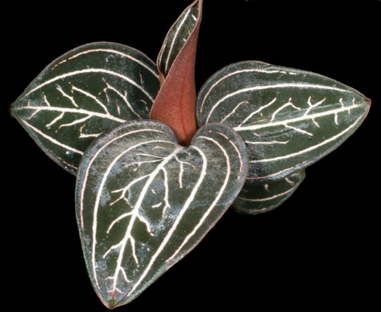
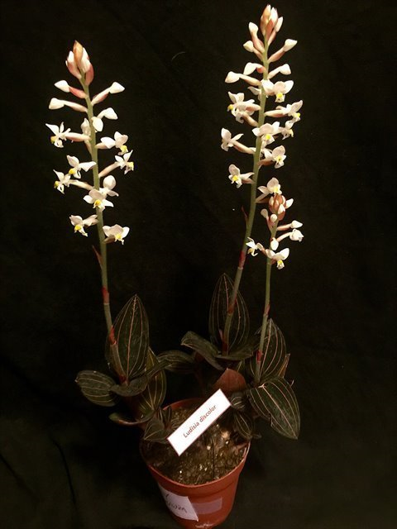
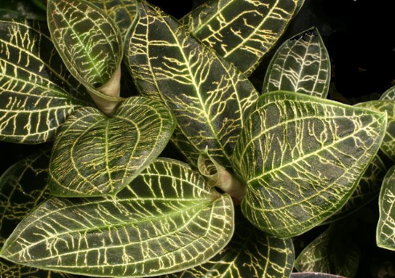
Easy Terrestrial Orchids
Jewel orchids

- Stunning leaf patterns/veinings/textures
- Care for it just like an African violet
- Light: 1-2 hours of filtered/morning sun or any bright unobstructed window is fine
- Temperature: average household temp
- Potting: wide and shallow bulb pan
- Medium: 50% regular potting mix and 50% perlite
- Watering: let dry slightly in between
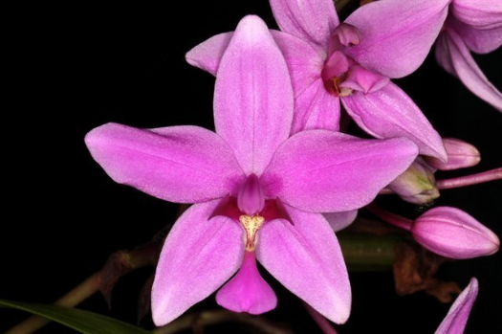
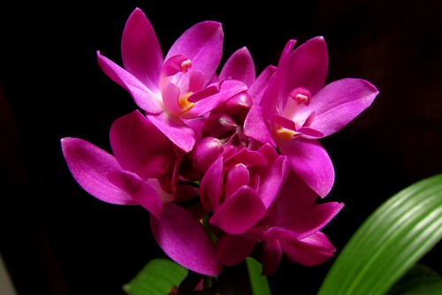
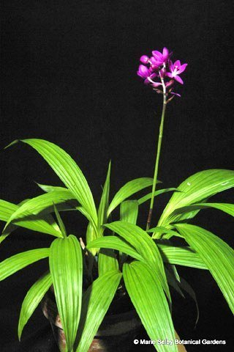
Spathoglottis

- Pleated/palm-like leaves, purple flowers
- Care for it just like a palm
- Light: as much direct indoor sun as possible. South windows preferred.
- Temperature: warmer is better (75-80F)
- Medium: 75% regular potting mix and 25% perlite.
- Humidity: above 50%, more is better
- Watering: keep evenly moist
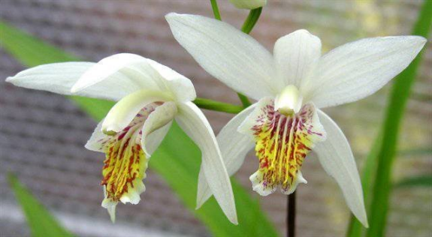
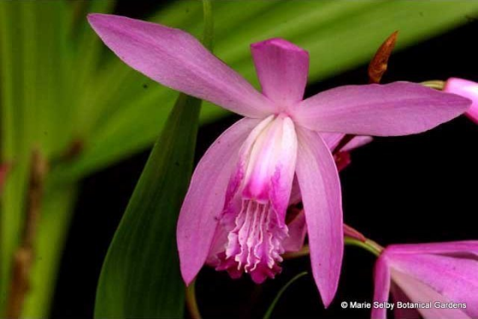
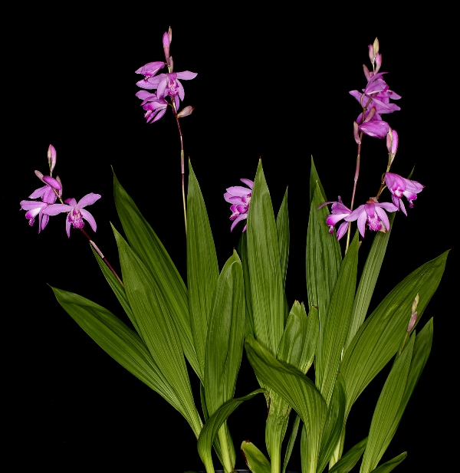
Bletilla

- Often called Chinese Ground Orchid
- Sold at big box stores late winter/early spring as bulb packages. Can be grown outdoor in part sun area
- Light: morning sun/dappled shade
- Soil: garden loam, well drained, rich in organic matters, keep evenly moist
- Will go dormant in winter, bloom in spring with new growth.
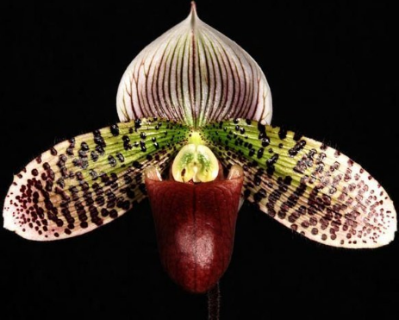
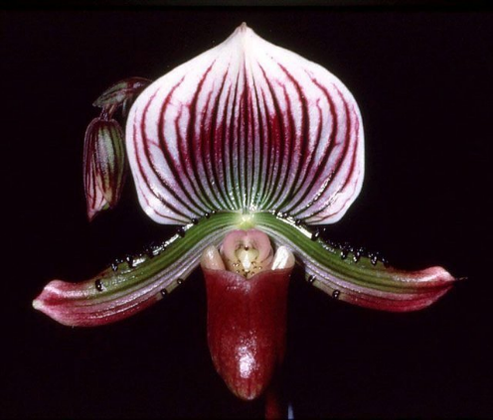
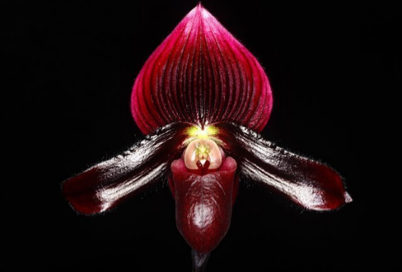
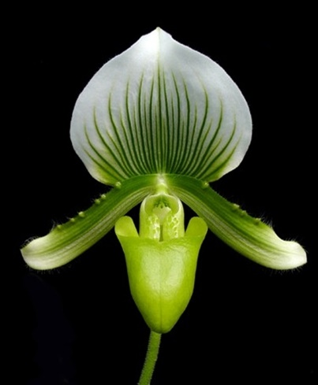
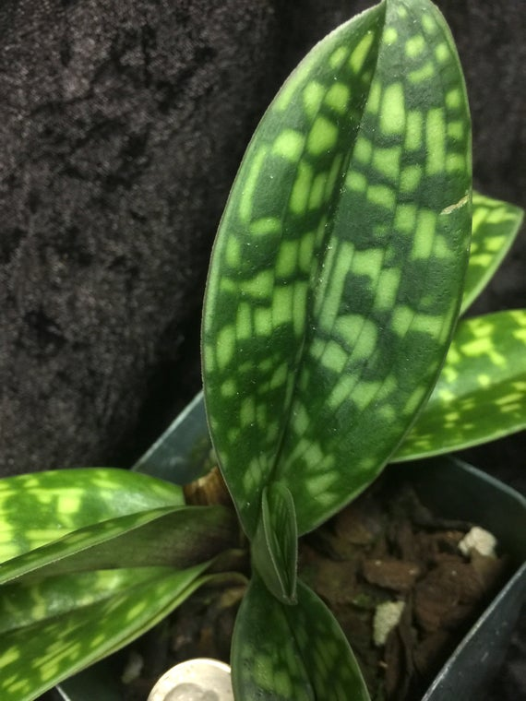
Maudiae type Paphiopedilum
- Semi-terrestrials with spectacularly patterned foliage and intriguing flowers with pouches
- Light: dappled sunlight preferably from an East window; more shade needed in the West and South window; North window OK only when very bright
- Temperature: average household temperature
- Medium: 50% sphagnum moss and 50% coarse perlite; alternatively, fine fir bark OK
- Potting: repot every 1-2 years, prefer smaller pot that only slightly larger than the root mass; also slightly cover the base with potting medium
- Watering: moist but dry slightly between watering

