The Genus Dracula
Luer 1978
Type species: Dracula chimaera
According to Carl Luer. The genus is made up of 141 or so species that spread through all of Andean America including the cordillera in Central America. The plants were once included in the genus Masdevallia, but became a separate genus in 1978. These small to medium sized orchids very unusual, somewhat other-worldly flowers, named after the Latin word for dragon, in reference to the strange, sinister appearance of the flowers. The names chosen for species such as Dracula diabola, D. gorgona and D. vampira unjustly stress the perceived 'nasty nature' of these fascinating and rather beautiful orchid flowers.
These caespitose (growing in turf) orchids grow from short rhizomes, with a dense pack of stems. Fairly thin, broad leaves with a sharply defined midrib are borne on a short ramicaul (the undifferentiated area/stem between rhizome and leaf) and distinguish this genus from Masdevallia without looking at the flowers, which have long tailed sepals and are borne singly or successively in commonly, pendant racemes which arise from the ramicaul with an annulus which is a considerable distance below the abscission layer (where the leaf separates from the stem). The flower stalks grow either horizontally from the base of the plant or descend, often for great distances. A few species grow upright flower stalks. The colorful, typically single flowers are usually large and pendent, although some species exhibit erect inflorescences. Individual flowers are usually produced singly in succession and in some species, inflorescences are capable of producing 5, 6 or more flowers during the lifetime of the inflorescence. 3 species (D. sodiroi, D. decussata/neisseniae, and D. papillosa) may have up to three simultaneously open flowers on a single stalk. The long-tailed terminal flowers are basically triangular. The small unique petals that flank the column are thickened apically and are usually verrucose(wart-like) between a pair of valve like laminae. This can give the appearance of two eyes along either side of the nose-like column (monkey face). The spathulated (spoonshaped)/saccated (forming a sac) lip is clearly divided into a cleft hypochile (basal portion) and a more or less rounded, concave epichile (distal portion) often coursed by lammellate radiating "veins" resembling mushroom/fungus and is movable to attracts insects. The semiterete column is well developed with a hooded ventral anther and stigma and a short, thick foot with two pollina.
Draculas are very popular in hobbyist collections and many species and hybrids are now in cultivation. Whether due to the interesting flowers or to the fanciful names, D. vampira, D. chimaera, D. bella, D. gorgona and D. simia are some of the sought-after species. They are epiphytes and are found at higher elevations so most are cool if not cold growers. They do best in pots and need to be kept in moist humid conditions (70-100%) with lower light similar to Phalaenopsis. Because the flower stems often grow downward, pot them in a plastic mesh basket. This also has the advantage of increasing airflow to the plant's roots, but they will dry out a bit more quickly. They should not be allowed to totally dry out, as they have no way to store water. They can die in a matter of hours if they dry out and the temperature is too high because they cannot close their stomatas. They're pretty hard to overwater, so water often, though this is less important if the humidity is high.
Draculas are fairly difficult to take to shows and meetings because their flowers wither under dry conditions. However, it is possible if precautions are taken, such as placing them in a polystyrene box containing a layer of damp sphagnum moss topped with ice and spray the flowers with water occasionally when they are on display, otherwise they quickly droop under the lower humidity that prevails at most venues. There are 457 awards registered on Orchidwiz for the entire genus up to June 2017. Draculas are closely related to Masdevallias and were once included in the genus Masdevallia. The hybrid genus Dracuvallia is made by crossing a Dracula with a Masdevallia. Judging for Dracula species should utilize Pleurothallis judging scale.
Significant species | Offsprings | Awards | Special characteristics
D. vampira* | 22 | 27 (3 FCC, 12 AM, 2 HCC, 2 cultural) | Large, widely spread sepals. Multiple longitudinal blackish/purple veins almost totally obscure greenish base color
D. bella* | 7 | 24 (7 AM, 6 HCC, 1 cultural) | Lovely blossoms. yellow sepals with irregular red-brown spots and dots and a dense covering of short hair
D. gorgona* | 4 | 20 (1 FCC, 5 AM, 3 HCC, 1 cultural) | Large flower, cream/yellow flower heavily marked with red/maroon spots and bars heavier centrally.
D. cordobae* | 7 | 18 (4 AM, 5 HCC, 2 cultural) | Creamy white and intensly spotted with red/brown marginally
D. hirtzii* | 8 | 15 (1 FCC, 5 AM, 3 HCC) | Large flowers, cream colored base densely and diffusely dotted and suffused with dark red
D. robledorum | 7 | 11 (8 AM, 1 cultural) | Yellow/green base and good contrasting mass of deep mahogany spots and central stripes. Infloresence held above the base of the plants
D. roezlii | 7 | 11 (4 AM, 3 HCC) | Similar to D. hirtzii but with dense hair on the inside of sepals
D. gigas* | 11 | 9 (2 AM, 1 HCC) | Pale yellow base with fine purple stippling more intense centrally. The spotting forms stripes longitudinally. Inflorescence held above the base of the plant
D. polyphemus | 8 | 7 (2 AM) | Dense brown/maroon spots coalesce toward apices and margins of sepals leaving the center with contrasting green/yellow/white

The species of Dracula have tentatively been divided into three subgenera, with sections and subsections within one of the subgenera.
- Subgenus Dracula : This subgenus contains all the species of the genus except two exceptional species (D. sodiroi and D. xenos)
  - Section Andreettaea : Monotypic: Dracula andreettae
  - Section Chestertonia : two species: Dracula chestertonii, D. cutis-bufonis
  - Section Cochliopsia : Monotypic: Dracula cochliops
  - Section Dodsonia : Four species: Dracula dodsonii, D. insolita, D. iricolor, D. portillae
  - Section Dracula : largest section
    - Subsection Costatae : e.g. Dracula bella, D. vespertilio
    - Subsection Dracula :
      - Series Dracula : e.g. Dracula chimaera, D. tubeana, D. vampira
      - Series Grandiflorae-Parvilabiatae : e.g. Dracula gigas, D. platycrater
      - Series Parviflorae : e.g. Dracula houtteana, D. lotax
- Subgenus Sodiroa : Two Dracula sodiroi, D. erythrocodon
- Subgenus Xenosia : Monotypic : Dracula xenos

BUILDING BLOCK DATA
Dracula vampira [Luer] Luer 1978
Synonym: Dracula ubanquia Luer & Andreeta 1980; Masdevallia vampira Luer 1978
Dracula vampira is a striking orchid species found limited on the Western slope of Mt Pichincha, Ecuador. The flowers are large and presented horizontally or pendent. Sepals are prominent and broad at the base. Greenish base color with multiple longitudinal blackish purple veins that converge toward the tip. The white to pinkish lip is concaved with rolled margin and multiple radiating veins to the inner surface resembling mushroom. This is hinged to the column foot and remains mobile.
Dracula vampira came onto the scene in 1978 and the first awarded plant was the clone ‘Bella Lugosa’ that won an FCC for 92 points in 1978 has beautifully veined flowers with contrasting stripes. Recent awards of the species has improved in clarity of the stripes and flatter flower shape in the case of Dracula vampira ‘Johnny Angel’ FCC/AOS (Right photo) with 92 points in 2004. Another direction is the increased in density of the stripes to fuse to almost solid black in color and that reflects in some of the famous breeding line of D. vampira. An example of this is D. vampira ‘J&L’s Midnight Theresa’ FCC/AOS (Left photo) with 91 points in 2000, remarked as “the darkest seen by the judges”. The newest award in 2015 also came out very darkly colored reflecting this particular trend in the case of D. vampira ‘Edgar’ AM/AOS
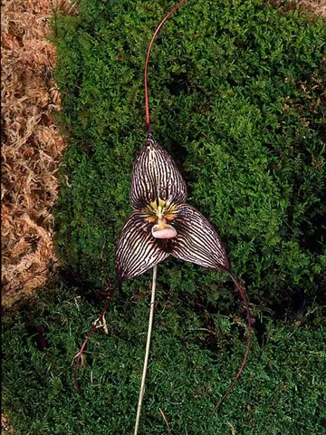
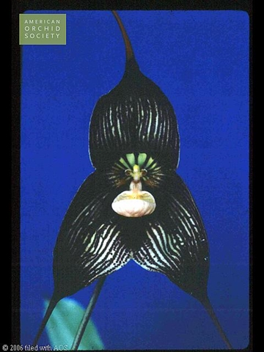
There isn’t many variation in the species otherwise, Dracula vampira is the most extensively hybridized species in the genus along with D. gigas due to being: large flowered, intense color giving an impression of almost black, high contrast between greenish yellow and dark stripes, broad segment. Down size with hybridizing with D. vampira is larger plants and a tendency for pendent flower that face downward. Also a common negative trait of most Dracula is the need for very high humidity making this a barrier for lover of Dracula.
Hybrids: Total of 25 progeny: 22 first generation hybrid, 3 2nd generation hybrids. There are 7 primary hybrids registered prior to the year 2000. After 2005, most hybrids are intergeneric cross with Masdevallia.
Most notable hybrids:
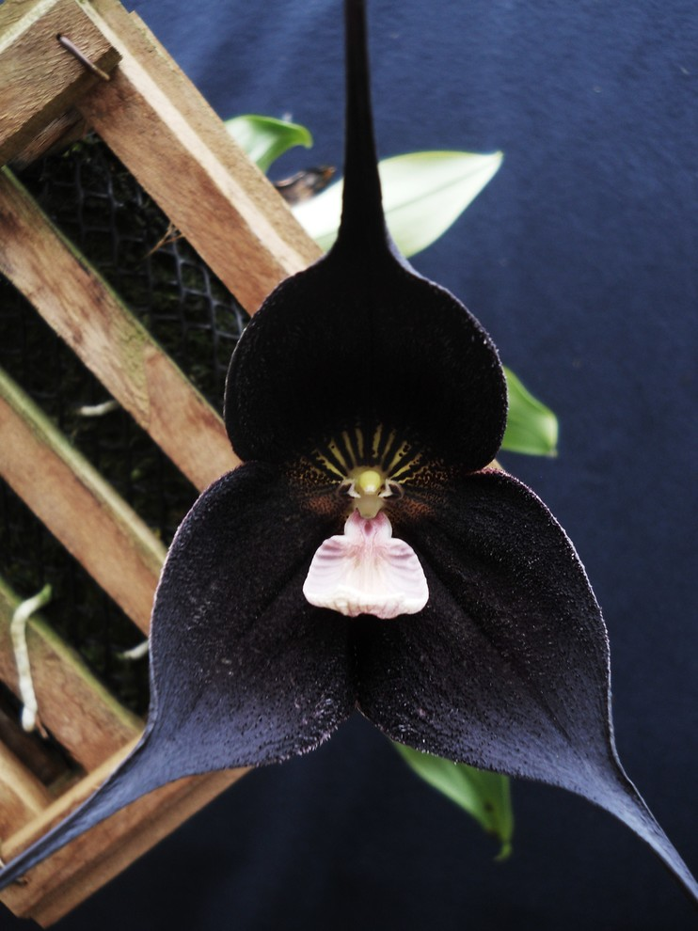
- Dracula Raven (vampira x roezlii) (2005) is noted with intensely colored flowers; this primary hybrid has garner its first FCC/AOS in 2006 (‘Lenore’ 91 pts). The most recent FCC in 2016 (‘Vamp’ 91 pts) is a very impressive flower with dense stripes and tessellation from both parents (Left picture) and from a distance, appeared black. This cross produced 7 awards from the AOS with 2 FCC, 3 AM, 2 HCC. And was bred with Masdevallia veitchiana (Dracuvallia Alletta Page) to hopefully improve its shape and perhaps intensify/add new color. Also a backcross with D. roezlii (D. Maltese Falcon) is already registered in 2012 and a solid black flower with high potential has already surfaced (Right picture). No awards has yet to be given to these hybrids

- Dracula Phantom (vampira x tubeana) (1997) is another popular primary hybrid with D. vampira. This primary hybrid has received 2 AM, 2 HCC, and a CCM. This create a platform for solid dark red/brown Dracula by breeding with D. platycrater to create Dracula Don Garling (2004) and this second generation hybrid received 3 AMs and the most recent award (‘Cookie Peschko’ AM/AOS) is a deep cordovan brown in color (Left Picture).
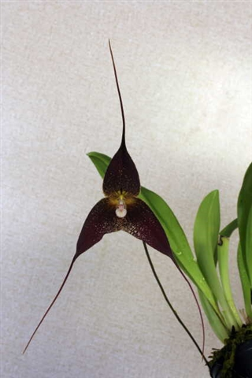
- Dracula Lynn’s Choice (vampira x cordobae) (2004) and D. Nightshade (vampira x robledorum) (1997) is similar breeding aiming to create highly contrast flowers centrally and marginally. D. Lynn’s Choice (Right picture) garnered 2 AM, 3 HCC, and a CCM, while D. Nightshade has received 4 AM from the AOS
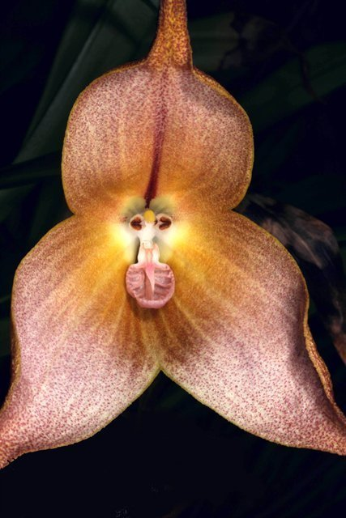
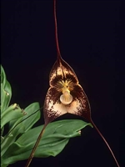
Dracula gigas [Luer] Luer 1978
Synonym: Masdevallia gigas Luer 1978
A terrific Dracula with a beautiful larger flower with pleasing warm tones, sequentially blooming upright inflorescences hold the flowers above the foliage. This unique trait is desirable but is often recessive in Dracula breeding where most flowers hang down limiting the display of flower. Sepals are yellow/green with diffused fine brown spot, darker and more concentrated centrally. The spotting forms stripes on the sepals. Lip is pale pink and mobile. This species is sometimes called Monkey orchid because the arrangement of 2 petals (eyes) and lip (nose) resembles the face of a monkey.
Dracula gigas was first awarded in 1985 with a CHM/AOS (‘Evergreen’ with 85 points). After a long hiatus, 2005 witness a renewed interest in this species with the clone ‘Harold’ AM/AOS 85 points, subsequently ‘Solar Place’ HCC/AOS 79 points (2007) and ‘Windflower’ AM/AOS 84 points (2010).
There exists a beautiful pure yellow form D. gigas var xanthina, extremely rare in cultivation, and none has yet been awarded.
There are a total of 18 progeny (most hybridized after D. vampira), among them there are 11 first generation hybrids and 7 second generation. The majority of hybrids (13) was registered between 1994 and 2001. The remaining 5 was registered between 2004 and 2014.
Most notable hybrids:
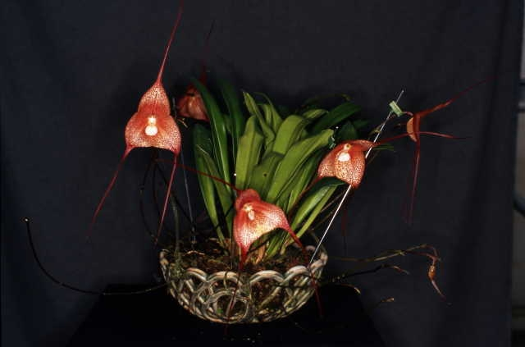
- Dracula Quasimodo (gigas x bella) (1994) is arguably the most awarded Dracula hybrid to date with 11 awards internationally includes 3 AM, 4 HCC, 1 CCM from the AOS. Certain clones took on the upright habit of D. gigas parent, for example the clone ‘Sanctuary’ AM/CCM/AOS in 2006 (pictured below). This is also the most recently awarded clone represent the best characteristics that this Hybrid can offer. The flower is beautifully colored with contrasting cream base and dark red spot overall. D. Quasimodo is platform in which most second generation Dracula hybrids are being developed (7 are registered between 1997 and 2001). This breeding line has yet to see the success of D. Quasimodo.

- Dracula Don Quixote (gigas x wallisii) (1995) and similar newer hybrid Dracula Sasquatch (gigas x chimaera) (2007) have both garner awards from the AOS including a total of 5 AM and 1 HCC. These are stately hybrid and is worthy of mentioning as promising breeding potential.

Reference:
OrchidWiz Encyclopedia version 3.3
Orchid Plus Online
American Orchid Society - Dracula
http://www.aos.org/orchids/orchids-a-to-z/letter-d/dracula.aspx - accessed 7/4/2017
Wikipedia Encyclopedia
https://en.wikipedia.org/wiki/Dracula_(plant) – accessed 7/4/2017
GardenWeb Forum
http://forums.gardenweb.com/discussions/3108039/dracula-maltese-falcon - accessed 7/4/2017
Jay Pfahl’s Internet Orchid Species Photo Encyclopedia:
http://www.orchidspecies.com/dracvampira.htm - accessed 7/4/2017
http://www.orchidspecies.com/dracgigas.htm - accessed 7/4/2017

