The Genus Masdevallia
Ruiz & Pavon 1794
Type species: Masdevallia uniflora
There are over 500 species, grouped into several subgenera. The genus is named for Jose Masdeval, a physician and botanist in the court of Charles III of Spain. These plants are found from Mexico to southern Brazil, but mostly in the higher regions (2,500-4,000 m elevation) of the Andes of Ecuador and Colombia, Peru and Bolivia. They may be epiphytes, terrestrials or growing as lithophytes on damp rocks.
Taxonomic work on the genus continues and most recently Carlyle Luer, MD has proposed the segregation of an additional 19 genera. Masdevallia continues to contain the bulk of the species with 225 currently. Alternatively, Genera Orchidacearum/Monocot Checklist continues to regard them all as Masdevallia. Species most commonly found in cultivation include the spectacular M. coccinea, M. racemosa (Luer’s Spectaculum racemosum), M. uniflora, M. triangularis, M. tovarensis (Luer’s Alaticaulia), M. strobelii, M. saltatrix, M. rosea, M. infracta (Alaticaulia), M. ignea and M. floribunda (Luer’s Acinopetala).
The plants are characterized by an abbreviated to elongate and creeping rhizome that gives rise to stems that lack pseudobulbs. The stem bears a single, fleshy, erect to pendent, ovate to lanceolate leaf. The flowers are triangular and occur singly or in racemose inflorescences. They are characterized by a showy calyx and reduced corolla. The unusual, brilliantly colored flowers range in size from less than an inch to over 12 inches across. Flower color varies. White, red and purple combinations are common. The sepals are variously connate (fused at the base) and frequently caudate (having a tail). Masdevallia is allied to Pleurothallis, differing mainly in showier flowers and having sepals that unite at the base to form a narrow bell-shaped tube. The petals flank the semiterete column containing hooded ventral anther with 2 pollina. The ligulate (tongue-shaped) lip is flexibly hinged to a free column foot.
Their origins in cool, damp environments make them an excellent choice for cool or coastal climates. Most species and hybrids are compact enough so that they can be easily accommodated on windowsills or under lights. This genus are as a whole, cool to cold growers that do best with a fine mix in pots. They like low light, high humidity and watering throughout the year but be careful not to overwater. Cool greenhouse conditions are a must for many of the species. Some will tolerate intermediate conditions and a few people have had luck with the warmth tolerant varieties as far south as Florida. There are a few Masdevallias that do well in warmer areas where summer night temperatures infrequently fall below 68-70 degrees F. They are Masdevallia floribunda, striatella, kuhniorum, bicolor, infracta, rimarima-alba, bangii, minuta, attenuata, and echo.
There are 3607 awards registered on Orchidwiz for the entire genus up to June 2017. Masdevallias and Draculas are closely related. In fact, Dracula was once included in the genus Masdevallia. Hybridizing is most often done within the genus, however there are crosses made with Dracula to form the hybrid genus Dracuvallia i.e. the popular Dracuvallia Blue Boy (M.uniflora x D chimaera). Judging for Masdevallia species should utilize Pleurothallis judging scale.
Significant species | Offsprings/ Progeny | Awards | Special characteristics
M. veitchiana * | 160/792 | 47 (2 FCC, 15 AM, 4 HCC, 2 Cultural) | Large dorsal sepal, extremely bright orange or vermilion with dense purple hair, erect and long inflorescence
M. coccinea* | 122/372 | 116 (3 FCC, 30 AM, 21 HCC, 15 Cultural) | Large, showy long lasting blossom held well above foliage, color can be from purple to red, orange, yellow, white
M. ignea* | 65/212 | 54 (20 AM, 12 HCC, 7 Cultural) | Showy, long lasting blossom raning from yellow to orange to bright red and normally marked with darker veins
M. triangularis* | 64/320 | 9 (4 AM, 2 HCC, 2 Cultural) | Can produce 2 infloresence /growth, sepals sulfur yellow with dense purple spots and brown/purple tails terminally
M. uniflora | 53/137 | 4 (3 HCC) | Small flower with white base color and heavily suffused bright pink/purple apically
M. decumana | 51/122 | 23 (9 AM, 4 HCC, 2 Cultural) | Very large, flat opening flower, sepals yellow base heavily dotted w purple /brown terminate w white/green tails
M. infracta | 37/128 | 15 (4 AM, 2 HCC, 2 Cultural) | Small flower with as many as 5/inflorescence, with sepals varies from white, yellow, brown, pale lilac to violet
M. yungasensis | 35/173 | 8 (1 AM, 1 HCC, 2 Cultural) | Showy blossoms with white to yellow base and contrasting purple to brown veins
M. strobelii* | 33/268 | 7 (1 AM, 1 HCC, 3 Cultural) | Floriferous, >1 inflorescence/growth. Sepals white & intensely suffused with bright orange basally, dense hair apically terminate with long orange tails
M. caudata | 32/105 | 34 (10 AM, 5 HCC, 3 Cultural) | White to yellow dorsal with thin purple veins and fine spots. Lateral sepals white densely dotted purple

Masdevallia was found to be polyphyletic and the taxonomy of the group is unresolved but the currently accepted taxonomy proceeds as follows:
- Subgenus Amanda (≡Spilotantha)
  - Section Amandae: 28+ species, e.g. M. amanda, M. bulbophyllopsis, M. melanopus, M. polysticta. Separated in Spilotantha.
  - Section Ophioglossae: 1-2 species – M. ophioglossa, M. ophioglossa ssp. grossa
- Subgenus Cucullatia: (≡Megema)4 species – M. cerastes, M. corniculata, M. cucullata, M. macrura
- Subgenus Fissia: (≡Fissia) 3 species – M. mutica, M. picturata, M. pleurothalloides
- Subgenus Masdevallia
  - Section Amaluzae: (≡Luzama) 6 species, e.g. M. amaluzae, M. carmenensis, M. patula
  - Section Aphanes: (≡Pteroon) 3 species – M. aphanes, M. capillaris, M. scopaea
  - Section Coriaceae :
    - Subsection Coriaceae: (≡Byrsella) ~35 species, e.g. M. angulata, M. caesia, M. civilis, M. elephanticeps, M. foetens, M. fractiflexa
    - Subsection Durae: (≡Regalia) 4 species – M. ayabacana, M. dura, M. panguiensis, M. utriculata
  - Section Ligiae: Monotypic – M. ligiae
  - Section Masdevallia:
    - Subsection Caudatae: ~28 species, e.g. M. bottae, M. caudata, M. decumana, M. lychniphora, M. triangularis, M. xanthina
    - Subsection Coccineae: 12 species, e.g. M. amabilis, M. barlaeana, M. coccinea, M. ignea, M. veitchiana
    - Subsection Masdevallia: ~58 species, e.g. M. agaster, M. calocodon, M. mejiana, M. pumila, M. uniflora
    - Subsection Oscillantes: ~11 species, e.g. M. andreettana, M. wageneriana (including M. pteroglossa)
    - Subsection Saltatrices: 14 species, e.g. M. angulifera, M. constricta, M. limax, M. saltatrix, M. urosalpinx, M. ventricularia
    - Subsection Tubulosae: 7 species, e.g. M. bangii, M. irapana, M. tubulosa
  - Section Mentosae: Monotypic – M. mentosa
  - Section Minutae: ~21 species, e.g. M. floribunda, M. herradurae, M. minuta, M. nicaraguae, M. wendlandiana
  - Section Racemosae: (≡Spectaculum) Monotypic – M. racemosa
  - Section Reichenbachianae:
    - Subsection Dentatae : (≡Petalodon) 2 species – M. collina, M. macrogenia
    - Subsection Reichenbachianae: (≡Reichantha) ~11 species, e.g. M. rolfeana, M. schroderiana, M. striatella
- Subgenus Meleagris: (≡Rodrigoa) 7 species, e.g. M. anisomorpha, M. heteroptera, M. meleagris
- Subgenus Nidifica: (≡Buccella) 4-5 species: e.g. M. dynastes, M. nidifica (including M. ventricosa)
- Subgenus Polyantha (≡Alaticaulia)
  - Section Alaticaules: 97 species, e.g. M. bicolor, M. infracta, M. scobina, M. stenorrhynchos, M. tovarensis, M. vargasii, M. weberbaueri
  - Section Polyanthae: 7 species, e.g. M. discoidea, M. lata, M. polyantha, M. schlimii
- Subgenus Scabripes (≡Portilla)
- Subgenus Volvula (≡Streptoura)
BUILDING BLOCK DATA
Masdevallia veitchiana Rchb.f 1868
Synonym: N/A
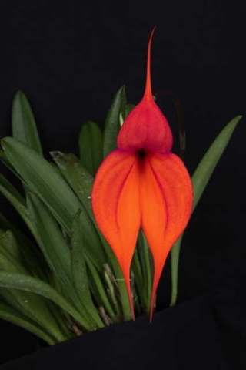
This small sized, cold growing terrestrial, sometimes lithophytic or rarely epiphytic, tufted species with erect leaves is found at 2000 to 4000 meters in elevation around Macchu Picchu in Peru on steep rocky slopes covered with grasses and shrubs in full sun but with the leaves protected by the grass that blooms in the spring and early summer with an long, erect, single flowered inflorescence with the long-lasting flowers held way above the leaves. Sepals are bright orange to vermilion covering in short densely clustered fine purple hairs on the inner surface. Dorsal sepal is broad, and petals are insignificant.
Masdevallia veitchiana is relatively uniform in appearance with bright color that is held high above the leaves to display the best quality of the flowers; the best example of the species is very flat, full and vibrant in the case of the clone ‘Juan Leather’ FCC/AOS (92 pts in 2010, Pictured right). All of those characteristics make this a very desirable parent.

Hybrids: Total of 792 registered, to the 5th generation
Before 1940 | 1940-49 | 1950-59 | 1960-69 | 1970-79 | 1980-89 | 1990-99 | After 1999
23 | 0 | 0 | 0 | 2 | 28 | 269 | 470

Most notable hybrids:
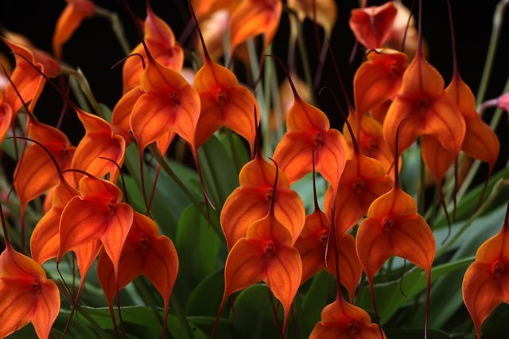
- Masdevallia Copper Angel (M. triangularis x M. veitchiana) (1982) has been garnering awards since first arrival on the scene with the clone ‘J & L’ AM/AOS (1982 81 points). Most plants awarded are AM quality (14), and an equally impressive amount of cultural awards (12). In total, 47 awards are given to this cross to date. Flower are typically from vibrant golden orange to orange in color consistence from the domination of M. veitchiana. Upright inflorescence but not as tall as M. veitchiana. And the other parent provide the dark tails and the floriferous nature of the cross i.e. the clone ‘Highland’ CCM/AOS (93 points, 1993) attains a whopping 195 flowers and 36 buds (Pictured above). This cross is behind other popular hybrids such as M. King of Kings ((Copper Angel x macrura) x veitchiana). Most awards of this cross are given in Australia (42). M. Highland Monarch (2001) (16 AM, 5 HCC, 1 AQ, 1 JC) is another beautiful and popular cross with M. veitchiana from both side of the parents. This second generation Copper Angel hybrid received an AQ from AOS in 2007 demonstrating the high quality potentials of breeding with M. Copper Angel. Additional notable hybrids among the 169 total progeny of M. Copper Angel includes M. Sunset Jaguar (chaparensis x Copper Angel, 1990, 9 AM, 9 HCC, 1 AQ, 1 CCM), M. Dean Haas (1st generation, 1992, 12 AM, 5 HCC), Golden Monarch (2nd generation, 2000, 4 AM, 7 HCC), etc….
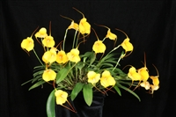
- Masdevallia Angel Frost (veitchiana x strobelii) (1982) This popular hybrid tend to take in more of the M. strobelii (long tails) parent but M. veitchiana definitely helps intensify the color and improves flower size and display since M. strobelii tends to tuck its flowers among leaves. Flowers are bright golden yellow to orange and some clones has purple hair of the veitchiana parent. This cross has immediate received AD award by the AOS in 1983. In addition, plants also received 3 AM, 6 HCC, 2 CCM, Most awards are given before 1999, however, the most recent award is in 2016 represents the best clone of this cross ‘Ord Court’ (AM/CCM/AOS) (Above picture). Among the 217 progeny of this hybrid the most popular is M. Dean Haas (1992, 12 AM, 5 HCC), M. Mary Staal (M. Angel Frost x M. coccinea, 1991, 3 AM, 3 HCC, 1 CCM), M. Sunny Angel (triangularis x Angel Frost, 1986, 6 AM, 3 HCC, 2 CCM), etc….
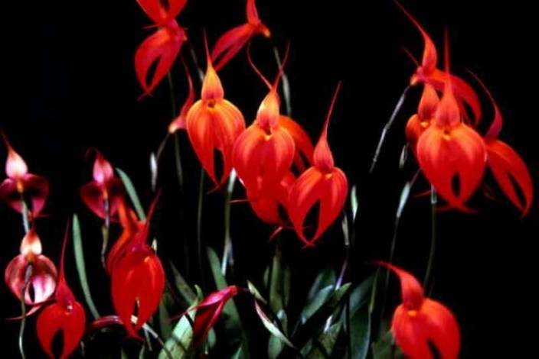
- Masdevallia Falcata (coccinea x veitchiana) (1899) (1 FCC, 12 AM, 5 HCC, 3 CCM) one of the oldest Masdevallia hybrids. It is an obvious choice to breed the 2 big colorful species of this genus together to make improvement over the original species. Notable characteristic of this cross is good form and tall strong stems with a wide range of colors from light pink, yellow, orange, sunset, to hot pink and fiery red. The best example is the clone ‘Jeanette’ (FCC/CCM/AOS in 1991) (pictured Right). Of the 104 total progeny of this hybrid several important hybrids arise including M. Falcon’s Gold (2nd generation, 2003, 2 AM, 1 HCC) which is a new breeding direction already involves in 27 hybrids originated from M. Falcon Sunrise (Falcata x ignea) (1997, 3 AM, 1 CCM), M. Midas Touch (2003, ((Copper Angel x macrura) x Falcata), all awarded in Australia), etc….

Masdevallia coccinea Linden ex Lindl. 1846
Synonym: Masdevallia coccinea var. harryana (Rchb.f.) A.H.Kent 1889; Masdevallia denisoniana T.Moore 1874; Masdevallia denisonii Dombrain 1872; Masdevallia harryana Rchb. f. 1871; Masdevallia harryana var. atrosanguinea B.S.Williams & T.Moore 1884; Masdevallia harryana var. decora B.S.Williams 1889; Masdevallia harryana var. miniata B.S.Williams & T.Moore 1884; Masdevallia lindenii André 1870; Masdevallia lindenii var. grandiflora L.Linden & Rodigas 1885; Masdevallia lindenii var. harryana (Rchb.f.) André 1873; Masdevallia militaris Rchb.f 1854; Masdevallia venusta Schltr. 1921
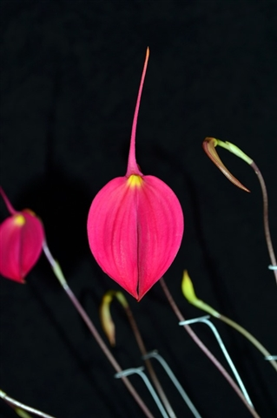
The Colombian orchid Masdevallia coccinea, colloquially known as “La Banderita” or the little flag. The botanical Latin term “coccinea” refers to a bright, deep red color. Masdevallia coccinea is found from an elevation ranging from 8,000 to 11,000 feet (2,500 to 3,400 m) in moist areas of the cloud forest in moderate shade. Importations from different elevations yield a palette of colors, with white and light forms coming from the higher elevations and darker forms from the lowest. Early collectors describe seeing M. coccinea blooming as masses of flowers in dazzling brilliancy, with an astonishing variety of colors from deep rich crimson-purple, through magenta-crimson, crimson-scarlet, scarlet, red, orange, yellow and white. This species is heavily line bred resulting in incredible color saturation and excellent lateral sepals shape. Flower is very long lasting, held on strong stem making excellent cut flowers. Downside is the narrow and pointy dorsal sepal
M. coccinea is heavily awarded with 3 FCC, 30 AM, 21 HCC, 15 Cultural awards, an AQ award in 1998, a JC award in 1984. The most recent FCC in 2015/AOS is the clone ‘Luna Dandelion’ (Above picture) with 90pts, is the best example of the species with flower extremely flat with rounded lateral sepals and minimal reflex of dorsal sepals, and an incredibly striking color, tall stem and well presented.

Hybrids: Total of 372 registered, to the 5th generation
Before 1940 | 1940-49 | 1950-59 | 1960-69 | 1970-79 | 1980-89 | 1990-99 | After 1999
8 | 0 | 0 | 0 | 0 | 11 | 94 | 259
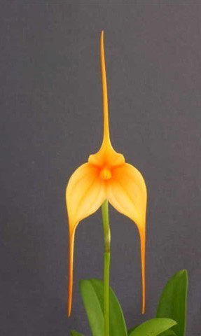
Most notable hybrids:
- Masdevalia Falcata (see above)
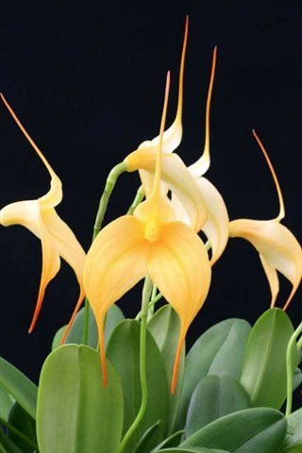
- Masdevallia Falcon Sunrise (Falcata x ignea, 1997, 1997, 3 AM, 1 CCM) is an improved version of M. ignea with a flipped up dorsal sepals but with M. ignea orange-red coloration and veinings. Not a lot of awards but it is a stepping stone to create Falcon’s Gold (Falcon Sunrise x contricta, 2003, 2 AM, 1 HCC) a third generation hybrid that has a striking white to golden color with very long pleasing long tails (picture above). Falcon’s Gold also produced 27 additional progeny and the potential is yet to be seen.
- Masdevallia Mary Staal (M. Angel Frost x M. coccinea, 1991, 3 AM, 3 HCC, 1 CCM) the alba form of coccinea are mostly used in this cross and has been producing soft shades of white to yellow flowers. 26 progeny has been produced since 1994. The clone ‘Free Spirit’ (AM/AOS, 81 points in 2009) (pictured Right Upper) represent the new standard of this cross with flat flower, long tails, pleasing color and well display.
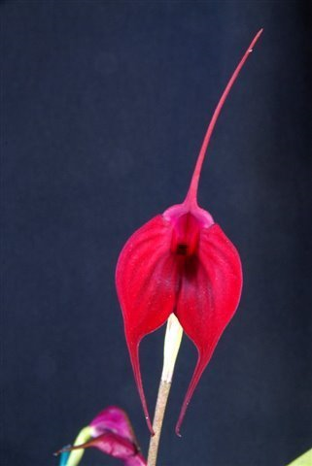
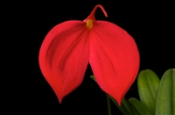
- Masedvallia Fraseri (coccinea x ignea, 1882, 1 FCC, 6 AM, 1 HCC), improves on the dorsal of ignea, similarly to M. Falcata. The best example is the recently awarded FCC/AOS clone ‘Hillsview’ (pictured Below) in 2011 with 92 points, lateral sepals are very rounded, flat flower, with “intense, rich, seemingly florescent red” color. This quality is utilized in further breeding for deep red Masdevalia by adding M. discoidea in the mix in the case of 3rd generation hybrid M. Bay Breeze (pictured Right Lower) registered in 2009 but already won 2 AM and 1 HCC.

Reference:
OrchidWiz Encyclopedia version 3.3
Orchid Plus Online
American Orchid Society - Masdevallia
http://www.aos.org/orchids/orchids-a-to-z/letter-m/masdevallia.aspx - accessed 7/4/2017
Masdevallia coccinea - American Orchid Society
http://www.aos.org/AOS/media/Content-Images/PDFs/Masd_coccinea.pdf
Wikipedia Encyclopedia
https://en.wikipedia.org/wiki/Masdevallia – accessed 7/4/2017
Jay Pfahl’s Internet Orchid Species Photo Encyclopedia:
http://www.orchidspecies.com/masveitchiana.htm - accessed 7/4/2017
http://www.orchidspecies.com/masdcoccinea.htm - accessed 7/4/2017
The Pleurothallid Alliance
http://www.pleurothallids.com/index.php?option=com_content&view=article&id=13:masdevallia-and-affiliates&catid=30&Itemid=2 – accessed 7/4/2017

