The Genus Restrepia
H. B. K. 1816
Type species: Restrepia antennifera
Historical
It has been one of the genera most confusing to botanists for many years. Current thinking accepts nearly 50 species distributed primarily in the Andes with some into Central America. Named in honor of Don Jose Restrepo, an investigator of Colombian flora
Restrepia is one of 26 different genera that comprise the sub-tribe Pleurothallidinae, the largest subtribe within the Orchidaceae with more than 4000 species. All are natives of tropical and sub-tropical America, the most widely grown genera, apart from Restrepia, being Masdevallia, Dracula, Pleurothallis, Stelis and Octomeria. The genus Restrepia commemorates José E. Restrepo, a Colombian explorer of the Andes. Restrepia antennifera (the type species) was found by Alexander von Humboldt in the early 1800s in the Colombian Andes, where it grew on tree trunks at an elevation of 3000 m. Humboldt and Kunth described it in 1815. Ever since that time there has been much mis-identification and confusion of the genus as a whole, and identical species are still frequently exhibited under different names.The first species of this genus was discovered by Ruiz and Pavon in 1779 in northern Peru and described in 1798 as Humboltia contorta. It was probably Restrepia guttulata. The genus was described and published in 1816 by Humbolt, Bompland and Kunth on the basis of Restrepia antennifera collected in Colombia. In the following years, several authors put together several species, some subsequently separated into the genera Barbosella, Brachionidium and Dresslerella. At the end of the 20th century, Luer was responsible for clarifying the situation (synonymous species, infrageneric classification) in his monograghy ​​of the Icones Pleurothallidinarum type XIII.
There are currently 57 species of Restrepia 44 of which was discovered since 1970, distributed from Mexico to Bolivia, via Venezuela. Ecuador and Colombia are the two richest countries in terms of species. In nature, Restrepias always growing in mountainous country where the humidity is high and temperatures cool to temperate. Restrepia antennifera grows in Colombia and Venezuela at altitudes ranging from 2100 to 3600 m, while R. trichoglossa (syn. R. elegans ) has been found on mossy tree trunks near Tovar ( Venezuela) at altitudes of 1500-1800 m. Under cultivation restrepias are able to withstand a large range of temperatures (0-40°C), provided that exposure to the extremes is not prolonged. I grow most of my restrepias in a temperature-controlled glasshouse in Melbourne, the main advantage being that I can limit the temperature in summer to a maximum of 30°C by use of an evaporative cooler. The minimum temperature of 11°C in this house is unnecessary for restrepias, as other Melbourne growers have equally good results when their plants are grown under shade-house conditions, where temperatures occasionally fall near to freezing point in winter.
Restrepia are simple plants without pseudobulbs. From the short rhizome are born stems, called ramicauls, more or less long depending on the species and surrounded by paper-like bracts. They are often bridged with purple and nested in each other. They surround and protect the leaf at birth. The leaves are fleshy, often almost as wide as long, with an obtuse base. The plants have short stems or ramicauls, have one tough, coriaceous, conduplicate, suberect or erect leaf that bears one to several, terminal, single flowered inflorescence that can bloom over and over for years. The lateral sepals are connate, forming a boat-shaped synsepal in most species, the dorsal sepal and the petals are completely free from one another and are thicker at the apex. The petals are transparent and have 3 visible veins, a ribbed lip with denticulate margins, has a pair of thread-like appendages basally and is attached to the foot of an incurved column which broadens apically and carries 4 pollina.
The flowers are borne singly on inflorescences that emerge from stem sheaths behind the leaves. Each mature leaf produces four or five flowers over a period of several months. Under favourable conditions of temperature and humidity individual flowers may last for several weeks but it is uncommon for two flowers to be produced by the one leaf at the same time
Their flowers range in colour from yellow through orange, brown, pink and red, some also with spots or stripes. Mostly their flowers are small but Restrepia antennifera 'Goliath' has flowers in which the fused lateral sepals are approximately 50 mm in length. The flowers are best described as curious, rather than beautiful, their filament-like petals and dorsal sepal giving them the appearance of insects; some unfeeling cymbidium growers refer to them as cockroach orchids! Most restrepia species grow into specimen plants in as little as five years. The flower is born from the base of the leaf and depending on the species, it is carried by a pedicel more or less long, sometimes taking the flower away from the leaf or the plating on the back of it. The 2 lateral sepals are welded into a synsepal, which is the most attractive part of the flower. It is often decorated with dashes or points on a creamy white to orange-yellow background. The flowers of restrepias are easily distinguished from those of other pleurothallids by their dominant fused lateral sepals (sometimes referred to as a synsepalum). Their petals and lateral sepals are narrow and filament-like, while the lip sits flat on the synsepalum and is so well camouflaged that it is often overlooked. In fact, the shape of the labellum is an important factor in distinguishing one restrepia species from another. The base of the lip bears 2 tiny filiform and curved lateral lobes), certainly intended to guide the pollinating insect towards the center of the flower. It is more or less broad, sometimes strangulated, sometimes verrucous. These characters are important for species determination. The petals and the dorsal sepal are filiform and ended in globule.
Although they prefer the cold greenhouse, most species of Restrepia are very tolerant of growing conditions. If the compost remains wet, they can withstand temperatures above 35 ° C. There is simply a slowing down of growth and flowering when temperatures are too high. The ideal cuture temperatures are between 10 and 18 ° C at night and 18 to 26 ° C during the day.They can be grown in pots in fine, draining compost of pine bark and ground sphagnum, to which can be added pearlite, charcoal, polyurethane foam, or small amounts of polystyrene. Care should be taken to maintain a good hygrometry, greater than 60% for potted plants, close to 80% for mounted plants. Good ventilation is recommended. As for masdevallias and other pleurothallids, restrepias must never be allowed to become totally dry. A variety of potting mixes may be used, provided that they drain well, yet retain some moisture. Sphagnum moss, used either alone or mixed with polystyrene foam or perlite, gives good results. It's advisable to re-pot every year or two, because the moss seems to deteriorate if left longer. In my experience, plants in large pots seem to grow better in a well-drained mix, rather than in moss alone. Restrepias respond well to the occasional application of liquid fertilisers, provided that the concentration is not so high as to kill the moss
Restrepia are also very tolerant of light. Crops under artificial light work very well. In natural light, an excess causes a redness of the leaves, without consequences for the health of the plant. Just avoid the direct sun that burns and necroses the leaves. Restrepias seem to handle brighter light, drier conditions and warmer temperatures than most other Pleurothallids.
Restrepias have no definite resting period but in cultivation they seem to grow fastest in autumn and spring, probably because the temperatures and humidity during these seasons are more favourable. They would probably grow at the same rate all year if a temperature range of 8-20°C, like that of their natural habitat, could be maintained throughout. The main flowering season is winter and spring, although a few flowers are produced at other times. Again, they would probably flower continuously given better temperature control.

Restrepias grow so rapidly that their plants may be divided every few years. An alternative way to produce extra plants is by taking leaf cuttings. Simply remove a leaf with 25-50 mm of stem attached and push the stem into some Sphagnum moss in a small pot until the blade of the leaf touches the surface of the moss. Within a few months a new growth will emerge from the sheath at the base of the leaf; in most cases the new plant will produce its first flowers within a year or two. Mature leaves that have flowered once or twice give best results; those that have flowered repeatedly and exhausted all their growth buds may fail to produce new plants. Leaf cuttings taken in spring seem to produce new growths most rapidly. Occasionally, new plants (complete with roots) emerge from the stem sheaths of mature restrepia plants. These keikis grow very rapidly if carefully removed and potted separately in moss.
When preparing restrepias for a show, carefully cut off the old flower stems, which otherwise detract from the overall appearance. Then insert the pot in a larger squat pot packed with damp moss - this helps to maintain a higher level of humidity around the plant and thereby reduces the risk of the flowers collapsing during the show. Remember to hide a few pellets of snail killer in the moss, just in case a slug or snail is lurking there ready to destroy your masterpiece overnight; restrepia flowers seem to be particularly attractive to these pests.

The infragenic classification was established by Carlyle Luer, which divides the Restrepia into 3 subgenera:
Ecmeles, with only one species close to Pleurothallis, Restrepia aberrans, characterized by a dorsal sepal not terminated in drop and lateral sepals not welded. This rare species was discovered in 1985 on the Atlantic coast of Panama at about 350 m altitude. Vegetatively, it resembles small species of the genus but the floral structure seems intermediate between Pleurothallis and Restrepia. This species is rare and absent from the collections. It seems to wither quite quickly in culture
Pachymeles, also monospecific, includes only Restrepia chocoensis, characterized by succulent and sickle leaves (think brassavola) and a synsepal only partially welded.
Restrepia, containing all the other species and divided into 2 sections according to the length of the floral peduncle:
Section Pleurothallopsis, includes species with short floral stalk (less than half a length of leaf), backing the flower to the leaf ( see example ).
Section Restrepia, contains species with long floral peduncle, sometimes taking the flower away from the leaf ( see example ).

Most hybridization is done by Eric Young Foundation in the UK. Most are registered recently between 2015-2017, most 3rd generation hybrid is in 2017. d/t the quick cycle of flowering/seeding
Judging is done using modified Pleurothallid judging scale.
Significant species | F1/Progeny/generations | Awards
Rstp. antennifera | 8/11/2 | 2 AMs, 1 HCC, 2 CCMs, 2 CHMs, 1 CBR
Rstp. sanguinea | 12/19/2 | 5 AMs, 3 HCCs, 1 CCE, 3 CCMs, 1 CBM
Rstp. brachypus | 16/43/3 | 2 AMs, 1 CCE, 1 CCM, 1 CHM, 1 CBR
Rtsp. guttulata | 21/26/2 | 2 AMs, 3 CCMs, 1 CHM, 2 CBMs
Rtsp. contorta | 17/43/3 | 1CCM, 1 CHM, 1 CBR
Rtsp. trichoglossa | 6/6/1 | 1 HCC, 2 CHMs, 1 CBR
Rtsp. chocoensis | 2/2/1 | 2 AMs, 1 CCM, 2 CHMs
Rtsp. aristulifera | 10/22/2 | 1 CBR
Rtsp. chameleon. | 9/30/3 | 1 CHM
SPECIES DATA REPORT
Restrepia brachypus Rchb. f. 1886
Synonym: Pleurothallis hawkesii Flickinger 1963; Renanthera striata Rolfe 1892; Restrepia antennifera Lindl. 1859; Restrepia antennifera subsp. striata H. Mohr 1996; Restrepia hawkesii Flickinger 1963; Restrepia striata Rolfe 1891

Found in Venezuela, Peru, Ecuador, Bolivia and Colombia in wet montane forests as a miniature sized, cool to cold growing epiphyte at elevations of 1180 to 3200 meters with erect ramicauls enveloped completely by several inflated sheaths and carrying a single, apical, broadly elliptical leaf that blooms on a terminal, erect, threadlike, to 5" [12 cm] long, single flowered inflorescence that has sheathed bracts on the ramicaul, occuring in the winter and spring.
It is a very widespread species in cultivation. It is recommended to all those who want to start with the genus. It is an easy-to-grow species that grows fast with abundant blooms most of the year.
R. brachypus may be confused with certain striated forms of R. trichoglossa. We must then examine the labellum, which is always less than 2 mm wide and is very fimbriated in R. trichoglossa
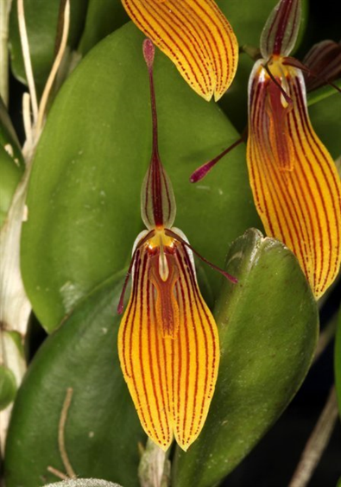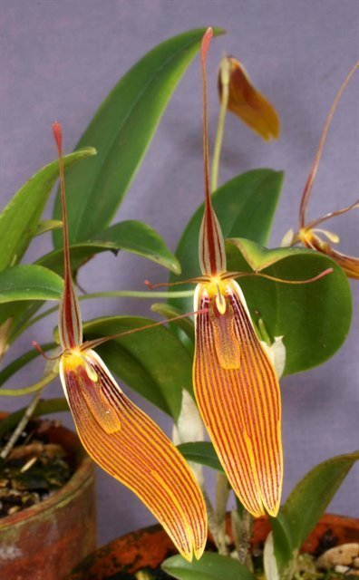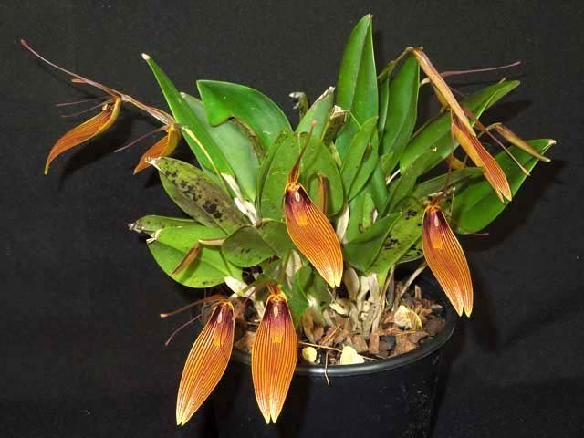

Varieties: var. xanthina
Awards: 2 AMs, 1 CCE, 1 CCM, 1 CHM, 1 CBR
Hybrids: Most widely bred along with R. contorta: 16 first, 17 second and 10 third generation hybrids, mostly between 2015-2017 by the Eric Young Foundation
SPECIES DATA REPORT
Restrepia antennifera Kunth 1816
Synonym: Pleurothallis ospinae R.E.Schult. 1957; Restrepia antennifera subsp. hemsleyana (Schltr.) H. Mohr 1996; Restrepia antennifera subsp. klabochorum H.Mohr 1994; Restrepia antennifera var. maculata R.Escobar 1992; Restrepia antennifera var. puntillosa R.Escobar 1992; Restrepia antennifera var. roseola R.Escobar 1992; Restrepia hemsleyana Schltr. 1920

This is the type species for the genus
Found in Venezuela, Colombia, Ecuador and Peru in andean forests on tree trunks at elevations of 1600 to 3500 meters as a small to just medium sized, cool to cold growing, tufted epiphyte with erect stems enveloped basally by 3 to 4 purple spotted, sheathing bracts and carrying a single, apical, erect or erect-spreading, ovate or elliptic, obtuse or rounded, coriaceous leaf that blooms in the later winter and early spring and again in the late summer and early fall on 1 to 4, axillary, terete, slender, glabrous, 1.2 to 3.2" [3 to 8 cm] long, single flowered inflorescence carrying a large [for the genus] flower.
Varieties: N/A
Awards: 2 AMs, 1 HCC, 2 CCMs, 2 CHMs, 1 CBR
Hybrids: 8 first generation hybrids and 3 second generation hybrids. Amongs those, Rstp. Tattoo are most well known and received 3 awards from the AOS (2 AMs and 1 JC)
