The Genus Stelis
Swartz 1800
Type species: Stelis ophioglossoides
Leach orchids (genus Stelis) is a large group of orchids, with perhaps 500 species. The generic name Stelis is the Greek word for 'mistletoe', referring to the epiphytic habit of these species. They inhabit moist, mossy forests on the trunks of trees or rarely on rocks throughout the tropical New World and many have light sensitive flowers which need direct temporary sun to open and some close completely at night. The species within Stelis are some of the most taxonomically complex of all the orchids, however they have never been popular in the horticultural industry.
This genus has no pseudobulbs and has ramicauls carrying a single apical oblanceolate leaf develops from narrow, leathery outgrowths from a creeping stem, and blooms on an inflorescence arising from the apex of the ramicaul and has a presence of a joint between the pedicel and the ovary, the flowers have flattened, variously connate, spreading sepals that are often equal in shape and very short, truncate petals with a small lip and a very short column often with a bilobed stigma enveloping the anther and carrying 2 hard pollina. Most species have long, dense racemes of small, translucent flowers in shades of white and yellow. The dorsal sepal is usually the most prominent part of the flower, with the other sepals and petals being minute. The three symmetrically rounded sepals generally form a triangle with a small central structure, made up of the column, small petals and small lip, though slight variation to this theme does occur. The tiny lip is often lobed and hairy.
Judging using Pleurothallis scale

Significant species | Offsprings | Awards | Special characteristics
Ste. quadrifida | 0 | 3 AMs, 1 CHM, 1 CBM, 1 CCE, 9 CCMs
Ste. gelida | 0 | 1 CCE, 4 CCMs, 1 CBR, 1 CBM, 1 CHM
Ste. cypripediloides | 0 | 5 CCMs, 1 CBR
Ste. argentata | 0 | 1 AM, 2 CHMs, 7 CCMs
Ste. immersa | 0 | 1 AM, 1 HCC, 2 CCMs, 2 CHMs
Ste. emarginata | 0 | 4 CCMs, 1 CBR, 1 CBM
Ste. megachlamys | 0 | 1 JC, 1 HCC, 1 CCM, 2 CHM, 1 CBM
Ste. kefersteiniana | 0 | 1 AM, 1 HCC, 2 CCEs, 1 CHM, 1 CBR

SPECIES DATA SHEET
Stelis quadrifida [Luer] Luer 1978
Synonym: Anathallis racemiflora (Lindl. ex Lodd) Pridgeon & M.W.Chase 2001; *Dendrobium quadrifidum La Llave & Lex. 1825; Humboldtia incompta (Rchb. f.) Kuntze ?; Humboldtia longissima (Lindl.) Kuntze ?; Humboldtia nicaraguensis (Rchb. f.) Kuntze ?; Humboldtia quadrifida (Lex.) Kuntze; Humboltia incompta (Rchb. f.) Kuntze 1891; Humboltia longissima (Lindl.) Kuntze 1891; Humboltia nicaraguensis (Liebm.) Kuntze 1891; Humboltia quadrifida (Lex.) Kuntze 1891; Humboltia racemiflora (Lindl. ex Lodd.) Kuntze 1891; Loddigesia quadrifida (La Llave & Lex.) Luer, 2006; Physosiphon nicaraguensis Liebm. 1853; Pleurothallis ghiesbreghtiana A. Rich. & Galeotti 1845; Pleurothallis ghiesbreghtiana var. cleistogama L.O.Williams 1951; Pleurothallis incompta Rchb. f. 1854; Pleurothallis longissima Lindl. 1859; Pleurothallis lyroglossa Schltr. 1910; Pleurothallis nicaraguensis (Liebm.) Rchb. f. 1861; Pleurothallis niederleinii Schltr. 1918; Pleurothallis racemiflora Lindl. ex G.Lodd. 1825; Pleurothallis tricostata Cogn. 1912; Specklinia quadrifida (Lex.) Luer 2004; Stelis nicaraguensis (Liebm.) Solano & Soto Arenas 2002 publ. 2003; Stelis quadrifida (Lex.) Solano & Soto Arenas 2002 publ. 2003; Stelis racemiflora Lodd. ex W.Baxter 1839; Stelis racemiflora (Pridgeon & M.W.Chase) Pridgeon & M.W.Chase 2001; Stelis superposita Schltr. 1915
This small to just medium sized, hot to cool growing epiphytic or occasional lithophytic species is found in the Jamaica, Mexico, Guatemala, El Salvador, Honduras, Nicaragua, Costa Rica, Panama, Colombia and Venezuela at altitudes up to 1800 meters in wet, exposed locations often in scrub forest with erect, terete, ramicauls carrying a single, apical, coriaceous, linear to oblong-elliptic or oblanceolate, retuse and obtuse apically, gradually narrowing below into the conduplicate (folded), petiolate base leaf that blooms mostly in the summer on an apical, erect, simple, to 15" [38 cm] long, simultaneously opening, many flowered inflorescence subtended by a compressed sheath carrying sweetly scented flowers held all to one side of the inflorescence which extends well above the leaves.
Grow in a pot or mounted with semi-shade and give cool to hot temperatures with year round moisture and good air movement.
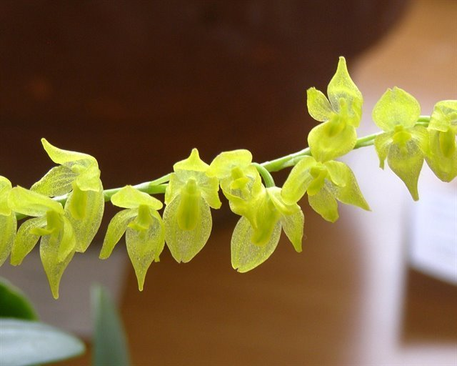
Varieties: N/A
Awards: 3 AMs, 1 CHM, 1 CBM, 1 CCE, 9 CCMs
Hybrids: No known hybrid

Reference:
OrchidWiz Encyclopedia version 3.3
Orchid Plus Online
Wikipedia Encyclopedia
https://en.wikipedia.org/wiki/Stelis – accessed 8/9/2017
Jay Pfahl’s Internet Orchid Species Photo Encyclopedia:
http://www.orchidspecies.com/pleuroquadrifida.htm - accessed 8/9/2017

